**Component contains**

**NON-Evaporative Getter (NEG)**

**Flammable Solid.**

**Keep away from heat, hot surfaces, sparks, open flames, and other ignition sources. No smoking.**

**Wear protective gloves and eye protection.**

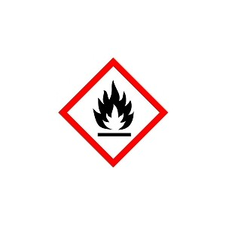

**1**

**1**

**3**

**2**

**0**