Dear Matt & Slava,
perfect. And you've attached the two most important papers to my mind!!!
Perhaps already now starting the physics discussion (forgive me) / giving some hints in what we are interested in:
a) Derbenev 1993 is excellent - but perhaps I am too stupid to get through the derivations (so far I tried my best and achieved already something) and hope that I get some private lecture on the H_res (I'm not able to get the first term with S_n) and how to solve the system of equations (5,6) to finally get to equation 8! And for an experimental physicist: By which mechanism is energy transferred from the beam to the cavity? In my simple world this is only possible when having a gradient in the B-field (Stern-Gerlach forces) ...
b) Cameron et al. is the longitudinal case where Stern-Gerlach forces are working. This to my mind is easy to understand and I arrived at almost the same equations. But: This is based on a transformation of the longitudinal magnetic moment with gamma!!! The transformation is discussed controversially (we got strong arguments that transformation is with 1/gamma!), in this case the signal would disappear almost completely. Part of this is already nicely discussed in Cameron-1998 which I have attached fyi.
Looking forward what Slava is teaching me ...
Best,
Wolfgang
Am 27.01.2016 um 14:36 schrieb Matt Poelker:
Hi Folks,
Sorry for including the cos(2theta) quadrupole reference in the agenda, this is a topic Richard is interested in and I mistakenly thought it related to your EDM endeavors. I updated the agenda per Wolfgang's comments, although I have no clever ideas how to manage the conflict of two sessions in parallel, but I bet we can work it out....maybe only start parallel sessions on Friday?
Of course weather predictions are no good 7 days in advance, but so far, no snow predicted for Virginia! that's a good thing for your travel because Virginia "closes" at the first hint of snow. It was 50 degrees outside yesterday and my youngest child had no school, there was still some snow on the ground in the shadows of trees! Very frightening for us here.
Two papers from Slava attached.
Matt
On 1/27/2016 3:30 AM, Wolfgang Hillert wrote:
Dear Mei & Co.,
very well done. The title of my talk will be: From Wolfgang Paul to eEDM: Why - and why in Bonn?
It will mainly address what you have promised ...
When looking at the table, I recognized that my travel dates are still missing. Sorry! Here they are:
arrival: 7:11pm, Feb. 2nd Newport News (PHF)
departure: 3:18pm, Feb. 5th Newport News (PHF)
accommodation: JLAB Guest House
Concerning the agenda:
I'm a bit in trouble Thursday afternoon, because I'm interested both in the activities of the ResPol group and the ExB group. (Remember: I am - at least in part - a technology guy ...) What shall I do? Could we rearrange a bit?
And - sorry for this maybe stupid question: What is planned with cos(2theta) (sc?!) quadrupole magnets with respect to EDM? Got lost a bit ...
Really looking forward to meeting you all
Wolfgang
Am 27.01.2016 00:29, schrieb Mei Bai:
Dear all
Thanks to Matt, the agenda for our visit is now finalized. Please see
attached.
Wolfgang, Richard, Frank, since I don't exactly remember the titles of
your talks, I just put a title that I hope is close to your real one.
And, my apologies if otherwise.
Best,
Mei
On 1/8/2016 5:21 PM, Mei Bai wrote:
Dear all
Finally, we are converging on visiting dates, i.e. Feb. 3, 4, and 5th.
The tentative plan is to start discussion with Derbenev on resonant
polarimetry on the 3rd and part of the 4th, and EB deflector
discussions on the 4th and 5th.
For better planning, could you please let me know whether you are
available for these dates? If so, when you plan for be there?
And, for resonant polarimetry folks, we plan to have a preparation
meeting in Bonn on the 21st. Shall we try to get it started at 2pm?
For EB deflector folks, would be great to also have a preparation
meeting.
Best,
Mei
------------------------------------------------------------------------------------------------
------------------------------------------------------------------------------------------------
Forschungszentrum Juelich GmbH
52425 Juelich
Sitz der Gesellschaft: Juelich
Eingetragen im Handelsregister des Amtsgerichts Dueren Nr. HR B 3498
Vorsitzender des Aufsichtsrats: MinDir Dr. Karl Eugen Huthmacher
Geschaeftsfuehrung: Prof. Dr.-Ing. Wolfgang Marquardt (Vorsitzender),
Karsten Beneke (stellv. Vorsitzender), Prof. Dr.-Ing. Harald Bolt,
Prof. Dr. Sebastian M. Schmidt
------------------------------------------------------------------------------------------------
------------------------------------------------------------------------------------------------

Dear Matt and all,
thanks a lot for the information. I've started going through all this in more detail and to first analytically (in "conventional" way without using Hamilton formalism which is to hard for a poor experimentalist) derive correct formulas, which will be presented soon in a detailed report/paper. I've filled already 5 pages, but I will need at least some more days to work out the integrals for different cavity modes. But I would like to make some comments already now, see below.
Best,
Wolfgang
A. Cavity:
1. We should start with a warm cavity. If simulations show a too small
signal, then we can use an SRF cavity - signal is proportional to Q.
2. We should start with 500 MHz beam. Again, if signal is too small,
then we can try 1500 MHz - signal is proportional to f^{^4}.
Why should the frequency scale with the 4th power of frequency?
Important: I expect a very weak signal which is additionally suppressed by the factor G (transverse) or 1/gamma (longitudinal). See less chance with nc cavities ....
3. The cavity must have a TM110 mode: B field on axis (zero on
entrance and exit and maximum at centre). No E field on axis
(longitudinal or transverse). Cavity length is lambda/4.
4. This cavity will not be sensitive to charge but there will be some
signal since the beam can be slightly off-axis.
5. The cavity will be sensitive to longitudinal polarization p and the
signal is proportional to (q p)^{^2}, where q is the bunch charge.
First: TM110 will have no longitudinal change of fields!!!
Second concerning long. polarisation: Definetively no! TM110 is only sensitive to transverse polarisation, because there is (by definition!) no longitudinal B-field! But it could be used for transverse polarisation. Length of lambda/4 will only waste signal, I would strongly recommend lambda/2. Hope that this will be clearly verified by formulas soon...
B. Data Collection:
1. Both helicities will give the same signal.
Not in case for longitudinal polarisation and TE011. This in my opinion is the favorte one for CEBAF! The cavity should be operated at low gamma because the longitudinal signal is supressed by factor 1/gamma. It should be tuned to the bunch frequency (no direct coupling to charge due to missing longitudinal E-fields). Data taking should be phase-locked to RF. In this case the signal should flip phase when flipping helicity.
So instead of flipping
between ±p, we will flip the Pockels Cell between 0 and p (i.e,
instead of ± 2.5 kV, it will be 0 and 2.5 kV).
2. We will use the parity DAQ to read BCM, BPMs, and the RF cavity.
3. The BCM and BPMs will be used to make sure the beam is the same
between 0 and +h (as in parity experiments).
4. For the RF cavity: when p=0, the signal will consist of thermal
noise and "background" from beam being off-axis. For p, the polarization
will contribute to signal. We will measure the difference: (p signal +
thermal + background) - (thermal + background) = p signal.
5. It is very important to have a parity DAQ and BCM and BPMs to
measure beam properties since p signal is very small (similar to
position differences in a parity experiment).
This is fine for transverse polarisation. But I would favorite a longitudinal setup. In addition, I doubt that the resolution of the BPMs will be sufficient to detect harmful changes in beam position and pointing ...
C. Location: There is two ideal places at CEBAF for such measurement
with DAQ, BPMs and BCM: Injector 5 MeV region and Hall A beamline.
Do it at low gamma!!!
D. Measurements:
1. With 50 uA, we can use the Wien flipper to scan the polarization in
3D (i.e, horizontal and vertical). Measure p signal vs p.
2. One open question in theory is the scaling of signal with energy: we
can study this by changing energy in injector between 3 and 9 MeV, or in
Hall A between 2.2 and 11 GeV.
This is trivial! For sufficiently high gamma, the transverse signal is independant of beam energy, whereas the longitudinal scales with 1/gamma. Wait a few days for the formulas ...
E. Deciding on cavity type: we can start the simulations with a warm
cavity, if signal is too small, we switch to SRF cavity. John Musson/SRF
can help with design and readout (receiver + amplifiers).
I would propose a phase-sensitive signal detection using a lockin amplifier locked to the rf. Zurich instruments can go up directly to 500MHz. If not available or use of higher frequencies, the signal has to be downconcerted by a dedicated LO. There is a paper of Pusch et al. in PR-STAB concerning this, where we have demonstrated detection of P < 10^-18W.
F. Deciding on location: We can start with injector since it is easier
to get beam time, then try Hall A if it turns out the higher energy
gives larger signal.
Again: I would propose to start with low gamma!
Thanks,
Riad.

Dear Haipeng et al.,
this is really good news! I totally agree to your comments and as well to your email sent on Feb 5th which I didn't got! If there already exist a TE011 cavity go for this!! Do it at the injector. If enough signal can be generated (which still has to be proven, I'm working on this), this could also serve as a non-invasive polarimeter, measuring the beam's polarisation within seconds only!
And: You will definitively be the first - what a pity for Bonn...
Good luck and best wishes,
Wolfgang
Am 11.02.2016 22:00, schrieb Haipeng Wang:
Raid and Matt,
You might missed following e-mail I sent on Feb. 5th. When I said that the second day's idea is better than the first day.
The best cavity type is the TE011 (cylindrical) type. So when the beam is running through the cavity axis, there is no beam impedance to the bunch charge. That will significantly reduce the noise due to the q but maximize to the p.
Using TM110 type, 1/4 lambda long would reduce the beam transient time factor. So my idea was to use it in side way, so magnetic field would not kick the beam (due to charge effect). Then you can use longer cavity length (but <= 1/2 lambda) in the beam path direction. Since the electric kick is 90 degree away near cavity entrance and exit, by a EM design such an effect can be minimized.
The cavity has to be superconducting in high Q in order to get high impedance to the polarization and filter out the rep rate frequency signal induced from the charge (side band discussion in our meeting), if any. It can be run in the passive mode as long as the design has a very high longitudinal polarization impedance.
We have developed such TE011 cavity by Gigi Ciovati in 2010. After overcame of a multipactor problem, we got ~90mT on the cavity wall with a high Q of ~10^{^10}.
I hope this information will help you on the cavity part of this experiment.
Regards
Haipeng
Haipeng wrote following e-mail on Feb. 5, 2016
Mei,
We had a few conversations about the SRF cavity design for your polarimeter between Matt and Bob yesterday and this morning. Based on our understanding. The best cavity type is to let polarization vector mu parallel to the RF magnetic field but to avoid the charge inducted voltage and beam abbreviation effect. That means longitudinal polarized beam is the best choice.
Bob has suggested that using a TE011 type cavity with the beam running though the magnetic field lines but all electric field lines are in the circular direction which I think is the best. The Q of such cavity can be much higher than regular TM type due to the low joint loss on the circular contacts of the cavity
I thought also about using TM110 type cavity but running beam in side way unlike we using the magnetic field for kicking the beam. So magnetic field is also parallel to the beam running direction. But beam abbreviation can cause the bunch kicked by the electric filed in side way (like in vertical direction, but in 90 deg phase, so for a short bunch there is possible no problem). The magnetic field cause no kick and also would not inducing voltage in the cavity
The best place to do this experiment is at CEBAF where beam is relativistic, bunch length can be very short compare to the cavity wavelength. The cavity frequency could be reasonable high to the multiple harmonics of 499MHz. The cavity can be passive to the beam, without LOM HOM damping? In fine tunable design for the sideband detection and rigid enough to minimize the microphonics or with a fancy LLRF control to reject unwanted signals.
We might be able to give you signal to noise ratio estimate for such idea and the a practicable design.
Best Regards
Haipeng
On 2016/2/11 2:46 PM, Matt Poelker wrote:
Hi Folks,
Riad summarized his thoughts on the RF-resonance polarimeter idea, shown below. I can imagine you are digesting the information from last week, and you will provide a similar summary. Probably a good idea, right?
Matt
-------- Forwarded Message --------
Subject: RF-resonance Polarimeter at CEBAF
Date: Tue, 9 Feb 2016 10:08:41 -0500
From: Riad Suleiman <suleiman@jlab.org>
To: Matt Poelker <poelker@jlab.org>, Joe Grames <grames@jlab.org>
Hello,
Here are my thoughts about RF-resonance Polarimeter at CEBAF:
A. Cavity:
1. We should start with a warm cavity. If simulations show a too small
signal, then we can use an SRF cavity - signal is proportional to Q.
2. We should start with 500 MHz beam. Again, if signal is too small,
then we can try 1500 MHz - signal is proportional to f^{^4}.
3. The cavity must have a TM110 mode: B field on axis (zero on
entrance and exit and maximum at centre). No E field on axis
(longitudinal or transverse). Cavity length is lambda/4.
4. This cavity will not be sensitive to charge but there will be some
signal since the beam can be slightly off-axis.
5. The cavity will be sensitive to longitudinal polarization p and the
signal is proportional to (q p)^{^2}, where q is the bunch charge.
B. Data Collection:
1. Both helicities will give the same signal. So instead of flipping
between ±p, we will flip the Pockels Cell between 0 and p (i.e,
instead of ± 2.5 kV, it will be 0 and 2.5 kV).
2. We will use the parity DAQ to read BCM, BPMs, and the RF cavity.
3. The BCM and BPMs will be used to make sure the beam is the same
between 0 and +h (as in parity experiments).
4. For the RF cavity: when p=0, the signal will consist of thermal
noise and "background" from beam being off-axis. For p, the polarization
will contribute to signal. We will measure the difference: (p signal +
thermal + background) - (thermal + background) = p signal.
5. It is very important to have a parity DAQ and BCM and BPMs to
measure beam properties since p signal is very small (similar to
position differences in a parity experiment).
C. Location: There is two ideal places at CEBAF for such measurement
with DAQ, BPMs and BCM: Injector 5 MeV region and Hall A beamline.
D. Measurements:
1. With 50 uA, we can use the Wien flipper to scan the polarization in
3D (i.e, horizontal and vertical). Measure p signal vs p.
2. One open question in theory is the scaling of signal with energy: we
can study this by changing energy in injector between 3 and 9 MeV, or in
Hall A between 2.2 and 11 GeV.
E. Deciding on cavity type: we can start the simulations with a warm
cavity, if signal is too small, we switch to SRF cavity. John Musson/SRF
can help with design and readout (receiver + amplifiers).
F. Deciding on location: We can start with injector since it is easier
to get beam time, then try Hall A if it turns out the higher energy
gives larger signal.
Thanks,
Riad.
--
_____________________________________________________________
| |
| Riad Suleiman Cell: (757) 254-7895 |
| Jefferson Lab Office: (757) 269-7159 |
| 600 Kelvin Dr |
| Suite 3 |
| Newport News, VA 23606Email:suleiman@jlab.org |
-------------------------------------------------------------

Dear all,
thanks for the info.
Re Richard: I'm still quite sure that the scaling for the longitudinal polarimeter goes with 1/gamma. This is caused by fundamental Lorentz transformation laws. I'm curious about your findings ...
Meanwhile, I have set up the full formalism and got analytical expressions for pill-box cavities. I calculated the signal power for different modes, including the effect of fringe fields in the transverse. I try to get this published as soon as possible ...
Attached is the situation for a longitudinal polarimeter @ CEBAF using a TE011 mode.
The parameters are:
beam current 100 microamps
bunch factor 0.7
unloaded quality factor 10^{^10}
coupling factor 10 (hard task, but the signal scales linearly with the inverse coupling!)
resonant frequency 1.5 GHz
beam energy 20 MeV (Gamma = 20)
Beta_ph is the corresponding phase velocity in the circular waveguide of the pill-box and determines the geometry of the cavity. Note that this parameter is of great importance!
And note that the excitation by the beam charge is about 14 orders of magnitude greater! This means that for getting above the charge background the beam has to be centered with a precision of 10 nm and 10 nrad - which I think is hardly achievable!
The cavity could be tuned to half the bunch frequency (750 MHz) and the spin flipped for every other bunch (use of two lasers?). But this would only work if the intensity variation between bunches with pos. and neg. helicity is at a level of about 10^{^-14} - again hard to be achieved!
So it turns out that the pop is not an easy task ...
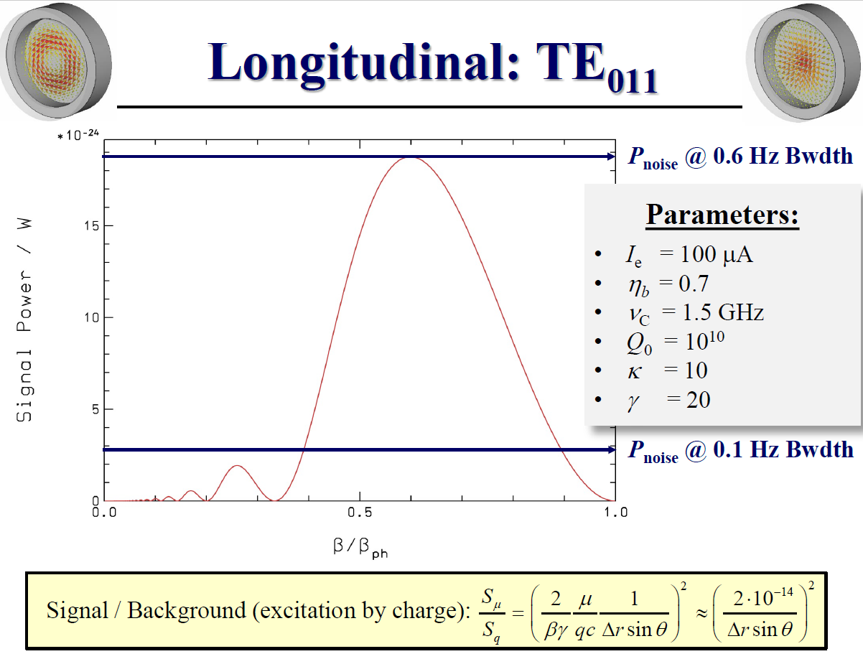
Best from Bonn
Wolfgang
Am 07.03.2016 um 21:13 schrieb Matt Poelker:
Hi Dick,
Good to hear from you. I include Bob Rimmer and Haipeng Wang on this email - they are the JLab guys who talked about an existing cavity at JLab. And I include Wolfgang Hillert too, we are anxiously awaiting his assessment of the resonant polarimeter technique!
Matt
On 3/7/2016 1:57 PM, Richard M. Talman wrote:
Matt
I have been diligently working away at resonant polarimetry. As usual it goes more slowly than one anticipates. One "conclusion" reached at the recent CEBAF workshop was, I am sure, incorrect; it was the conclusion that longitudinal resonant polarimetry peters out with increasing energy proportional to 1/gamma. But this in not why I write.
During the workshop there was discussion of an existing superconducting cavity intended for diagnosing electron beams in CEBAF injection lines. I should remember what was said, and by whom but, regrettably, I do not.
I would very much like to have information about properties of that resonator, especially its dimensions and frequencies. (Or other resonators, if you have come to regard them as more promising.) This would help me to make my calculations more concrete.
Thanks
Dick Talman

Dear Haipeng,
you're right concerning delta_r and sine(theta). And the signal-to-noise ratio is exactly as you have mentioned, but with an additional factor 1/gamma caused by the transformation of the longitudinal fields.
Concerning the coupling, I've not told the full truth. The inverse scaling I've mentioned is only valid for large kappa. The correct scaling goes with kappa/(1+kappa)^{^2}, which is already well known from cavity BPM's. So small kappa values will not help either, best for signal strength would be kappa = 1.
And btw, the frequency scaling goes with omega^{^2} for fixed quality factor (which, for sc resonators, may be limited by other issues).
Best,
Wolfgang
Am 08.03.2016 16:51, schrieb Haipeng Wang:
Dear Wolfgang, and Richard,
Thanks for your updated information and further discussions. Since our meeting, I started to look at the SRF cavity candidates including the TE011 cavity, but quickly dropped out due to my other commitments....
Attached paper copy is my PAC2011's publication about Gigi's TE011 cavity at 3.29GHz. As Bob said, this cavity shape probably is not suitable for our experiment to be proposed. The cavity coupling port asymmetry caused field distortion of the purely circular TE011 mode (a weak perpendicular E-field to the bottom wall of this TE011 cavity) and then electrons are pulled out from the bottom wall and bent back to strike the wall again. The multipactoring problem happened (electron activity in the RF structure which prevents the magnetic field going to a higher level)
Yes, in my hand note, I had figured out a similar signal-to-noise ratio related to the polarization to charge induced power wgich should be in 10^{^-26}, or voltage ratio be in 10^{^-13}. The physics origin is the ratio of (mu_B/q/clight)! But I think, it is still possible to detect it. For example, if the cavity can be operated in the passive mode, then the coupling beta (Wolfgang's kappa) could be as low as 10^{^-3} or 10^{^-4}.
I still don't know what is the Delta_r and sine(theta) in Wolfgang's slide, I assume it is off-axis distance and the sine of beam tilting angle related to the pill-box axis. In my opinion, these errors can be minimized by the design and an interactive beam based alignment system.
If your signal-to-noise analysis can be published, then I can come to a practicable design from the pill-box model.
Regards
Haipeng

