Summer SAD Injector – 2018 (REV 1 – April 12, 2018)

- Perform Bubble Experiment Engineering Run
  - Vacuum work - install harp and ceramic break on 5D beam line
  - Bubble chamber – reinstall target chamber as before
  - Beam Run – approximately one week of 24/7 running (up to 100uA)
- Install 350 kV HVPS
  - Assemble HVPS/SF6 tank near Gun2
  - Install HVPS controls/software
  - Modify and integrate PSS controls
  - Certify operation of HVPS
  - Demonstrate capability to switch between new/old supplies
- Install 200 kV Gun
  - Protect photocathode supply in Gun2
  - Vent Gun2 to install/align the 200kV electrode from UITF
  - Bake Gun2, leak free
  - High voltage condition Gun2, vacuum and/or gas conditioning
  - Make photocathode, check laser alignment
  - Restore and run beam at 130keV (new gun and HVPS)
  - Increase voltage to test injector settings needed w/ 200keV beam
- Reliable Polarized Source
  - Demonstrate “new gun” ready for operations
  - Gun back-out possible
  - HVPS back-out possible

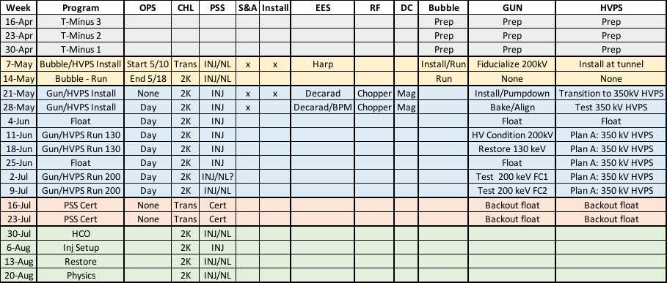

May 6 – May 19: First two weeks of SAD are highly integrated

- Sun/6
  - Beam off at 6am, then surveys
  - Attach turbo pump to 5D over board valve, clean-up overnight
- Mon/7
  - Bubble
    - Secure 5D vacuum valve
    - Unstack lead hut (RCG)
    - Vent 5D, install harp + ceramic break, verify isolation
    - S&A set harp rotation
    - Pump down + leak check vacuum OK
    - Install move crates tunnel, work w/ Brad begin install
    - S&A work w/ Brad set Bubble chamber
    - Install Bubble laser shutter
- Tue/8
  - Bubble
    - Final leak check Bubble line
    - Tony (re)allocate harp cable, make-up + HCO harp
    - Connect dump picoammeter
    - Install work w/ Brad to roughly set Bubble chamber
    - When ready S&A check 5D radiator/collimator set Bubble
  - Gun
    - Install move Suitcase, mate to Load and start bake
- Wed/9
  - Bubble
    - S&A complete alignment of Bubble chamber
    - ACE support for network controls
    - Brad continues Bubble assembly and training
  - Gun/HVPS
    - Install move/assemble SF6 + HV stack w/ John in tunnel
    - End suitcase bake
- Thu/10
  - Bubble
    - Complete Bubble assembly and training
    - Complete Bubble HCO checklists
  - Gun/HVPS
    - Continue HVPS assembly (short bar, LV circuit, SF6 charge?)
- Thu/10 1600 – Fri/18 0800
  - 24/7 Ops and INJ/NL begins…(CA/RA by exp’t as needed)
- Sat/19
  - Open House

May 21– June 1: These two weeks we install 350kV HVPS and 200kV gun

- HVPS
  - Secure 150kV Glassman
  - Facilities/PSS install conduit and AC contactors, cabling
  - John install 350kV Glassman control unit
  - Install 350kV Glassman interface chassis
  - Install 350kV Glassman control software
  - Move Keithley readbacks from 150kV to 350kV (no soft lock)
  - John/Software install DAC iocin3, software/cabling
  - PSS/Software install VME comparator card (HV window), cabling
  - Complete assembly/cabling, HCO w/o PSS permissive
  - When ready BP lock-up for HCO up to resistor tank
- Gun
  - Check laser retro-reflection
  - Secure HVPS from Gun
  - Isolate Gun valve
  - Move photocathodes to Suitcase
  - S&A fiducialize 10” flange to gun
  - Vent gun, remove electrode to S&A lab
  - S&A fiducialize electrode to 10” flange => to set 200kV electrode
  - Check 200kV vs. 130kV puck cage => choose best one
  - Remove existing NEG tube
  - Install fiducialized 200kV electrode to Gun2, set/align
  - Install NEG tube w/ M20 BPM’s
  - Replace RGA? w/ Kr gas valve/plumbing
  - Check all electrical isolations
  - Pump down Gun2, leak check
  - Setup bake (HV chamber, NEG tube, Kr line, overboard)
  - Careful bake: up – soak – down – activate – down => leak check
  - Rejoice in leak free bake, check vacuum
  - When ready, move photocathode to HV, check retroreflection
  - Hook-up two new BPM’s, perform HCO
  - Reconnect cables, magnets (not HV yet!)
- Other
  - Install Decarad
  - Move PSS kicker to “200kV location”
  - RF condition choppers for 200kV operation
  - Test magnets/PS for 200kV limits

June 4 – June 8: This week is FLOAT, but if going well we move to next stage…

June 11 – June 22 : These weeks we restore gun operation!

- Perform HCO of PSS/HVPS (interlocks, controls, software)
- W/o connection to gun demonstrate PSS/HVPS operation
- W/ connection to gun via resistor tank HV condition w/ vacuum condition
- Assess x-ray/vacuum vs. HV, then Kr condition if needed
- Complete conditioning to X kV
- Make photocathode, install gun, use LV to measure QE, check retro-reflection
- Restore at 130kV for standard operation INJ SEG mode
- Use 130kV beam and test PSS kicker in “200kV location”
- Test operations of 130 keV beam using new gun, HVPS and PSS… to FC2
- Once satisfied, stop so can test migration/steps to go between 350/150 HVPS
- Rejoice!

June 25 – July 6: Another week of float, but if successful we charge forward !!!

July 2 – July 13: Break for the July 4th , and test for 200 keV operation

- Configured and scale injector for 200keV beam
- Operate gun at 200kV, setup/test injector for beam to FC1 (chopper OFF)
- Perform PSS kicker and PSS dipole (INJ SEG) testing/certification
- Use Wien or spectrometer to measure energy stability
- Turn on chopper, measure deflection v. power, perform chopper setup
- Benchmark beam v. charge (transmission, emittance)
- Decide on possible setup to FC2 (chopper ON/OFF, capture ON/OFF)

July 16 – July 27: Backout Float !

- Planning on success we are done by now, and would consider introducing opportunistic INJ studies over these two weeks, e.g. PQB laser/beam work.
- IF we had any problem w/ Gun or HVPS or NEG tube we would’ve learned this ~two weeks ago, and by now would have resolved or backed-out…so, this is really Float for a Backout.

