JLAB-TN-18-020
Radiation Safety Aspects of the Upgraded Injector Test Facility
Vashek Vylet

Abstract
Upgraded Injector Test Facility (UITF) is a new 10 MeV electron accelerator designed to test advanced concepts in the design of accelerator guns, accelerator diagnostic devices, detectors and other equipment to be used in JLab’s CEBAF accelerator, experimental halls and possible future installations. The facility consist of a heavily shielded existing electron gun test area, Cave 1, currently housing an electron linac with a short “1/4” cryogenic accelerator module (¼-CM). A new area, Cave 2, has been added to provide space for testing experimental equipment. The use of a cryogenic gas, liquid helium, and the requirement of movable roof panels presented challenges for shielding design. A large opening in the side shielding wall just under the the roof shielding is required to keep the facility at the desired Oxygen Deficiency Hazard 0 level. This text presents a radiation safety assessment for normal operation and accident scenarios using a combination of Monte Carlo and simpler shielding calculation techniques.

Background
UITF is a recent extension of a well-shielded enclosure used for research and tests of electron accelerator guns. The “Test Lab” building housing this facility, shown if Figure 1, originally contained the Space Radiation Effect Laboratory (SREL) operated by a consortium of universities for NASA from 1966 until 1980. The SREL included a synchrocyclotron with a primary beam of 600 MeV protons and secondary beams of 400 MeV pions and muons produced for studying the effects of radiation on materials planned for use in space. After Jlab acquired the site, the original shielding has been largely removed or reconfigured for other purposes.
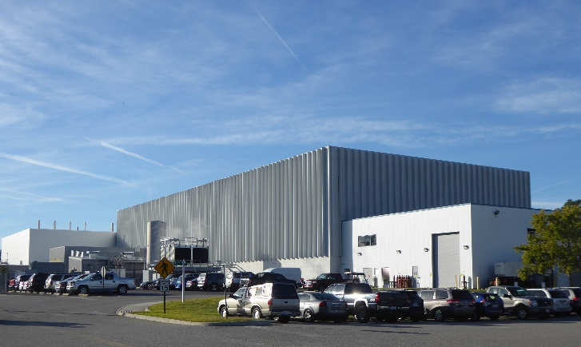
Fig. 1: Test Lab housing UITF in its northeast corner, facing the viewer. The white North Annex building is on the right side of the picture.

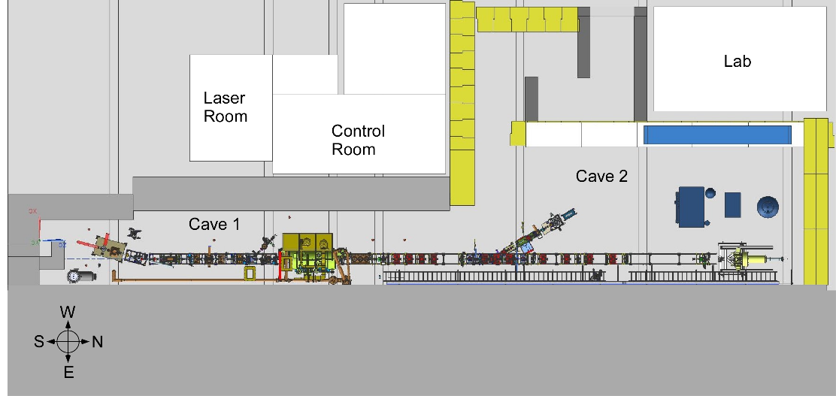
Fig. 2: Layout of UITF, including existing Cave 1 and newly added Cave 2 area. Legacy shielding shown in light grey color.

The gun test area, Cave 1, is a remainder of the original shielding shown in grey in Fig. 2. The shielding wall on its east side is approximately 5.5 m thick. Cave 1 now contains an electron gun that injects electrons to a short accelerator module containing cryogen-cooled RF cavities. The 10 MeV beam will be used in the newly built addition, Cave 2, to test experimental equipment and accelerator diagnostic devices. In the near future the facility program will focus on testing the cryogenic target for the HDIce experiment^{[1, 2]}. The experiment will use an elevated beam line shown in Fig. 3.

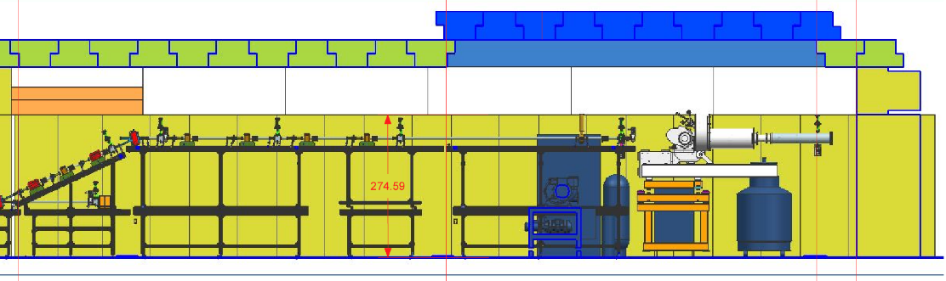
Fig. 3: Vertical South – North section through Cave 2 containing the cryogenic HDIce target. Removable roof panels (in blue) allow installation and removal of bulky experimental equipment

Operational Parameters and Shielding Requirements
During the HDIce tests, it is expected that beam current of 100 nA will be used for tuning and current calibration measurements, approximately 20% of the total running time of 900 hours per year^{[3]}. This is necessary because the very low currents equal or below 10 nA needed for HDIce target tests are unsuitable for steering and current calibrations. The HDIce target tests will consume the remaining 80% of time budget.
The Test Lab building is accessible to any Jlab employees without requirement of radiation safety training. The shielding requirements are therefore the same as for public, i.e. not to exceed the effective dose regulatory limit of 100 mrem per year. The shielding design goal for such areas is conservatively lower, 10 mrem/y. However, facility use and occupancy factors can be applied. As part of the ALARA approach, Jlab Radiation Safety uses the concept of Radiologically Control Area (RCA), accessible only to radiation workers. RCAs are posted where routinely exceeding dose rates of 50 μrem/h may be expected, e.g. around radioactive material storage locations. This RCA dose rate threshold value is derived from the above 100 mrem/y regulatory limit, assuming a 2000 h/y occupancy.
If the shielding were designed so that a loss of 100 nA results in a dose rate outside shielding at the RCA limit, this would already slightly exceed the design goal of 10 mrem/y if we assume the above usage and full beam loss (which would be a very conservative assumption). While not all such losses will occur in places without local shielding (e.g. outside Faraday cups or dumps), calculated dose rates consistent with the RCA limit are in this case a useful reference used throughout this text. It is envisioned that future tests and experiments in Cave 2 would use 10 MeV beams with currents up to 100 μA. This operation may be possible as long as routine beam losses anywhere along the beamline can be kept below 100 nA, the value for which the current Cave 2 shielding has been designed. It is of course assumed that beam dumps, Faraday cups and other points of frequent beam loss will have local shielding. The issue of accident scenarios is discussed further in this document.

Initial Shielding Evaluation

Cave 2
The UITF project collaboration envisioned to assemble the Cave 2 extension mostly by reusing spare interlocking shielding blocks, available in a thickness of ~120 cm (4 feet). Similarly, interlocking roof panels recovered from earlier projects, ~ 53 cm (1.75 ft) thick, were available. Use of thicker roof panels is precluded by the need to periodically remove part of the roof to allow installation of bulky experimental equipment and by the limitations of the overhead crane. Additional 60 cm (2 ft) thick blocks were used for elements of the entry maze.
The initial shielding evaluation used source terms and attenuation tenth-value layers from the NCRP Reports 51^{[4]} and 144^{[5]}. The exception was a forward source term, calculated using GEANT3 for a narrow electron beam hitting, under a glancing angle, a steel pipe terminated by a thick flange^{[4]}. The source term is averaged within a 2º forward angle and is an order of magnitude lower than the NCRP value of 300 rad at 1 m for a 100 nA beam loss. It is worth noting that at 90º the GEANT3 source term is 3 rem/h at 1 m, almost 60% lower than the NCRP value of 7.2 rem/h. Results are summarized in Table 1 below, assuming that 5% of the 100 nA beam is being lost constantly, with occasional mis-steering loss of up to 100 nA. These results show that, with the wall and roof thickness as specified above, there is potential for exceeding dose rate limits corresponding to Radiation Area and High Radiation Area designation, i.e. 5 and 100 mrem in an hour, respectively. Since there is no need for frequent access to the roof and additional shielding is not practical for logistical reasons, the roof can be managed with appropriate administrative controls and monitoring.
Location | Beam loss | E [mrem/h] | Note
Side wall | 5% | 2.21E-03 | below RCA
 | 100% | 4.42E-02 | below RCA
Forward | 5% | 0.28 | RCA
 | 100% | 5.6 | Radiation Area
Roof | 5% | 2.76 | RCA
 | 100% | 55.2 | Radiation Area

Table 1: Expected dose rates from routine and accidental beam losses

The design of the access maze to Cave 2 is such that rays scattering from the enclosure towards the exit will undergo at least 2 reflections in the maze if they originate in the short section of the beamline that can irradiate the end wall of the first maze leg; any other rays. Rough estimates using NCRP source term at 90º for a 100 nA loss at 10 MeV, with source facing the maze entrance and photon albedo of 0.01 for each reflection, yield dose rates on the order of ~6 μrem/h at the maze exit. Local shielding of this short beamline section would easily mitigate radiation levels if higher losses are routinely expected.
A singular shielding complication in Cave 2 roof is a large opening on its north-east side. It is designed to allow He gas to vent out of the UITF Cave 2 enclosure in case of accidental cryogen loss from the large Dewar container near the HDIce target. Another issue is that the forward shielding on the north side of Cave 2 borders an infrequently occupied passage towards an exit door from the building. However, adjacent to this passage is the North Annex building (see Figure 1 above). Its second floor, approximately at the roof level of UITF, contains a storage area permanently occupied by three custodians. This area could be affected by both radiation leakage through the forward shielding and the roof. In the next phase, we studied these issues and their solutions using the FLUKA^{[7,8]} particle transport code.

Cave 1
A section through Cave 1 in Fig. 4 below indicates that its shielding, lateral (west side) and roof, is more substantial than in Cave 2. The roof is also higher and thicker and the beam energy will reach MeV energies only at the exit of the ¼-CM, in approximately the last third of Cave 1.

Figure 4: Schematic drawing of West – East section through Cave 1 shielding (not to scale).
30”
27”
28”

Figure 5: Iron penetration shield in MeV area of Cave 1
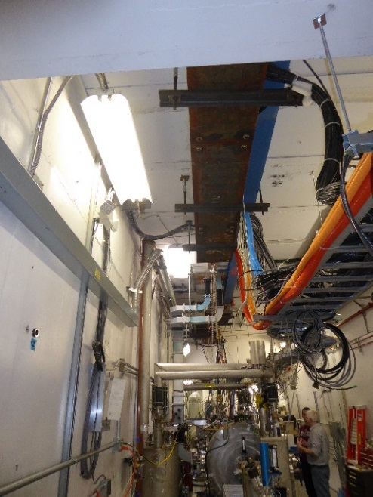 | There are six round penetrations 10” in diameter, two in the keV and 4 in the MeV region, that are unfortunately located close to the vertical position above the beamline, so that a large portion of rays tranced from a radiation source located below the penetration pass through without reflection, as indicated in Fig. 4. Iron plates 3.25” thick suspended below provide partial shielding that is not fully equivalent to the 30” thickness of the concrete roof.  Results of semi-empirical shielding estimates for the roof and side shielding for Cave 1 are presented in Table 2 below. These results indicate that during accelerator operation at 10 MeV and 100 μA, routine beam losses should be maintained at or below 0.1% to maintain occupied areas on the Test Lab floor below RCA levels.

Table 2: Expected radiation levels from 100 μA, 10 MeV, beam loss in Cave1.

CAVE 1  Scenarios | Dose rate  [mrem/h] | Note
Side 100% loss | 41 | RA
Side 1% loss | 0.4 | RCA
Side up 1% loss | 26 | RA
Roof 100% loss | 2973 | HRA
Roof 1% loss | 30 | RA
Roof penetration⁽¹⁾ 100% loss | 40621 | HRA
Roof penetration⁽¹⁾ 1% loss | 406 | HRA
(1) with current 3.25” local steel slab shield

Another type of shielding penetrations in Cave 1 are four cable trenches crossing Cave 1 perpendicularly to the beamline, as shown in Figure 6 below (also visible in Figure 2). These trenches with a 12”x12” cross-section cross the Cave 1 floor and pass under the west shielding wall, lead to occupied areas on Test Lab first floor. Trenches 1 and 2 are located in the “keV” region of Cave 1, while 3 and 4 are in the “MeV” region, beyond the ¼-CM. The latter two lead to the UITF Control Room where high occupancy is expected.

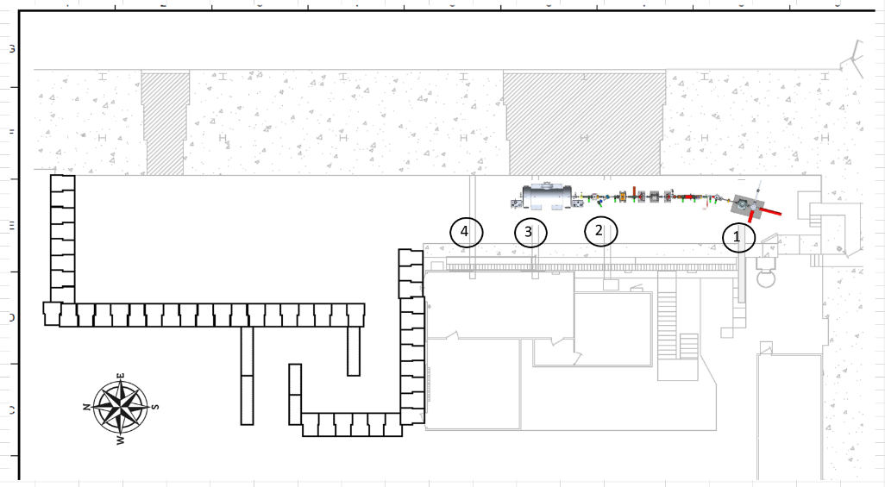
Figure 6: Cable penetrations in Cave 1, numbered 1 – 4.

In estimating radiation source terms in Cave 1 use of two electron guns was considered, yielding either 13.4 mA at 225 keV or 3 mA at 400 keV, respectively, available in the keV region. In the MeV region, 10 MeV and either 100 nA (during HDIce experiment) or 100 μA was assumed. Using simple semi-empirical methods as in Cave 2, with albedo factor estimate of 0.01 for each photon reflection, we obtained radiation level estimates summarized in Table 3 below. The last two columns indicate shielding (lead, concrete or sand) needed to achieve radiation levels below the RCA threshold.
Table 3: Estimates of radiation levels outside cable penetrations for full beam loss.

 |  | Dose rate out of | # of TVL | Thickness Pb | Thickness conc.
E [MeV] | I [A] | Trench [mrem/h] | needed | [in] | (or sand) [in]
0.225 | 1.32E-02 | 16.2 | 2.5 | 0.2 | 9.2
0.4 | 3.00E-03 | 2.6 | 1.7 | 0.6 | 6.9
10 | 1.00E-07 | 0.006 | 0 | 0 | 0
10 | 1.00E-04 | 5.9 | 2.1 | 4.6 | 32.1

These estimates are conservative (and sometimes unrealistic) in assuming a protracted duration of beam loss. In addition, the presence of 0.75”-thick steel plates covering all trenches was neglected. These plates are certainly a significant factor in the keV region. Additional information regarding likelihood and duration of various beam loss scenarios provided by Matt Poelker [3] helped to refine the assessment as follows:

Penetration #1 | Low occupancy at exit (~1/40). Possible sources: gun, insertable cup1, chopper master slit. Losses of 100 μA in the last two are possible for one minute, about once per hour. Most significant is continuous loss of 10 μA on chopper master slit during HDIce operation. Distance to trench is 16.5 feet (no straight shot). This penetrations is fairly well packed with cables. Conclusion: no additional shielding needed when compared with assumptions in Table 3.
Penetration #2 | Penetration is densely packed with cables. Occupancy in adjacent laser room is ~1/8 during operation. The most significant source will be the beam dump absorbing full current, 3 mA and 32 mA, for protracted periods. This dump is shielded with lead (see Figure 7), but not perfectly encapsulated – there will be some leaks and scatter. 0.6” lead recommended in trench, with some overlap at wall edge.
Penetrationn #3 | Trench leads to the Control Room, 100% occupancy when running. Possible QCM field emission, the intent is to run under that threshold – TBD. 100 nA or 100 μA into Faraday cup, 1 min/hour – mitigated by local FC shielding. Possible 10 μA in beampipe, maximum duration 10 minutes, stopped by vacuum loss. 2” lead in trench recommended with some overlap at wall edge.
Penetrationn #4 | 100 nA or 100 μA into Faraday cup, 1 min/hour – mitigated by local FC shielding. Possible 10 μA in beampipe, maximum duration 10 minutes, stopped by vacuum loss. 2” lead in trench recommended with some overlap at wall edge.

It is worth noting that there are two similar penetrations in Cave 2 as well. Considering planned experiments with currents up to 100 μA delivered to Cave 2, we recommend similar approach as for penetrations #3 and #4 above.

Figure 7: Partially shielded beam dump at trench #2

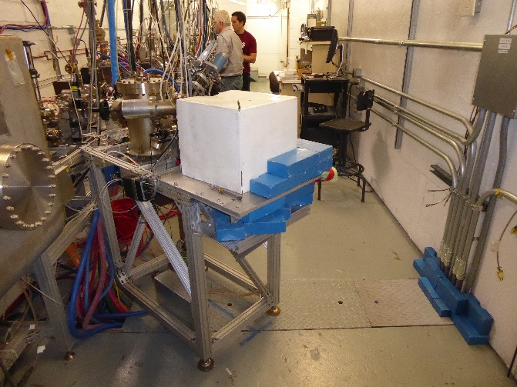

Cave 1 also includes a large ventilation penetration, shown in Fig. 8 below, through the thick concrete structure on the east side. It has a circular opening of 30” in diameter, a length of approximately 4 m, after which it bends upwards and vents air into a vertical pipe starting at 10 ft above floor level. Simple estimate of radiation levels at the exit point in the gallery predicts approximately 14 mrem/h for a 100 μA loss in the vent vicinity.

Figure 8: Large penetration at downstream end of Cave 1

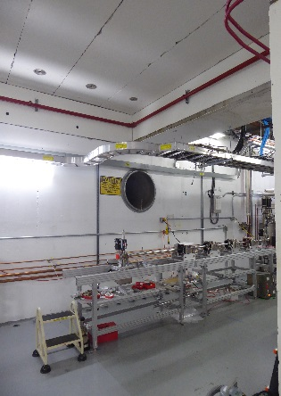

Monte Carlo Shielding and Skyshine Calculations

Forward Shielding and North Annex Storage Area
Both early simple estimates and Fluka simulations confirmed that the original forward shielding is not entirely sufficient to keep radiation levels below the RCA limit in the 1st floor access corridor and the 2nd floor storage area in the North Annex. Furthermore, using “notched” concrete blocks lying on their side created 7.5 cm thick and 60 cm deep gaps in the shielding at a height of 2.4 m above ground in both the north and west side walls. These gaps were covered with a hollow square-profile steel tube and painted, which delayed discovering this before it became impractical to disassemble the structure and fill the gaps. Insufficient overlaps of roof planks over the north and west sidewalls also introduce additional weak points. Considering these aspects and future plans to operate with higher beam currents above 100 nA, it was decided to add a 66 cm-thick layer of steel blocks to the north wall that are available on site. Since the steel block wall will not quite reach the top of the second roof panel layer, several options were investigated. The first one consists of erecting vertical steel plates attached to the end of concrete roof panels on the north side and protruding over the top of the roof to limit roof shine into the North Annex storage area. In the second option a custom concrete block, spanning the iron wall and the north end of the roof, would be installed. The latter option was chosen based on considerations of cost and ease of installation. Fluka results for this configuration, with a 100 nA loss at HDIce, is presented in figures 9 and 10 below. It is clear that with the enhanced forward shielding radiation levels at the 1st floor access corridor and the 2nd floor storage area in the North Annex will remain well below RCA level. Accidental scenario of a 100 μA beam loss is shown in figure 11.

Figure 9: Radiation levels in a YZ slice along beamline with source at HDIce. 50 cm bins, white is below RCA levels.
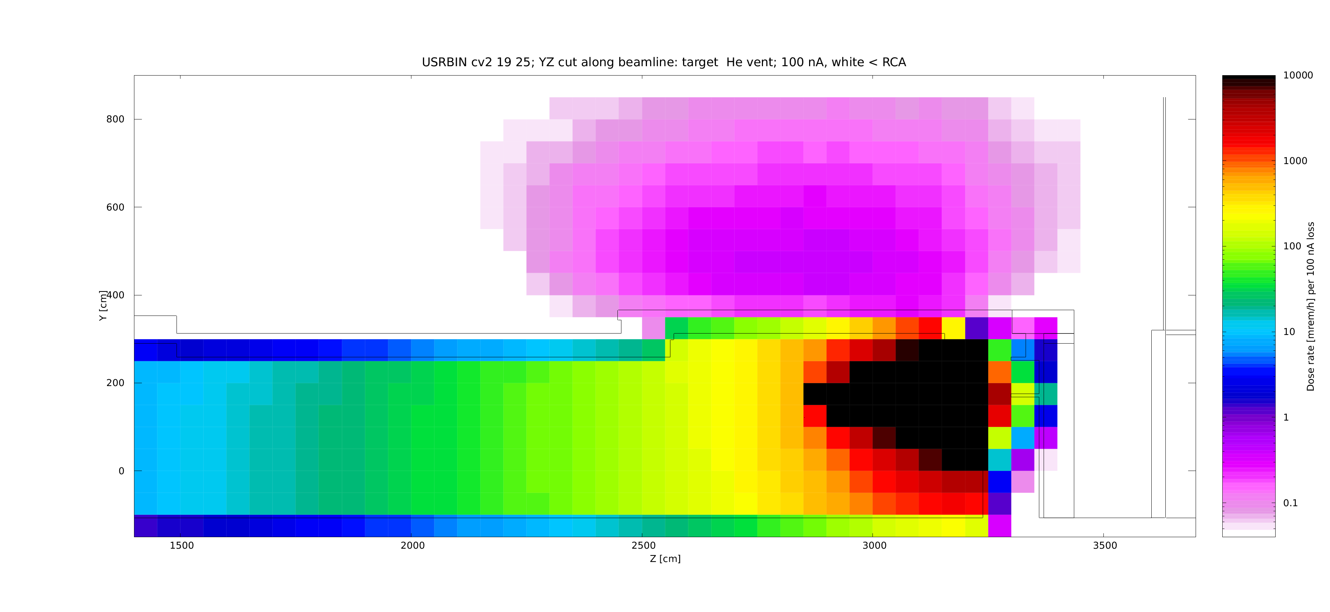
Figure 10: YZ slice at HDIce near target level, finer binning shows the effect of air gaps in shielding blocks. White areas are below RCA levels.
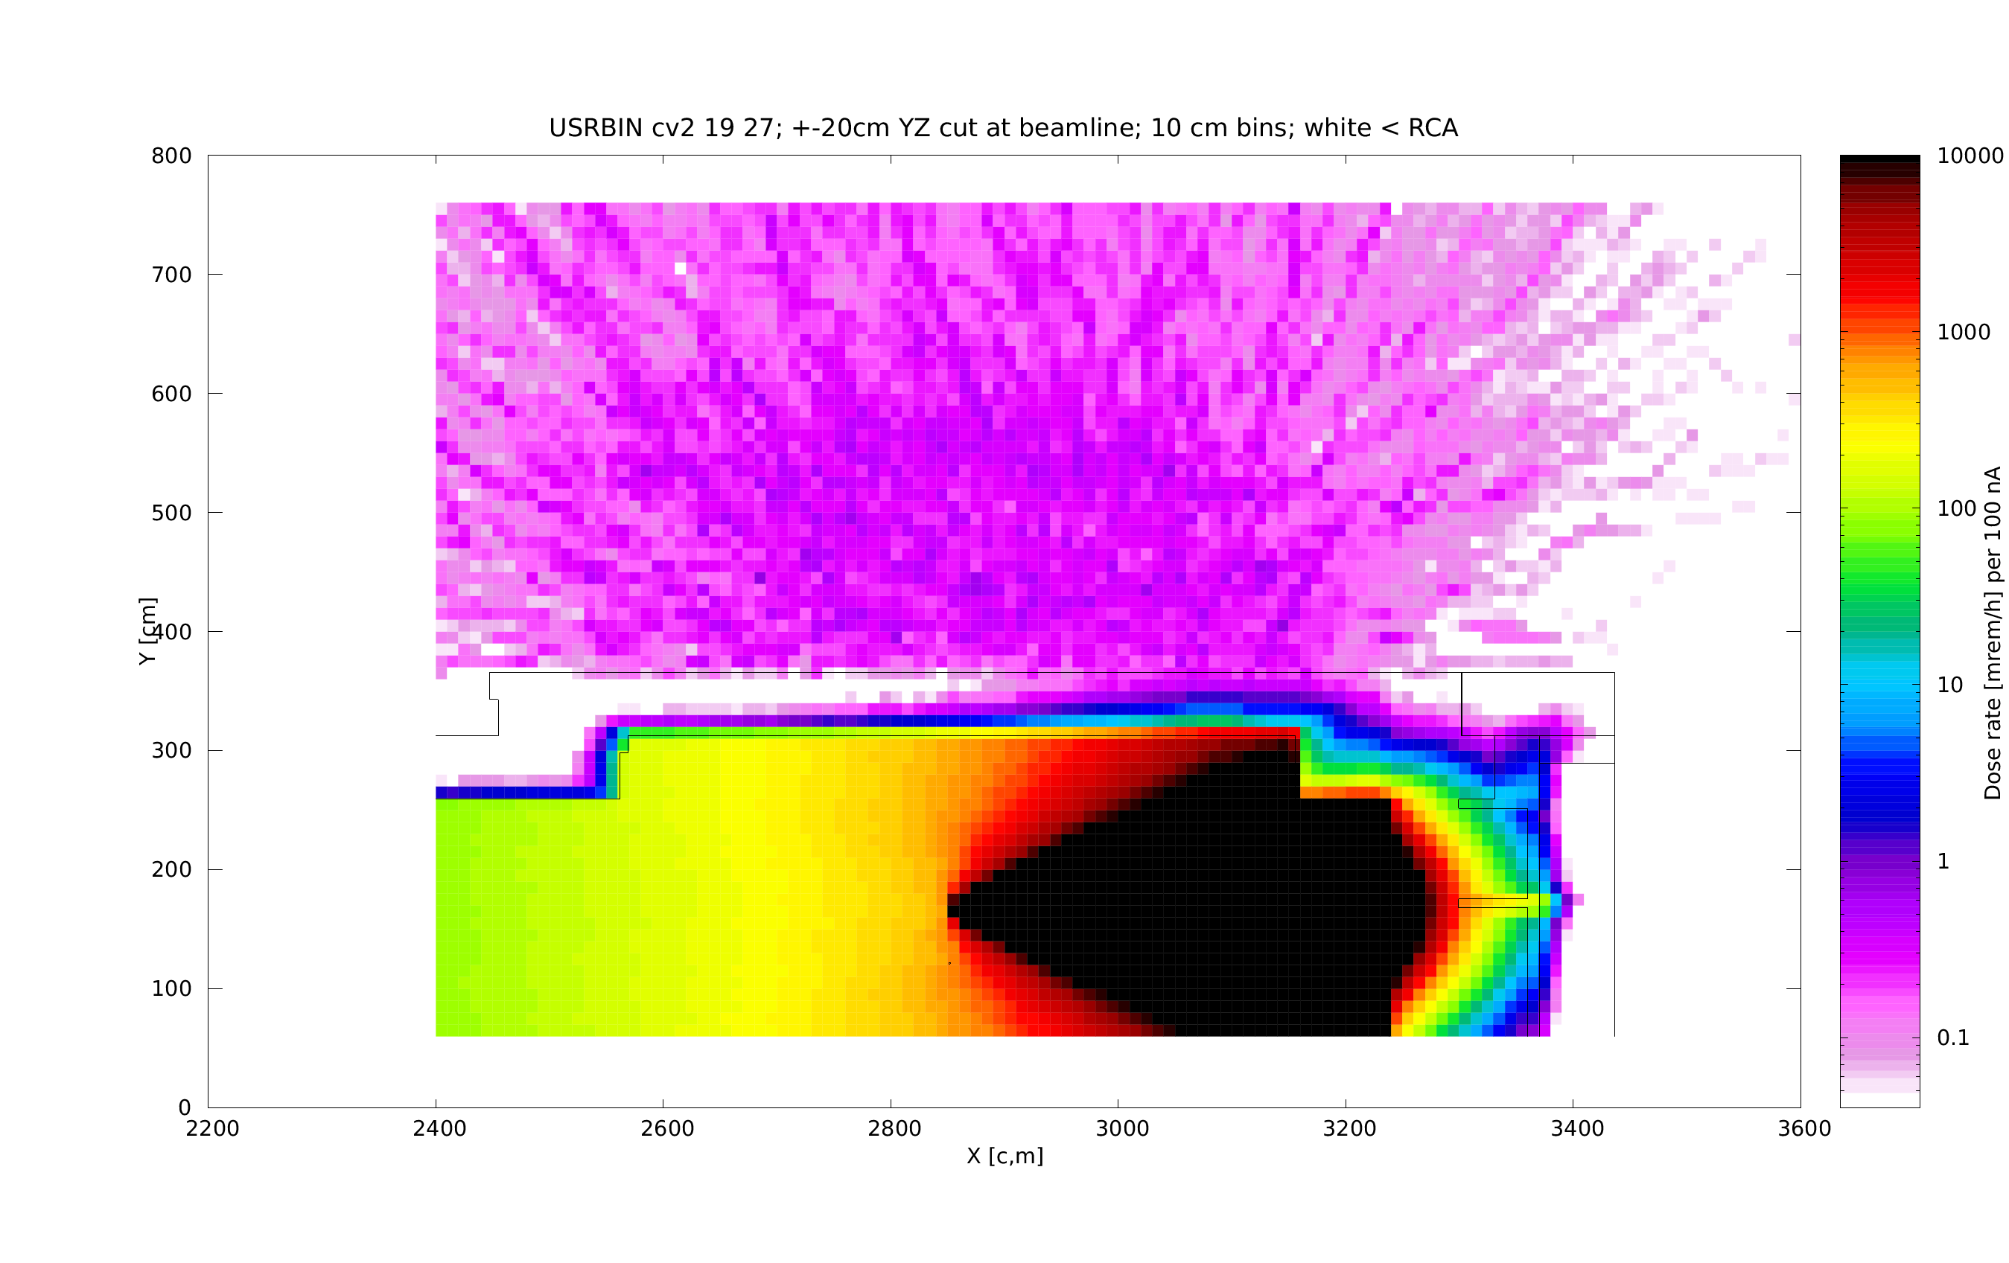
Figure 11: YZ slice at HDIce for accident scenario with 100 μA loss, no local shielding, 1 m binning.
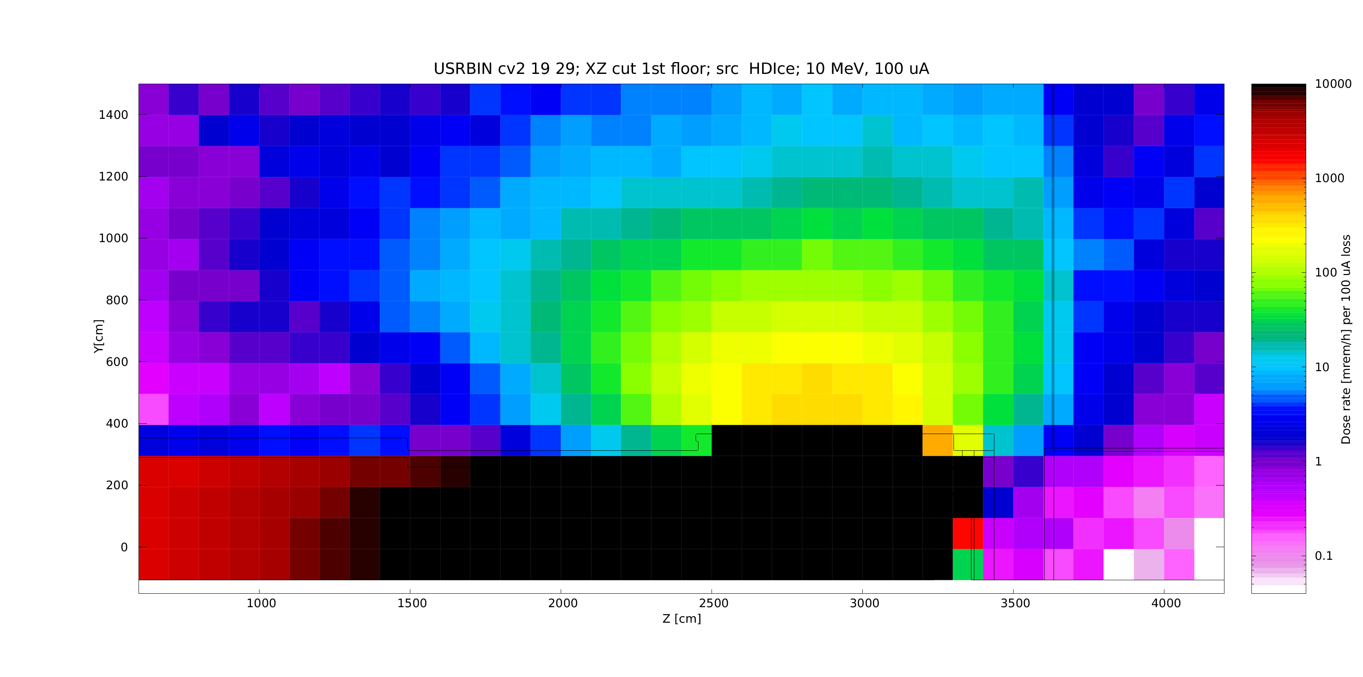
Lateral Shielding and Entrance Maze
The beamline emerges from Cave 1 at a height of 107 cm above ground. As it enters Cave 2 space, it bends upwards, as shown in Figure 3, to bring beam to the HDIce experimental area. This inflection point faces the entrance to the exit maze from Cave 2. Another side beamline will be added in the future to bring the beam towards the west sidewall as shown in Figure 2. Since beam losses due to mis-steering may occur in this area, we simulated this scenario shown below in Figure 12 for a full loss of 100 nA. It appears that for the operation at 100 nA no local shielding will be needed. The same also applies for the 100 nA unshielded beam loss in the HDIce area, as shown in Figure 13.
Figure 12: Radiation levels from 10 MeV, 100 nA beam loss facing the maze; XZ 50 cm binning.
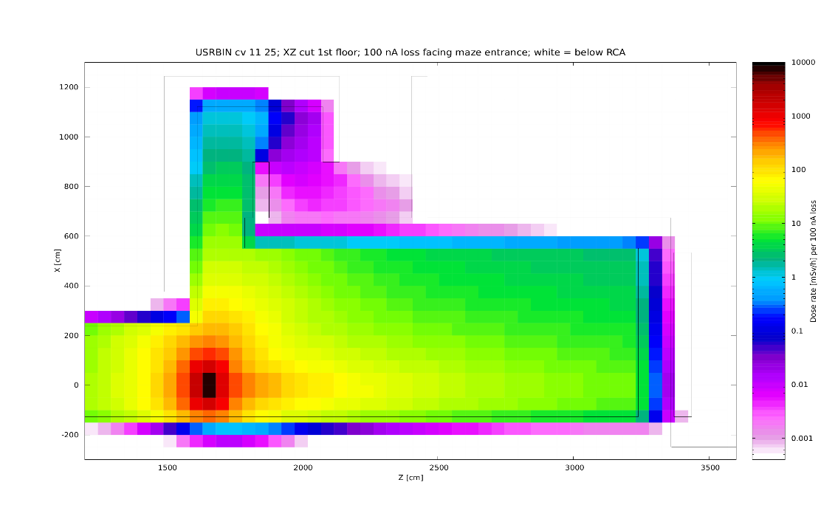
Figure 13: Radiation levels from 10 MeV, 100 nA beam loss at HDIce; XZ 50 cm binning. The 1 ft thick, 14 ft high concrete wall separating the North Annex from Test Lab has an opening on the ground floor covered only by drywall. The extent of this area is indicated by blue arrows.
Only drywall here
Radiation levels at the first floor from an accidental loss of 100 μA are presented in Figure 14 below. While these results would benefit from better statistics, they indicate that radiation levels on the west side in this scenario would be around 2 mrem/h or less. The attenuation by the 1 ft thick concrete wall on the north side is clearly seen, as well as the effect of the opening in this wall indicated in Figure 13 above. Radiation levels in the passage towards the building NE exit will be at or below 0.6 mrem/h under such scenario.

Figure 14: Radiation levels on the Test Lab floor from a 10 MeV, 100 μA beam loss at HDIce; XZ 1x1x2 m binning, at floor level
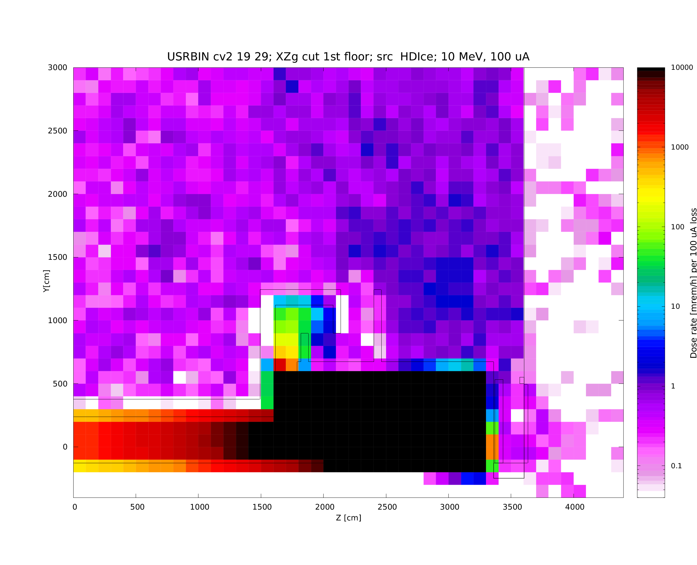
Helium Vent
The helium vent mentioned earlier creates a rectangular opening, 564 cm long and 105.6 cm high, in the east wall of Cave 2, just under the roof towards the north-east corner. In case of an accidental release helium flows through this aperture into a trench between the end of the roof panels and the massive shielding wall on the eastern side. A large concrete block plugs the north end of the trench between the roof and the east wall. As the helium flows upwards, it passes through a limiting aperture of of same length as the wall opening, 564 cm, but only 60 cm wide. The XY cross-section of this opening is shown in Figure 15a. The vent location is in in the area of the HDIce experiment, with an elevated beamline, and levels of radiation streaming through the vent will be most sensitive to beam losses in this area. The beamline runs parallel to this aperture, at a distance of 127 cm from the east wall and 75 cm below the lower aperture limit. Initial FLUKA simulations indicated that in the absence of the He vent radiation levels on the roof remain below 100 mrem/h in case of 100 nA beam loss, almost a factor of 10 lower than predicted by the semi-empirical method. However, with the vent in its original configuration and levels exceeding 1 rem/h, High Radiation Area may be reached near the vent exhaust on the roof. This will be mitigated by addition of a second concrete block at the south end of the vent. The two blocks in the trench will then support a roof plank spanning the space above, with an access barrier grating at the vertical plane of the opening. Figure15b shows a 3D view of a section through this configuration. The flow of helium is restricted by the 60 cm wide horizontal aperture between roof blocks and the adjacent east wall. Adding a slab of iron (section 15cm x 7.5 cm) at the bottom of the trench, as shown in Fig. 4 b, could be an option that would not impede the gas flow at that point and would help to restrict the scatter into the trench. The access barrier grid will prevent access to the vault and prevents access to areas with possible dose rate > 1 R/h during normal operations. This arrangement also limits the spread of the skyshine to the east and south sides of the building.
Figure 15: a) North-facing XY Cross-section view of the Helium vent as built; b) 3D view of the same vent with concrete plank, access barrier (orange) and iron plate (green)
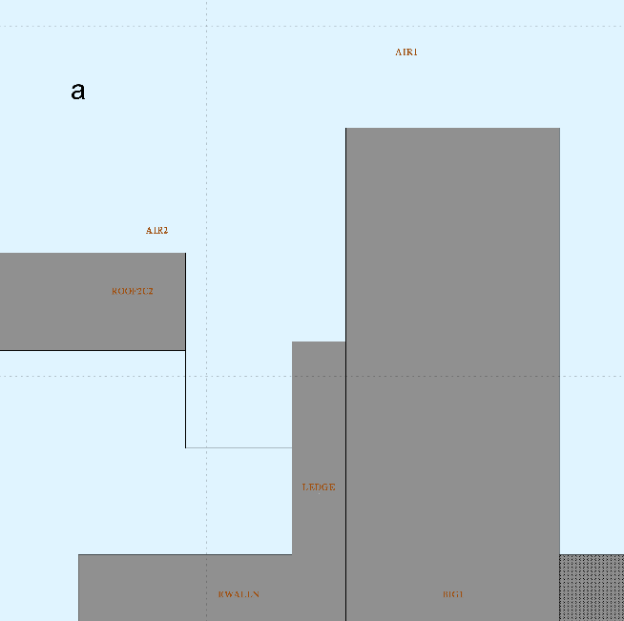 | 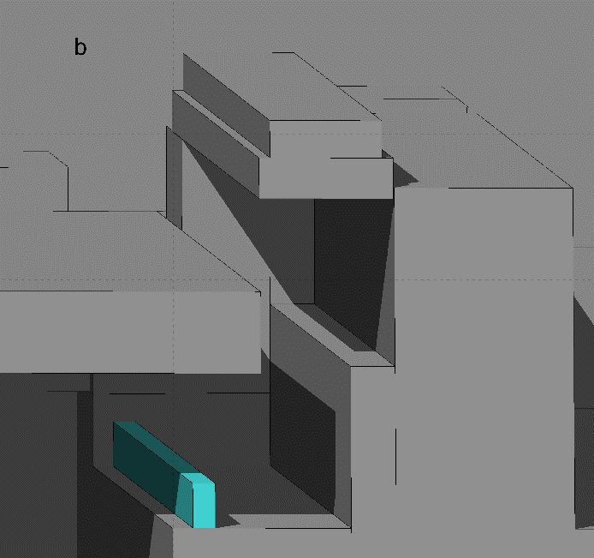  Top plank

Figure 16: Comparison of radiation levels at He vent a) at source level (left), and b) two meters downstream, towards north end of the vent (right); radiation levels correspond to a loss of 100 nA.
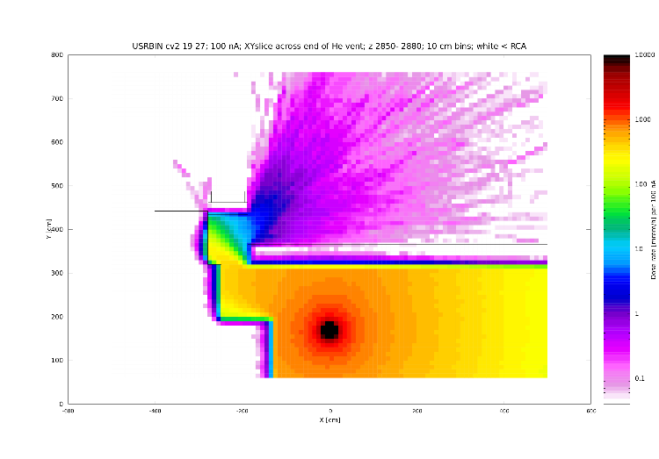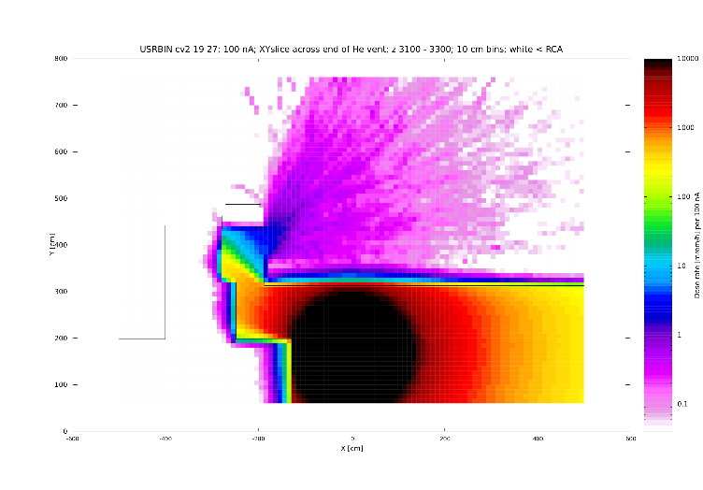
Figure 16 clearly illustrates the effect of widening bremsstrahlung cone downstream from the source. However, radiation levels on the roof at the vent output face will be highest at source level, approaching 8 – 10 mrem/h.

Figure17: Radiation levels [mrem/h] for an accidental loss of 100 μA in the He vent; 50 cm bins
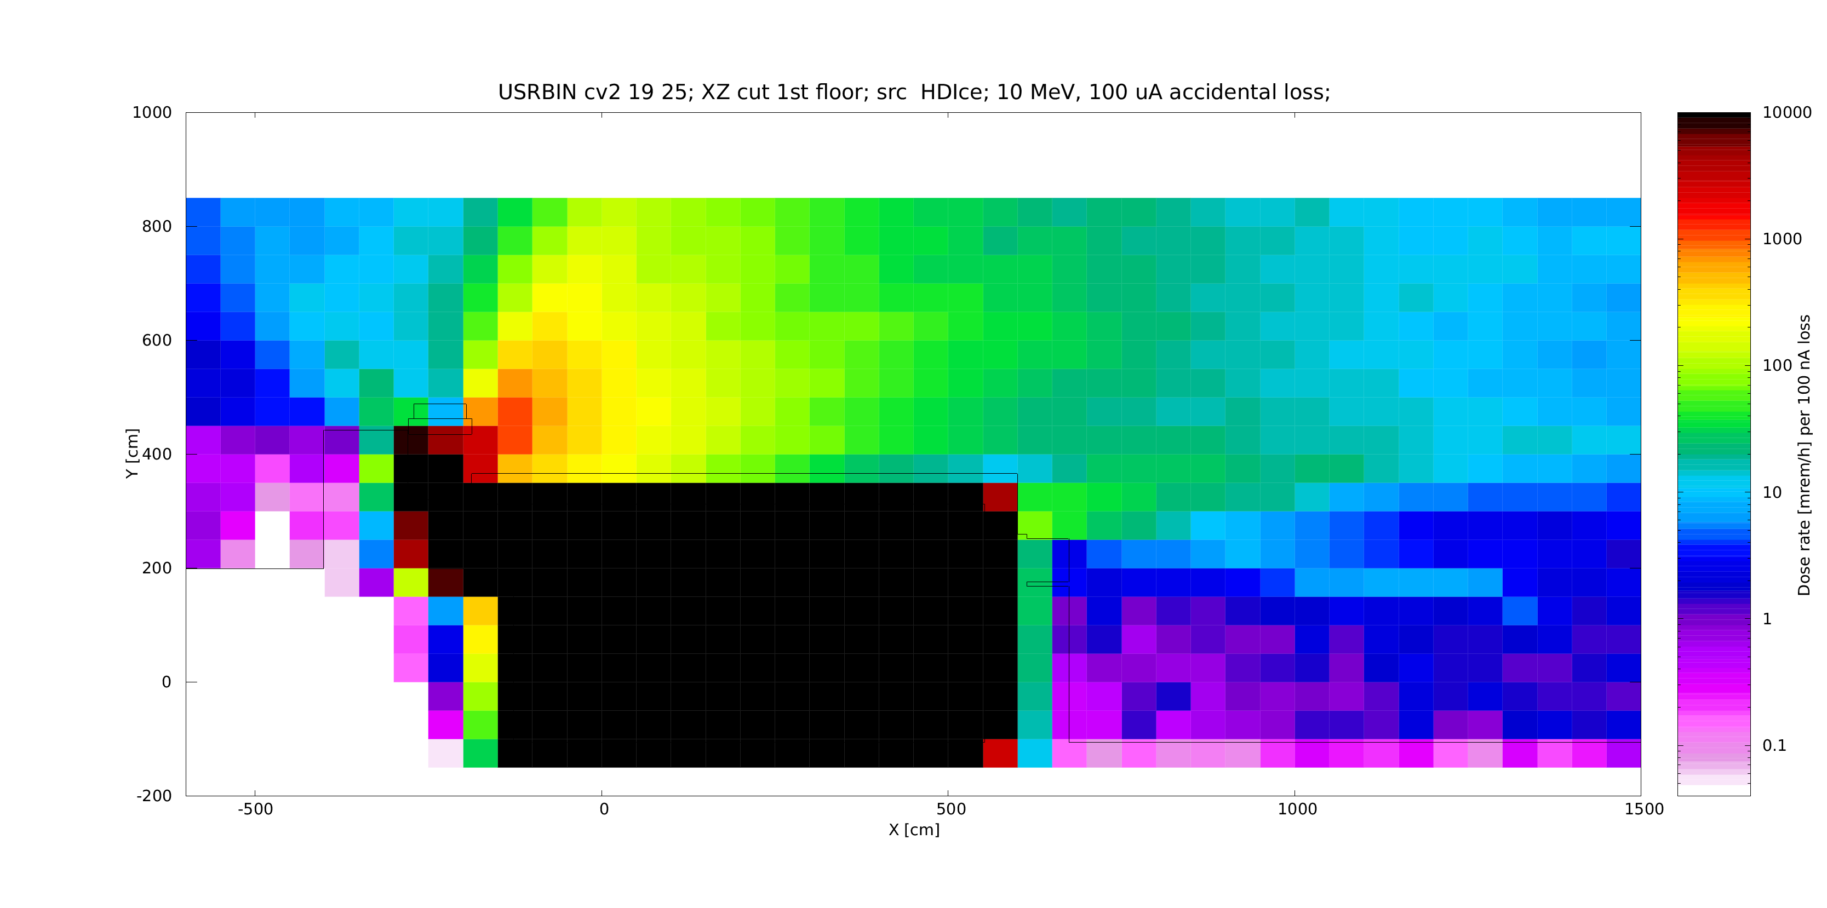
An accident scenario in the same area with a100 μA loss is shown in figure 17 above. It is clear that leakage from the roof and He vent is responsible for higher radiation levels above ~2 m from the floor. The lateral leakage from incomplete overlap of roof blocks, combined with skyshine, create a slight penumbra just outside the west shielding wall. Radiation levels on the floor would reach few (below 5) mrem/h on the floor under these circumstances.

Cave1 Penetrations
Figure 18: Large vent on east side in MeV region of Cave . Loss of 100 nA at 10 MeV leads to radiation levels below RCA at the exhaust.
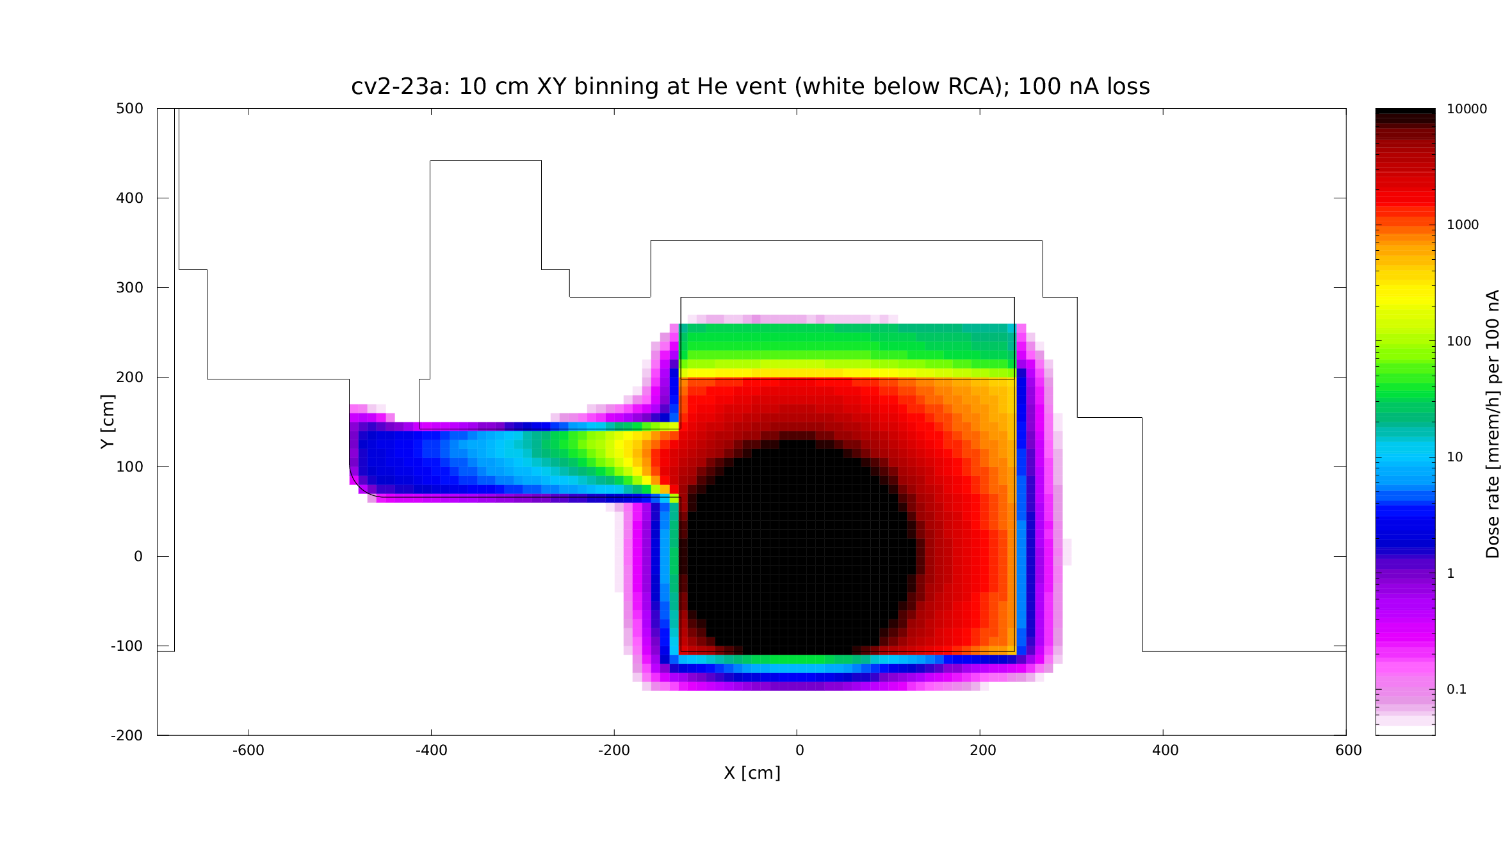

Figure 19: Loss of 100 μA 2 m upstream of the 30” vent in Cave 1 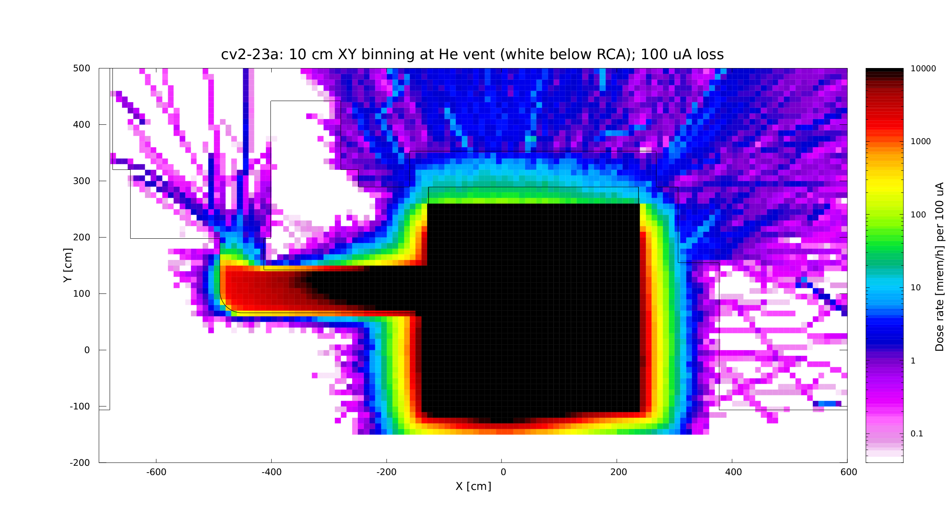
The above figures 18 and 19 show Fluka simulation results for a 100 nA and 100 μA loss, respectively. The source was located slightly upstream of the large 30” vent in the MeV area of Cave1, in order to use a stronger source term from forward bremsstrahlung. Radiation levels at the vent exit are equal or below 10 mrem/h in the 100 μA scenario. This is in relatively good agreement with the simple estimate of ~14 mrem/h mentioned previously for a closer position, but a weaker source term at 90°.
Figures 20 and 21 below present results for losses of 100 nA and 100 μA, respectively, in the XY plane containing the source. A cable trench, a roof penetration shielded with 3.25” of steel and a 6” horizontal cable penetration in the west side wall at a height close to the ceiling were all co-located in the same plane. While these penetrations are not so perfectly aligned in reality, this arrangement was chosen for computational efficiency. In the case of the 100 nA loss, there are no radiation levels outside shielding exceeding RCA level of 50 μrem/h, with perhaps the exception of a small region immediately above the cable trench in the Control Room. However, the simulation did not include the presence of the 0.75” thick steel cover over the trench, nor the lead and sandbag shielding in and above the trench, so the actual levels will certainly remain below RCA. In the case of a 100 μA loss, radiation levels above the shielded roof penetrations around 10 to 40 mrem/h are expected. Under same conditions less than 100 mrem/h should be detected few centimeters above the cable penetration in the Control Room. At 30 cm above the floor level this number drops to ~40 mrem/h. This is substantially higher than the 5.87 mrem/h predicted by simple estimates. Those estimates assumed that all rays will undergo two reflections when channeling through the duct. However, when the source is perfectly aligned with the cable trench, as in this simulation, many rays may reach the area only after only one reflection. For that scenario the simple model would predict 587 mrem/h in the control room, which is undoubtedly an overestimate. As mentioned above, the presence of the steel plate, lead bricks, sand bags and existing cables should reduce these levels by at least two orders of magnitude, to around 1 mrem/h at most. Radiation leakage through the 6” penetration in the west wall is barely noticeable, no mitigation is needed, considering its inaccessible location outside the Cave 1 enclosure.

Figure 20: Loss of 100 nA at 10 MeV, aligned with ceiling penetration and cable trench.
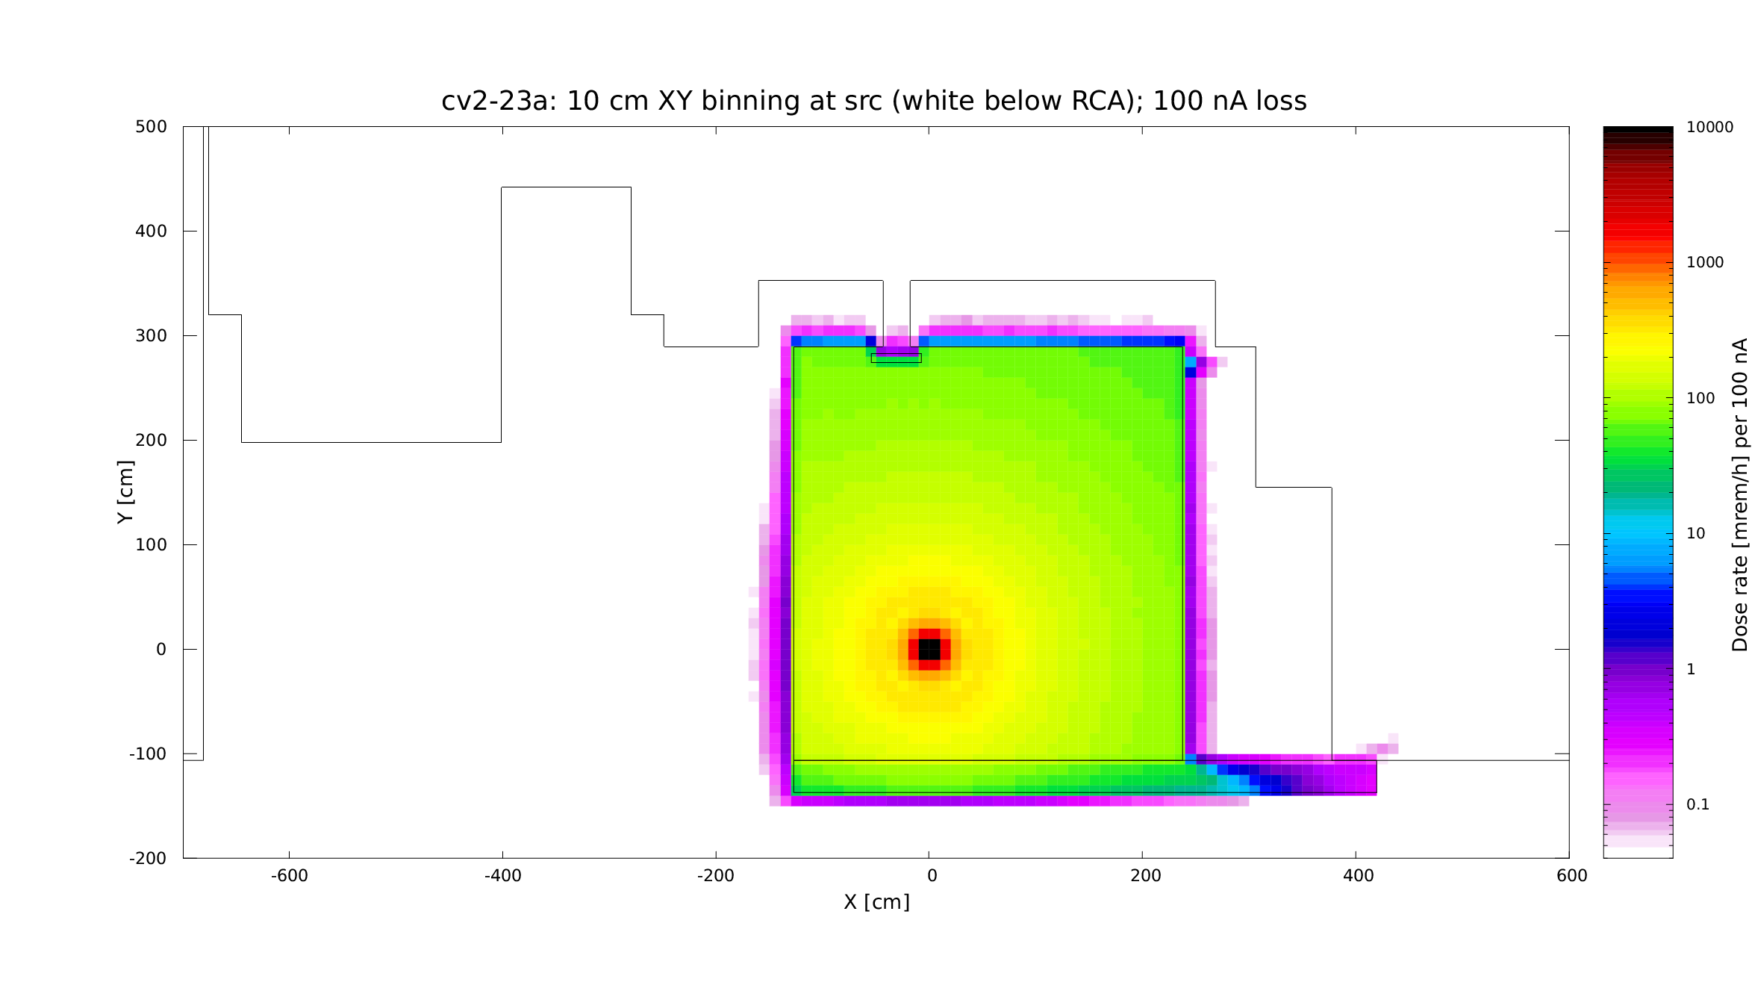

Figure 21: Loss of 100 μA at 10 MeV, aligned with ceiling penetration and cable trench
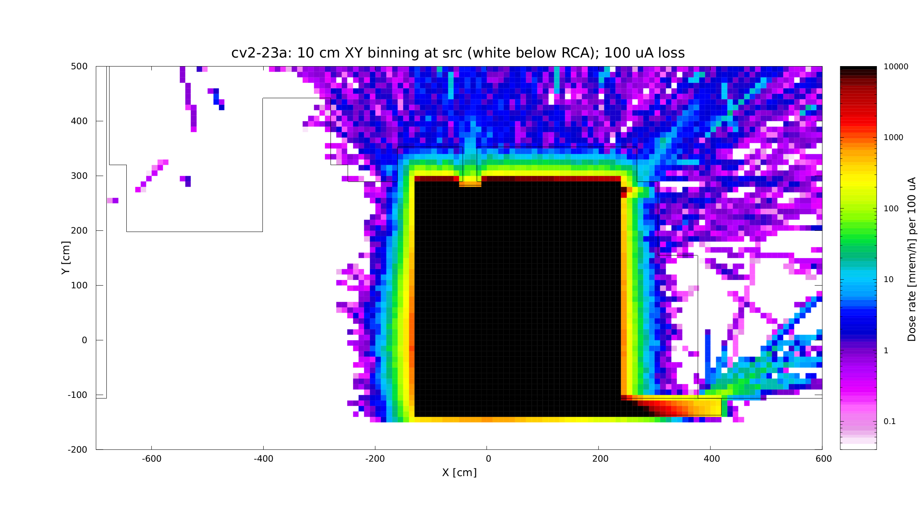

Figure 22: Dose rate above 10” cable penetrations, YZ plane (parallel with beamline direction)
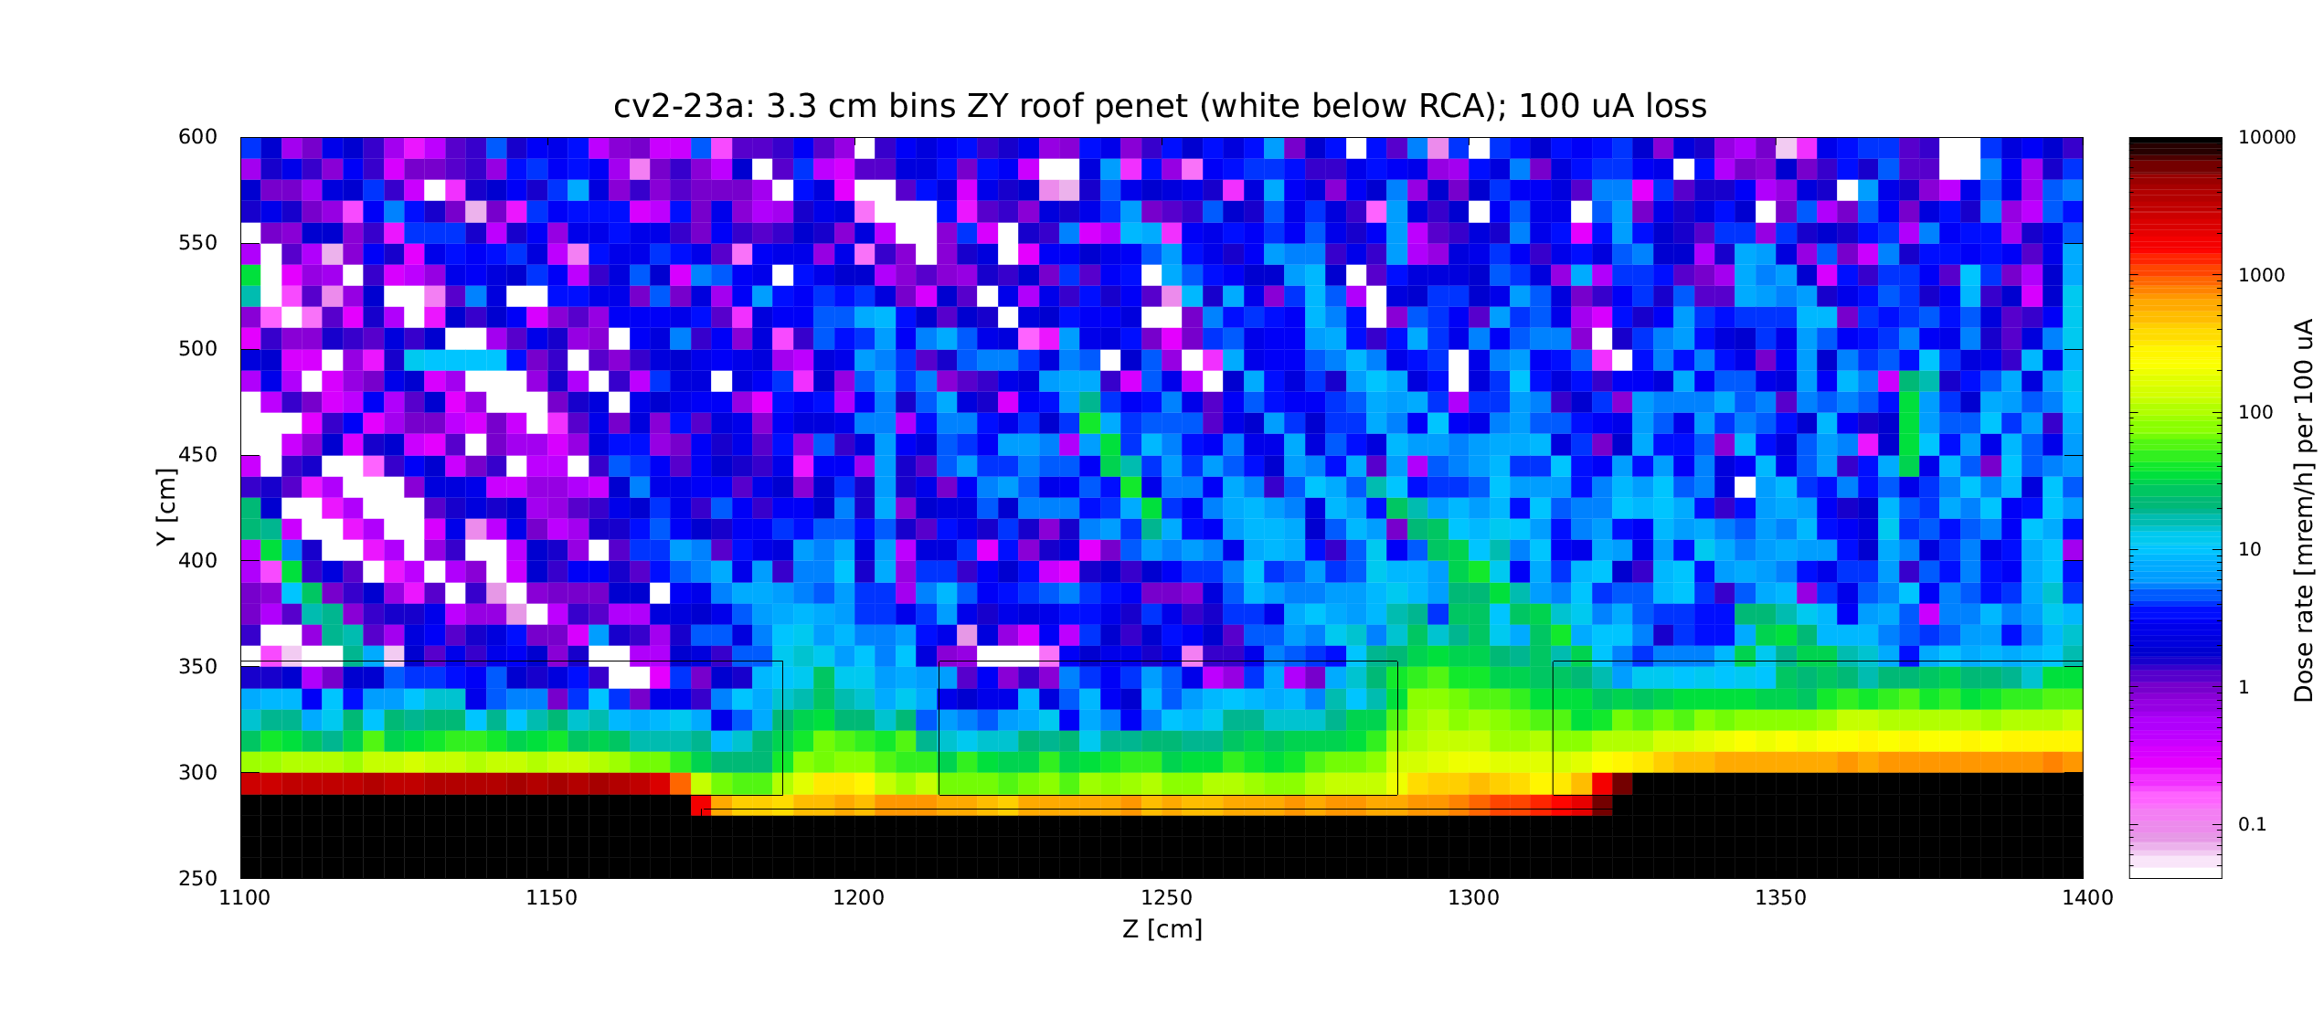
Figure 22 above shows a vertical XY section parallel with the beamline direction (Z) through the Cave 1 roof. The first penetration (at z = 1200) is directly above the source where a 100 uA at 10 MeV is terminated. Dose rates ~1 ft above the roof are higher at the penetration one meter downstream, due to a higher bremsstrahlung in the forward direction, approximately 80 mrem/h at z = 1300, compared to ~10 mrem/h at z = 1200.

Building Effect on Scatter and Skyshine
The results and discussion above indicate that radiation levels on the floor level surrounding UITF are not likely to exceed RCA levels during UITF operations. Most radiation leakage will occur through the thin roof and helium vent. The perimeter around the facility will remain under RCA levels, as illustrated in Figures 12 and 13.
It appears that radiation on the work floor results from leakage through side shielding, skyshine. and scatter of these from the building walls and ceiling. To evaluate the effect of scatter in the building, we performed two almost identical simulations, where in one of them the materials of the Test Lab walls and ceiling were changed to air. The results are presented in Figure 23.
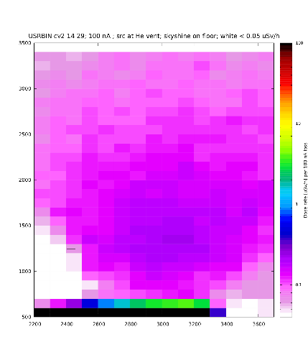
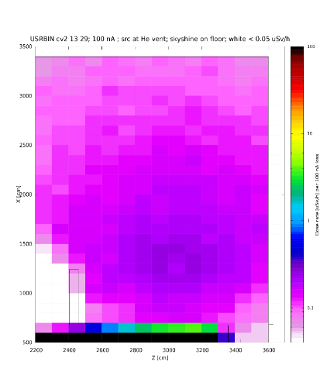
Figure 23: Dose rates at west side of Cave 2; left: no building; right: building walls and ceiling included.
While the comparison would benefit from a greater number of events scored, a slight enhancement of the radiation levels due to backscatter from the building is apparent in the right side of the figure. The white penumbra in lower right corner of the picture on the left exhibits higher levels when walls are present.
The XY dose rate binning presented in Figure 24 again confirms levels below RCA on the work floor. A ray streaking from the western edge of the roof indicates leakage from insufficient roof overlap over the sidewall. Slightly below, the effect of the gap under the notched block is apparent as well. A coarser XY binning in figure 25 shows the same slice extended over and beyond the boundaries of the Test Lab building.

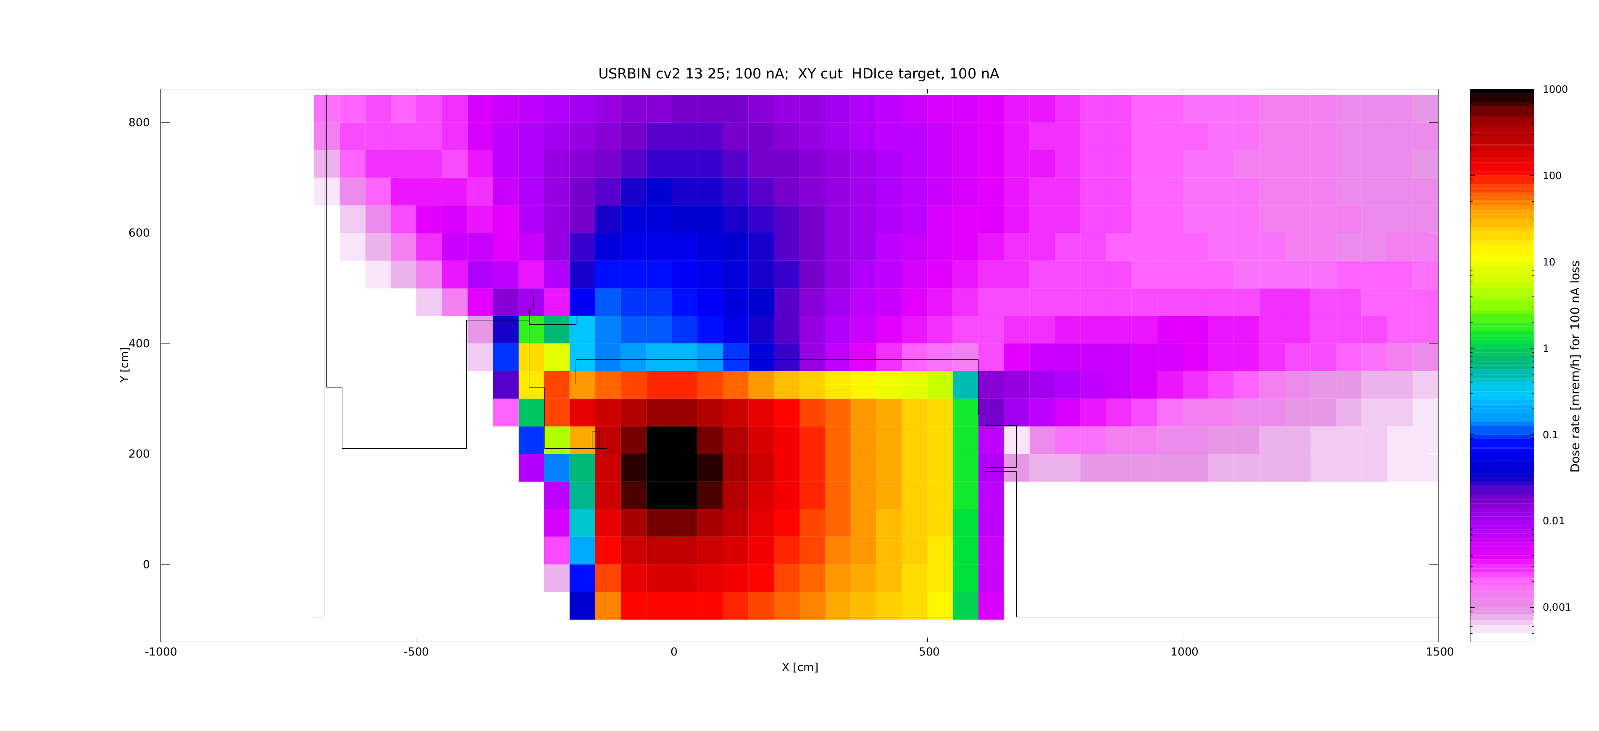
Figure 24: XY slice at HDIce target level, finer binning. White areas are below RCA levels.
Figure 25: XY slice at HDIce target level – 1 m³ binning. White areas are below RCA levels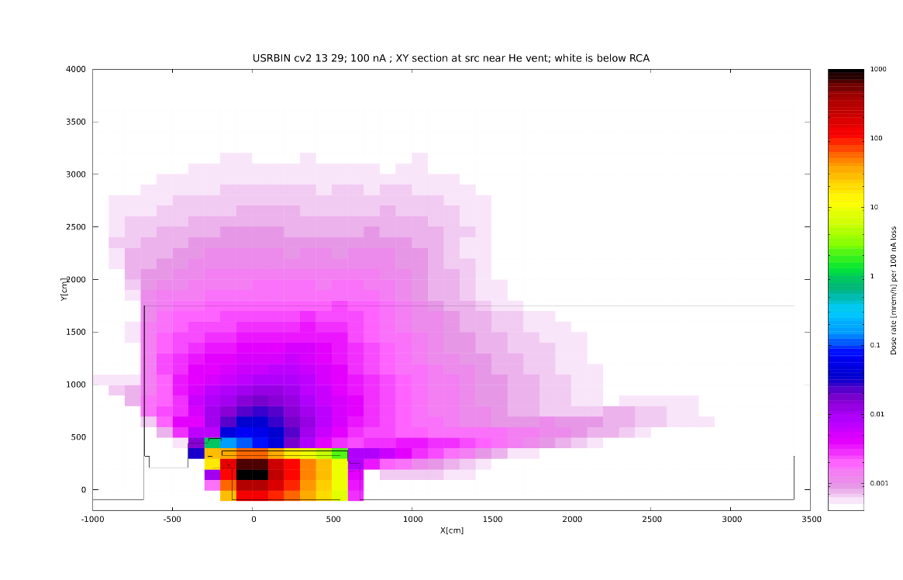
Decreasing the binning threshold to dose rates well below RCA level in Figure 26, it is apparent that there is a slight penumbra at the west wall, with isodoses curving first downwards and then lifting up, as one would expect.
Figure 26: XY slice at HDIce target level – 1 m³ binning. Range extended below RCA.
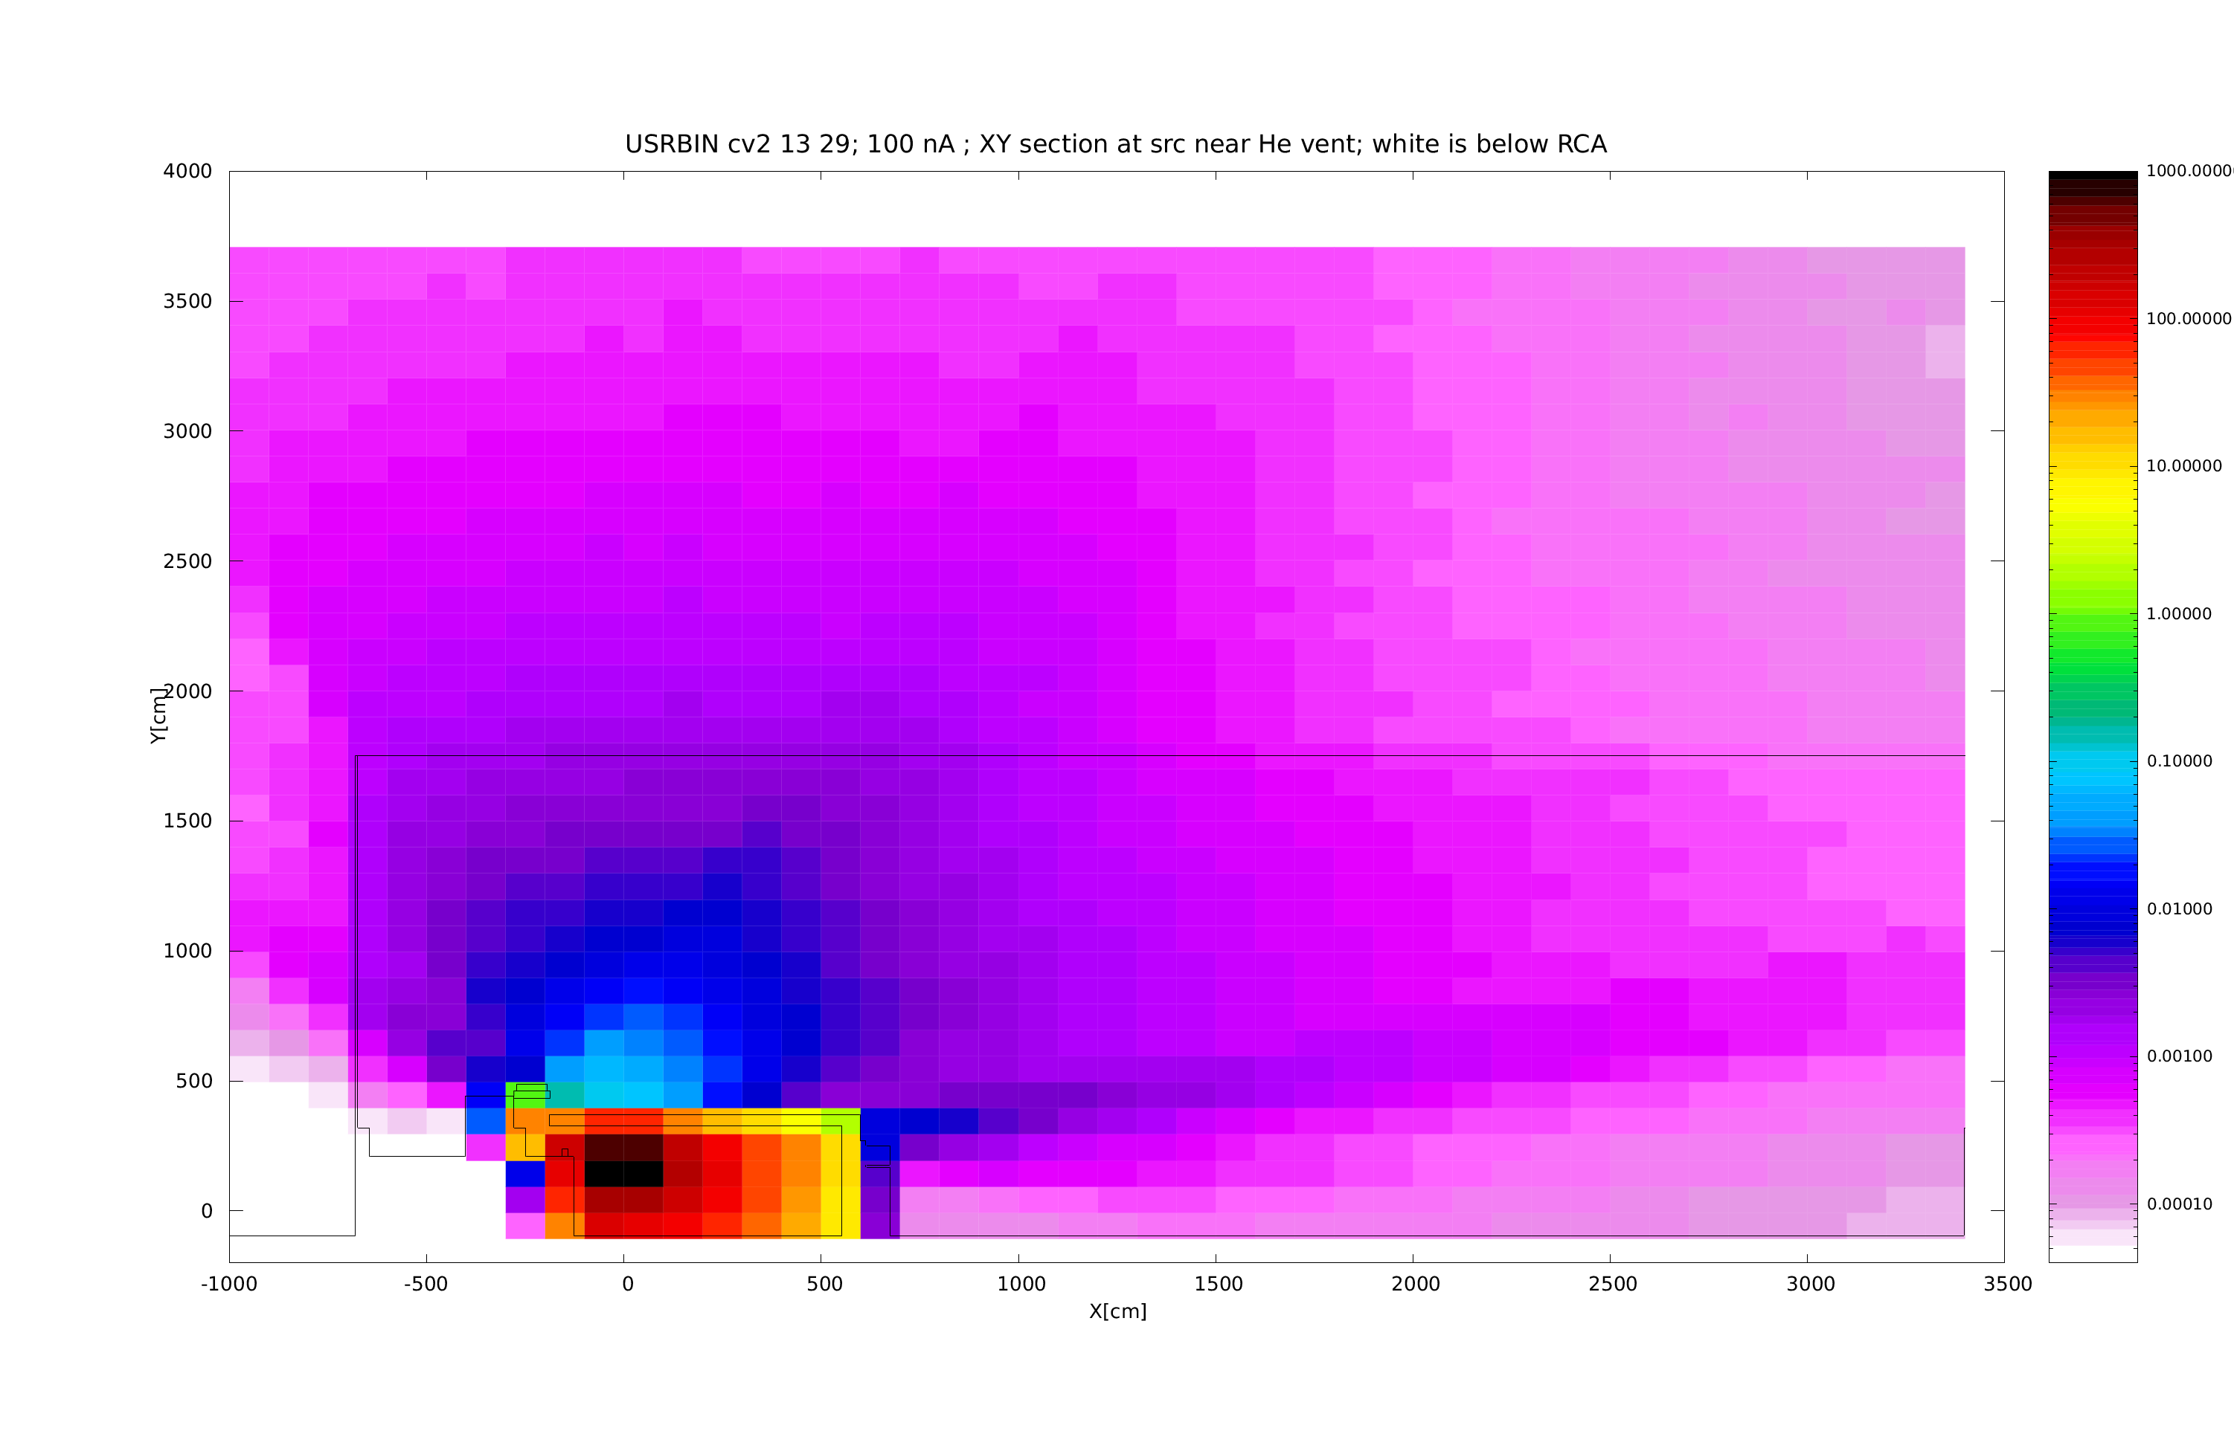

Accident scenarios
As indicated above, the current shielding in Cave 2 and the MeV portion of Cave 2 is adequate for running the UITF experiment, where running currents up to 100 nA would be part of normal operations, and the shielding is adequate (with stated access restrictions/posting for specific areas) for routine losses up to 100 nA. During other experiments using currents up to 100 μA, losses exceeding 100 nA up to 100 μA are considered as accidents (e.g. 100 μA loss in HDIce area, Fig. 17). In the keV area of Cave 1, the worst accident considered was the full beam, either 13.4 mA at 225 keV or 3 mA at 450 keV, depending on the gun and power supply used. More recently, members of the Center for Injectors and Sources (CIS) envisioned other possible scenarios that were shared and discussed with RadCon and the Safety System Group (SSG), as follows:
- 225 keV, 13.4 mA beam drifts through QCM (with no acceleration) and is lost at an unshielded point facing the exit maze in Cave 2.
- 450 keV, 3 mA beam drifts through QCM (with no acceleration) and is lost at an unshielded point facing the exit maze in Cave 2.
- 10 MeV, 300 μA overcurrent lost at a point facing the exit maze in Cave 2.
- 5 MeV, 840 μA overcurrent (which lowers the QCM gradient) lost at a point facing the exit maze in Cave 2

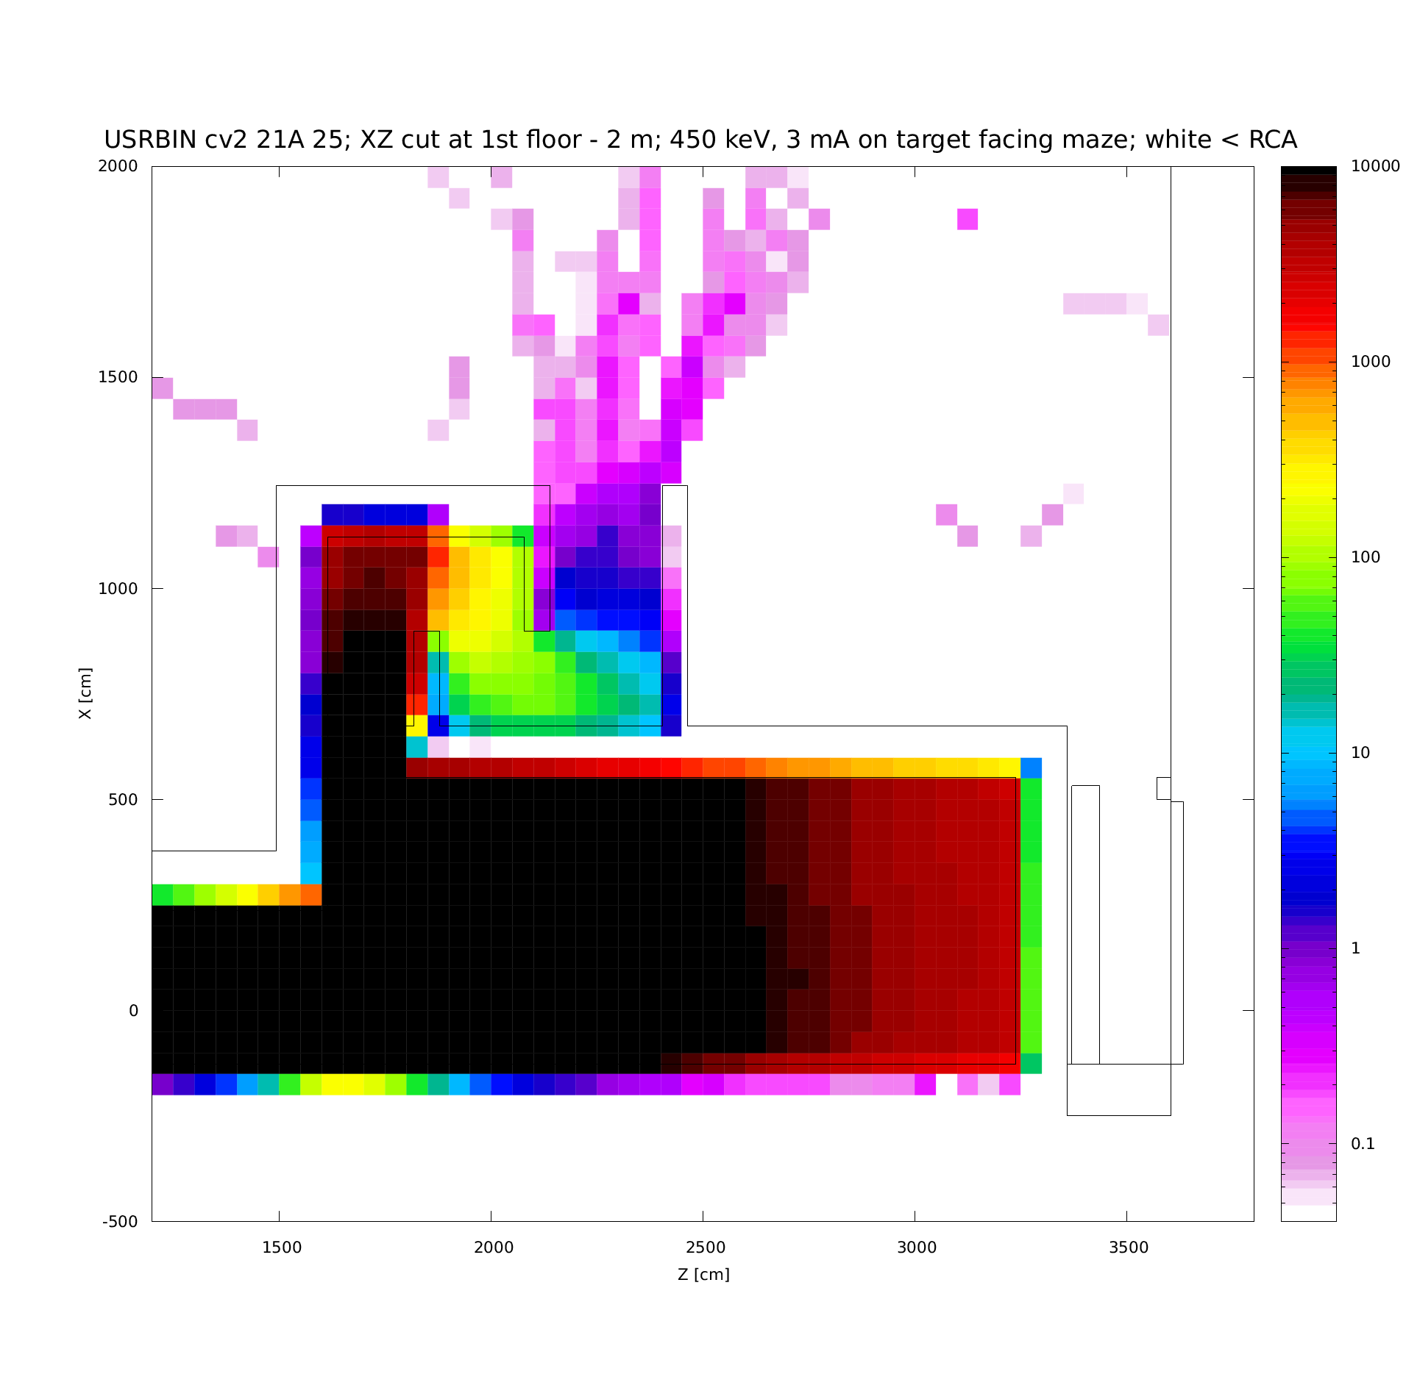
Figure 27: Dose rates outside shielding on 1st floor for a 3 mA loss facing the maze at 450 keV

Figure 27: Dose rates outside shielding on 1st floor for a 841 μA loss facing the maze at 5 MeV 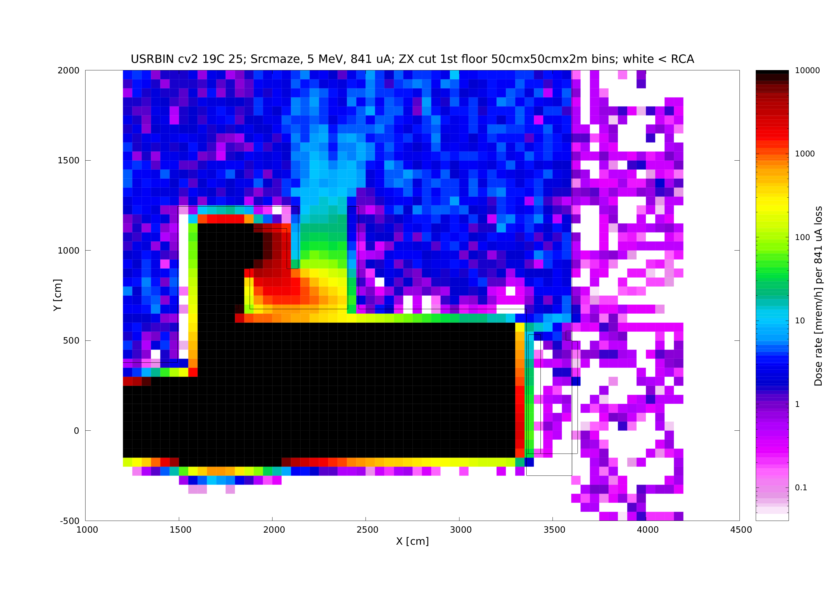
In all of the above scenarios the beam could also be lost at a point at the QCM exit in Cave 1, with likely lesser impact on non-radiation workers who are less likely to frequent areas adjacent to Cave 1.
Radiation levels predicted by Fluka calculations for various behind shielding at specific locations around Cave 1 and Cave 2 are summarized in Appendix 1. Using these results and input from CIS and SSG regarding likely durations of individual scenarios, Keith Welch [10] prepared and presented to the Safety Configuration Management Board (SCMB) estimates of dose resulting from all plausible accidents. These estimates are presented in Appendix 2.

Conclusions
An unusual aspect of this project was that at times construction preceded design, due to reuse of an earlier facility and need to quickly use or reuse available shielding material. First shielding estimates by semi-empirical methods were typically conservative compared to Monte Carlo, within a factor of 3 to 5 for side or roof shielding, and up to a factor of 10 in the forward direction. Fluka Monte Carlo simulations were useful in estimating radiation levels for complex geometries. Extensive radiation surveys should be planned and conducted at the startup and during incremental changes in the operation of the facility. Results of such surveys will be useful for verification and benchmarking of the techniques used in this assessment. The results presented here demonstrates that the current shielding is adequate for the planned operation modes and that both planned operation modes and credible accident scenarios envisioned are very unlikely to violate the terms of JLab Radiation Shielding Policy.

Appendix 1 : Summary of radiation levels from plausible beam loss scenarios obtained by Fluka simulations

Source location | HDIce | facing maze | facing maze | facing maze | facing maze
Electron energy [MeV] | 10 | 10 | 5 | 0.450 | 0.225
Current lost | 100 μA | 100 μA | 841 μA | 3 mA | 13.3 mA
- Cave 2 | Dose rate [mrem/h]
Cv2 side* | < 2.0 | 4.0 | 2.0 | - | <=0.1
Cv2 maze exit | 0.4 | 6.0 | 9.0 | 0.5 | <=0.4
Cv2 forward 1st floor** | 1.0 | 0.8 | 0.4 | - | -
Roof2 @ He vent | 4000 | 1000 | 1500 | 30 | <=13
Roof2 @ maze | 100 | 3000 | 10000 | 2 | <0.2
North Annex, 2nd floor | 3 | 10 | <2 | - | -
Run | Cv2_19 | Cv2_19B | Cv2_19C | Cv2_21 | Cv2_10
* Values for Cave 2 side may be read further away from the wall, where dose rates were higher due to skyshine and Test Lab north wall scatter contribution.
** Assuming NE end of iron wall will be extended by concrete block or sandbags
Values with “<” or “<=” are conservative estimates of results with less than optimal accuracy/statistics.

- Cave 1  10 MeV, 100 μA loss | Dose rate  [mrem/h]
West side floor | < 0.3
West side up | < 10
Roof (no penetration) | < 30
Cable trench exit - Control Room | 40
Shielded 10 inch roof penetrations | 40
Big vent at Cave 2 boundary | 5

Appendix 2: Likely dose to individuals around UITF during normal and various accident conditions
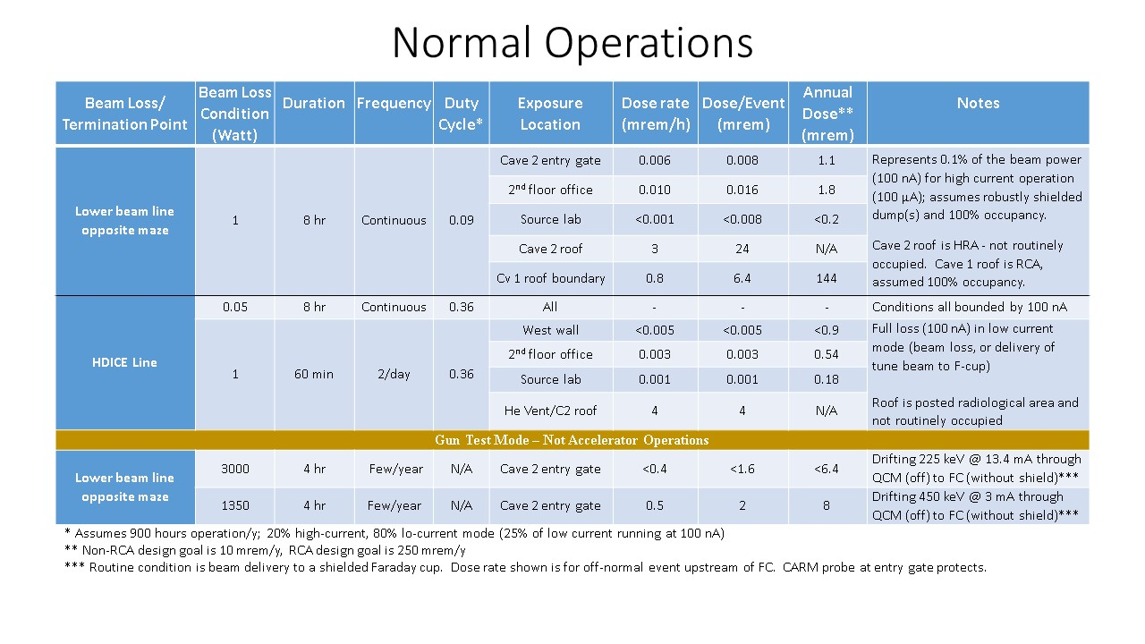
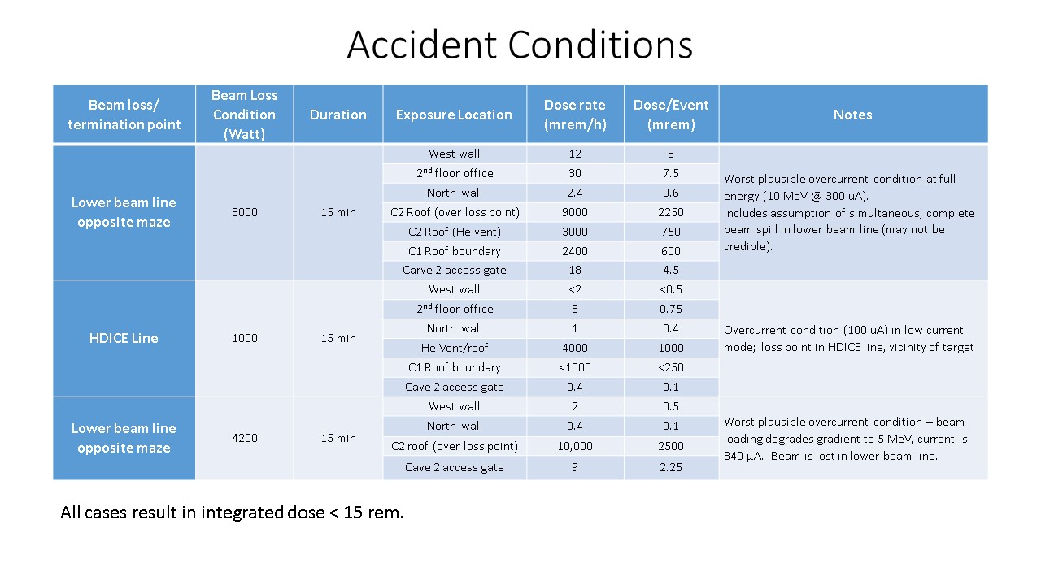
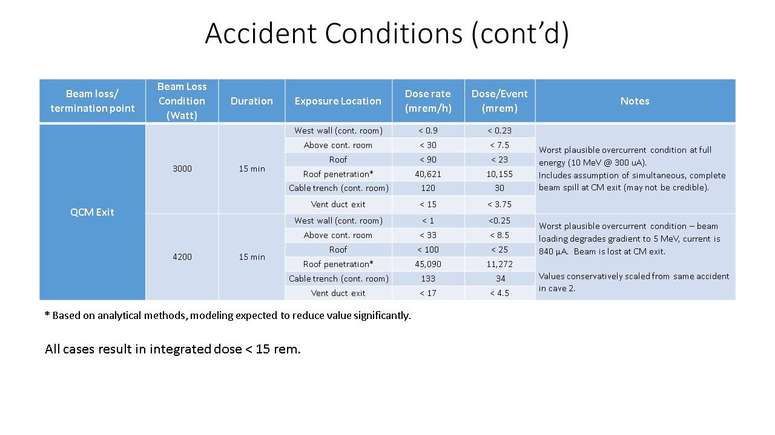

References
- C.D. Bass, et al. (2014), “A portable cryostat for the cold transfer of polarized solid HD targets: HDice-I, Nuclear Instruments and Methods in Physics Research A 737, pp. 107-116
- M.M. Lowry, et al. (2016), “A cryostat to hold frozen-spin polarized HD targets in CLAS: HDice-II”, Nuclear Instruments and Methods in Physics Research A 815, pp. 31-41
- Matt Poelker, private communications regarding beamline components, planned activities, operating parameters and capabilities of the facility
- NCRP Report No. 51 (1977), Radiation Protection Design Guidelines for 0.1 to 100 MeV Particle Accelerator Facilities, National Council on Radiation Protection and Measurements, Washington, D.C. (USA)
- NCRP Report No. 144 (2003), Radiation Protection for Particle Accelerator Facilities, National Council on Radiation Protection and Measurements, Washington, D.C. (USA)
- Pavel Degtiarenko (2015), Geant-3 source tems, private communication
- Ferrari, A., P.R. Sala, A. Fassò, and J. Ranft (2005), “FLUKA: a multi-particle transport code”, CERN-2005-10, INFN/TC_05/11, SLAC-R-773.
- Vlachoudis, V. (2009), “FLAIR: A Powerful But User Friendly Graphical Interface For FLUKA” Proc. Int. Conf. on Mathematics, Computational Methods and Reactor Physics (M&C 2009), Saratoga Springs, New York
- Tom Renzo (2015 – 2019), private communications regarding dimensions and civil engineering aspects
- Keith Welch (2019), private communication

Calculations indicate that this may not be necessary, but it remains an option based on results of surveys during operation

