History
- March 2009 stack ceramic baked 3x to address leaky NEG feed through braze
- July 2009 inverted ceramic baked upon installation, NEG shorted to ground

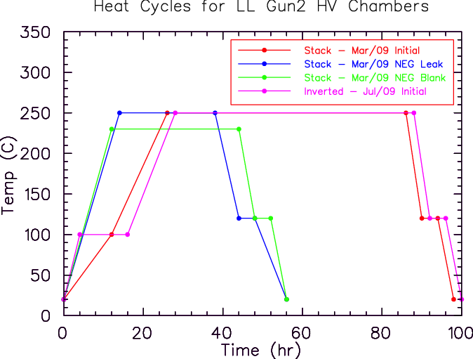
Pre Bake
- QE scan and retract puck to HV chamber
- Record retro-reflection from photocathode
- Cycle and close valves to override
- LOTO HV cable blue tank, remove HV cable and grease from ceramic
- Remove 2I magnets
- Test isolation of NEG (short) and anode (open)
- If schedule permits: extractor gauge ON & rate of rise measurement
Bake
- Apply vac seal to braze joints
- Bake oven on HV + tapes on tube + gradient across PREP/2I values
- “Clean bake” so expect bake IP ok; bake line to turbo just in case?
- Suggest: 4+4+4 to 250, soak 24-36, 4+4+4
- Check IP HV cable (connectors loosen/go bad)
- Degas RGA and leak check at RT
- Degas extractor
Post Bake
- Test isolation of NEG (still short) and anode (open)
- Insert puck to test retro-reflection from photocathode
- Restore magnets, grease and insert HV cable
- Remove puck and hi-pot gun
- Make photocathode and test for QE in HV chamber
- Lifetime measurement
- Extractor gauge ON to base pressure
- Rate of rise measurement?

