CIS INTERLOCK RACK BYPASS

CIS has three relays that need to be in an active state to release beam: Dipole 15°, “Global” (vacuum) and a “SPARE”. You can see in the schematics below that +24V and a switch leg is provided for all three relays. The bypass simply connects the three switch legs to +24V.
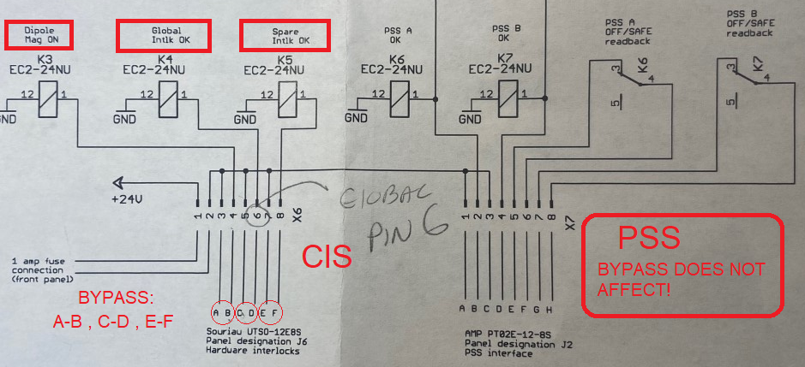

Instructions posted in cabinet:
STORE THE BYPASS IN THE PLASTIC SLEEVE OF THE INSTRUCTION!
PLUG IN THE BYPASS, VERIFY ACC-CIS INTERLOCKS ARE SHOWING HEALTHY:
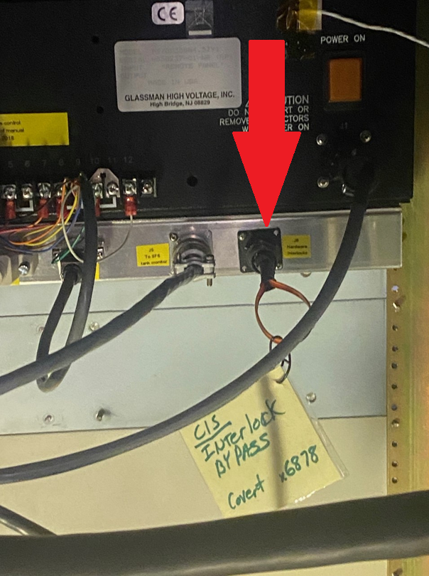
ALL GOOD!
