UITF QCM CM Cooldown Procedure

Document Number: |  | Approval Date:
Revision Number: | 1A | Periodic Review Date:
Document Owner: | David Savransky | Department Owner: | SRF Ops

Purpose

The purpose of this document is to outline the procedure to cooldown the QCM in the UITF from 100K to pumpdown to 2K

Scope

This document applies to the cooldown of any QCM in the UIFT from 100K to 2K. This procedure will only outline the steps necessary to be done by an SRF cryo operator, any steps that are to be done by other sources will not be described unless they connect directly to what an SRF operator must perform.

In this procedure, the SRF operator will perform all the pre-checks to begin cooldown, perform the cooldown of the primary circuit, and then stabilize the CM at 4K. Following the stabilization at 4K, the CM will be pumped down by Cryo with SRF assistance. The SRF operator will then assist stabilizing the CM at 2K along with Cryo.

Supporting Drawings

Description | Number
CTF Main | 72000-0001
Valve Box | 72400-0001
Junction Box | 72400-0018
Cooldown System | 72500-0023
Recovery System | 72500-0004
Main Vacuum Pumps | 72800-0011

Terms, Definitions, and Acronyms

Abbreviation | Meaning | Notes
CM | Cryomodule
QCM | Quarter-Cryomodule
CD | Cooldown
SC | Subcooler
HP | High Pressure
LP | Low Pressure
LVDT | Linear variable differential transformer | Sensors that feeds back the position of the electric valve
UITF | Upgrade Injector Test Facility
CTF | Cryogenics Testing Facility

Roles and Responsibilities

The following roles have responsibilities described in this document.

Role | Responsibility
SRY Cryo Operator | Perform and Monitor UITF QCM CD
Cryo Operator | Assist with CM pumpdown and provide support during CD

Procedure

Preliminary Checks
Ensure that the following checks are done the day before the cooldown begins

Signal Verification
- Verify all signals area reading back
  - Ensure that all signals are reading back a correct value
  - If any signals read back unrealistic values (e.x the CM is at 300K but a sensor readback is 30K) or have no readback (NAN or Blank EPICS Box)
    - Ensure that cables are connected
    - Contact instrumentation lead for assistance
- Verify that all signals are being logged with MyaPlot
  - If signals are not logging or logging a ‘0’ contact the individual in charge of MyaPlot
- Ensure that the LL probe controller is turned on
  - Location can be found in section 9.0

Vacuum System Verification
- Ensure that all vacuum signals are active
- Use the following as guidelines of what values the vacuum should be at:
  - VIPM1011/VIPM1012: E-11 range
  - VIPM101B: E-11 range
  - VQGM101: E-6 to E-7 range
- If any of the gauges are outside their range check with SRF on how to proceed
  - If the insulating vacuum gauge read above the guideline range, ask an SRF technician to attach a pump to it

Initial Guard Vacuum Arrangement
- Ensure that all guard vacuum valves are open before starting the cooldown
- The valve locations can be found in section 7.0

HX bypass valve
- Ensure that the HX manual bypass valve is fully open
- The valve locations can be found in section 7.0

LivePlots
- Plot all the PV’s from section 7.0 on separate LivePlots

Cooldown of QCM

- Verify that the CTF dewar (CLL2762MAO) is over 60% full
  - If the dewar is not full, confirm with cryo before starting

- Make a log entry stating that the UITF QCM CD is about to begin
  - Included logs: ELOG,SRFLOG,CLOG,SRFVTALOG, UITFLOG

- Inform VTA that the cooldown is about to begin
  - Ensure that they will have no ongoing 2K work during the CD

- Begin with the JT (CEV27JT) valve fully closed

- Things to monitor during the full length of the CD:
  - Monitor the purifier line pressures (CPI284) and flow (CFI282) :
    - If CPI284 exceeds 1.15 atm (while CFI282 is at 16 g/s), dial back on the JT Valve (CEV27JT) to reduce the flow.
  - If the cryomodule return helium pressure goes above 1.2 atm (CPI2762), back off on CEV37JT.
  - Monitor the kinney return pressure (CPI2091):
    - If CPI2091 exceeds 0.025 atm, dial back on the JT Valve (CEV27JT) to reduce the flow.
  - Any sudden changes to the JT valve can affect CPI284 or CPI2091; follow up any intentional or unintentional fast movements of the JT valve with a check on the recovery pressures.
  - If the CM pressure (CPI2762) drops below 1atm during the cooldown, it should not be cause for alarm.
    - Ensure that all CM guard vacuums are open

- Request from the cryo operator that the RT valve be put to manual mode and slowly opened up to allow the CM to begin pumping down

- Once the CM pressure begins pumping down, slowly begin opening the JT valve:
  - Open the valve in 5% steps every 10 seconds to 100%
    - Continue to communicate with the Cryo operator to ensure that the RT valve is being opened to compensate for the extra flow
  - Every 10%, stop opening the valve and allow the return pressure to stabilize

- Once the JT is fully open and a stable RT position is found by the cryo operator the main CD will begin

- Once the inlet line begins to cooldown, perform a walk of the CM to ensure that none of the U-tubes or CM feels cold.
  - Some ice will form on the male bayonet of the u-tube, it should not be cause for alarm.

- The transfer line to the UITF will take about 30-45 minutes to fully cooldown before cold flow is able to reach the CM
  - Usually the flow will start cooling down slowly and then experience a sudden drop at around 50-70K.

- Once the sudden jump occurs, the CM pressure will begin to rise.
  - Slowly back off the JT valve if the pressure begins to get too high or recovery begins reaching its limit

- Once all the inlet lines are cold, confirm with the Cryo operator that the RT can be opened slightly more to allow the JT to be opened more
  - Follow every JT or RT move with about 1 minute of inactivity to ensure that the system can handle the extra flow

- At this point the return line diodes will begin to cooldown followed by the cavity diodes
  - Ensure that the cooldown rate for any of the cavity diodes is between 100K to 140K an hour
  - Adjust the JT valve to keep this rate

- Once the cavities reach around 50K the cavity temperature will begin to stall, work with the Cryo operator to find a new RT valve position that will allow to open the JT to maximize the flow
  - At least a 92.5% JT position is necessary for this
  - The cavity temps will quickly drop from ~50K to 5-10K; this marks the start of liquid collection

- Once the cavities temperature are around 5-20K, it will require about 10-15 minutes of hard pushing to begin collecting liquid in the CM

- Monitor the LL readback and once it is over 75% set the JT to control automatically.

- Inform the Cryo operator that the CM is full and ready to be pumped down

- Soak the CM at 4K before proceeding to the pumpdown.

- Once the CM is pumped down to 2K, await cryo confirm to go into the cave and close the HX bypass valve
  - This action should be done in step of about 2 rotation per 15 seconds
  - Monitor the CM PV’s to ensure that cryo is still stable
  - If the HX bypass valve is frozen and cannot be fully closed, come back in about 3-4 hours or once the ice has melted and fully close the valve.

- Ensure that the RT valve input is set to CPI2760
  - If not contact the cryo operator and verify if the current value is correct

LivePlot Charts

QCM Temperature Sensors
Description (Temperature Diodes) | PV
CTF Inlet Temperature to UITF | CTD2722
HX By-Pass Temperature | CTD27BY
Inlet Temperature (After HX) | CTD2721
CM Inlet Temperature | CTD2710
Cav 8 (Upper) | CTD2753
Cav 8 (Lower) | CTD2752
Cav 7 (Upper) | CTD2751
Cav 7 (Lower) | CTD2750
CM Return Temperature | CTD2760
Return Temperature (Before HX) | CTD2731
Return Temperature at CTF | CTD27RT
Table 1: QCM Temperature for LivePlot 1

Helium Characteristics
Description (Temperature Diodes) | PV
Helium Pressure 0 - 5000 Torr | CPI2762
Helium Pressure 0 - 100 Torr | CPI2760
Inlet Helium Pressure | CPI2721
CM Return Pressure (Before HX) | CPI2731
CM Return Pressure (After HX) | CPI2732
QCM Liquid Level | CLL2750
Table 2: CM Properties

Characteristic Valves
Description | PV
Cryomodule JT Valve | CEV27JTORBV
Cryomodule RT Valve | CEV27RT.ORBV
Table 3: Valves to Watch

Return & Recovery Characteristics
Description (Temperature Diodes) | PV
Purifier Line Pressure | CPI284
Purifier Line Flow | CFI282
Kinney Inlet Pressure | CPI2091
Table 4: Recovery Pressure and Characteristics

Guard Vacuum and HX Bypass Locations in UITF
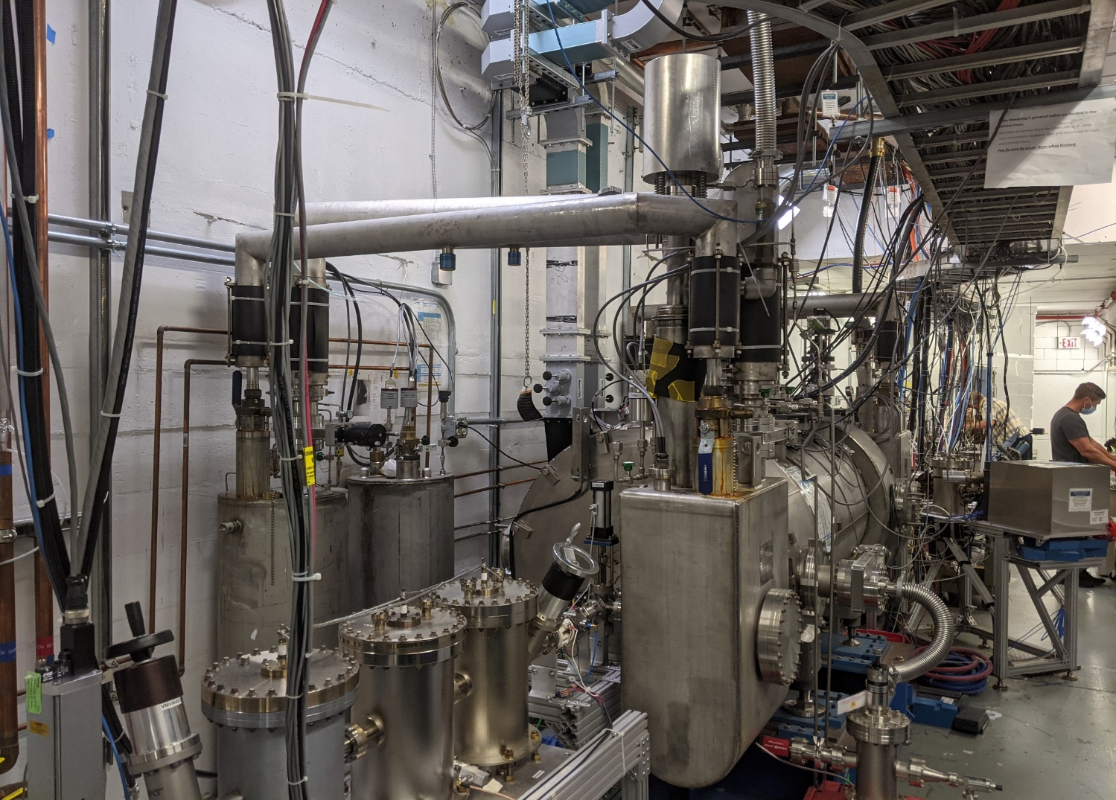
Return Guard Vac Valve
CM Guard Vac Valves ValvesValve
HX Bypass Valve (Red Valve)

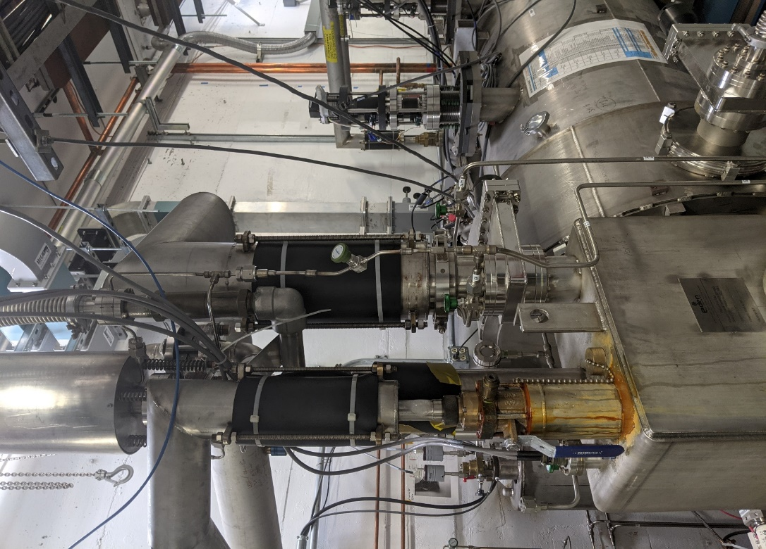
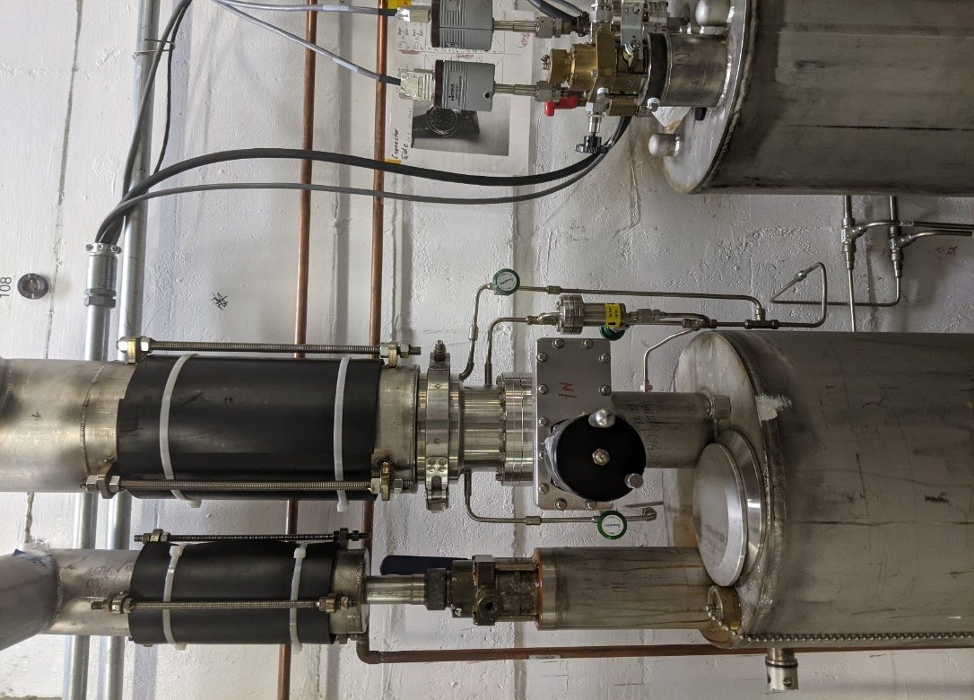
CM Guard Vac Valves
Return Guard Vac Valves
Return U-tube Guard Vacuum Valves
Relief Valve Guard Vacuum Valve

LL Readback Controller Location

The UITF LL readback controller is located on top of the UITF cave. In order to get to it, follow to following instructions:
- Use the stairs in from the of the CMTF control room to get on top of the UITF cave
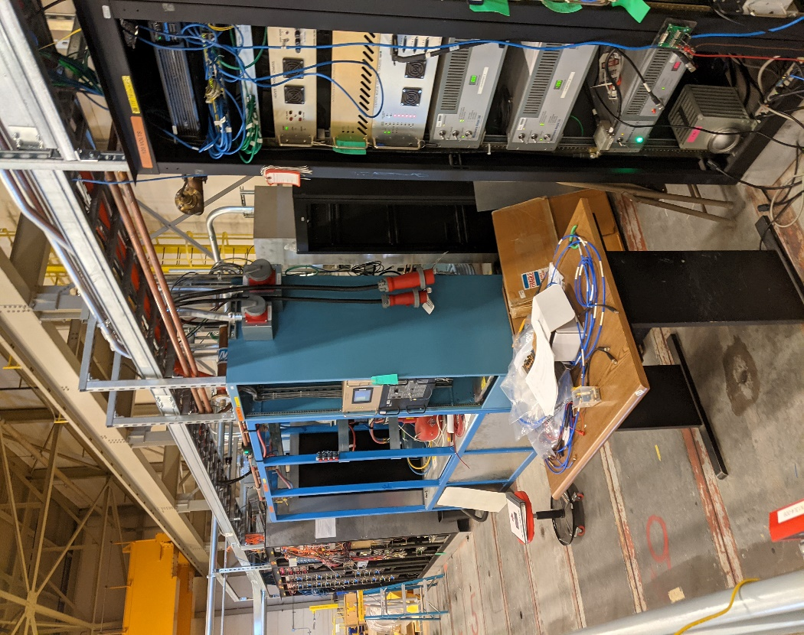
- From the top of the stairs, turn left and walk through the gap between the two racks (pictured below)
- Walk through the gap to the second set of racks and turn left

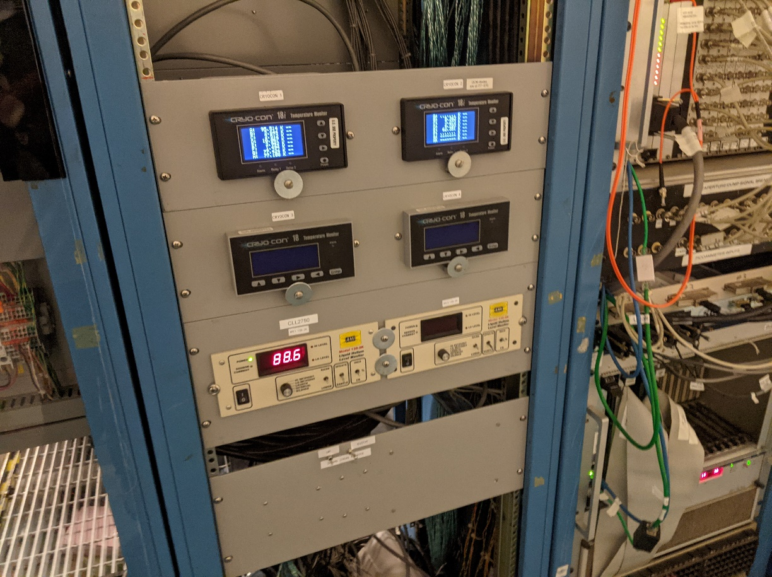
- The LL readback controller will be about two feet away from the gap right below the CC’s

- To turn it on, press the on/off switch on the bottom left of the front pannel

On Call List

Cryo Group Contact Information:

Jonathan Creel
Extension: 7722
Cell 757-869-8910

Thilan Wijeratne
Extension: 7058
Cell: 954-554-6329

Aswathaman Rangharajan (Primary)
Extension: 5956
Cell: 732-258-5365

SRF Contact Information:

John Fischer
Extension: 7408
Cell: 757-334-2758

Release and Revision History

Rev # | Revision or update: | Effective:
1A | Initial version | 6/11/2020

Approvals

Approved by: | Signature: | Date:
Document Owner | David Savransky
CMTF Testing Coordination | Michael Drury
UITF Testing Coordinator | Mike McCaughan
SME | Naeem Huque
Cryo Lead CTF Operator | Aswathaman Rangharajan

