How to perform a QE Scan

- Turn OFF the anode bias:
  - disconnect the red SHV cable from the HV power supply (UHV supply with adjustable positive HV), wait a couple minutes for stored charge to dissipate, and plug the free end of the red SHV cable into the junction box that serves as SHV to BNC adapter
- Lock Out the Glassman HV power supply.
  - Don arc flash Cat 2 PPE
  - Turn breaker (#2) OFF
  - Apply breaker lock, then hasp, then personal lock
  - Look at the Voltage Verification Unit (VVU) and see there is no voltage on all three phases
- Bias the anode and connect to the picoammeter located upstairs. It is important to use this picoammeter because its signal in EPICS is used by the QE scan tool to monitor the photocurrent.
  - The battery bias box is located in the rack near the gun: grab a sufficiently long bnc cable and attach the “+” bias to the BNC connector on the SHV to BNC adapter box
  - The battery bias box near the gun: attach the gray cable that goes upstairs to picommeter to the “-” terminal on the battery bias box
- If the prep chamber vacuum is good (~ 10nA), open the valve to the gun chamber
- Ground the cathode electrode using the long manipulator
- Laser bypass key: grab it from the PPS console in the control room and insert into the black box upstairs [Carlos to add picture here]. Turn the key clockwise 90 degrees
- Measure the laser power from the control room
  - Open the Laser Controls screen from the main UITF Menu:

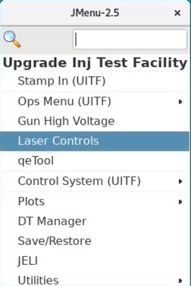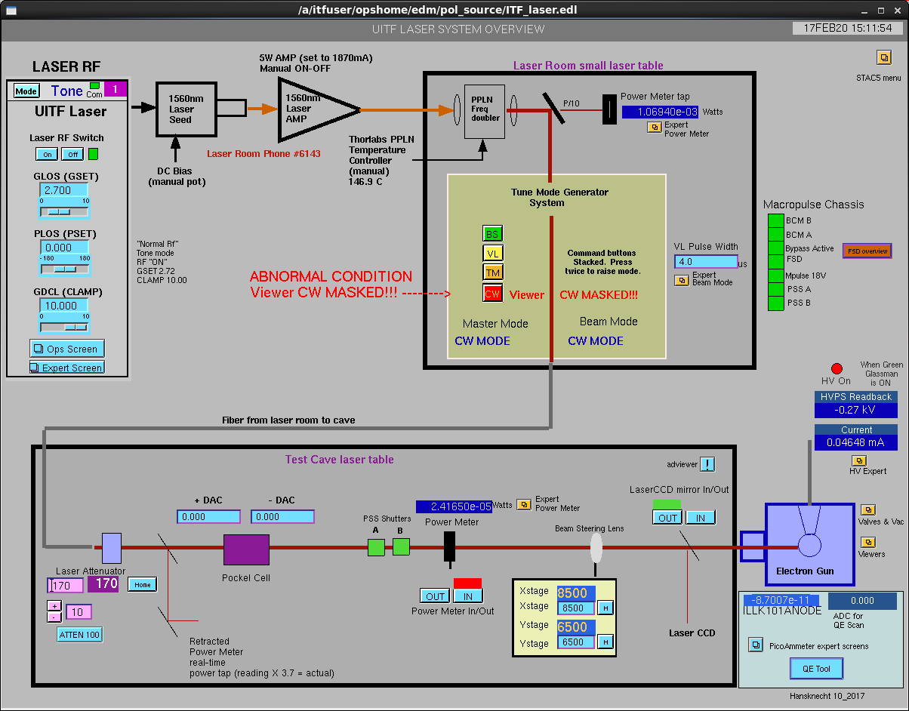
  - To insert the power meter click on Power meter IN
  - Open the expert beam mode screen, then click CW Enable located on the upper right under Master Model Select, and next select Viewer Mask OFF under Status on the upper right
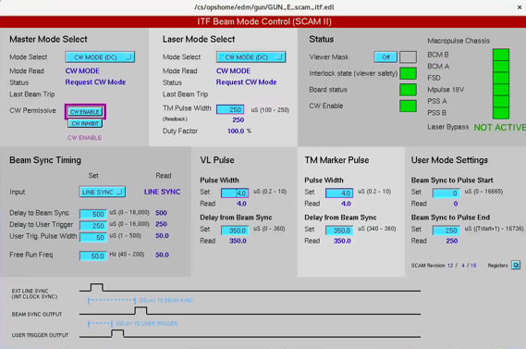
  - Ensure the gun beamline valve VBVK201 is OPEN.
  - Ensure Viewer ITVK201 is OUT
- Adjusting laser power to obtain a value expected to provide ~ 1uA. For a new photocathode, this is 10s of uW. For a used cathode, this could be few mW.
- Open the Anode picoammeter controls screen. This screen can be easily found from the Laser Controls Screen under Picoammeter expert screens on the lower right. Set the Range to 2 uA.
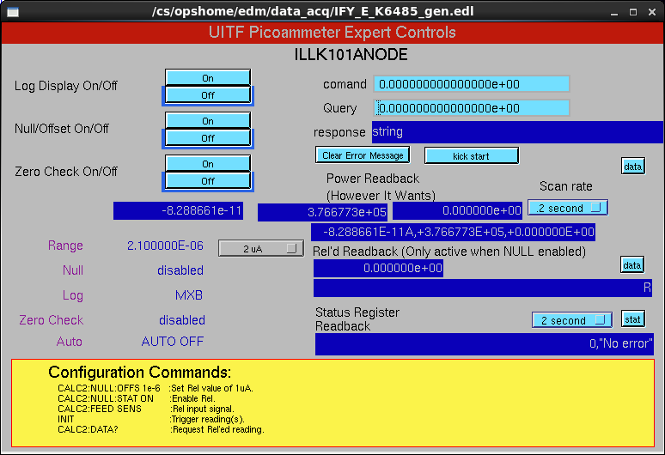
- Pull out the laser power meter by clicking Power Meter OUT on the Laser Controls screen and read the current on the “anode” picoammeter. Adjust laser power by changing the Laser Attenuator setting (range is 100 to 1000) located on the lower left corner of the Laser Controls screen until the anode picoammeter current reads about 1 uA. Record the current, then insert the Laser Power Meter again and record the laser power. Calculate QE. Pull OUT the Laser Power Meter.
- Open QETool from machine that employs RHEL6 operating system, presently the terminal far right inside the UITF control room. The QETool can be accessed from the Main UITF Menu, or from the Laser Controls Screen lower right corner
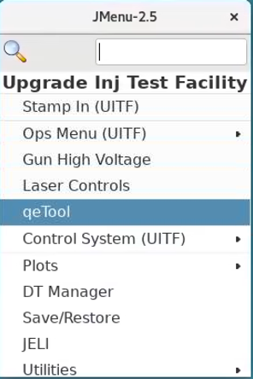
  - Type in the ADC fields shown on recent logged QE scan (See Appendix below to set the ADC values, how to calibrate the QETool program). To open a recent logged scan, click on the PLOT ONE FILE button on the top of the QETool screen, then select the most recent file to open. This should open the selected QE map screen that shows the ADC values and scan parameters.
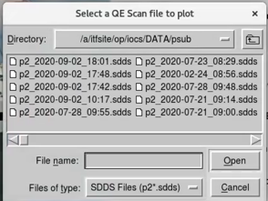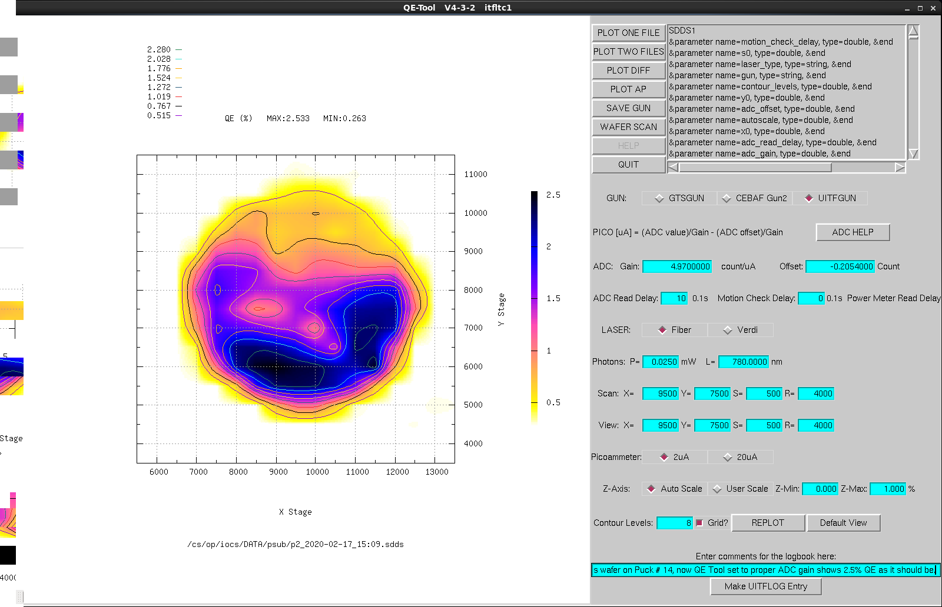
  - Set the scan parameters, use a recent QE scan for reference like the one shown above.
  - Enter the recorded laser power.
  - Start the scan, log the results.
- Backout for operations, or go to “Heat and Activate the Photocathode” if that is your next step
  - Turn off the laser by setting gun mode to beam sync
  - Deselect Viewer Mask OFF
  - Turn OFF the anode bias
  - Close the beamline valve
  - Pull the manipulator from the gun chamber
  - Close the valve to the prep chamber
  - Reconfigure the anode: connect the anode to the Positve HV power supply (UHV supply with variable output), or….
  - To read anode current, attach the anode to the SHV to BNC adapter box, gray cable with BNC cable attached to the adapter box.

Heat and Activate the Photocathode
- Finish the QE scan
- Power meter IN, laser to Beam Sync
- Turn OFF the anode bias
- Close the beamline valve
- orient manipulator ears horizontal, metric “90 degrees” on the magnet pointing up
- Hunt around until you feel the ears go into the puck groove
- Rotate the ears at least 20 degrees and pull puck OUT, into the prep chamber
- Close the valve to the gun chamber
- note text scribed on side manipulator and orient correctly, grab puck with the side manipulator, pull on the long manipulator to remove the schneedle from the puck
- Now raise the heater to insert into the puck, watch to see the puck and manipulator bend upward a small amount, back off on the heater height a smidge, pull on the side manipulator to complete the transfer of the puck to heater
- Lower the heater/puck to “oven” which is at the bottom of the manipulator range of travel
- Apply 9A to the heater to heat the puck to ~ 500 C in about one hour

APPENDIX 1 One way to calibrate the ADC values for QETool
The anode picoammter analog signal is connected to an Analog Digital Converter allowing to read the value in EPICS. The ADC range is between 0 and 10 Volts DC. This corresponds to the range selected in the piccoammeter controls screen. For the QE measurement case, this range was set to 2 uA. One way to set the ADC Gain is by using LivePlot to graph the picoammter readback ILLK101ANODEK6485data and the ADC value ITF:XLASER:AIN. These two signal readback are found on the lower right corner of the Laser Controls screen just above the QETool button. Figure A1 shows a snapshot of the LivePlot with these two signals. By clicking on one of the max picoammeter reading values (the picoammter current is negative) on LivePlot the value (in Amps) is recorded. Do the same for the corresponding ADV value (these are positive values). The Gain is then calculated as: ADC value / picoammter value in uA. In the example below: Gain = 1.735 [Counts] / 0.349836 [uA] = 4.959.

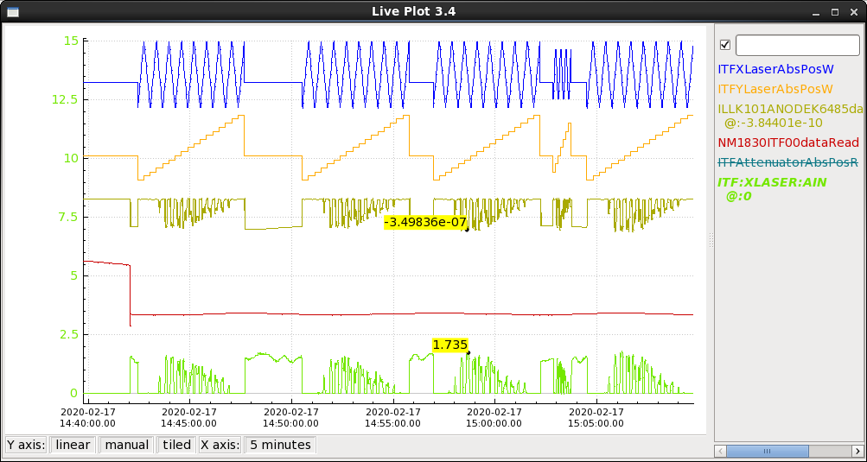
Fig. A1. LivePlot during a QETool scan. Blue: Laser X position. Orange: Laser Y position. Gold: Anode current. Green: ADC value.

