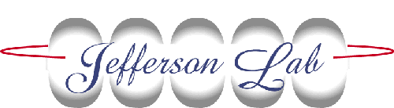
Jefferson Lab Alignment Group
Data Transmittal
TO: S. Riad |  | DATE: 16 Sep 2015
FROM: Jacob Walker | Checked: JCD |  | # : L1669
DETAILS: Data: M:\align\DATA\Step2B\INJ\081215A

Below are the results from the recent survey carried out on the Bubble Chamber. The coordinates below are given in millimeters. A right-handed coordinate system was established with the origin at the intersection of the Main Beamline and the 5D line rotated 25 degrees about the vertical axis. A +X is left, +Y is above, and +Z is downstream from ideal.

Component | X | Y | Z
Copper Collimator
Upstream | 0.29 | -0.01 | 3299.70
Downstream | 0.04 | 0.00 | 3405.65
Bubble Chamber
Left Side Flange | 152.54 | -0.14 | 3667.41
Right Side Flange | -183.96 | -0.25 | 3667.56
Upstream Flange | -0.02 | -0.13 | 3483.90
Upstream Entry Hole | 0.15 | -0.28 | 3474.13
Downstream Flange | 0.05 | -0.10 | 3819.32
Downstream Exit Hole | 0.14 | -0.19 | 3860.51

