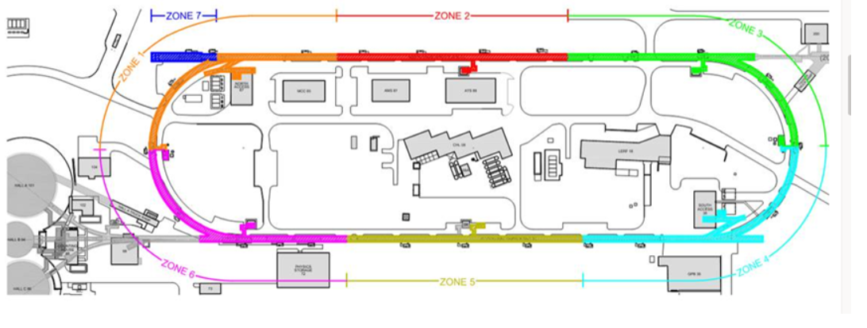
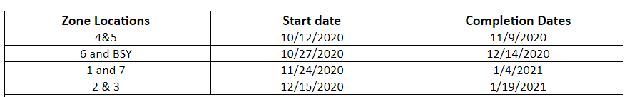

Task Name |  | ZONE
Girder Remove and Transport 1L08A | 10/28/20 | 2
Girder Remove and Transport 1L07A | 10/28/20 | 1,2
Girder Remove and Transport 1L06A | 10/27/20 | 1
Girder Remove and Transport 1L05A | 10/28/20 | 1
Girder Remove and Transport 1L04A | 11/09/20 | 1
Girder Remove and Transport 1L27A | 11/24/20 | 2,3
Girder Remove and Transport 1L26A | 11/24/20 | 2,3
Girder Remove and Transport 1L25A | 11/24/20 | 2
Girder Remove and Transport 1L24A | 11/24/20 | 2
Girder Remove and Transport 1L23A | 12/04/20 | 2
Girder Remove and Transport 1L22A | 12/07/20 | 2
Girder Remove and Transport 1L13A | 01/06/21 | 2
Girder Remove and Transport 1L12A | 01/07/21 | 2
Girder Remove and Transport 1L11A | 01/20/21 | 2
Transport 1L07 | 10/29/21 | 1,2
Transport 1L05 | 11/02/21 | 1
Transport 1L26 | 11/25/21 | 1,2,3
Some general comments.
1. The following list from Mike Drury and Anthony DiPette (and from your email) does not tell the complete story. I have filled in the zones for each step, as you asked.
2. It might be better to work from the first tab, Top Level NL Work. This tab shows removal and reinstallations.
3. The dates shows the girder removal and transport but each of these activities is preceded by 4 to 6 days of preparation and cleanroom work.
4. The Transport of the Cryomodules (1L07, 05, 26) are preceded by 4-6 days and followed days of additional work.
5. Because of the nature of the work, the locations for each activity are ganged with multiple positions in the NLinac.
6. In essence, there will be four cleanrooms going darn near all the time from this Friday, 10-16-20 until the work is completed ~4/22/21.

I suspect we can work in all of Fire Zone 3 (East Arc and down toward the NLinac)
Fire Zone 1 (WArc to NL07), (11/24/20 to 1/4/21) might be possible.
Fire Zone 7 (Injector), (11/24/20 to 1/4/21) has not been analyzed by me.
Fire Zone 2 (NL07 to the end of the cryomodules in the NLinac) is problematic.

Zones 4&5 are starting today with no issues
6 and BSY – There are no reported issues
Zone 1 – Steve believes it may be possible to fit it during the 11/24/20 to 1/4/21 time frame
Zone 7 – Tom Renzo will walk this with Joe Grames to ensure both can complete their work. I will report after the walk around has been complete and Steve has had time to review the plan.
Zone 3 - can work in all of Fire Zone 3 during the time frame shown
Zone 2 – We need to further evaluate this as we get to know how well the subcontractor is performing. We are going to have the subcontractor develop his shop drawings and start to fabricate piping as soon has he can. When the piping is fabricated, have it brought to the lab so if we have an opportunity to fit this into the schedule, we will be ready. May be if INST is working M-Few have the Sub come in Friday night and work the weekend to stay ahead of the valve work.

