Investigation of high frequency isolation using a 14,970 MHz waveguide slot coupled TE011 cylindrical cavity.

In our last meeting Matt made the point that there will always be some charge difference between two interleaved bunch streams. This indicates that even using Reza’s interleaved bunch streams of alternating polarity (still a great idea), there will always be potential competition between the magnetic and charge signals, at least at low frequency…
Comparing the Fourier series of the charge signal, and the current waveform induced by the passing longitudinal magnetic field, is it possible the magnetic signal has more harmonic content than the electric signal? The charge signal is Gaussian, the current signal is a bipolar pulse.
If so, one could measure a high frequency harmonic that has more magnetic content than electric. This is what is meant by “high frequency isolation” in the title.
To investigate this, a series of six cavities were manufactured allowing experimentation with slot coupling and fine tuning the cavity’s resonant frequency.
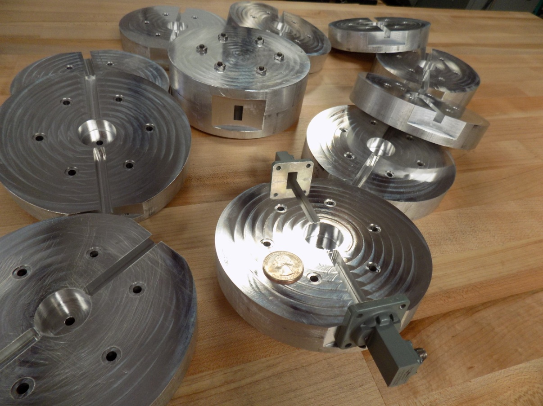
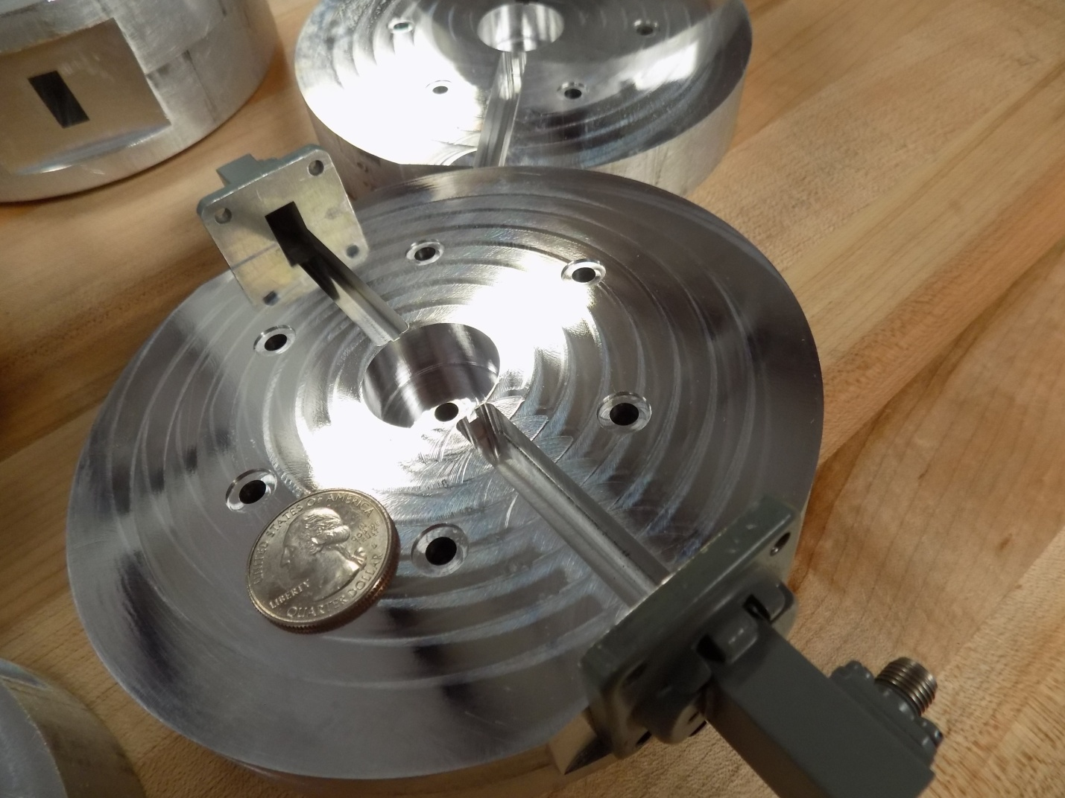

The cavities were constructed in two halves and bolted together. The waveguide is WR-62 (that is .62 inches wide) and spans the frequency range of 12-18 GHz. The bore is 5mm.
The wideband sweep shows only TE modes; this is because the waveguide only transmits TE signals over the frequency range of the waveguide.
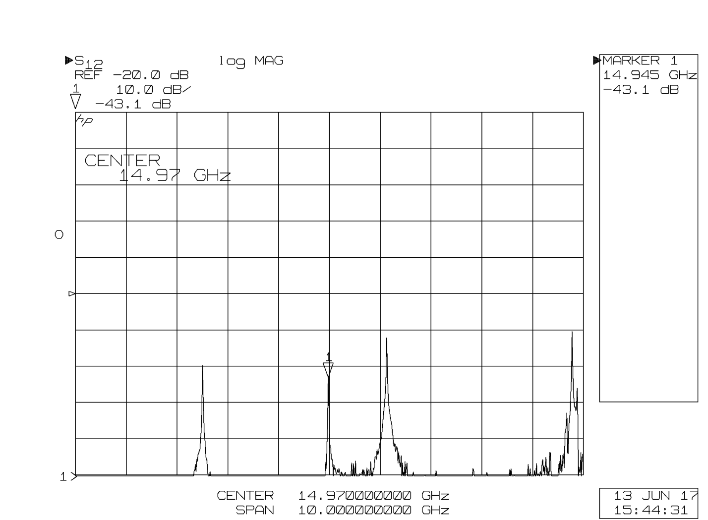
A swept transmission measurement of the cavity showing the TE211, TE011, and TE311 in the 0-19 GHz frequency band.
The waveguide and the slot coupler appear to act as a TE mode selective filter.
The slots were initially tuned by incrementally filing the coupling slots and testing. The results were included into the CNC program. One slot is matched; the other is under-coupled -43 dB.
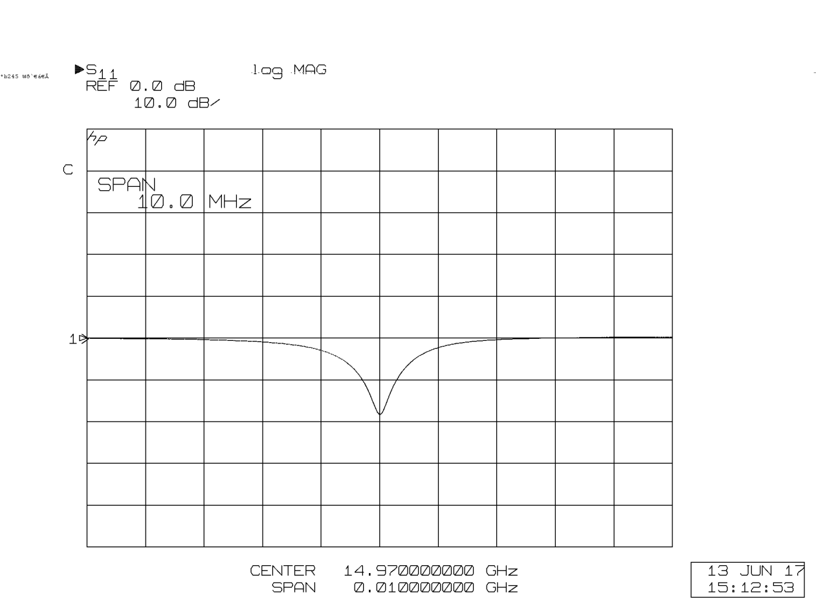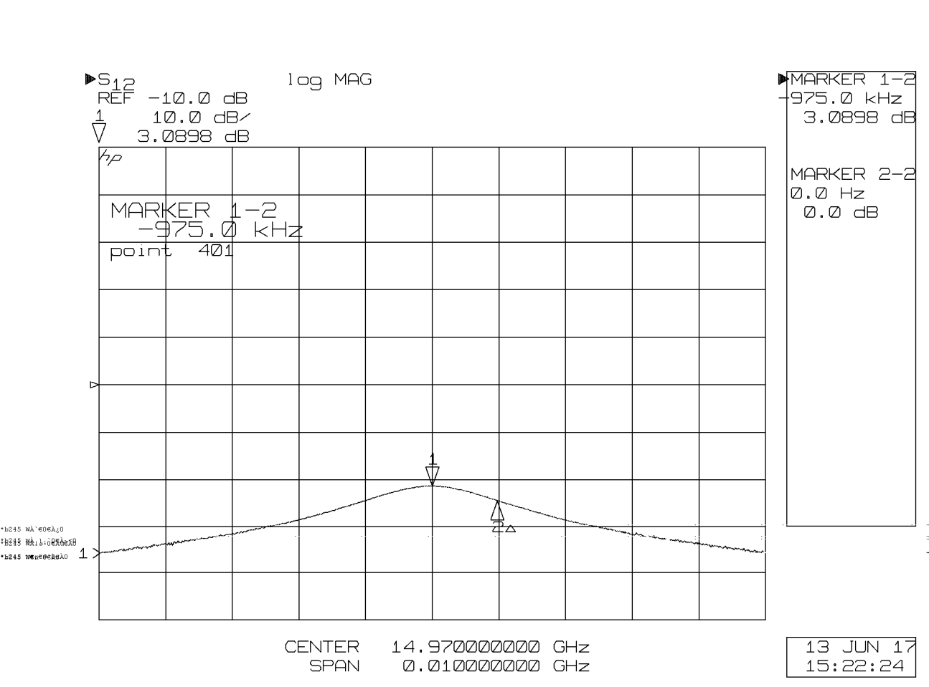

The cavity has a measured QL of 7,677. Because the coupler is matched, the unloaded Qo is twice this or 15,334.
Nice things about this design:
- The design is scalable to any harmonic desired.
- The TE waveguide and slot coupler appears to exclude all TM modes.
- The cavity is a perfect cylinder, there are no antenna’s or rings inside making it easy to model.
- The design is composed of only two parts that are made in one CNC setup. The cavity is very frequency stable and robust.

Future work:

- Need to build either a waveguide vacuum feedthrough (does anyone have a source for waveguide vacuum windows?) or a coaxial to waveguide coupler.
- Need to build a downconverter to process the signal between the cavity and the the I/Q receiver.

Split-Cylinder Resonant Electron Polarimeter:
An initial prototype has been constructed, but not tested.

