Conduct of Operations
for the
E-beam Irradiation Experiment (UE-21-001)
July 9th, 2021

Updates and Revisions

{Date of change}

- page {number}: {Revision made}
Contents
1. Preface 3
2. Documentation 3
3. Shift Personnel Training 4
3.1. General Training Requirements 4
3.2. Additional Training Requirements 4
3.2.1. Ladder Safety 4
3.2.2. Lead Safety 4
3.2.3. Electrical Safety 4
3.3. High School and Undergraduate Students 5
4. Organization and Administration 5
4.1. Experiment Organization 5
4.2. UITF Facility Manager 6
4.3. UITF Experiment Principal Investigator 6
4.4. Control Room Staff 7
4.5. Technical Support 7
5. Operating Procedures 8
5.1. Shift Routines 8
5.1.1. Operations Turnover 8
5.1.2. Timely Orders to Operators 8
5.1.3. Operator Aid Postings 9
5.2. Access to the E-beam Irradiation Experiment within the Experiment Facility 9
5.3. Collaboration Request for Laboratory Resources 10
5.4. Scheduling of Work by Outside Groups 10
5.5. Equipment Labeling 10
5.6. Logkeeping 11
6. Emergency response guidelines 11

Preface
As part of its mission, Jefferson Lab provides the resources necessary for international collaborations of scientists to carry out basic research in nuclear physics and related disciplines. This research must be conducted in a manner that ensures environmental, safety and health (ES&H) concerns receive the highest consideration. At the same time, the programmatic goals of the lab require that it produce the highest quality physics results efficiently.
Guidance on how to balance thoughtful, measured ES&H concerns with efficient operation has been taken from the Director’s Office, the Director’s Safety Council, and the JLab ES&H Manual. A graded approach is followed in which the measures taken are matched to the scale, cost, complexity, and hazards of the operation.
The Conduct of Operations (COO) for Accelerator experiments outlines how the experiment collaboration will operate in a safe and effective manner during the time period that the E-beam Irradiation experiment is on the floor. Installation periods are not covered by the Accelerator Experiment COO. This document is directed to experiment users, physics staff, and must be read, understood, and followed by all members of the collaboration.

Documentation
This experiment uses the standard facility’s accelerator setup. All procedures to be used during the course of the experiment are contained in the following documents:
- The Accelerator Experiment Conduct of Operations (COO) for the E-beam Irradiation Experiment
- Experiment Safety Assessment Document (ESAD) for the E-beam Irradiation Experiment (referring to the base equipment as well as any experiment-specific changes)
- Radiation Safety Assessment Document (RSAD)
- Jefferson Lab Emergency Response Guidelines (ERG)

The present document shall hereafter be referred to as the COO. The Experiment Safety Assessment Document shall hereafter be referred to as the ESAD. The Radiation Safety Assessment Document shall hereafter be referred to as the RSAD. All three documents are required reading for shift personnel. Each shift taker will sign-off to acknowledge they have read the documents and participated in a walk-through. Reference copies of these documents are available in the UITF Control Room for the duration of the experiment. The COO, ESAD, and RSAD may also be available on the web at an experiment-specific website.

Shift Personnel Training

General Training Requirements
All personnel on shift are required to be current in the following JLab safety training:
- ES&H Orientation (SAF100)
- Radiation Worker I Training (SAF801)
- Oxygen Deficiency Hazard Training (SAF103)
- UITF Operator Training (SAF162)

Hazards which are unique to the experimental setup are addressed in the appendices of this document. All shift personnel will be trained in the safety procedures to be followed for access to the UITF complex. A brief discussion will be given on UITF PSS state recognition and expectations.
Individuals participating in the experiment collaboration may be required to have other equipment or procedure-specific training. Training needs shall be determined by the experiment spokesperson in consultation with the Director of Accelerator Operations or the UITF Facility Manager along with the Accelerator Division Safety Officer (DSO).

Additional Training Requirements
Experiment personnel must familiarize themselves with the sections of the JLab ES&H Manual relevant for their work in the specific beam enclosure. It is available via http://www.jlab.org/ehs/ehsmanual/index.html

Ladder Safety
Prior to using a ladder at Jefferson Lab, you are required to take Ladder Safety Awareness (SAF307). If your task requires you to wear a safety harness to work from a position other than between the ladder rails, you may be required to take Personal Fall Protection (SAF202) and site specific Fall Protection (SAF202B). Please see you sponsor or supervisor.

Lead Safety
Prior to handling lead bricks, sheets, pellets or solder, you are required to take Lead Worker Safety Awareness (SAF136).

Electrical Safety
Prior to working on electrical equipment, beyond just plugging it into 120 Volts or below, you are required to take Basic Electrical Safety for Electrical Workers (ESC001). This training is required so that you can make a proper hazard assessment of the electrical equipment you are working on and know the requirements for locking out a piece of equipment prior to working on it.
If the staff/user will be switching a circuit breaker, switching a motor control center, switching a disconnect/safety switch, or switching a main disconnect on Class 2 or Class 3 equipment (contact equipment owner if unsure of equipment classification), you are required to take Safe Switching of Electrical Equipment (ESC005). This training applies only to electrical equipment in a closed cover scenario. For any activity beyond simple switching of equipment, please follow PPE and training requirements described in ES&H Manual Chapter 6200.
If the staff/user will be performing maintenance on electrical or mechanical equipment which cannot be physically and verifiably isolated from an energy source, you are required to take Lock Out, Tag Out (ESC007).

High School and Undergraduate Students
In addition to the above guidelines, JLab has special policies for high school and undergraduate students:
- No one under 18 (student or otherwise) may work in the UITF Cave where tasks require medical qualifications (exposure to acids, lasers, hearing loss, radiation, etc.).
- No high school student may work outside regular working hours.
- Undergraduates working outside regular working hours must be pre-approved by the Division Safety Officer
- Graduate school students are considered users
During their first three months, working in conjunction with JLab or the JLab User community, undergraduate students 18 and over are permitted to work in the beam enclosures (following all other aforementioned rules) ONLY under the supervision of an authorized mentor (i.e. a buddy); that person may not be another undergraduate. A fully trained JLab staff member or member of the JLab User community must be cognizant of the work to be done and must approve the authorized mentor that is supervising the undergraduate student. At the end of the 3-month “trial period”, undergraduates demonstrating that they are responsible and safety conscious are permitted to work in the beam enclosure under the same guidelines that apply to other users.

Organization and Administration

Experiment Organization
The operation of the experiment is directed by the UITF Experiment Principal Investigator(s) and the UITF Facility Manager. The E-beam Irradiation experiment leadership structure is shown here
UITF Facility Manager Michael McCaughan
Experiment PI Gianluigi Ciovati
Technical Support Safety Warden(s)
Shift workers
Figure 1: Functional Organization of the UITF Team. Dashed lines = information flow. Solid lines = responsibility.

UITF Facility Manager
The UITF Facility Manager coordinates with a variety of internal stakeholders and outside entities to ensure that the intended facility best accommodates potential users and to ensure the operating program is well defined and supported with appropriate resources. Currently, the UITF Facility Manager responsibilities include:
- Serve as the designated spokesperson for the facility.
- Set high-level programmatic goals and priorities in consultation with JLab Management and present those goals and priorities to the appropriate scheduling authority.
- Work directly with the Accelerator Division Leadership to approve potential outside funded experiments.
- Meet with representatives of potential outside-funded experiments to determine if their requirements are in line with the capabilities of the facility and help move appropriate experiments through the approval and scheduling process. This includes working directly with the Experiment Lead Scientist to address all safety and technical requirements for the experiment.
- Refer to the ESH&Q division for special review of any potential outside-funded experiment with requirements that fall outside the normal facility operating envelope as defined in the FSAD and facility ASE.
- Verify that all outside-funded experiments have completed the appropriate Experiment Safety Review Process before scheduling beam time.
- Present the appropriate safety documents for potential experiments to the Division Safety Officer (DSO) before moving to the design phase of the Experiment Review Process.
- Maintain programmatic balance for the facility by prioritizing activities and working with the various stakeholders.
- Maintain records for each experiment in an electronic database, including safety documentation such as the COO, ESAD, and LOSP as applicable.

UITF Experiment Principal Investigator
Each proposed Accelerator Experiment is required to have an associated Principal Investigator, who supplies all experiment-specific information necessary for the design and safety review process. The Principal Investigator is often a non-JLab employee. Responsibilities include:
- Work with experiment representatives and the UITF Facility Manager to conduct a thorough design and safety analysis of all experiment equipment and proposed operating conditions, especially those unique to the experiment.
- Work with the UITF Facility Manager to guide the experiment through all phases of the readiness and safety review process; including primary responsibility for completion of the steps defined in ES&H Manual Chapter 3130 Accelerator Experiment Safety Review Process.
- Work with the UITF Facility Manager to prepare and submit the final ESAD and COO for the experiment.
- Organize the experiment collaboration to fabricate any new experimental apparatus and develop the work control documents for reviewing, installing, commissioning, and operating the apparatus.
- Work with the area UITF Facility manager to safely install any new experiment equipment.
- Organize the decommissioning of any equipment that is to be removed and arrange for removal at the conclusion of the experiment.

Control Room Staff
Facility control room staff are trained as Operators. Control room staff also includes the physicists, engineers, experimenters, and others who operate the machine controls to commission new hardware or software, diagnose problems, and perform specific experiments, test plans, or beam studies. All must comply with the directives specified herein, regardless of group or institutional affiliation. UITF staffing requirements for normal operations are described in UITF Operation Directives (UOD).
The UITF Operator controls and monitors acceleration systems to deliver the beam required for scheduled and alternate beam programs. UITF Operators are the primary oversight of the program. All control system manipulations that could affect electron beam must take place in the presence of the Operator (i.e. in the same control room), who can open channel access privileges to qualified staff as appropriate. All other manipulations under channel access that do not directly affect the electron beam delivery at the same time can be made remotely but must be made under the Operator’s full knowledge. UITF Operator responsibilities are defined in the UOD.

Technical Support
System Owners oversee all aspects of an accelerator facility system (e.g., SRF, RF, magnets, BPMs) to assure system performance in support of the scheduled program. Detailed responsibilities are described in the respective Operation Directives for each accelerator facility.

Operating Procedures

Shift Routines
UITF operations refers to the activities associated with operating the UITF. UOD Chapter 3.1 UITF Operations Overview describes the roles and responsibilities of the operating staff and others involved with UITF program execution, provides protocol for critical event response, and lists directives that govern specific aspects of the conduct of operations. UITF operations are conducted from the UITF Control Room by authorized staff. The UITF Operator (the shift lead) controls and monitors the UITF beam acceleration systems. The UITF Operator can be reach in the UITF Control Room at {(757) 269-7354 or (757) 269-6142}.

Operations Turnover
The electronic log book is a very effective means of remotely obtaining information about experimental operations. Experimenters can log in remotely and view all logbook entries prior to commencing their shift. Information which can only be recorded in the paper logbook should be noted accordingly in the electronic logbook, and directly communicated between incoming and outgoing shift personnel.
Efficient and effective shift changeovers during experiment operation are enhanced by overlapping shifts. Shift members must show up at least ten minutes prior to shift start and plan to stay ten minutes after for the purpose of information exchange to those taking over the same tasks. In all cases, incoming shift operators must discuss the experiment and facility status with the outgoing experiment shift operator.
Since the UITF is a test facility, the need for a shift turnover meeting will be rare. The shift-turnover meetings are held at the end of each shift so that the off-going staff can transfer information to the oncoming staff.
The shift-turnover meetings are held in the UITF Control Room and usually last less than fifteen minutes.

Timely Orders to Operators
The initial run plan is the responsibility of the UITF Facility Manager and shall be clearly recorded in the logbook. This plan specifies the tasks to be performed in the next 48 - 72 hours; including any special conditions or data runs, updated documentation and its location and/or alternate plans. Any changes to the run plan shall be recorded in the logbook. The UITF Facility Manager will communicate any orders or changes to the operational plan in the UITF Logbook under the “Operational Plan for the Day.”

Operator Aid Postings
The day-to-day schedule, contact instructions for key personnel, and any other information relevant to current activities are located in the UITF Logbook under “Operational Plan for the Day.” Shift personnel should consult the logbook, especially at the beginning of their shift, to be aware of any updates to current running conditions.
Information pertaining to daily activities within the facility must be posted in the appropriate logbook Conference room whiteboard or on bulletin boards within the UITF control rooms or written on the white board at the entrance to the UITF labyrinth entrance.

Access to the E-beam Irradiation Experiment within the Experiment Facility
Work in designated radiation areas will be carried out in accordance with the JLab RadCon Manual. There are no RadCon restrictions on removing items from the UITF caves after beam operation due to the low energy of the machine is insufficient to activate material.
During a running experiment, the UITF Cave will normally be in Run Permit. The UITF cave can only be accessed in one Personnel Safety System state, Open State. Open State (in UITF) is a state where delivery of beam and/or RF power is not permitted, and entry to and exit from the beam enclosures is not controlled by the Personnel Safety System. This is the normal state of the UITF cave when the accelerator is off. Well-defined checklist procedures are to be followed whenever the beam enclosure is brought to and from Open State for UITF.
Open State is the period when all major work must be completed in the beam enclosure. All activities require advanced planning and must be scheduled for resources and safe operation. In order to streamline activities in the beam enclosure and ensure everyone has ready access to the current status and requirements for work, one should refer to the information board at the entrance to the UITF cave entrance.
The content on the information board is the responsibility of the UITF Safety Warden, UITF Operator and UITF Facility Manager

The information board will contain all critical information required for safe entry into the beam enclosure:
- A succinct, one page safety summary covering current safety hazards within the facility and mitigating measures (to be read by all persons working in the beam enclosure)
- Active Operational Safety Procedures (OSPs) and Temporary Operational Safety Procedures (TOSPs)
- Required temporary work permits (e.g., Radiation Work Permits)
- Current activities in the beam enclosure
- Points of contact
- Required training and safety equipment

Collaboration Request for Laboratory Resources
The collaboration may request additional services from the Accelerator Division through the UITF Facility Manager. These requests should be noted in the logbook. Some requests may require that an OSP or TOSP be developed. Major, abnormal, or unanticipated configuration modifications such as stacking or movement of significant shielding, unanticipated vacuum work, unanticipated beam line modifications, the replacement of a wire chamber, etc., require approval of the UITF Facility Manager and the use of properly trained personnel. The UITF Facility Manager may require that an OSP or TOSP be prepared.

Scheduling of Work by Outside Groups
Work in the beam enclosure that is to be performed by groups outside the collaboration such as survey and alignment, plant services, air conditioning, etc., must be scheduled so that it does not endanger personnel or equipment or interfere with the experiment. Non-emergency activities by these groups should be scheduled to coincide with planned accelerator maintenance periods. To maximize efficiency, the Principal Investigator and the UITF Facility Manager will concur on work scheduling. The UITF Facility Manager shall coordinate activities in the accelerator facility so that work can take place smoothly and safely and to insure that multiple activities do not interfere. The area UITF Facility Manager and the Principal Investigator will meet as needed to plan the work scheduled for the upcoming maintenance period. The product of this meeting will be a list of work in the accelerator facility, appropriate work control documents, and educational or other safety measures (such as escorts) that are needed. The work scheduling tools UITFList or TATL should be used for coordinating the cross-divisional work activities http://www.jlab.org/listsites/. Configuration changes as outlined above can affect site boundary dose and the production of airborne radioactivity. They require consulting with RadCon or ES&H personnel as appropriate.

Equipment Labeling
The experiment and the E-beam Irradiation experiment equipment shall be properly labeled so it can be quickly identified by both shift and maintenance personnel. Proper labeling helps prevent incorrect operation or modification of equipment by non-experts and facilitates proper and efficient operation by qualified personnel. Labeling also increases the likelihood that proper procedures will be followed in case of emergency. Improper labels should be corrected immediately if possible. Otherwise, the Shift Leader should be notified so that correct labeling can be requested from the qualified expert.

Logkeeping
Shift personnel will update the electronic logbook, which serves as the record of the experiment. The quality of the information recorded in the logbook determines the utility of the data. All data recorded electronically will be referenced in the computer logbook with the appropriate run number and run information. All relevant activities are to be recorded, including all changes of experiment conditions and equipment failures.
Checklists performed using E-beam Irradiation specific forms should also be scanned into the computer logbook when completed. The completed paper forms should be stored in a binder in the counting house. All deviations from normal operating parameters shall be recorded in the logbook.
The computer logbook will also serve as the primary reference for the determination of the operational efficiency of the experimental apparatus in the vault. As such, it is essential that it provide an accurate record of the capability of the equipment to carry out the intended research program. The computer logbook is the place of record for all safety issues and introductions of new or updated documentation and procedures.

Emergency response guidelines
The experiment does not require any additional emergency guideline, other than what has been established already for the UITF. Below are the general Emergency Response Procedures and the Emergency evacuation plan for the portion of Building 58 where the UITF is located.
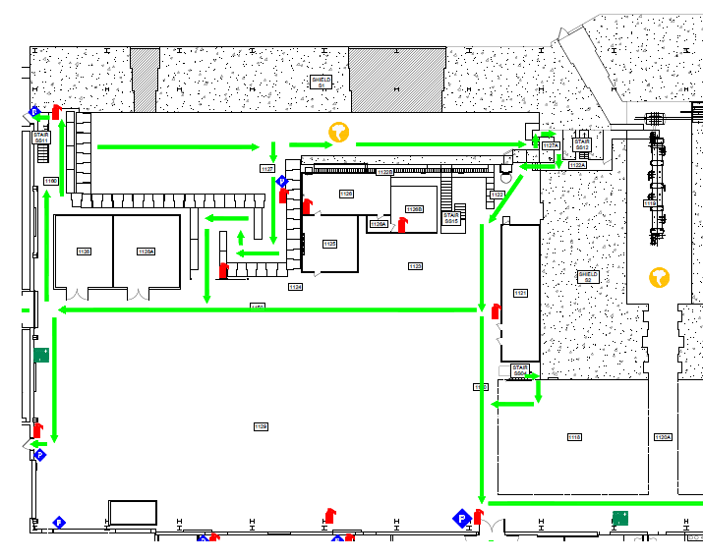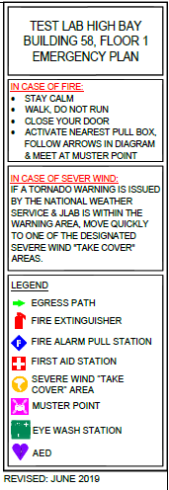
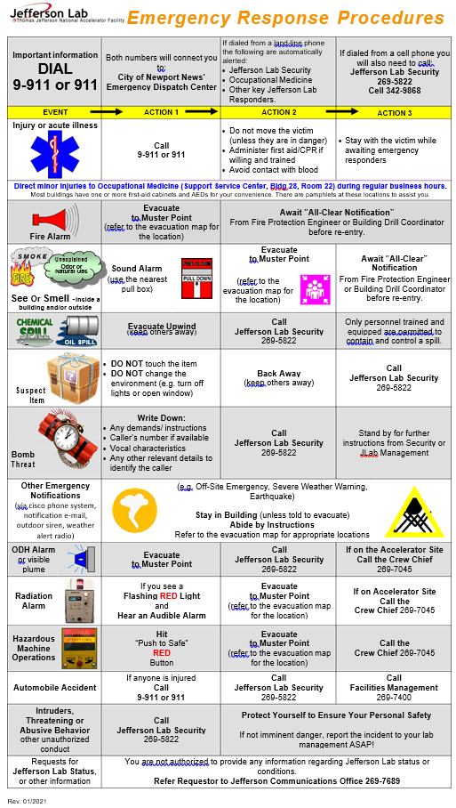
Appendix A – Special Procedures for the Accelerator Experiment
A target carousel operated remotely from the UITF Control Room is used to position a target cell in front of the beamline exit window. A software interlock prevents the UITF Beam Mode to be set greater than “Beam Sync” when the motor operating the target carousel is enabled. A camera pointed at the target carousel allows for a direct view of the target cells, relative to the beamline exit. The Operator must ensure that one of the target cells is placed in front of the beam exit window prior to delivering beam through the irradiation beamline.

Appendix B – Special Procedures for Base Equipment Commissioning
Each shift requires a shift worker, which is assigned according to the E-beam Irradiation experiment shift policy. The safe operation of the “standard" facility equipment is described in the facility’s shift documentation and/or Operation Safety Procedures (OSPs). Additional experts may be required to operate or monitor the operation of the specialized equipment.

Appendix C – Signature Sheet
After reading this document, as well as the ESAD and RSAD for this experiment, workers need to sign the signature sheet located in the "yellow binder" located in the UITF Control Room.

