High Dynamic Range Diagnostic Station (HDRDS)
Kevin Jordan 876-1742 for Pavel Evtushenko
December 23, 2014 Update

The HDRDS will be located in a new location; 5D – “Bubble line”

It was decided that the HDRDS would interfere with other activities in the MHB0L02B H/V to MHE0L03 H/V region.

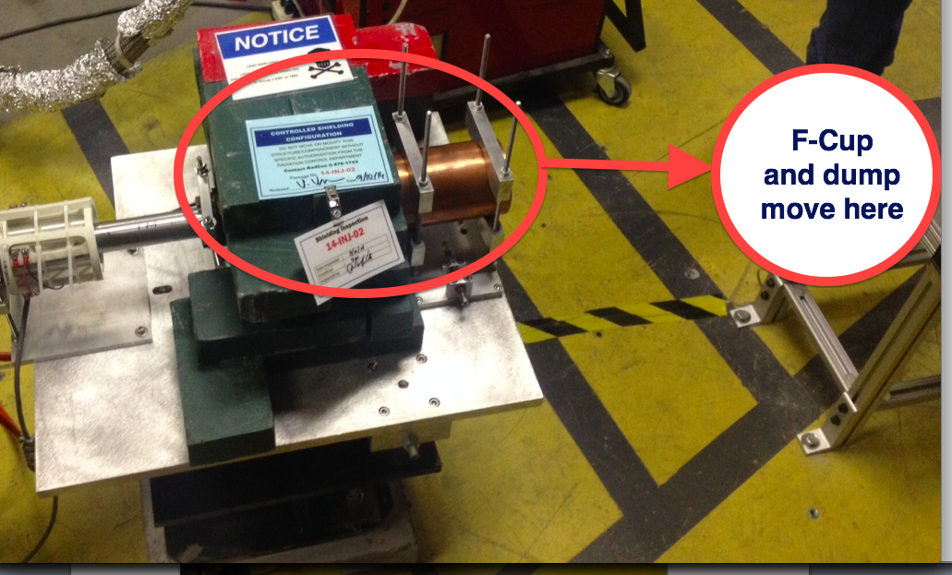
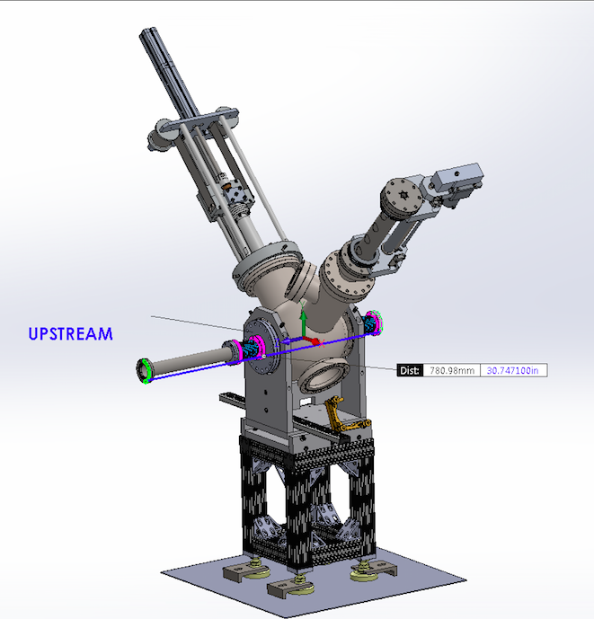
Figure 1, Faraday cup will be relocated ~20" to the right to make room for the device
A new structure will be made & installed to support the shielding, collimator, and dump. This new location will have an added advantage of being able to measure energy spread as well transverse spot size and emittance.

To the right is the model of the combination YAG:Ce beam viewer + wire scanner

