Appendix A: Detailed JLab report

Report Period of Performance:
04/1/2022 –06/30/2022

Co-Principal Investigator:
Riad Suleiman, with Joe Grames and Matt Poelker (Jefferson Lab), and Eric Voutier (IJCLab, Orsay, France)

Work-scope Highlights:
Jefferson Lab’s contribution to this project is to provide a Compton Transmission Polarimeter, which will be used to measure beam polarization when SRF photogun employs a GaAs photocathode. IJCLab is contributing to Jefferson Lab’s effort.

Q3 FY22 Brief summary of activity issues, concerns, successes:

Activity successes:
- We plan to install the polarimeter at the Upgraded Injector Test Facility (UITF) by October. Figure 1 shows the layout at the UITF.
- Our designer is working with the BNL engineer (Jean Clifford Brutus) for the layout there.
- One Radiator is ready, need to fabricate a second radiator and two Collimators.
- The Physics Magnet Group completed the design of the iron core solenoid magnet. Iron pieces have been fabricated. Coil winding is underway. Expected delivery by end of July. Magnet power supplies were ordered. Figure 2 shows magnet geometry.
- Two BGO crystals arrived at Jefferson Lab from IJCLab. The detector box is being fabricated at IJCLab, then ship to Jefferson Lab. The photomultiplier tubes were ordered and their bases are being fabricated at IJCLab.
- All parts of the portable data acquisition system have been ordered or on-site. Now, working on firmware and controls.
- New Wien filter and Mott polarimeter are installed and hot checkout is completed. Beam commissioning is planned in July. The Mott polarimeter is needed to calibrate the Compton polarimeter.
- Graduate student Greg Blume is working on GEANT4 simulation of the final design.

Issues and concerns:
- Competing activities at the UITF and tight schedule; we only have a two-week window in October-November to commission the polarimeter.

Milestones
- All designs are completed and all parts are ordered or on-site. To be ready to install in October.

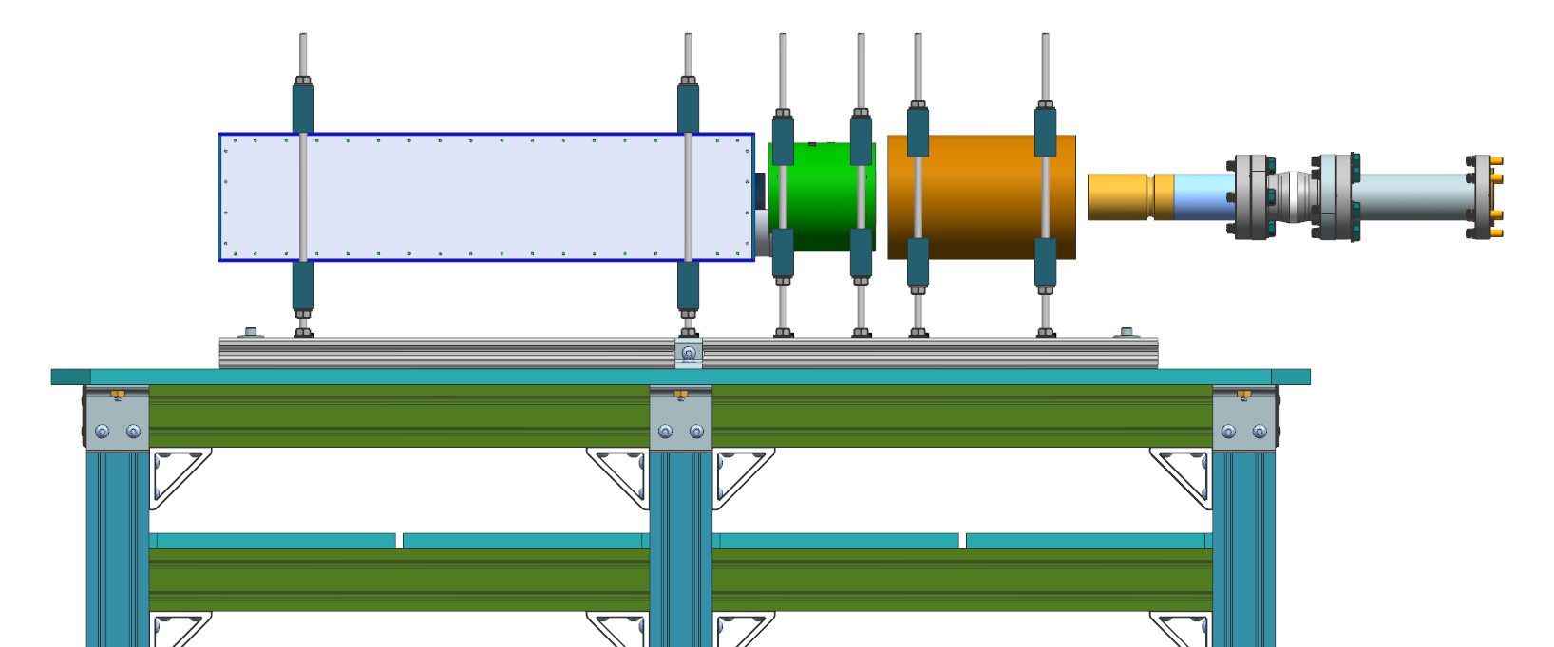

Figure 1: Layout of the Compton Transmission Polarimeter. From right to left, shown are the radiator, copper collimator, magnet and the detector box. Electron beam is coming from the left.
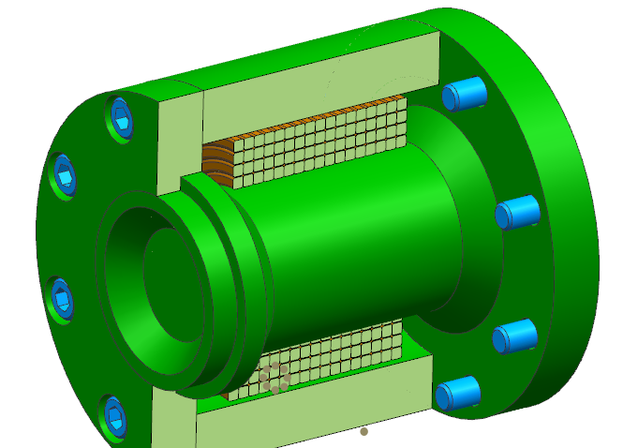
Sleeve
Core
Coil
Flange

Figure 2: The magnet design showing the iron core and the coils.

Budget

Summary of total expenditures:

ID # | Item/Task | Baseline  Total Cost  (AY$) | Costed &  Committed  (AY$) | Estimate  To Complete  (AY$) | Estimated  Total Cost  (AY$)
COMTRA | Compton Trans Polarimeter | $400,200 | $193,355 | $206,845 | $400,200
 | Totals: | $400,200 | $193,355 | $206,845 | $400,200
Notes:
- Costed and Committed numbers are as of June 30th, 2022.

Summary of expenditures by fiscal year (FY):

 | FY 2020 | FY 2021 | FY2022
a) Funds allocated | $200,100 | $200,100 | $400,200
b) Actual costs to date | $139,986 | $0 | $139,986
c) Uncosted commitments | $53,369 | $0 | $53,369
d) Uncommitted funds | $6,745 | $200,100 | $206,845

