Water Irradiation
Meeting 1/7/21

Poelker, Yan Wang, Xi Li, Gigi Ciovati, Hannes Vennekate, Shaun Gregory
We discussed the timeframe for commissioning a new beamline for water irradiation:
- Now through mid-March, the UITF will be locked up on regular basis (i.e., daily) to improve the rf performance of the booster, and to make optics measurements and to learn how to beta-match across the booster
- Mid-March through mid-April, CMTF tests with C75-1 (or P1?). Gigi to get CMTF schedule, find out details of CMTF tests, i.e., the dates and duration
- While CMTF is being used for CM testing, we will modify the UITF beamline, build the water irradiation beamline
- First commissioning of water irradiation beamline in May? Our goal
We talked about temperature limits of the QJ quads required for this experiment: pasted below is Joe Meyers assessment. These quads are connected to 10A cards. Assuming it takes less than 10A to reach the fields Xi specifies, we do NOT need to water cool these quads.
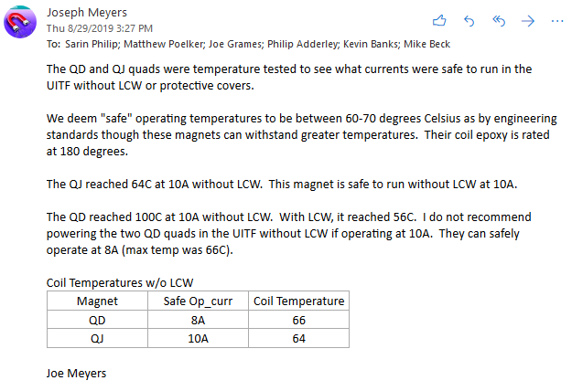
What is the operating current for the solenoid magnet you obtained from Joe Grames? Will it operate with a current card in magnet rack, or a stand-alone current supply?
We need to add lead shielding to FCup3, and the brick will need to have specific shapes. Shaun to design lead brick shielding and order lead brick from Mars Metal
Three MPS nodes related to this experiment: 1) fast valve, 2) solenoid current in a window cmparator (maybe not needed, since worst case scenario shows only small temp rise at window), and 3) BCM current trip setpoint. Joe Grames tells me we use a BCM at CEBAF injector for mps fsd, in a manner identical to what we want for waste water tests. So it’s a question of getting a receiver and implementing something similar at UITF
List all the tasks we have for Engineering: I&C, DC power, SSG and provide as much notice as possible.
Shaun says all of the hardware needed for new beamline is on-site and in Gigi’s office. Would be good to verify
There are 5 sets of steering coils arriving soon, Haimson magnets but built by Stangenes, they can be used for your experiment
I will campaign for a Work Coordinator/Facility Manager from Operations, this person would organize the experimental readiness review
Action items:
- Gigi will discuss with colleagues in SRF the schedule for CMTF, to verify May as realistic time frame for commissioning the new beamline. I volunteer Gigi to be the person who keeps SRF informed of UITF schedule, re: this experiment
- Matt will discuss with Keith Cole and Paul Metcalf implementation of MPS BCM
- Shaun will verify we have in house, all hardware to build the beamline, e.g., mounts for magnets, 80/20 pieces and flange v-blocks
- Matt will check arrival time of new large bore haimsons needed for beamline
- Shaun will study/design lead brick shielding for our Faraday Cup3, which we can move downstream. We can isolate FCup3 in separate cross to simplify implementation of lead brick shielding. We should order this by April from Mars Metal
- The region with FCup3 and BCM is going to be modified when we install the fast valve, drawings should reflect all our intended changes
- Xi will start coming in to learn how to deliver beam, and to participate in optics measurements
- Matt will discuss with Camille our options for a Work Coordinator and Facility Manager for this work
- Once we have identified the Work Coordinator/Facility Manager, that person will organize the ERR. Gigi and Team will respond to all ERR committee questions and issues. Harry Fanning will be our facilitator.
- Xi to work with Yan to list in detail the modifications to magnets, that we pass on to DC power (how many steering magnets with 1 A cards, the quad needs a 10 amp card, what current supply does the solenoid need – I suspect it will use something different from a card?)
- Xi will tell us the operating current of the solenoid magnet, current card or stand-alone supply
- Buy an ion pump, if we don’t have one
- YAG screen 2” diameter? Order it if not yet ordered
- X-ray image intensifier behind the sample? With camera. Do we have the image intensifier film?
- Matt to get permission to use the HDIce “control room” to enable participation > 2 two people
- Matt to list all vacuum mods, including fixing harp M703, and he will sit with Shaun to make sure the CAD layout includes all mods
- Can Xi post all magnet field maps on our UITF wiki? By all, I mean field maps for every style magnet used at UITF. https://wiki.jlab.org/ciswiki/index.php/Technical_Areas
- Meet on a bi-weekly basis?
- Gigi: 8 MeV/c beam at 100nA, this is what you want? Are there plans to vary the beam current and/or energy?
- We will need to flesh out a run plan that includes radiation measurements, to get approval to operate > 25 nA average current that is the present RadCon limit
- At the moment, we think Matt, Xi and Hannes will do the vacuum work….

