Operation of Jefferson Lab Polarized Electron Sources at High Currents*
R. Suleiman#, P. Adderley, J. Clark, S. Covert, J. Grames,
J. Hansknecht, M. Poelker, M. Stutzman
Jefferson Lab, Newport News, VA 23606, USA

Abstract
Two DC high voltage GaAs photoguns have been built at Jefferson Lab based on a compact inverted insulator design. One photogun provides the polarized electron beam at the Continuous Electron Beam Accelerator Facility (CEBAF) up to 200 µA. The other gun is used for high average current photocathode lifetime studies at a dedicated test facility up to 4 mA of polarized beam and 10 mA of un-polarized beam. GaAs-based photoguns used at accelerators with extensive user programs must exhibit long photocathode operating lifetime. Achieving this goal represents a significant challenge for proposed facilities that must operate in excess of tens of mA of polarized average current. This contribution describes techniques to maintain good vacuum while delivering high beam currents, and techniques that minimize damage due to ion bombardment, the dominant mechanism that reduces photocathode yield. Advantages of higher DC voltage include reduced space-charge emittance growth and the potential for better photocathode lifetime. Highlights of R&D to improve the performance of polarized electron sources and prolong the lifetime of strained-superlattice GaAs are presented.

Introduction
The CEBAF load lock DC high voltage GaAs photogun employs inverted insulator geometry [1]. This describes a photogun with a ceramic insulator that extends into the vacuum chamber, as shown in Fig. 1. The primary benefit of this approach is that a large metal structure is not required to support the cathode electrode. As a result, there is significantly less metal biased at high voltage, and consequently there is less metal to generate field emission. Another appealing feature of the design is that the insulator is a common element of medical x-ray sources, and therefore relatively inexpensive compared to cylindrical insulators purchased solely for accelerator electron gun applications. A load-locked photogun design with an inverted insulator helps to reduce the surface area of the high voltage vacuum chamber, which in turn reduces the gas load. Finally, because there is no exposed high voltage, corona shields and a tank for dry nitrogen gas or SF₆ are not required.
The polarized GaAs photogun operating at CEBAF uses a tee-shaped cathode electrode made of 316L stainless steel polished to sub-micron finish using diamond grit. This gun was high voltage processed to 150 kV without detectable field emission and now provides beam at 130 kV. It has a charge lifetime ~ 200 C at 200 μA with transmission of 95%. Recently, the gun delivered 1800 C of polarized beam to the QWeak experiment [2].

*Work supported by the U.S. DOE under Contract No. DE-AC05-06OR23177
# suleiman@jlab.org
A second inverted gun located at an Injector Test Facility is used for lifetime studies at high currents. It employs a similar tee-shaped cathode electrode but made of large-grain niobium. The first application of high voltage was disappointing, with field emission detected at voltage > 140 kV. By increasing the applied voltage, some field emitters were eliminated but processing was limited to 225 kV which was the maximum voltage of the high voltage power supply. Not surprisingly, photocathode lifetime was poor while delivering beam at 200 kV due to field emission which served to degrade the vacuum within the photogun. And often there were high voltage discharges that completely eliminated photocathode quantum efficiency (QE).

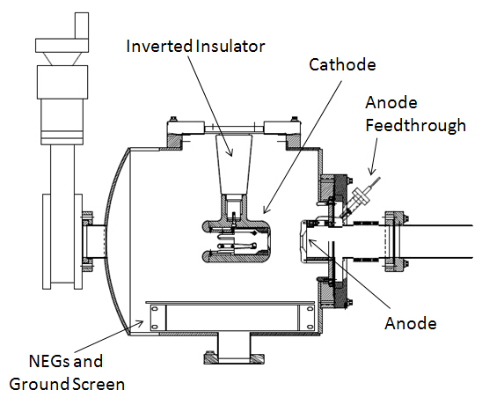
Figure 1: CEBAF inverted gun high voltage chamber.
The large-grain niobium electrode was removed from the photogun and another surface treatment was performed. Upon re-installation of the cathode electrode into the photogun and vacuum chamber bake-out, no field emission was detected at voltage up to 225 kV.
The previous record of polarized beam from a photogun was 1 mA [3]. This photogun was used to deliver 4 mA average beam current from a high polarization strained-superlattice GaAs photocathode that was illuminated with light from an RF-pulsed fiber-based drive laser operating at 780 nm and with 1500 MHz pulse repetition rate. This is a new record [4] and an important development toward realizing some of the requirements for proposed high current accelerators. Table 1 gives the details of the two polarized high current tests.
Table 1: Two Polarized High Current Records
Parameter | Value | Value
Laser Rep Rate | 499 MHz | 1500 MHz
Laser Pulse Length | 30 ps | 50 ps
Laser Wavelength | 780 nm | 780 nm
Laser Spot Size | 0.45 mm | 0.35 mm
Photocathode | GaAs/GaAsP | GaAs/GaAsP
Gun Voltage | 100 kV | 200 kV
Beam Current | 1 mA | 4 mA
Run Duration | 8.25 hour | 1.4 hour
Extracted Charge | 30.3 C | 20 C
Charge Lifetime | 210 C | 80 C
Fluence Lifetime | 132 kC/cm² | 83 kC/cm²
Bunch Charge | 2.0 pC | 2.7 pC
Peak Current | 67 mA | 53 mA
Peak Current Density | 42 A/cm² | 55 A/cm²

The operating lifetime of a GaAs-based DC high voltage photogun is set by the vacuum level inside the photogun. Imperfect vacuum leads to ion bombardment, the mechanism where residual gas is ionized by the extracted electron beam and transported backward to the photocathode where the ions adversely affect photocathode yield. Ions with sufficient kinetic energy penetrate the surface of the photocathode, where they might damage the GaAs crystal structure or serve as trapped interstitial defects that reduce the electron diffusion length. Impinging ions might also sputter away the chemicals (Cs and F) used to reduce the work function at the surface of the photocathode.
The rate of ion production depends strongly on the electron beam energy which varies across the cathode/anode gap. The peak of electron-impact ionization cross-section for molecular hydrogen (the prevalent gas species in a photogun) occurs at ~ 100 eV, and dropping by nearly three orders of magnitude at 100 keV. It is likely that low and high energy ions do different things to the photocathode (e.g., sputter versus implant), but the presence of the QE trench suggests that all ions (low and high energy) are problematic and lead to QE decay.
Photocathode QE decays more quickly at high current, compared to low current, since more electrons lead to the production of more ions and consequently, more ion bombardment. If the vacuum level inside the photogun were constant, the photocathode QE would decay at a rate inversely proportional to beam current. But in practice, the vacuum level inside the gun is not constant; rather it varies with beam current for dynamic reasons related to beam loss. Photocathode QE can drop precipitously at high current, particularly if the electron beam is not efficiently delivered to the desired final location (i.e., a beam dump or target far away). This dynamic QE dependence on beam current makes it very difficult to infer the lifetime at high current based on measurements at low current. However, a crude gun performance can be estimated based on hours-long demonstrations listed in Table 1 from a strained-superlattice GaAs photocathode. During these tests, the photocathode QE was monitored and an exponential fit applied to the data. This provides a measure of the photogun “charge lifetime” which is a useful metric describing the amount of charge that can be extracted before QE falls to 1/e of its initial value. Of course, the photogun can continue to operate beyond its charge lifetime if the drive laser is sufficiently powerful. However, now there is the risk of overheating the photocathode and there are experimental measurements that show the beam polarization is lower when the QE becomes very small.
At 4 mA, the photogun can provide 14 C/hour, or 346 C/day. Using the empirically determined photogun charge lifetime of 80 C at 4 mA, and assuming the use of a 10 W laser, a high-polarization photocathode with typical 1% initial QE could operate for 13 hours before running out of laser power and QE. At this point, moving the laser beam to a fresh photocathode location would take 1 hour. Assuming there are 6 spots (since laser spot size is much smaller than active area), this provides 3 days of operation before heat and reactivate is needed (8 hours). Accelerators with dedicated user programs require highly reliable equipment that can operate for days without interruption, including photoguns. Experiments at higher current require photoguns with significantly improved charge lifetime. A suitable charge lifetime R&D goal is 1000s C.
Table 2 lists the parameters of the sources at CEBAF and JLab FEL and of the sources needed for future facilities. Charge per microbunch and average current from the gun are the two most relevant parameters that affect the design of the source. If polarization is not required, then the new facilities are planning to use multi-alkali photocathodes like K₂CsSb or Na₂KSb. Unlike GaAs, these are positive electron affinity (PEA) bulk photocathodes that do not require an activation layer on
Table 2: Source Parameters for Existing Accelerators (CEBAF and JLab FEL) and Proposed Facilities
Parameter | CEBAF | JLab/FEL | eRHIC | MEIC | Cornell ERL | LHeC | CLIC | ILC
Polarization | Yes | No | Yes | Yes | No | Yes | Yes | Yes
Photocathode | GaAs/GaAsP | Bulk GaAs |  |  | K₂CsSb
Width of microbunch (ps) | 50 | 35 | 100 | 50 | 2 | 100 | 100 | 1000
Time between microbunches (ns) | 2 | 13 | 106 | 1.34 | 0.77 | 25 | 0.5002 | 337
Microbunch rep rate (MHz) | 499 | 75 | 9.4 | 748.5 | 1300 | 40 | 1999 | 3
Width of macropulse | - | - | - | 2.3 µs | - | - | 156 ns | 1 ms
Macropulse repetition rate (Hz) | - | - | - | 20 | - | - | 50 | 5
Charge per microbunch (pC) | 0.4 | 133 | 5300 | 173.5 | 77 | 640 | 960 | 4800
Peak current of microbunch (A) | 0.008 | 3.8 | 53 | 3.5 | 38.5 | 6.4 | 9.6 | 4.8
Laser spot size (cm, diameter) | 0.1 | 0.5 | 0.6 | 0.3 | 0.3 | 0.5 | 1 | 1
Peak current density (A/cm²) | 1 | 19 | 188 | 50 | 500 | 32 | 12 | 6
Average current from gun (mA) | 0.2 | 10 | 50 | 0.006 | 100 | 25 | 0.015 | 0.072

the surface and thus not sensitive to ion bombardment. If polarization is required then as of now, there is no choice other than using strained-superlattice GaAs. This photocathode requires surface activation to lower the work function and generate the negative electron affinity (NEA) needed for photo-emission and thus susceptible to ion bombardment that sputters the active layer and damages the supper-lattice structure.

Improving Photogun Vacuum
In order to minimize ion bombardment and improve the charge lifetime of the photogun, one must improve the vacuum inside the photogun, which is a function of statistic (i.e., no beam) and dynamic (i.e., with beam) conditions. Static vacuum is determined from the gas load from all sources including outgassing and leaks, and the effective pump speed. Obviously, to reduce pressure, the pump speed should be maximized and the gas load minimized. Most, if not all, polarized photoguns today rely on load-locked designs, with the photogun composed of multiple vacuum chambers separated by valves. Load-locked photoguns provide superior vacuum inside the high voltage chamber, where the beam is produced, by moving comparatively poor vacuum tasks like photocathode installation and heating and activation to other chambers where ion bombardment is not a concern.
The static vacuum level inside the high voltage chamber at CEBAF is 10⁻¹² Torr or better [5].
The cathode/anode gap inside the high voltage chamber of a modern DC high voltage photogun is surrounded by non-evaporable getter (NEG) pumps, which have very high pump speed for hydrogen, the dominant gas species of baked stainless steel vacuum chambers. Modern photoguns also employ an ion pump, which serves to pump gas species not efficiently pumped by the NEG such as methane, carbon monoxide and helium. It is worthwhile to degas the vacuum chamber via an extended 400 °C pre-bake (10 days long) to reduce the outgassing rate by more than an order of magnitude, from typical 2 × 10⁻¹² to 1 × 10⁻¹³ TorrLs⁻¹cm⁻² [6].
The list of potential vacuum improvements that could be applied to the next generation of photoguns is rather meager. One possibility is to replace the ion pump with a cryopump. Another potential vacuum improvement involves using coatings that are considered to be diffusion barriers that limit hydrogen outgassing, such as titanium nitride (TiN) [6].
At Jefferson Lab, the biggest vacuum improvement at the photogun will be realized when improvements are made to the adjoining beamline. The most obvious, but frequently overlooked, assessment of the vacuum condition of the beamline is to monitor the photogun vacuum when the valve to the beamline is opened. Of course, when properly engineered, the photogun vacuum should not increase when the valve is opened. A beamline designed for high current will be pre-baked at 400 °C to achieve low outgassing rate, and it will include a significant level of pumping, both localized, and distributed along the beamline via NEG coating.
Dynamic vacuum is determined by field emission and beam loss. Ion bombardment is greatly enhanced in the presence of field emission from the cathode electrode, even at levels that are difficult to measure. Field emitted electrons strike surfaces near the photocathode, generating a gas load. Field emission is often more problematic for high current applications because these applications frequently require very high bias voltages to overcome space charge forces. Every effort must be made to monitor and eliminate field emission. Monitoring field emission can be accomplished by using an anode that is electrically isolated from ground and attached to a sensitive current meter. An ion pump with a sensitive current monitor can also provide an indication of field emission and x-ray radiation monitors placed near the photogun represent another very useful diagnostic.
Beyond eliminating field emission, there are other steps that can be taken to ensure dynamic vacuum conditions are suitable for high current beam delivery. It is extremely important to effectively manage all extracted beam leaving the photocathode, including beam not intentionally produced, for example, from extraneous laser reflections or background light illuminating the activated surface of the photocathode.

Belonging Photogun LIFETIme
It is possible to enhance the operating lifetime of the photocathode at high beam currents by: (a) operating with the drive laser beam positioned away from the electrostatic center of the photocathode, (b) limiting the photocathode active area to eliminate photoemission from regions of the photocathode that do not support efficient beam delivery, (c) using a large drive laser beam to distribute ion damage over a larger area, and (d) by applying a relatively low bias voltage to the anode to repel ions created within the downstream beam line. These techniques are described in detail in reference [7]. Granted, some of these techniques (a and c) degrade emittance, but the benefits of longer photogun operating lifetime might warrant their implementation.
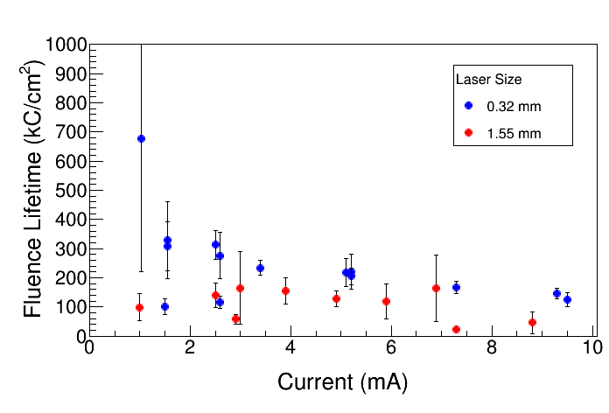
Figure 2: Fluence lifetime vs average beam current for the two laser spot sizes. These measurements were taken with bulk GaAs, 532 nm, and 5 mm active area.

The reasoning for (c) is that the same number of ions will be produced within the cathode-anode gap regardless if the laser beam was big or small, but for a larger laser beam, the ions will be distributed over a larger area and QE should decrease more slowly. With this in mind, the concept of fluence lifetime, the amount of charge that could be extracted per unit area before QE falls to of its original value, was studied and with the expectation that fluence lifetime would be a constant for each photogun. Furthermore, the fluence lifetime of a gun measured with a small laser spot could be used to predict the charge lifetime of a gun illuminated with a large laser spot.
Lifetime measurements were made over a broad range of currents by illuminating a freshly activated photocathode with 5 mm active area, with small and large laser beam sizes. Results shown in Fig. 2 clearly indicate an improved lifetime when using the larger spot size.
Most of these techniques are routinely employed at CEBAF - only the center portion of the photocathode is activated to negative electron affinity to reduce the likelihood of generating stray electrons that would hit the vacuum chamber walls, and the laser beam is always positioned away from the electrostatic center. And recently during the QWeak experiment, the laser beam spot size was doubled from 0.5 to 1.0 mm. The charge lifetime (Fig. 3) improved by a factor of four while using the 1.0 mm diameter laser spot because the offending ions produced by the extracted beam were distributed over a larger area.
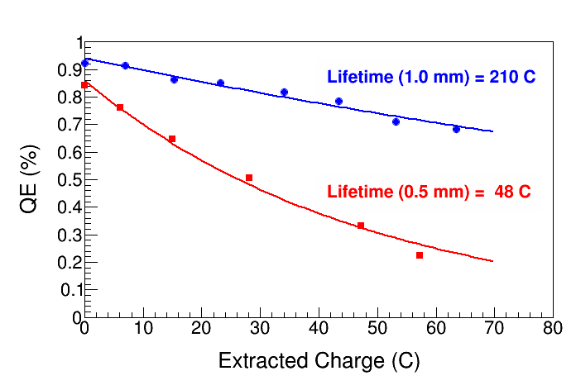
Figure 3: Measured charge lifetime while delivering 200 µA average current during the QWeak experiment using two different laser beam diameters at the photocathode. Different spot sizes were obtained by using different focusing lenses.

HIGHER Photogun HV
High average current and/or high bunch charge applications benefit from the operation of the photogun at very high voltage, which serves to minimize the ill-effects of space charge forces which degrade the emittance and introduce beam loss leading to a diminished photogun charge lifetime. Guns with higher high voltage allow for compact, less-complicated injectors. Higher HV would also increase QE by lowering the potential barrier (Schottky effect) [8] and suppresses the surface charge limit [9]. As an added benefit, operation at very high bias voltage may enhance the operating lifetime of the photogun by quickly accelerating the beam to energy with very small ionization cross section. The total number of ions generated at 500 kV, for example, will be substantially reduced compared to operation at 100 kV, assuming the same cathode/anode gap, see Fig. 4.
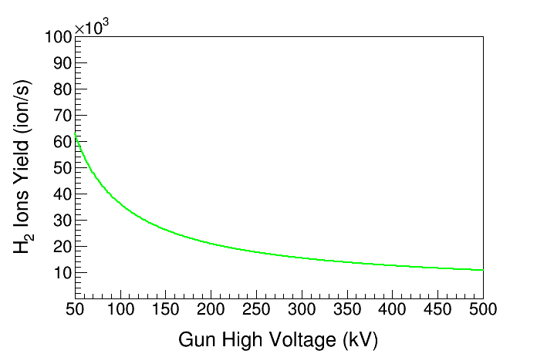
Figure 4: Ions yield assuming electron beam current of 2.0 mA and gun vacuum of 8.0 × 10⁻¹² Torr.
A number of photogun groups are working to build 500 kV guns, however without exception; efforts to operate photoguns at 500 kV and maximum field strength greater than 10 MV/m have met with problems due to field emission. At Jefferson Lab, a new photogun is being constructed that will employ proven vacuum techniques such as pre-baking at 400 °C to reduce outgassing, as well as cryopumping if ongoing vacuum tests indicate an improvement over conventional pumping with NEGs and ion pumps. The adjoining beamline will be properly engineered for 10⁻¹² Torr operation and techniques will be used to minimize the effect of ion bombardment, in particular the use of a large laser beam at the photocathode. But the main focus of the new photogun design effort is directed at operation at high voltage of 500 kV. The new inverted gun will use a longer ceramic insulator and a spherical cathode.

PHOTOCATHODE R&D
Roughly 70% of the light incident on the photocathode is absorbed while the remaining 30% is reflected. With high laser power, the photocathode must be cooled. Otherwise, if the photocathode temperature rises above a certain threshold, the activation chemicals (Cs and F) of GaAs or the actual chemical elements of a multi-alkali photocathode start to evaporate which lowers the QE. For strained-superlattice GaAs, another approach would be to reduce the overall laser light absorption in the photocathode material. This can be accomplished by adding a reflector between the superlattice layers and the substrate so no light is absorbed in the substrate and more light is absorbed in the superlattice material when the light is reflected back. It is important to steer the reflected light away from the photocathode so it would not scatter from the surrounding structures and hit the photocathode again to generate halo beam.
A possible candidate for a new polarized material photocathode is the strained-superlattice GaAsSb/ AlGaAsP from SVTA [10]. This new photocathode will provide higher than 90% polarization and 5-10% QE. Sb has three orders of magnitude lower diffusivity than Ga and two orders of magnitude lower diffusivity than As. Diffusion is one of the main reasons for structural and surface decomposition of cathodes, especially during heat cleaning and ion bombardment. Sb based photocathodes can thus be more robust in poor vacuum environment.
The goals of polarized photocathode R&D are: (a) higher QE (>> 1%) with a thicker superlattice absorber region (with fully strain-compensated structure) and more efficient photon absorption, (b) an effective distributed Bragg reflector (DBR) structure on a GaAs substrate to enhance QE and reduce heating, (c) longer lifetime by reducing structural and surface decomposition and with new photocathode material that is more robust in poor vacuum, and (d) higher polarization with higher-gradient-doping to reduce surface charge limit and depolarization.

References
[1] P. A. Adderley et al., “Load-locked dc high voltage GaAs photogun with an inverted-geometry ceramic insulator,” Phys. Rev. ST Accel. Beams 13, 010101 (2010).
[2] R. Carlini et al., “The QWeak Experiment: A Search for New Physics at the TeV Scale”, JLAB Experiment E02-020, December 6, 2004.
[3] J. Grames et al., “Lifetime Measurements of High Polarization Strained Gallium Arsenide at Beam Current > 1mA using a new 100kV Load Lock Photogun”, Proceedings of the 2007 Particle Accelerator Conference, Albuquerque, NM.
[4] R. Suleiman et al., “CEBAF 200 kV Inverted Electron Gun”, Proceedings of the 2011 Particle Accelerator Conference, New York, NY.
[5] M. Stutzman et al., “Continued Work toward XHV for the Jefferson Lab Polarized Electron Source,” presented at the AVS 58th International Symposium and Exhibition, Nashville, TN, 2011.
[6] M. A. Mamun, M.L. Stutzman et al., “Effect of heat treatments and coatings on the outgassing rate of stainless steel chamber,” Journal of Vacuum Science & Technology A 32, 021604 (2014).
[7] J. Grames, R. Suleiman et al., “Charge and fluence lifetime measurements of a DC high voltage GaAs photogun at high average current,” Phys. Rev. ST Accel. Beams 14, 043501 (2011).
[8] J. R. Howorth et al., “Electric field enhancement of escape probability on negative electron affinity surfaces,” Applied Physics Letters 23, 123, (1973).
[9] G. A. Mulhollan et al., “Photovoltage effects in photoemission from thin GaAs layers,” Physics Letters A 282, 309 (2001).
[10] Y. Chen et al., “DOE/SBIR Phase I/II: GaAsSb/AlGaAsP Superlattice Polarized Electron Source,” SVT Associates, Inc., Eden Prairie, MN.

