A detailed examination of the MDL field map and the TOSCA model of this "5 MeV" dipole

Jay Benesch

**Abstract**

The MDL field map from EPICS and the TOSCA model of the dipole have been examined in great detail in support of the upcoming bubble chamber experiment which is aiming for 0.1% energy accuracy. The TOSCA model with minimum allowable gap allowed by drawing and the TOSCA default BH curve agrees with the EPICS field map at the 0.1% level in the linear approximation. Fifth order fits are required to reduce residuals to small levels and make them normal for either field map or model. BdL vs P and BdL vs KE tables were generated from the model for three beam lines: -30o, +25o and -12.5o. These also require higher order fits if residuals are to be normal. These tables or fits provide a much more accurate method for setting BdL(P) than the hitherto used approximation to the usual formula for long magnets, B*(T-m) = 3.335641*P(GeV/c). The MDL dipole and its predecessor are both 102 mm long and have ~26 mm gaps, so length/gap is small.

**EPICS field map**

Magnet ID: DL 001, location 0L02

|  |  |
| --- | --- |
| Amps | Hall Probe BdL(G-cm) |
| -9.992 | -23944.2 |
| -8.996 | -21569.6 |
| -7.991 | -19169.0 |
| -6.990 | -16769.5 |
| -5.990 | -14360.7 |
| -4.993 | -11954.6 |
| -3.994 | -9542.8 |
| -2.989 | -7116.1 |
| -1.989 | -4698.2 |
| -0.990 | -2283.6 |
| 0.003 | 126.0 |
| 1.009 | 2548.4 |
| 2.009 | 4960.8 |
| 3.009 | 7374.6 |
| 4.010 | 9785.8 |
| 5.010 | 12192.0 |
| 6.010 | 14589.8 |
| 7.011 | 16980.4 |
| 8.013 | 19360.4 |
| 9.015 | 21720.5 |
| 10.014 | 24038.1 |



Point at zero current excluded from these plots as residuals were off the smooth curve. I will now fit the data with third and fifth order polynomials in another program because of the curves in the residual by predicted plot. I will compute residuals for those fits and examine for normality.





|  |  |  |  |
| --- | --- | --- | --- |
| Fit | Mean residual | Standard deviation | Residuals normal? |
| First order | -3.87 | 47.08 | No |
| Third order | -0.72 | 8.48 | No |
| Fifth order | -0.11 | 1.92 | yes |

EPICS field map data fits





Three fits to model data for BdL(I), no hysteresis. The slopes of the first order fits for EPICS map (2407.2) and model (2410) are in the ratio 1:1.001, hence abstract claim of agreement at 0.1% level.

|  |  |  |  |
| --- | --- | --- | --- |
| Fit to model Bdl(I) | Mean residual | Standard deviation | Residuals normal? |
| First order | -0.207 | 1.605 | No |
| Third order | 0.010 | 0.255 | No |
| Fifth order | -0.004 | 0.026 | Yes |

**Straight BdL vs momenta of particles bent into various beam lines**

There is one beam line into the 5 MeV dipole, normal to the pole face. There are four exiting the dipole, the 5D line at 25o, the straight-through line to CEBAF, the 3D Mott line at -12.5o and the 2D spectrometer line at -30o . Even though the MDL is 160 mm wide vs 102 mm for the old BV, the field still falls off at the extreme angles. Simulations were run at 40 different currents encompassing most of the momenta expected to be possible even with the new quarter cryomodule. The simulation at the lowest current, 1A, stands out in residuals for linear fits but is included in all fits shown below.

The bubble chamber experiment will be mounted on the 5D beam line. One needs to be able to set the magnet to a current derived from the EPICS map BdL(I) which is measured straight through the magnet, normal to both poles. Electrons were tracked through simulations. Energy was varied until the desired angles were reached for each simulation. Momentum was then calculated from this kinetic energy value assuming electron mass 511 keV. Values obtained by this procedure are shown in the table and plots below. Because the model does not have hysteresis effects, as seen in the low constant terms in the fits on the previous page, the electrons were always bent to the left as seen from below in the model. This doesn't matter for the model but does matter for the real magnet. In the machine, the 2D and 3D lines (beam left) require negative currents and the 5D line (beam right) requires a positive current. Appropriate BdL signs are used in the plots but not in the table which immediately follows. One will therefore be able to use the fits on the plots to set the (straight) BdL via EPICS to get the desired momentum.

The question then becomes how good is the field map? The work on pages 2 and 3 suggest it's not bad. Piece-wise linear extrapolation between points, used in EPICS, has not been examined. It is suggested that a new EPICS field map be created by evaluating the fifth order fit on page 3 at 0.2A intervals, replacing the measured map (page 1).

Three Opera trajectory images follow illustrating the procedure at 25 degrees.

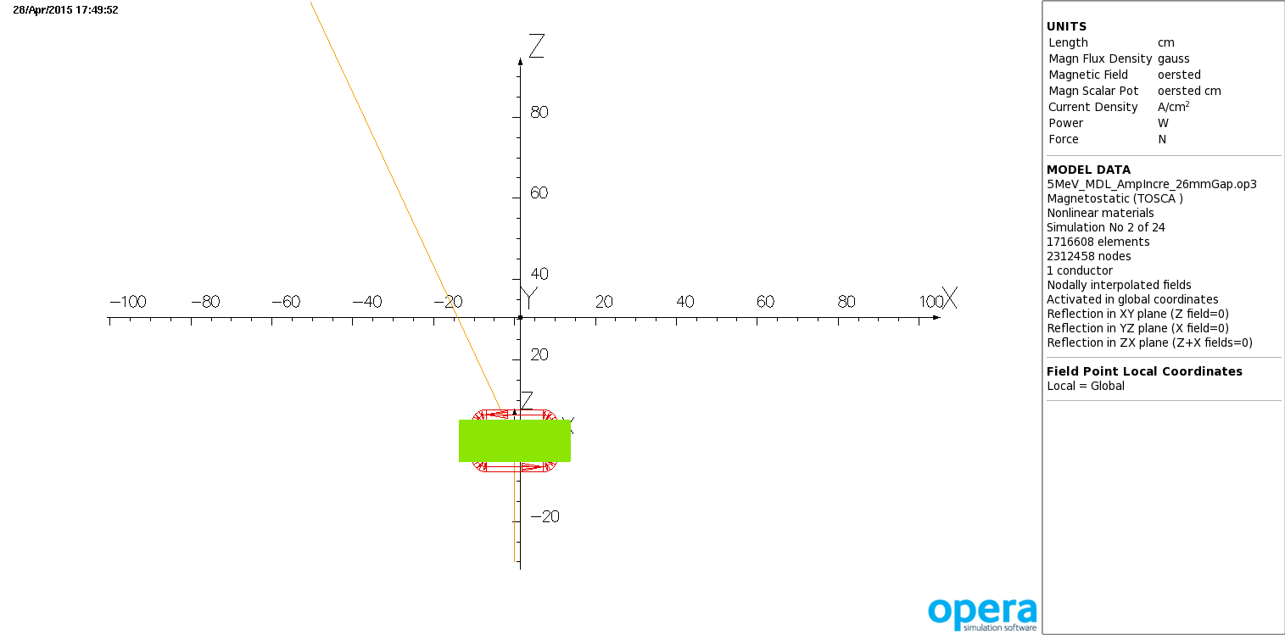

Overall path of particle with 2.9816 MeV kinetic energy launched at (0,0,-30).

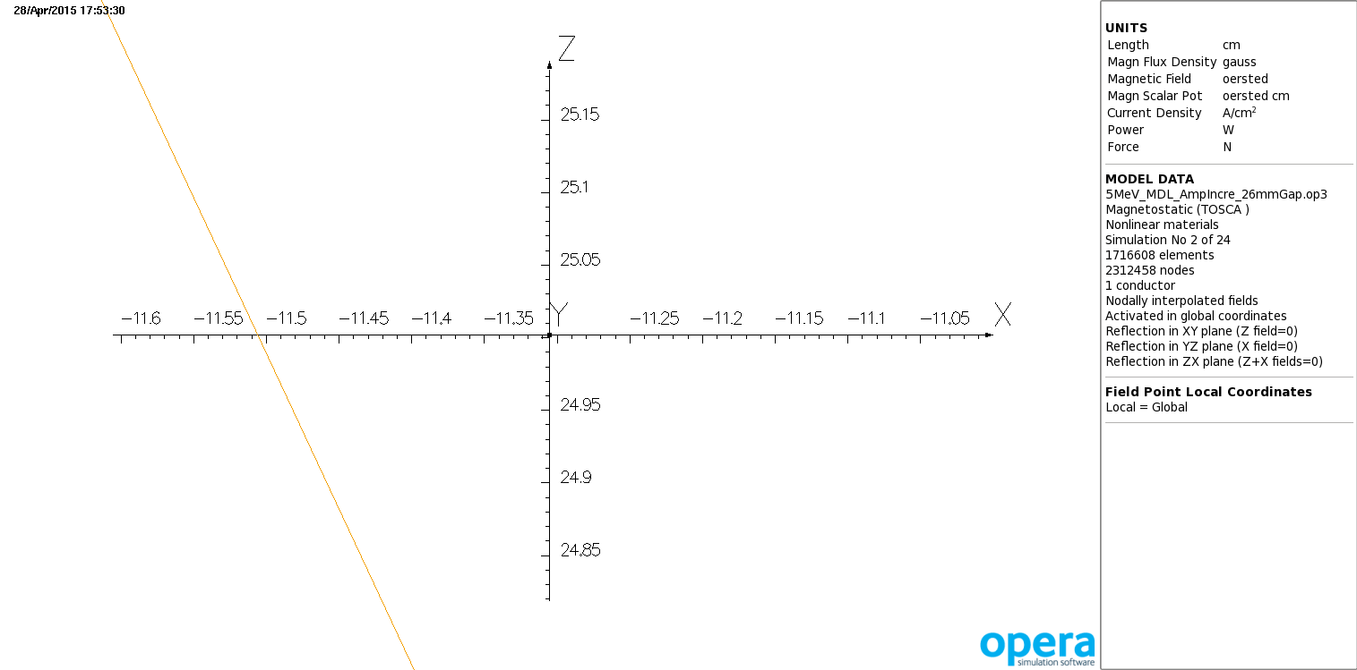

Starting point for angle calculation (-11.505, 25)

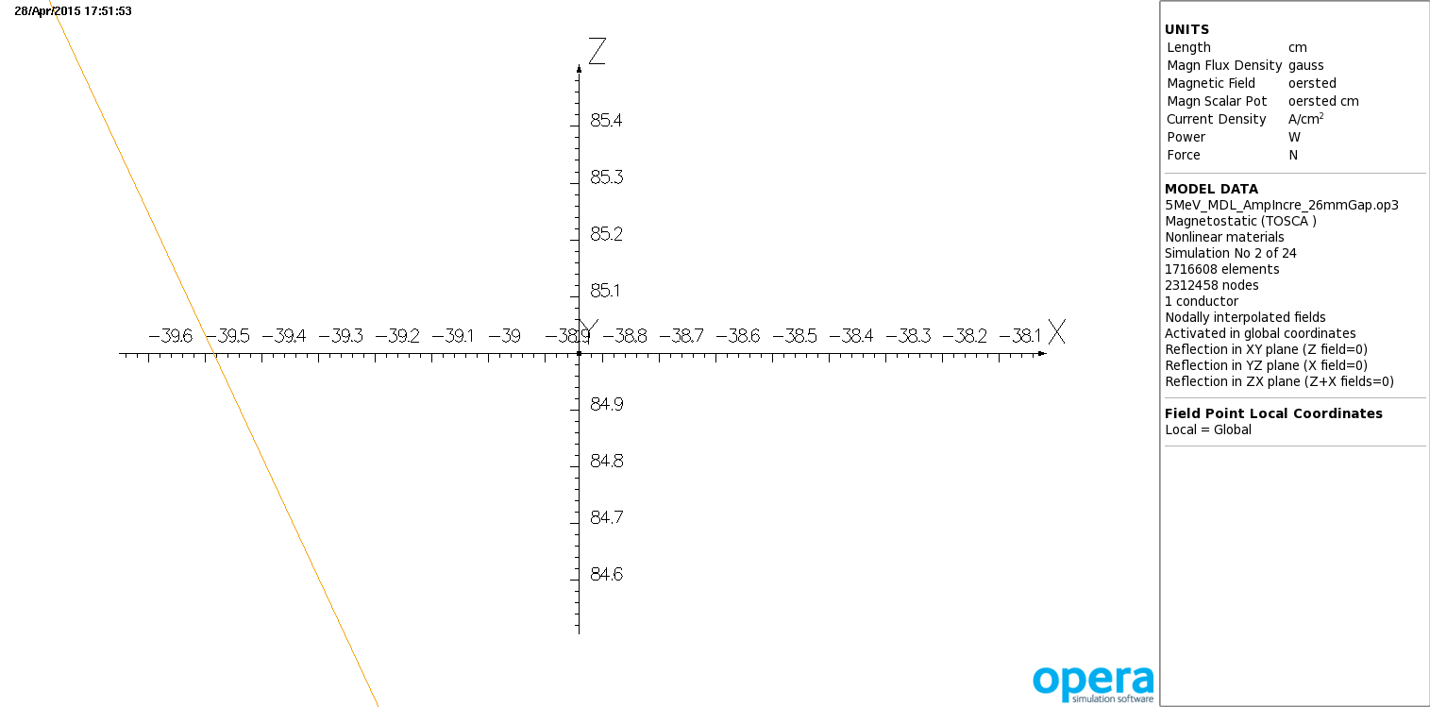

End point for angle calculation (-39.485, 85). Angle 25.001 degrees

The multipoles for the MDL model for 6.3 MeV KE to 30 degrees are:

|  |  |  |  |  |  |
| --- | --- | --- | --- | --- | --- |
| Orbit angle (degrees) | Dipole | Quadrupole | sextupole | Octupole | Decapole |
| 29.995 | -11831.28 | -16.26 | 3.67 | -0.91 | -0.64 |
| 25.002 | -11677.54 | -9.91 | 2.14 | -1.09 | -0.52 |
| 12.51 | -11415.70 | -3.09 | 0.06 | -0.37 | 0.37 |

evaluated on 1 cm radius circles.

corrected

|  |  |  |  |
| --- | --- | --- | --- |
| BdL_neg_str | P_model_30deg | P_model_25deg | P_model_12.5deg |
| -2410.64 | 1.4411 | 1.7073 | 3.3381 |
| -3615.96 | 2.1619 | 2.5609 | 5.0060 |
| -4098.08 | 2.4503 | 2.9024 | 5.6730 |
| -4580.21 | 2.7384 | 3.2438 | 6.3404 |
| -4821.28 | 2.8820 | 3.4146 | 6.6765 |
| -5062.34 | 3.0270 | 3.5853 | 7.0064 |
| -5544.47 | 3.3151 | 3.9266 | 7.6740 |
| -6026.59 | 3.6029 | 4.2680 | 8.3434 |
| -6508.72 | 3.8905 | 4.6088 | 9.0115 |
| -6990.84 | 4.1759 | 4.9507 | 9.6795 |
| -7231.9 | 4.3239 | 5.1218 | 10.0150 |
| -7472.97 | 4.4633 | 5.2924 | 10.3464 |
| -7955.09 | 4.7510 | 5.6339 | 11.0182 |
| -8437.2 | 5.0389 | 5.9752 | 11.6848 |
| -8919.32 | 5.3268 | 6.3164 | 12.3544 |
| -9401.43 | 5.6148 | 6.6574 | 13.0220 |
| -9642.49 | 5.7644 | 6.8291 | 13.3532 |
| -9883.54 | 5.9027 | 6.9999 |  |
| -10365.6 | 6.1906 | 7.3402 |  |
| -10847.7 | 6.4786 | 7.6820 |  |
| -11329.8 | 6.7738 | 8.0242 | 15.6907 |
| -11811.9 | 7.0615 | 8.3659 |  |
| -12053 | 7.2059 | 8.5363 |  |
| -12294 | 7.3503 | 8.7065 |  |
| -12776.1 | 7.6379 | 9.0478 |  |
| -13258.1 | 7.9265 | 9.3891 |  |
| -13740.2 | 8.2151 | 9.7306 |  |
| -14222.2 | 8.5037 | 10.0720 |  |
| -14463.3 | 8.6469 | 10.2433 |  |
| -14704.3 | 8.7821 | 10.4145 |  |
| -15186.3 | 9.0697 | 10.7539 |  |
| -15668.3 | 9.3576 | 11.0952 |  |
| -16150.2 | 9.6455 | 11.4366 |  |
| -16632.2 | 9.9333 | 11.7779 |  |
| -16873.2 | 10.0881 | 11.9501 |  |
| -17114.1 | 10.2211 | 12.1192 |  |
| -17596 | 10.5089 | 12.4605 |  |
| -19282.3 | 11.5277 | 13.6564 |  |
| -21689.6 | 12.9669 | 15.3615 |  |
| -24093.9 | 14.4049 | 17.0634 |  |

The kinetic energy range 7.85-10 MeV is most important for the bubble chamber experiment so simulation currents were chosen most densely there and where CEBAF normally runs. Blank entries in the table above can be filled in upon request.





First, third and fifth order fits for BdL(P), G-cm(MeV/c), for 2D line at 30 degrees.

|  |  |  |  |
| --- | --- | --- | --- |
| Fit to model Bdl(I) | Mean residual | Standard deviation | Residuals normal? |
| First order | 0.1568 | 6.4678 | No, binormal |
| Third order | -0.3122 | 6.0392 | No, binormal |
| Fifth order | 0.1364 | 5.9401 | No, binormal |





First, third and fifth order fits for BdL(P), G-cm(MeV/c), for 5D line at 25 degrees.

|  |  |  |  |
| --- | --- | --- | --- |
| Fit to model Bdl(I) | Mean residual | Standard deviation | Residuals normal? |
| First order | -0.3414 | 0.7818 | No |
| Third order | -0.1102 | 0.7386 | marginal |
| Fifth order | 0.2714 | 0.7118 | a bit better |





First, third and fifth order fits for BdL(P), G-cm(MeV/c), for 3D line at 12.5 degrees.

|  |  |  |  |
| --- | --- | --- | --- |
| Fit to model Bdl(I) | Mean residual | Standard deviation | Residuals normal? |
| First order | -0.4911 | 0.0095 | yes |
| Third order | -0.0315 | 0.8919 | yes |
| Fifth order | -0.0181 | 0.8061 | yes |

Now that I'm calculating P properly from KE, the linear fits all have near-zero intercepts.

**Kinetic energy data and plots**

I am told that the Optim decks have 6.3 MeV kinetic energy, not momentum, so I add the KE info that I actually obtained from the models, and fits thereto.

|  |  |  |  |
| --- | --- | --- | --- |
| BdL_neg_str | KE_model_30deg | KE_model_25deg | KE_model_12.5deg |
| -2410.64 | 1.018 | 1.27112 | 2.866 |
| -3615.96 |  |  | 4.521 |
| -4098.08 |  |  | 5.185 |
| -4580.21 |  |  | 5.85 |
| -4821.28 | 2.416 | 2.9416 | 6.185 |
| -5062.34 |  |  | 6.514 |
| -5544.47 |  |  | 7.18 |
| -6026.59 | 3.128 | 3.7875 | 7.848 |
| -6508.72 | 3.4129 | 4.126 | 8.515 |
| -6990.84 | 3.696 | 4.466 | 9.182 |
| -7231.9 | 3.843 | 4.63625 | 9.517 |
| -7472.97 | 3.9815 | 4.806 | 9.848 |
| -7955.09 | 4.2674 | 5.146 | 10.519 |
| -8437.2 | 4.5537 | 5.486 | 11.185 |
| -8919.32 | 4.84025 | 5.826 | 11.854 |
| -9401.43 | 5.127 | 6.166 | 12.521 |
| -9642.49 | 5.276 | 6.3372 | 12.852 |
| -9883.54 | 5.4138 | 6.5075 |  |
| -10365.6 | 5.7007 | 6.847 |  |
| -10847.7 | 5.9877 | 7.188 |  |
| -11329.8 | 6.282 | 7.5295 | 15.188 |
| -11811.9 | 6.569 | 7.8705 |  |
| -12053 | 6.713 | 8.0406 |  |
| -12294 | 6.857 | 8.2105 |  |
| -12776.1 | 7.144 | 8.5512 |  |
| -13258.1 | 7.432 | 8.892 |  |
| -13740.2 | 7.72 | 9.233 |  |
| -14222.2 | 8.008 | 9.574 |  |
| -14463.3 | 8.151 | 9.745 |  |
| -14704.3 | 8.286 | 9.916 |  |
| -15186.3 | 8.5731 | 10.255 |  |
| -15668.3 | 8.8605 | 10.596 |  |
| -16150.2 | 9.148 | 10.937 |  |
| -16632.2 | 9.4354 | 11.278 |  |
| -16873.2 | 9.59 | 11.45 |  |
| -17114.1 | 9.7229 | 11.619 |  |
| -17596 | 10.0103 | 11.96 |  |
| -19282.3 | 11.028 | 13.155 |  |
| -21689.6 | 12.466 | 14.859 |  |
| -24093.9 | 13.903 | 16.56 |  |



Straight-through BdL and the kinetic energy which bends 30 degrees left in each model. I show only the linear and fifth order fits because those are the only two one might use, the linear fit as adequate for most purposes and the fifth order for best available precision. I haven't calculated and checked residuals.



Straight-through BdL and the kinetic energy which bends 25 degrees right in each model. I show only the linear and fifth order fits. This fit could be used for the bubble chamber experiment.



Straight-through BdL and the kinetic energy which bends 25 degrees right in each model using only the central region of the previous graph. I show the linear and fifth order fits. This alternate fit could be used for the bubble chamber experiment. I will compare residuals for the two fits to 25 degree KE results to make a recommendation.

.



Straight-through BdL and the kinetic energy which bends 12.5 degrees left in each model, to the Mott polarimeter. I show only the linear and fifth order fits.

|  |  |  |  |  |  |
| --- | --- | --- | --- | --- | --- |
| Bdl (G-cm)  straight | KE_model  25deg | full_range_fit | Residual of  full_range_fit | central  range fit | Residual of  central_fit |
| 2410.64 | 1.27112 | 2411.12 | -0.4827 |  |  |
| 3615.96 |  |  |  |  |  |
| 4098.08 |  |  |  |  |  |
| 4580.21 |  |  |  |  |  |
| 4821.28 | 2.9416 | 4819.56 | 1.7151 |  |  |
| 5062.34 |  |  |  |  |  |
| 5544.47 |  |  |  |  |  |
| 6026.59 | 3.7875 | 6026.67 | -0.0773 |  |  |
| 6508.72 | 4.126 | 6508.24 | 0.4807 |  |  |
| 6990.84 | 4.466 | 6991.31 | -0.4690 |  |  |
| 7231.9 | 4.63625 | 7233.00 | -1.0968 |  |  |
| 7472.97 | 4.806 | 7473.86 | -0.8885 |  |  |
| 7955.09 | 5.146 | 7955.99 | -0.9012 | 7954.81 | 0.2801 |
| 8437.2 | 5.486 | 8437.80 | -0.5960 | 8437.11 | 0.0921 |
| 8919.32 | 5.826 | 8919.35 | -0.0289 | 8918.95 | 0.3699 |
| 9401.43 | 6.166 | 9400.71 | 0.7162 | 9400.47 | 0.9568 |
| 9642.49 | 6.3372 | 9643.04 | -0.5510 | 9642.85 | -0.3573 |
| 9883.54 | 6.5075 | 9884.07 | -0.5259 | 9883.90 | -0.3633 |
| 10365.6 | 6.847 | 10364.49 | 1.1061 | 10364.36 | 1.2398 |
| 10847.7 | 7.188 | 10846.98 | 0.7166 | 10846.85 | 0.8529 |
| 11329.8 | 7.5295 | 11330.14 | -0.3430 | 11329.98 | -0.1792 |
| 11811.9 | 7.8705 | 11812.57 | -0.6743 | 11812.36 | -0.4578 |
| 12053 | 8.0406 | 12053.22 | -0.2193 | 12052.97 | 0.0336 |
| 12294 | 8.2105 | 12293.58 | 0.4208 | 12293.28 | 0.7175 |
| 12776.1 | 8.5512 | 12775.57 | 0.5340 | 12775.16 | 0.9401 |
| 13258.1 | 8.892 | 13257.68 | 0.4159 | 13257.14 | 0.9565 |
| 13740.2 | 9.233 | 13740.07 | 0.1310 | 13739.38 | 0.8179 |
| 14222.2 | 9.574 | 14222.43 | -0.2283 | 14221.61 | 0.5895 |
| 14463.3 | 9.745 | 14464.30 | -1.0020 | 14463.44 | -0.1376 |
| 14704.3 | 9.916 | 14706.16 | -1.8648 | 14705.28 | -0.9759 |
| 15186.3 | 10.255 | 15185.61 | 0.6921 | 15184.77 | 1.5264 |
| 15668.3 | 10.596 | 15667.82 | 0.4844 | 15667.25 | 1.0470 |
| 16150.2 | 10.937 | 16149.95 | 0.2544 | 16149.99 | 0.2065 |
| 16632.2 | 11.278 | 16631.99 | 0.2142 |  |  |
| 16873.2 | 11.45 | 16875.09 | -1.8888 |  |  |
| 17114.1 | 11.619 | 17113.93 | 0.1741 |  |  |
| 17596 | 11.96 | 17595.76 | 0.2410 |  |  |
| 19282.3 | 13.155 | 19283.45 | -1.1506 |  |  |
| 21689.6 | 14.859 | 21688.88 | 0.7210 |  |  |
| 24093.9 | 16.56 | 24094.44 | -0.5402 |  |  |
|  |  | mean | -0.1289 |  |  |
|  |  | stdev | 0.7945 |  |  |
| mean central range |  |  | -0.0697 |  | 0.3883 |
| stdev central range |  |  | 0.7239 |  | 0.6523 |

Looking at the numbers, the fifth order fit over the full range of kinetic energy might be better for the bubble chamber experiment because the mean residual is closer to zero and the difference in standard deviation is not large. The experiment will run 11800-14800 G-cm; the worst case residual of the full range fit in this restricted BdL range is 126 ppm - OK.



Plots of the all of the residuals in the preceeding table. Both are consistent with normality. The mean of the residuals in the left plot is consistent with zero at the 95% level while this is not true for the right plot, which leads me to prefer the left.



Residuals for the same 21 kinetic energy points, 5-11 MeV, with fit using all 35 points (left) and only 21 points (right). The mean of the residuals being consistent with zero in the left plot is persuasive that this fit is better.

**Conclusion**

For the bubble chamber experiment I'd use the fifth order fit encompassing all simulations as the residuals are centered about zero and the difference in the span of residuals is not significant for the desired energy resolution. For normal machine setup even the linear fit would be better than 1% and much better than the approximation which has been in use.

**Acknowledgement**

Joe Grames's question about the large intercepts in the previous P(BdL) fits led to my determination that I had erred in calculating P from KE.