Gun Upgrades for SAD Aug – Sept 2019

I have listed the four main upgrades planned for the summer SAD. With each I have listed some objectives and considerations. Give some thought, we’ll meet for feedback and decisions.

The four main upgrades…

Upgrade to 200kV cathode electrode
- Test new small-shed cathode electrode at UITF to 200kV and for beam quality
- Build-up a new black insulator w/ degassed new style flange
- After UITF testing, move cathode electrode to new flange/insulator
- Pre-survey, ready for installation at CEBAF

Upgrade anode feedthrough voltage capability
- While gun is vented, replace 600V BNC feedthrough w/ 10kV SHV feedthrough
- New anode bias supply (+2.5kV) or standard UHV bias supply (+6.5kV) are ready

Upgrade krypton plumbing line configuration
- Matt installed new Kr bottle, regulator, pump-out port like in fixed/convenient location
- Replace long bellows w/ steel tubing
- Simplify valves on gun flange e.g. make similar to UITF configuration?

Upgrade puck exchange functionality
- Replace “tee” w/ new load chamber to exchange two pucks at gun w/ one bake out
  - Modify the 4 puck holder w/ a 2 puck holder, mate with existing suitcase fork
  - Implement a vertical goes up/down linear actuator
  - Can we forego puck holder heating, agree to suitably degas pucks in advance?
  - Permanent heat tapes, thermocouple for reliability
  - Ion pump w/ overboard board for bakeout, good isolation valves
- Retain capability for suitcase to exchange four pucks w/ existing docking chamber
  - Replace leaky suitcase valve w/ new one (Marcy purchased already?)
  - We may need a longer manipulator to reach PREP, that’s OK
- Install improved permanent stand for load chamber and suitcase, w/ better alignment

“Old hotness” (left) at CEBAF vs. “new hotness” coming from UITF:

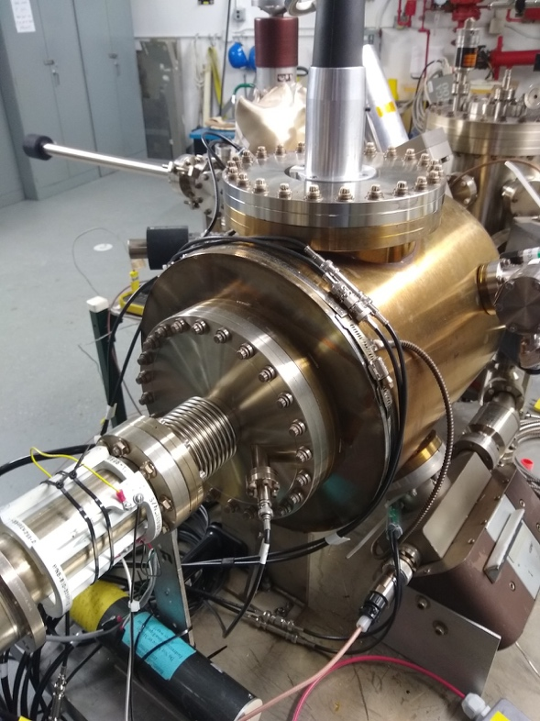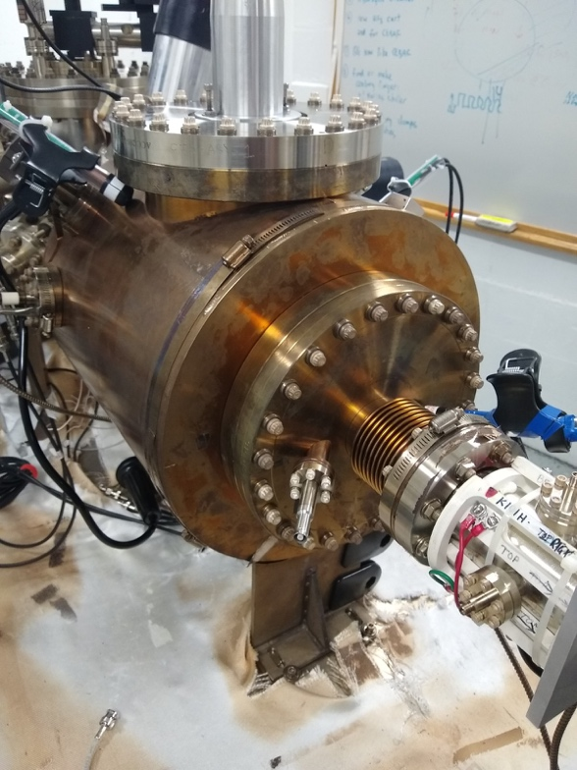

Kr plumbing on gun chamber at CEBAF (left) vs. UITF (right):

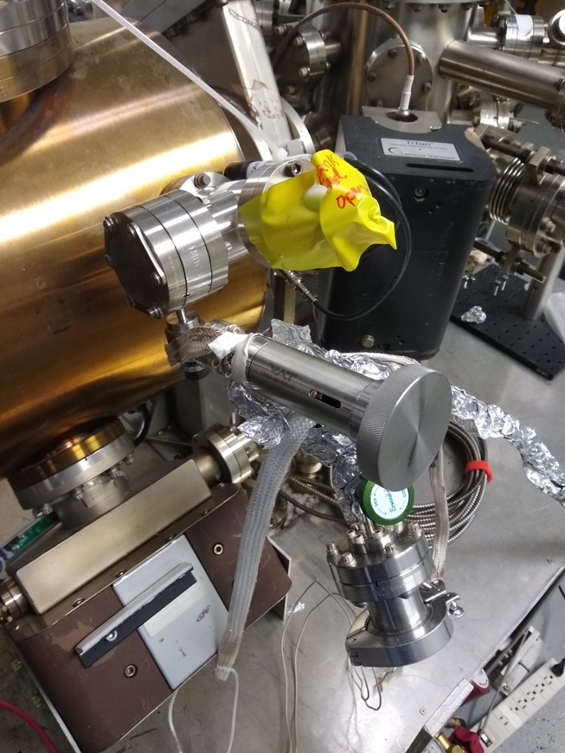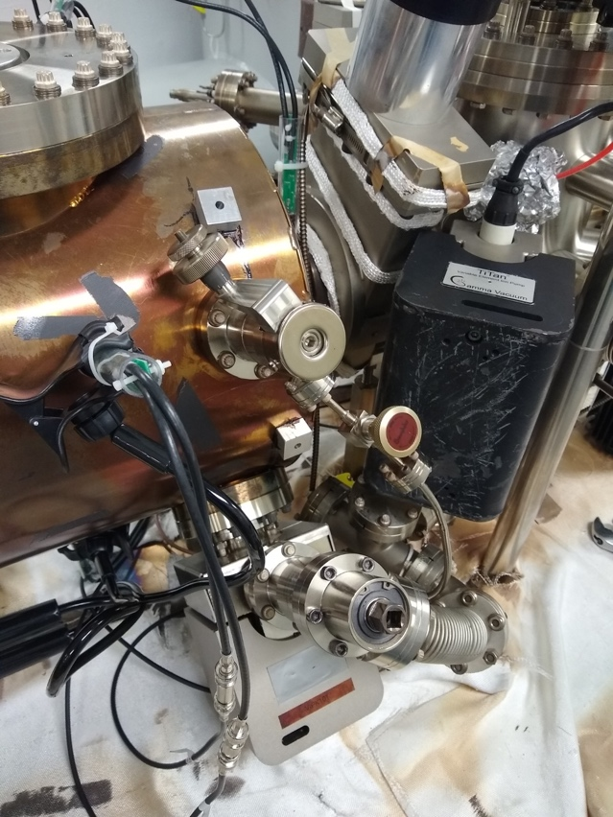
Kr bottle and supply line at CEBAF (left) vs. UITF (right):

