Beam Systematics for Mott Experiment Runs I and II
Joe Grames and Brian Freeman
March 9, 2017
JLab-TN-17-007

Abstract
Systematic studies of the Mott experimental asymmetry to electron beam conditions such as beam position, beam size, and energy spread measured during Runs I and II are summarized in this note.

- Beam Lines

Beam Lines
A dipole (MDL0L02) deflects the polarized electrons to either the Mott polarimeter or a spectrometer beam line (see Fig. 1). Quads (MQJ0L02/MQJ0L02A) control transverse beam size while an SRF cavity (R028GSET/R028PSET) controls beam momentum/spread. Wire scanners IHA0L03 and IHA2D00 measure beam sizes to respectively determine the beam emittance at MQJ0L02 and the momentum spread. The Mott target is viewed by camera ITV3D01.
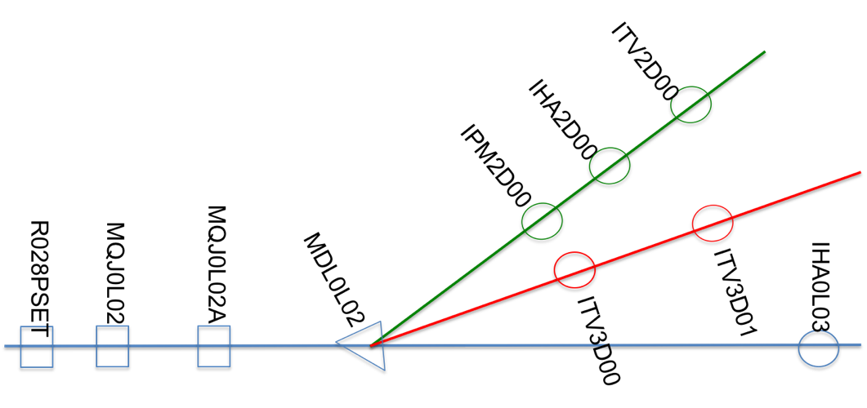
Fig. 1. A schematic of the Mott polarimeter (red) and spectrometer (green) beam lines.

Beam Line Optics Model
A beam line modelled with Elegant begins at MQJ0L02 and ends at IHA2D00 or ITV3D01.

"cle" ! clear whole RPN stack for safety
% 1 atan 4 * sto pi
% pi 180 / sto cdtor
% 180 pi / sto crtod
! DRIFT BETWEEN QUADS
D1 : DRIFT, L=0.4596
! DRIFT TO 2D LINE
D2 : DRIFT, L=1.0065
D3 : DRIFT, L=3.1385
D4 : DRIFT, L=0.1778
D5 : DRIFT, L=0.1270
! DRIFT TO 3DLINE
D6 : DRIFT, L=1.0041
D7 : DRIFT, L=0.5584
D8 : DRIFT, L=0.2667
D9 : DRIFT, L=0.8113
! NORMAL MOTT
MQJ0L02: KQUAD, L=0.15, K1= -5.04003396226415
MQJ0L02A: KQUAD, L=0.15, K1= +5.00232327044025
! 2D DIPOLE
MDL0L02_2D: CSBEND, L=0.1230, ANGLE="-30.0 180.0 / -1 acos * ", &
E1=" 0.0 180.0 / -1 acos * ", E2="-30.0 180.0 / -1 acos * ", &
EDGE_ORDER=2, HGAP=0.013564, FINT=0.5, NONLINEAR=1, &
N_KICKS=15, INTEGRATION_ORDER=4
! 3D DIPOLE
MDL0L02_3D: CSBEND, L=0.1278, ANGLE="-12.5 180.0 / -1 acos * ", &
E1=" 0.0 180.0 / -1 acos * ", E2="-12.5 180.0 / -1 acos * ", &
EDGE_ORDER=2, HGAP=0.013564, FINT=0.5, NONLINEAR=1, &
N_KICKS=15, INTEGRATION_ORDER=4
! DIAGNOSTIC IN 2D LINE
IPM2D00: WATCH, FILENAME="%s.ITV2D00", MODE=COORD
ITV2D00: WATCH, FILENAME="%s.ITV2D00", MODE=COORD
IHA2D00: WATCH, FILENAME="%s.IHA2D00", MODE=COORD
! DIAGNOSTIC IN 3D LINE
ITV3D00: WATCH, FILENAME="%s.ITV3D00", MODE=COORD
ITV3D01: WATCH, FILENAME="%s.ITV3D00", MODE=COORD
! BEAM LINES
2D: LINE=(MQJ0L02, D1, MQJ0L02A, D2, MDL0L02_2D, D3, IPM2D00, D4, IHA2D00, D5, ITV2D00)
3D: LINE=(MQJ0L02, D1, MQJ0L02A, D6, MDL0L02_3D, D7, D8, ITV3D00, D9, ITV3D01)

- Run I Results

Run I Energy
The electron beam kinetic energy for Run I is 4.806 ± 0.097 MeV [1] and corresponds to a momentum of 5.292 ± 0.098 MeV/c.

Run I Beam Emittance
The horizontal and vertical beam projections at wire scanner IHA0L03 were measured as a function of MQJ0L02 quad strength using the JLab software tool qsUtility 3.21 (see Fig. 2). The beam emittance and Twiss parameters are calculated at the entrance of MQJ0L02 by SDDS toolkit utility sddsemitproc. Details are given in e3466292 and results are summarized in Table 1.

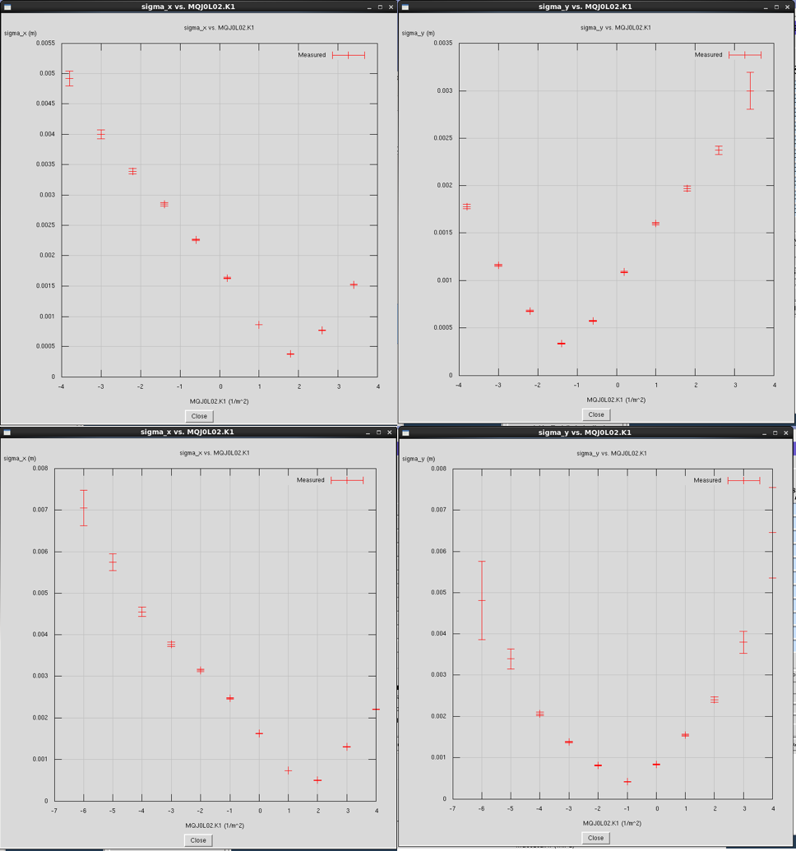
Fig. 2. Upper (lower) plots show horizontal and vertical RMS beam size at IHA0L03 as a function of MQJ0L02 quad strength on 2015-01-18_22:36 (IHA0L03_2015-01-19_17:15).

Table 1. Summary of measured normalized emittance and Twiss parameters at MQJ0L02.
qsUtility  (run date) | ε_{n,x}  (μm) | β_{x}  (m) | α_{x}  (rad) | ε_{n,y}  (μm) | β_{y}  (m) | α_{y}  (rad)
2015-01-18_22:36 | 0.534(3) | 15.8(1) | -2.01(2) | 0.342(2) | 13.3(5) | -0.617(11)
2015-01-19_17:15 | 0.593(5) | 14.4(2) | -1.42(3) | 0.461(2) | 11.2(2) | -0.070(06)

Run I: Asymmetry vs. Beam Energy Spread
The Mott asymmetry as a function of energy spread was studied by varying the phase R028PSET of the last QCM SRF cavity upstream of the polarimeter. The relative momentum spread (dp/p) is first determined from a measurement of the beam size at a dispersive location
$$S_{x}^{2}=ε_{x}β_{x}+{\left(\frac{dp}{p} η_{x}\right)}^{2}$$
where S_{x} is the horizontal RMS beam size. For each value of R028PSET the beam size at IHA2D00 [IHA2D00_2015-01-19_*] (see Fig. 3) and the Mott asymmetry using both foil #15 (Au:1 μm) were measured. and summarized in Table 2.
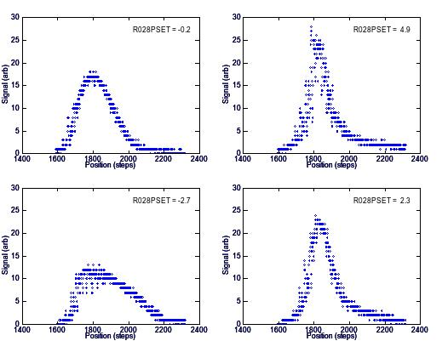
Fig. 3. The horizontal wire scanner signal as a function of motor position for four values of R028PSET are shown. The wire scanner reports a position calibration of 0.02041 mm/step.

The non-dispersive beam size at IHA2D00 was computed to be 0.21 mm using the measured emittance (2015-01-19_17:15) and quad set points: MQJ0L02 = -133.65 G (K = -5.048 m⁻¹), MQJ0L02A = 132.95 G (K = 5.010 m⁻¹). The horizontal dispersion function at IHA2D00 was computed to be η_{x} = -1.946 m. The calculated relative momentum spread (δp/p) and energy spread (δT) vs. R028PSET is summarized in Table 2 and Fig. 4. The horizontal and vertical RMS beam size at Mott target including energy spread is computed is also reported in Table 2, where the dispersion at the Mott target ITV3D01 is η_{x} = -0.3767 m. The spot diameter is computed as the ellipsoidal quadratic mean diameter and the largest value of the four cases is 0.63 mm. Finally, the Mott physics asymmetry vs. phase offset and energy spread is shown in Fig. 5.

Table 2. Parameters and results of energy spread measurements.
R028-  PSET | Δ-  PSET | R028  GSET | MAD  3D00H | Mott  Runs |  | File | S_{x} (RMS)  IHA2D00 |  | δp/p | δT | Sx  ITV3D01 | Sy  ITV3D01
deg | deg | MV/m | G-cm | IN | OUT |  | steps | mm | 10⁻³ | keV | mm | mm
-0.2 | 0.0 | 4.81 | 0 | 8180 | 8181 | 22:55 | 76.00 | 1.55 | 0.79 | 3.46 | 0.76 | 0.37
4.8 | -5.0 | 4.82 | 20 | 8182 | 8183 | 22:44 | 136.29 | 2.78 | 1.00 | 4.41 | 0.80 | 0.38
-2.7 | 2.5 | 4.81 | -9 | 8184 | 8185 | 22:53 | 137.63 | 2.81 | 1.02 | 4.45 | 0.80 | 0.38
2.3 | -2.5 | 4.81 | 11 | 8186 | 8187 | 22:51 | 118.55 | 2.42 | 0.87 | 3.83 | 0.78 | 0.38

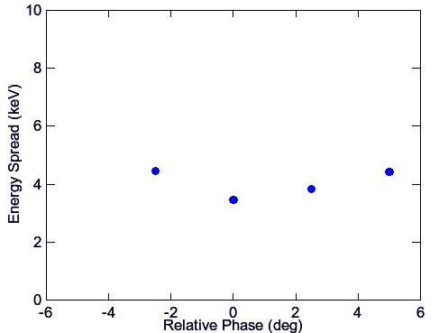
Fig. 4. Absolute energy spread (δT) vs. relative phase about Run I operating set point.

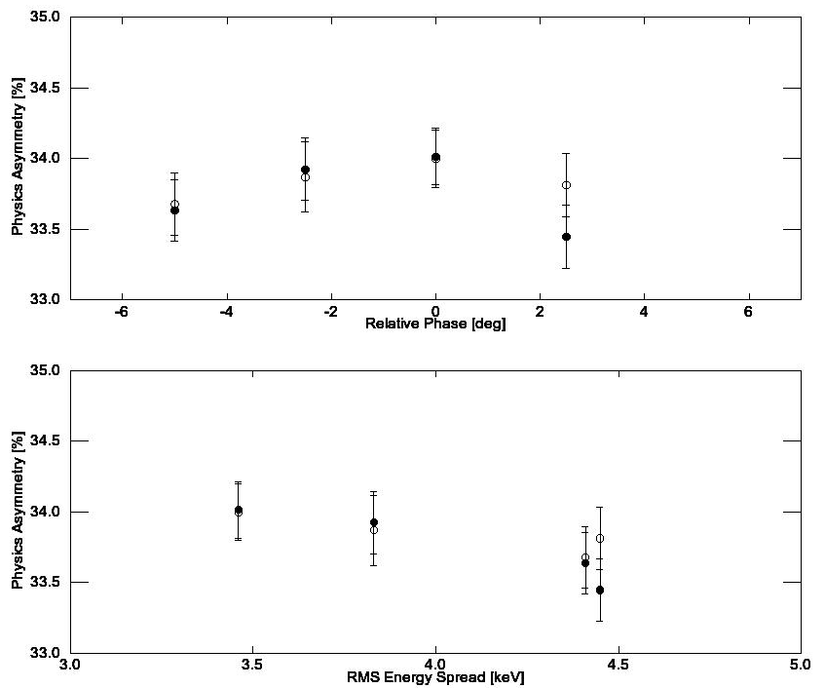
Fig. 5. Physics asymmetry versus relative phase (top) and RMS energy spread (bottom).
Run I: Asymmetry vs. Beam Spot Size
The Mott asymmetry using foil #15 (Au:1 μm) was measured vs. beam spot size by varying the quad strengths MQJ0L02 and MQJ0L02A about their nominal operating set point. The calculated horizontal and vertical RMS beam spot sizes at the Mott target using the measured emittance (2015-01-19_17:15) and relative momentum spread (7.9 x 10⁻⁴) are summarized in Table 3 (runs with visually poor spectra are listed in bold ) and plotted in Fig. 6. The spot diameter is computed as the ellipsoidal quadratic mean diameter (see Appendix B). The Mott asymmetry for spot sizes less than 1 millimeter is 0.3380.

Table 3. Summary of spot size measurements. “Name” is estimated size during Run I and “Fig.” corresponds to the OTR image in e3318205. Runs with visually bad spectra are in bold.
Name  (mm) | Fig. | MQJ0L02 |  | MQJ0L02A |  | IHWP  IN | IHWP  OUT | Sx | Sy
 |  | G | 1/m | G | 1/m |  |  | mm | mm
0.100 | 1 | -133.00 | -5.0231 | 153.00 | 5.7785 | 8163 | 8164 | 0.40 | 0.30
0.250 | 2 | -115.00 | -4.3433 | 139.00 | 5.2497 | 8165 | 8166 | 0.47 | 0.23
0.500 | 3 | -164.00 | -6.1939 | 153.00 | 5.7785 | 8167 | 8169 | 0.66 | 0.68
1.000 | 4 | -188.00 | -7.1003 | 141.00 | 5.3252 | 8170 | 8171 | 1.17 | 1.05
2.000 | 5,6 | -264.00 | -9.9707 | 130.00 | 4.9098 | 8172 | 8173 | 2.34 | 2.10
0.750 | 7 | -182.00 | -6.8737 | 148.00 | 5.5896 | 8174 | 8175 | 0.94 | 0.94
1.500 | 8,9 | -225.00 | -8.4977 | 135.00 | 5.0986 | 8176 | 8177 | 1.74 | 1.57
0.475 | 10 | -133.65 | -5.0477 | 132.65 | 5.0099 | 8178 | 8179 | 0.76 | 0.38

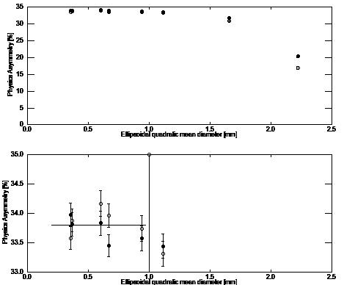
Fig. 6. Mott asymmetry vs. spot size.

Run I: Asymmetry vs. Beam Position
The Mott asymmetry vs. beam position was studied by varying two upstream steering coils MBH0L01AH and MBH0L01AV to locate the beam at 6 locations within one spot size of the operating position. At various positions the Mott asymmetry was measured using foil #15 (Au:1μm) e3318095 and foil #1 (Au:0.225 μm) e3318137 and an OTR camera image was recorded. Three steps are applied to transform the OTR image to the beam position at the foil:

- Software ImageJ refines the camera PNG image to one that is 165 by 165 pixel with absolute resolution of about 2 pixels. The OTR beam centroid coordinates are computed within the camera reference frame,

- The camera coordinates are transformed to target foil coordinates. The transformation between the (c)amera pixels and the (b)eam pixels is given by (see Appendix A for details):

$$\left({x_{b} \atop y_{b}}\right) =\left(\begin{matrix}-0.579 & -0.579 \\ -0.819 & 0.595\end{matrix}\right)\left({x_{c} \atop y_{c}}\right)$$

- By taking images of the ladder for known linear vertical motion a calibration of the transformed pixel size to real vertical size is determined to be 37.9 px/mm.

Results are summarized in Table 4 and the corresponding Mott asymmetry is shown in Fig. 7.

Table 4. Summary of position measurements.
Foil | Motion |  | MBH0L01A  Relative |  | Image | Mott Run |  | Image  Pixels |  | Image Rel  Pixels |  | Foil Rel  Pixels |  | Foil Rel  (mm)
 | Real | OTR | Hor | Ver |  | IN | OUT | X | Y | Xc | Yc | Xb | Yb | X | Y | R
15 | 0 | 0 | 0 | 0 | run1-foil15-fig7.png | 8132 | 8131 | 80.2 | 93.2 | 0.0 | 0.0 | 0.0 | 0.0 | 0.0 | 0.0 | 0.0
15 | U | U | 0 | 30 | run1-foil15-fig5.png | 8134 | 8133 | 61.9 | 107.5 | -18.4 | 14.3 | 2.4 | 23.5 | 0.1 | 0.6 | 0.6
15 | D | D | -0.2 | -30 | run1-foil15-fig6.png | 8136 | 8135 | 99.4 | 75.8 | 19.1 | -17.4 | -1.0 | -26.0 | 0.0 | -0.7 | 0.7
15 | R | L | 29.8 | 0 | run1-foil15-fig8.png | 8138 | 8137 | 65.2 | 78.6 | -15.1 | -14.6 | 17.2 | 3.7 | 0.5 | 0.1 | 0.5
15 | L | R | -30 | 0 | run1-foil15-fig9.png | 8140 | 8139 | 97.4 | 109.8 | 17.2 | 16.6 | -19.5 | -4.2 | -0.5 | -0.1 | 0.5
15 | LD | RD | -30 | -30 | run1-foil15-fig10.png | 8142 | 8141 | 114.5 | 95.2 | 34.3 | 2.0 | -21.0 | -26.9 | -0.6 | -0.7 | 0.9
15 | RU | LU | 30 | 30 | run1-foil15-fig11.png | 8144 | 8143 | 46.4 | 97.0 | -33.9 | 3.8 | 17.4 | 30.0 | 0.5 | 0.8 | 0.9
1 | 0 | 0 | 0 | 0 | run1-foil1-fig3.png | 8146 | 8145 | 86.0 | 95.4 | 0.0 | 0.0 | 0.0 | 0.0 | 0.0 | 0.0 | 0.0
1 | LD | RD | -30 | -30 | run1-foil1-fig4.png | 8149 | 8147 | 121.2 | 92.8 | 35.1 | -2.6 | -18.8 | -30.3 | -0.5 | -0.8 | 0.9
1 | LU | RU | -30 | 30 | run1-foil1-fig5.png | 8151 | 8150 | 83.7 | 125.2 | -2.3 | 29.8 | -15.9 | 19.6 | -0.4 | 0.5 | 0.7
1 | RU | LU | 30 | 30 | run1-foil1-fig6.png | 8153 | 8152 | 52.1 | 99.4 | -34.0 | 4.0 | 17.3 | 30.2 | 0.5 | 0.8 | 0.9
1 | RD | LD | 30 | -30 | run1-foil1-fig8.png | 8155 | 8154 | 86.2 | 62.6 | 0.2 | -32.8 | 18.8 | -19.7 | 0.5 | -0.5 | 0.7
1 | D | D | 0 | -30 | run1-foil1-fig9.png | 8157 | 8156 | 102.4 | 78.8 | 16.3 | -16.6 | 0.1 | -23.2 | 0.0 | -0.6 | 0.6
1 | L | R | -30 | 0 | run1-foil1-fig10.png | 8159 | 8158 | 101.7 | 106.8 | 15.7 | 11.4 | -15.7 | -6.0 | -0.4 | -0.2 | 0.4
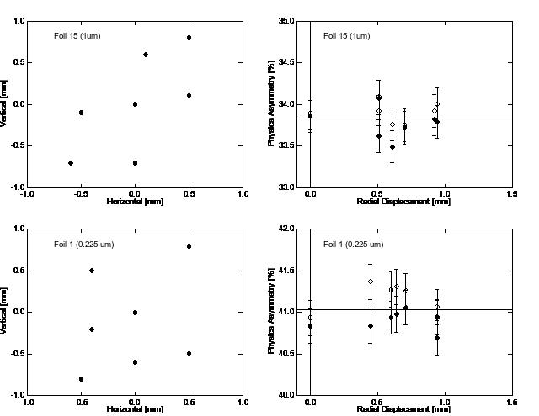
Fig. 7. Physics asymmetry vs. radial position foil #15 (Au: 1.0 μm) and foil #1 (Au: 0.225 μm). The left plots show the position relative to nominal operating point (0,0) and the right plots show a scatter of asymmetry vs. radiation displacement from (0,0).

- Run II Asymmetry vs. Beam Energy
The Mott asymmetry was measured vs. at four beam energies about the operating set point by varying QCM R028GSET while minimizing energy spread with R028PSET. The Mott asymmetry was measured using foil #15 (Au:1μm) and foil #14 (Au:0.35 μm). The electron beam energies [1] and Mott runs are summarized in Table 5. Mott asymmetries are shown in Fig. 8.

Table 5. Run II Beam Momentum and Kinetic Energy
R028 | Momentum |  | Kinetic Energy |  | Mott Runs |  | Mott Runs
GSET | P | δP | T | ΔT | Foil #15 (1 μm) |  | Foil #14 (0.35 μm)
MV/m | MeV/c | MeV/c | MeV | MeV | In | Out | In | Out
3.350 | 5.025 | 0.012 | 4.540 | 0.012 | 8457  8459 | 8458  8460 | 8462  8464 | 8461  8463
3.740 | 5.219 | 0.013 | 4.733 | 0.012 | 8445  8447 | 8446  8448 | 8450  8452 | 8449  8451
4.120 | 5.404 | 0.013 | 4.917 | 0.013 | 8433  8435 | 8434  8436 | 8438  8440 | 8437  8439
4.500 | 5.603 | 0.013 | 5.115 | 0.013 | 8466  8469 | 8467  8470 | 8473  8475 | 8471  8474
4.890 | 5.785 | 0.014 | 5.297 | 0.014 | 8477  8479 | 8478  8480 | 8482  8484 | 8481  8483

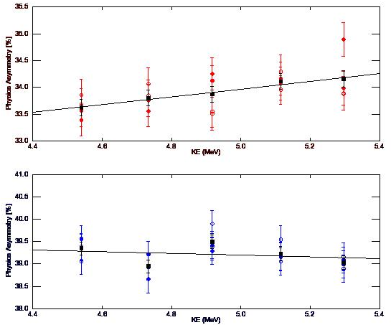
Fig. 8. Mott asymmetry vs. kinetic energy for foil #15 (Au: 1.0 μm) and foil #14 (Au: 0.35 μm).

The variation with energy is 0.022/MeV for foil #15 and -0.0046/MeV for foil #14. The variation with asymmetry is consistent with the Sherman function variation with energy in the region of 172.5-173.5 degrees.

- Reference

- J. Grames, “Mott Experiment Run I/II Beam Energies”, JLAB-TN-17-001 (2017).
- J. Grames “Fall 2014 Mott Target Replacement and Ladder Position Re-Calibration”, JLAB-TN-14-026 (2014).

- Appendix A

Step 1. The ELOG entry images were saved as PNG files and cropped to 165 x 165 pixels. An example is shown here and summarized for all images below.

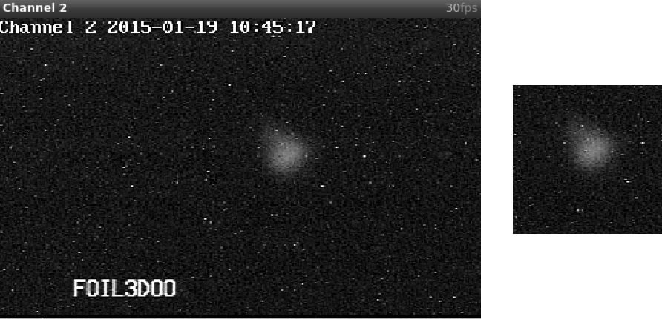

FILENAME | WIDTH | HEIGHT | CEN_X | SIG_X | FWHM_X | CEN_Y | SIG_Y | FWHM_Y
run1-foil15-fig10.png | 165 | 165 | 114.5 | 12.9 | 30.5 | 95.2 | 18.6 | 43.9
run1-foil15-fig11.png | 165 | 165 | 46.4 | 13.2 | 31.0 | 97.0 | 12.0 | 28.2
run1-foil15-fig1.png | 165 | 165 | 47.2 | 13.8 | 32.6 | 117.7 | 14.5 | 34.2
run1-foil15-fig5.png | 165 | 165 | 61.9 | 12.5 | 29.5 | 107.5 | 19.0 | 44.7
run1-foil15-fig6.png | 165 | 165 | 99.4 | 13.2 | 31.0 | 75.8 | 14.1 | 33.3
run1-foil15-fig7.png | 165 | 165 | 80.2 | 13.8 | 32.4 | 93.2 | 13.8 | 32.6
run1-foil15-fig8.png | 165 | 165 | 65.2 | 13.9 | 32.6 | 78.6 | 16.4 | 38.6
run1-foil15-fig9.png | 165 | 165 | 97.4 | 12.9 | 30.4 | 109.8 | 16.4 | 38.7
run1-foil1-fig10.png | 165 | 165 | 101.7 | 15.3 | 36.0 | 106.8 | 17.4 | 40.9
run1-foil1-fig3.png | 165 | 165 | 86.0 | 14.7 | 34.6 | 95.4 | 15.4 | 36.4
run1-foil1-fig4.png | 165 | 165 | 121.2 | 15.3 | 35.9 | 92.8 | 16.5 | 38.9
run1-foil1-fig5.png | 165 | 165 | 83.7 | 15.4 | 36.4 | 125.2 | 18.9 | 44.4
run1-foil1-fig6.png | 165 | 165 | 52.1 | 15.6 | 36.7 | 99.4 | 14.5 | 34.2
run1-foil1-fig8.png | 165 | 165 | 86.2 | 14.2 | 33.5 | 62.6 | 14.7 | 34.6
run1-foil1-fig9.png | 165 | 165 | 102.4 | 14.4 | 34.0 | 78.8 | 17.6 | 41.6

Step 2. The true beam position at the target is reduced in the plane of the target-mirror-camera by the projected distance of the mirror-foil vector relative to the beam axis. This value is estimated from drawings to be 13° from drawings however actual alignment of the mirror and its support fixture may result in a variation by as much as ±6°. This sub-tended image is collected along a target-mirror-camera plane of about 45° cw with respect the horizontal beam plane and is thus coupled. The image is also inverted by the mirror. Finally, the true beam position (x_{b},y_{b}) is related to the camera pixel position (x_{p},y_{p}) by the following transformation:

$$\left({x_{c} \atop y_{c}}\right) = {\left(\begin{matrix}-1 & 0 \\ 0 & 1\end{matrix}\right)}_{Inv}{\left(\begin{matrix}\cos{ϕ} & -\sin{ϕ} \\ \sin{ϕ} & \cos{ϕ}\end{matrix}\right)}_{ϕ=-45°}{\left(\begin{matrix}\frac{1}{\cos{θ}} & 0 \\ 0 & 1\end{matrix}\right)}_{θ=13°}\left({x_{b} \atop y_{b}}\right)$$

$$\left({x_{c} \atop y_{c}}\right) =\left(\begin{matrix}-0.726 & -0.707 \\ -1.000 & 0.707\end{matrix}\right)\left({x_{b} \atop y_{b}}\right)$$

This 2 x 2 matrix is inverted to finally yield true beam position as a function of camera pixels.

$$\left({x_{b} \atop y_{b}}\right) =\left(\begin{matrix}-0.579 & -0.579 \\ -0.819 & 0.595\end{matrix}\right)\left({x_{c} \atop y_{c}}\right)$$

Step 3. On a separate occasion images of the target ladder were saved for small 200 step increments of the target ladder. The transformed position of a specific item may then be calibrated to the known physical motion of 4464 ladder steps = 25.4 mm of linear vertical travel [2]. The table below shows the transformed images indicate purely vertical motion of the target ladder and indicate a calibration of 37.9 +/- 1.1 pixels/mm.

Image ABS  Pixels |  | Image REL  Pixels |  | Foil REL  Pixels |  | Ladder ABS  Steps | Ladder REL  Steps | Ladder  (mm) | pixels/mm
-421 | 476 | 0 | 0 | 0.0 | 0.0 | -73800 | 0 | 0
-392 | 447 | 29 | -29 | 0.0 | -41.0 | -73600 | 200 | 1.14 | -36.03
-362 | 419 | 59 | -57 | -1.2 | -82.2 | -73400 | 400 | 2.28 | -36.13
-329 | 385 | 92 | -91 | -0.6 | -129.5 | -73200 | 600 | 3.41 | -37.93
-299 | 355 | 122 | -121 | -0.6 | -171.9 | -73000 | 800 | 4.55 | -37.77
-267 | 322 | 154 | -154 | 0.0 | -217.8 | -72800 | 1000 | 5.69 | -38.27
-235 | 290 | 186 | -186 | 0.0 | -263.0 | -72600 | 1200 | 6.83 | -38.52
-204 | 259 | 217 | -217 | 0.0 | -306.8 | -72400 | 1400 | 7.97 | -38.52
-171 | 226 | 250 | -250 | 0.0 | -353.5 | -72200 | 1600 | 9.10 | -38.83
-140 | 194 | 281 | -282 | 0.6 | -397.9 | -72000 | 1800 | 10.24 | -38.85

- Appendix B

