Requirements of SCAM for 4-Laser Operations

Version 1.0 (March 31, 2016)

Contact J. Grames
grames@jlab.org

Introduction

The SCAM (Service Building Catch All Module) is a programmable interface to the Laser Macropulse chassis to select the desired laser beam modes. The previous SCAM module supported 3-laser operation and both polarized and thermionic sources. This version supports 4-laser operation and only a polarized source.

Functional Description

Laser control is partitioned in 5 ways: Master, Laser A, Laser B, Laser C and Laser D. The Master partition limits the accessible modes of the individual Lasers (A, B, C, D).

Each partition allows 5 beam modes of user selected laser operation, where the User mode is the highest order.

- Off mode
- Viewer mode
- Tune mode
- Continuous mode
- User mode

Beam modes are defined:

- Off mode
In this mode the user can turn the beam off to any Laser individually. The user can turn all Lasers off by setting the Master to Beam Off Lasers by setting the Accelerator mode to Beam Off.

- Viewer mode
In this mode the user can individually set any Laser to Viewer mode, provided the Master mode is of equal or higher value. Lasers of order higher than Master mode will automatically be set to the Master mode. The SCAM will generate the same macro-pulse structure for each laser. The macro-pulse structure is nominally generated at a variable time from 347-354us after Beam Sync with variable pulse width duration from 250ns - 10us in 250ns increments. The macro-pulse frequency may be adjusted to 10, 15, 30 Hz relative to Beam Sync or free-run from a crystal oscillation in the range of 57-60Hz.

- Tune mode
In this mode the user can individually set any Laser to Tune mode, provided the Master mode is of equal or higher order. Lasers of order higher than the Master mode will automatically be set to the Master mode. The SCAM will generate the same pulse structure for each laser. The macro-pulse structure is triggered at Beam Sync and is a fixed time length of 250us with variable beam-on period from 100us - 250us in 10us increments, a “Beam-off” time period from 97-104us in 250ns increments, and marker pulse width duration from 250ns – 10us in 250ns increments. The macro-pulse frequency may be adjusted to 10, 15, 30 Hz relative to Beam Sync or free-run from a crystal oscillation in the range of 57-60Hz.

- Continuous mode
In this mode the user can set individually any Laser to Continuous mode, provided the Master mode is of equal or higher order. There is no macro-pulse structure; the continuous-wave microstructure of the beam is generated.

- User mode
Text here.

I/O Interface

In order to provide the above functionality and requisite CEBAF safety features the SCAM will have the following interfaces.

- Beam Sync Input
- Beam Sync Output
- Aux Sync Output
- Beam Mode Outputs
- VME bus I/O
- Fast Shut Down (FSD) Inputs
- Personal Safety System (PSS) Inputs

We define the interfaces below. For clarity a timing diagram is shown in Fig. 1 and an interface diagram is shown in Fig. 2. The text “x4” refers to four independent channels for Laser A, B, C, D.

- Beam Sync Input
The SCAM will receive on fiber a Beam Sync Input derived from the zero crossing of the AC line.

- Beam Sync Output
The SCAM will provide on fiber a one-microsecond pulse of Beam Sync Input.

- Aux Sync Output
The SCAM will provide on fiber a delayed time-variable pulse allowing triggering of diagnostics synchronously with Beam Sync. Requirements are XYZ.

- Beam Mode Outputs
The SCAM will provide drive signals (x4) by fiber to the Laser Macropulse chassis enabling the Beam modes of laser operation.

- VME Bus I/O
The SCAM will have a VME bus interface. The user will access control and status registers through this interface in order to select the modes of the SCAM. The SCAM will identify itself by version identification through a register.

- Fast Shut Down (FSD) Inputs
The SCAM will receive courtesy FSD inputs on fiber from the PSS system for all five partitions (Master, Hall A, Hall B, Hall C, Hall D). SCAM will provide both live and latched status for EPICS readback. The primary functional FSD signals are provided directly to the Laser Macropulse chassis.

- Personal Safety System (PSS) Inputs
The SCAM will receive courtesy PSS inputs on fiber from the PSS system for both PSSA and PSSB. The SCAM will provide both live and latched status for EPICS readback. The primary functional PSS signals are provided directly to the Laser Macropulse chassis.

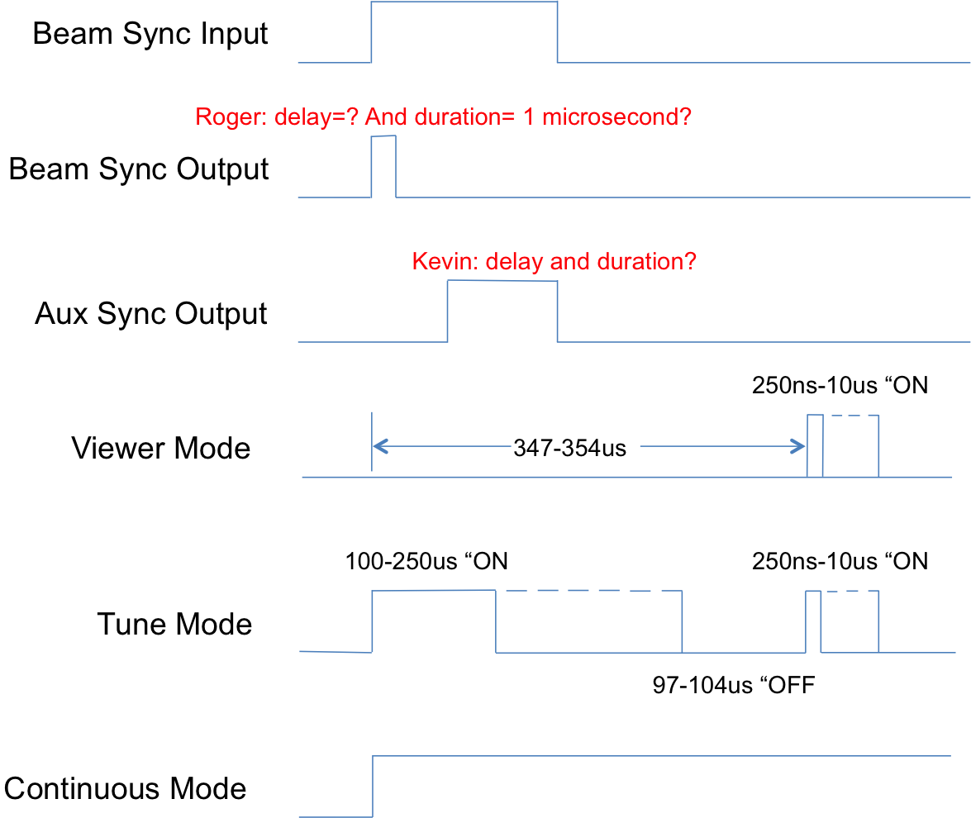

Fig. 1 Shown is the timing diagram for standard (non-User mode) operation.

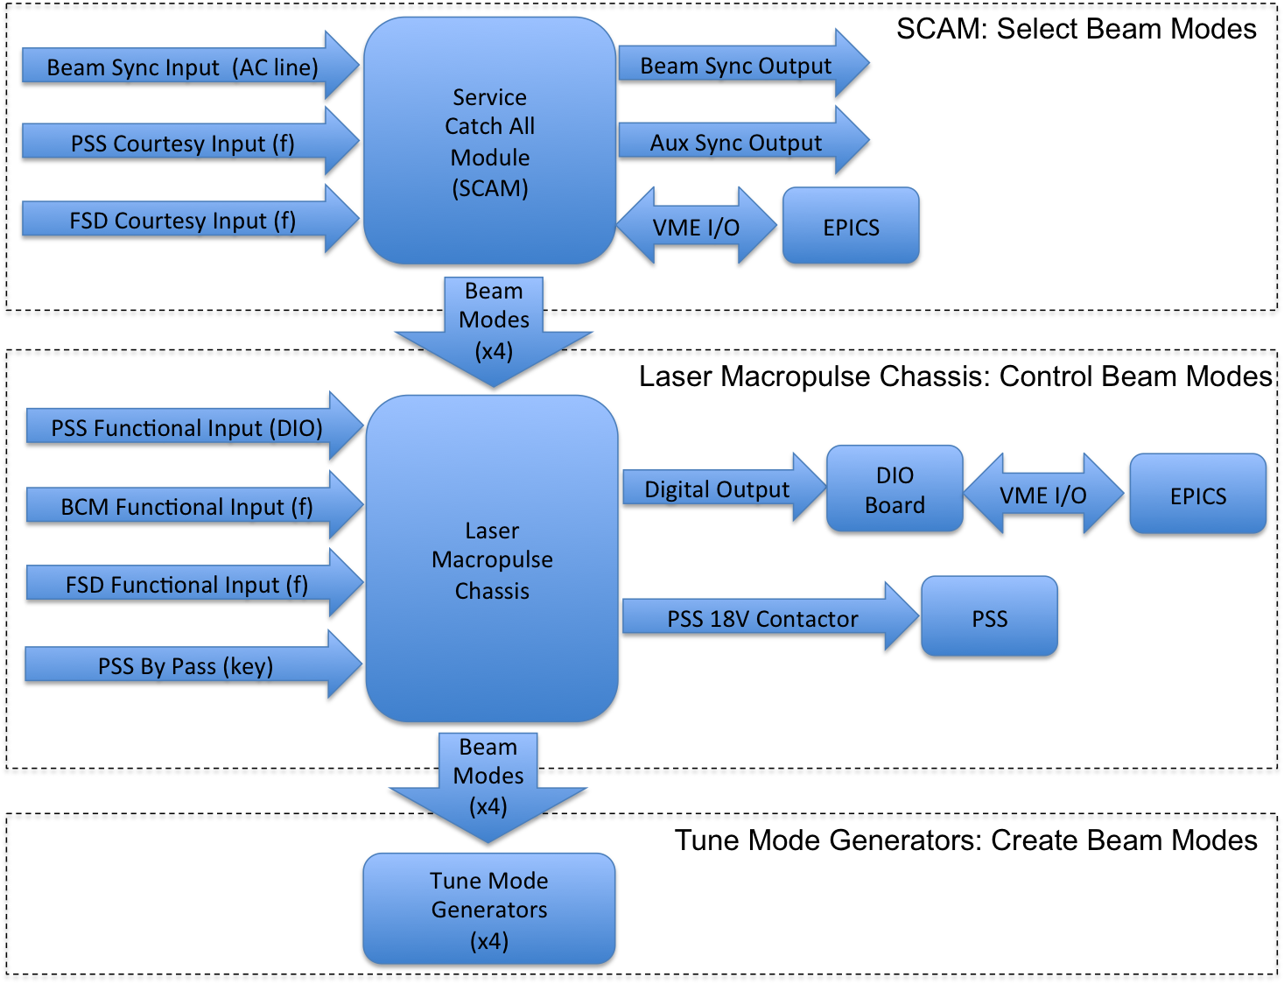

Fig. 2. Shown is the interface diagram of the SCAM, Laser Macropulse Chassis and Tune Mode Generators along with I/O dependencies and interface to the EPICS control system.

