STANDARD OPERATING PROCEDURE

Division Serial Number: Rev. 1

Issue Date: February 12, 2006
Title: DC Photocathode Gun Cathode Re-cesiation procedure
Location: B18 (FEL), Vault
Author: C. Hernandez-Garcia
Risk classification:
(See EH&S Manual Chapter 3210.)
Without mitigation measures: 4
With specified measures implemented: 1

Supplemental Technical Validations:
Hazard reviewed: | Reviewer Signature & Date:
Ionizing Radiation | E. Abkemeier
High Voltages (AC & DC) | W. Merz
Oxygen Deficient Hazards | P. Hunt
Pressure Vessel | D. Kausch
Material Handling | M. Nevarez

Coordination Review & Approval | Signature & Date:
Personnel Safety System | K. Mahoney

Management & EH&S Approval | Signature & Date:
Division EH&S Officer | R. May
FEL Facility Manager | G. Neil
FEL Department Head | F. Dylla

Distribution:
Copies to: affected area, signers
Original: author
Maintenance and Safety Procedures
DC Photocathode Gun cathode re-cesiation

1 SCOPE:

This document covers the cathode re-cesiation procedure as part of the DC photocathode gun maintenance. A re-cesiation is performed to replenish the QE by applying a fresh coat of Cs to the cathode. This procedure is designed to be performed without disrupting the vacuum environment in the gun chamber. However, access to the back end of the gun is necessary. To access to the back end of the photocathode gun the gun tank needs to be opened first strictly following the 500 KV Gas Insulated Power Supply Maintenance & Safety A-04-008–SOP.

The procedures contained in this document supplements the procedures contained in the current revision of the Jefferson Laboratory EH&S Manual (or chapters). This document should also be used in conjunction with the 500 KV Gas Insulated Power Supply Maintenance & Safety A-04-008–SOP. They must be used together.

THIS DOCUMENT DOES NOT COVER OPERATION OF THE DC PHOTOCATHODE GUN.

2 SAFETY RESPONSIBILITY:

The following is a partial list of the people responsible for the operation and maintenance of the DC photocathode gun.

Accelerator Physics George Neil
Injector Physics Carlos Hernandez-Garcia
Mechanical Engineer Lawrence Dillon-Townes

3 SYSTEM DESCRIPTION:

The DC photocathode gun is enclosed in a pressurized SF6 vessel known as the gun tank located in the injector pit inside the FEL vault. The 500 kV HVPS is also enclosed by another SF6 pressurized tank. The connection between the power supply and the photocathode gun is a gas insulated 20 inch OD coaxial transmission line. The safety and conditioning resistors are an integral part of the transmission line inner conductor.

Figure 1 is a schematic of the photocathode gun. The gun is comprised by three main components; the gun chamber (a), the ceramic stack (b) and the back end flange (c). The ceramic stack and the back end flange are inside the gun tank. The gun chamber houses the cathode (d) in UHV environment. The cathode sits at the end of the ball electrode (e) during nominal operation. The ball is mechanically attached to the back end flange by a support tube (f). The photocathode is mounted at the end of a retractable stalk (g) driven by a gear mechanism (h) outside the vacuum environment. The gear and electrical connections (i,j)necessary for the re-cesiation are mounted on the outside of the back end flange and covered during normal operations by a corona shield (k) AKA as ‘salad bowl’.
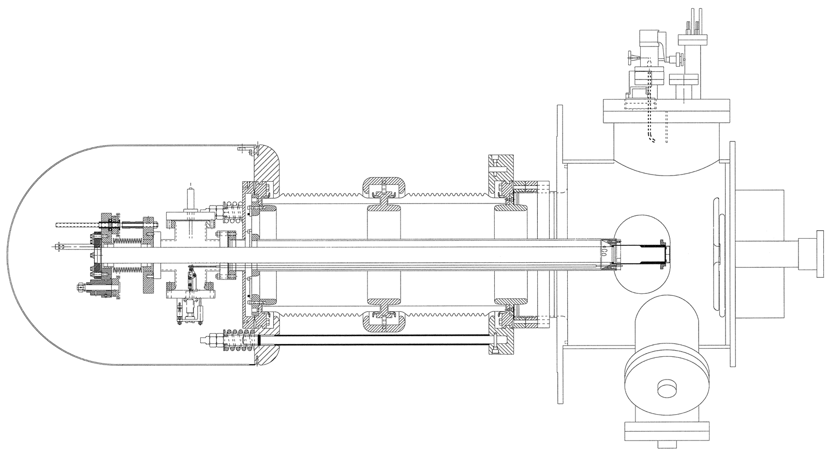
(a)
(b)
(c)
(d)
(e)
(f)
(g)
(h)
(i)
(j)
(k)

4 HAZARD ANALYSIS:

A IONIZING RADIATION:

Primary Hazard (Al) Risk Code 3

Exposure to radiation (X-rays) in excess of applicable standards.

When the high voltage power supply is connected to the photocathode gun, the gun will produce significant amounts of relatively hard X-rays.

Primary Hazard (A1) Mitigation Risk Code 1

The high voltage power supply contains no vacuum insulated high voltage components therefore it cannot produce X-rays.

The FEL Personnel Safety System (PSS) provides primary mitigation for the photocathode gun.

Regular maintenance of the photocathode gun DOES NOT require energizing the HVPS.

When the HVPS is connected to the gun photocathode, no one will be allowed to enter the accelerator enclosure while the high voltage power supply is energized. The PSS interlock system is connected to the high voltage power supply control system with two redundant shut down schemes. This is the normal mode of operation for the accelerator.

NOTE - Members of the JLab Safety System group are the only JLab staff authorized to reconfigure the PSS. A PSS Jumper Request is required.

WHEN THE POWER SUPPLY IS CONNECTED TO THE PHOTOCATHODE GUN, THE PSS INTERLOCKS MUST NEVER BE BY-PASSED.

B HIGH VOLTAGE, DC:

Primary Hazard (B1) - Risk Code 4

Injury or death may result from interaction with high DC voltages.

The 500 kV produced by the power supply system is a serious hazard, even with the power supply maximum output current limited to 10 mA. This is a Class 3, Mode 2 Hazard.

The power supply also contains 48 stages of voltage-multiplying capacitors. Each stage stores about 12 Joules of electrical energy when the HVPS is operating at 500 kV. These capacitors, when charged can be a significant hazard and require about 1/2 minute to discharge to a safe value through the normal bleeder or metering resistors.

Primary Hazard (B1) Mitigation - Risk Code 1

During normal operations, electrical discharge of the capacitor stages requires about 1 minute. This is much less than the time to open the high voltage tank and associated flanges. This engineering constraint of the system is adequate to ensure workers cannot come in contact with the stored electrical energy before it's had an opportunity to bleed off.

The power supply is only operated inside the pressure tank and has many large bolts that must be removed to gain access to the power supply inside. Independent dual interlocks are provided to insure that the pressure tank door is closed during operation of the power supply.

Dual pressure sensing switches are installed to insure that all covers are in place and the tank is pressurized before the high voltage is energized.

In the Test and Maintenance mode, the HVPS may be operated as an open unpressurized system. The area is roped-off and Danger High Voltage signs are posted, ensuring that access is restricted and safe for the tests. The voltage from HVPS is limited by corona to about 200 kV and by the present Test Resistor load to about 60 kV.

Prior to performing work within the high voltage tank, transmission line, or photocathode gun, workers will attach the appropriate grounding hook to discharge any remaining energy stored in the HVPS. The grounding hook shall remain in place during Test and Maintenance mode, whenever practicable, to prevent reaccumulation of energy.

The 12 kV square wave to the multipliers is enclosed in 40 kV insulated wire, with additional vinyl tubing over the outside. This connection is only a few inches long and has a protective barrier.

Secondary Hazard (B2) - Risk Code 3

Injury from involuntary reaction to electrical shock.

Secondary Hazard (B2) Mitigation - Risk Code 1

See Hazard Mitigation (B1).

5 MAINTENANCE PROCEDURES:

All work must be accomplished by authorized personnel in accordance with the JLab EH&S Manual, Chapter 6200, Electrical Safety. Personnel authorized to perform maintenance on this equipment: (1) Must be familiar with the JLab EH&S Manual, Chapter 6200, Electrical Safety, (2) Must have specific training on this equipment, (3) Must be trained and authorized to perform work per JLab EH&S Manual, Chapter 6110, Lock, Tag, and Try (4) Must be trained in ODH (or escorted by a trained individual), (5) Must have read, understood and followed the 500 KV Gas Insulated Power Supply Maintenance & Safety A-04-008–SOP and (6) Must have read and understood this document.

Prior to any work in the photocathode gun, the system must be made safe under Lock, Tag, & Test using the VVU and the wall mounted disconnect switch, labeled “GUN HVPS”. If work is to be performed inside the HVPS or gun tanks, the output of the HVPS must also be grounded with the appropriate ground hook. Safety glasses must be worn when installing the ground hook. Face completely away from the grounding point just prior to touching it with the grounding hook for the first time. This is to prevent temporary blindness from a bright flash, if the HVPS were still charged. This ground hook will remain attached to the grounding point as long as the tank is open or until a bolted ground strap is installed.

- Strictly follow the 500 KV Gas Insulated Power Supply Maintenance & Safety A-04-008–SOP to safely transfer SF6 gas from the gun and HVPS tanks to the bladder, vent to atmospheric pressure with instrument air, and remove bolts securing the gun tank door. See Figure 2.
- Remove the electrostatic shield (k) (A.K.A. salad bowl, see Figure 2) covering the stalk gear mechanism (h). There are four screws holding the shield to the gun corona ring. Make sure to avoid scratching the shield with the screwdriver.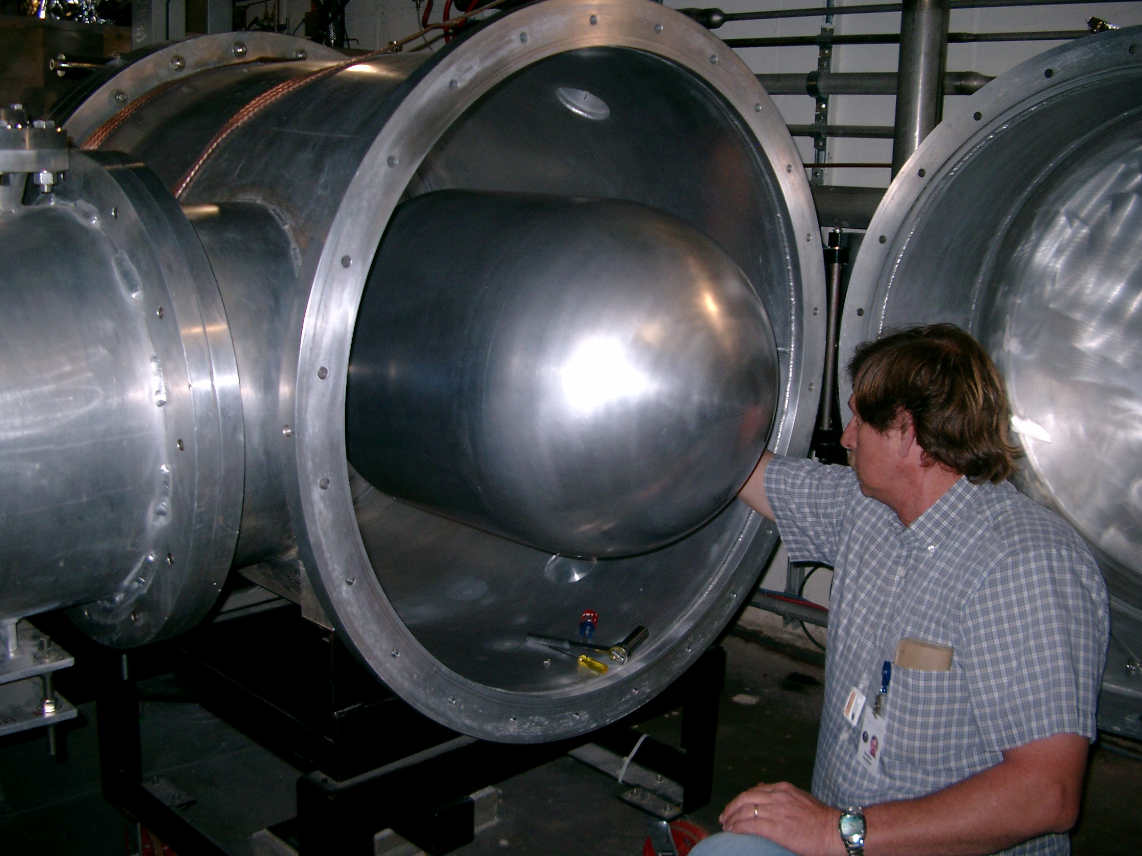
Fig. 2. Gun tank with the door open showing the corona shield (salad bowl) in place.

- Remove the blue wire that keeps the charge collector (i), ground flange (c) and Cs channels feedthrough (j) at the same potential. See Figures 1 and 3.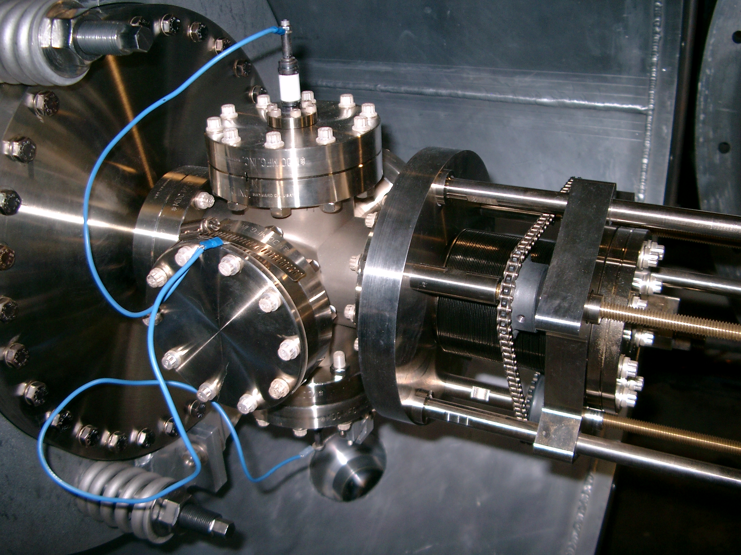
Fig. 3. The gear mechanism with the compressed belows means that the cathode is seated at the end of the ball electrode in the nominal opeariting conidtion. The bluse wire keep the charge collector (top), the Cs channels feedthrough (bottom) and the ground flange (middle) at the same potential during normal operation.

- Retract the cathode stalk by turning counter-clockwise the driving bolt on the gear mechanism (h). This action will extend the bellows. Make sure to go slow. Keep turning until the gears meet the stop in each of the sliding rods. Figure 4 shows the gear mechanism with the extended bellows, meaning the cathode is in the retracted position inside the ball electrode. 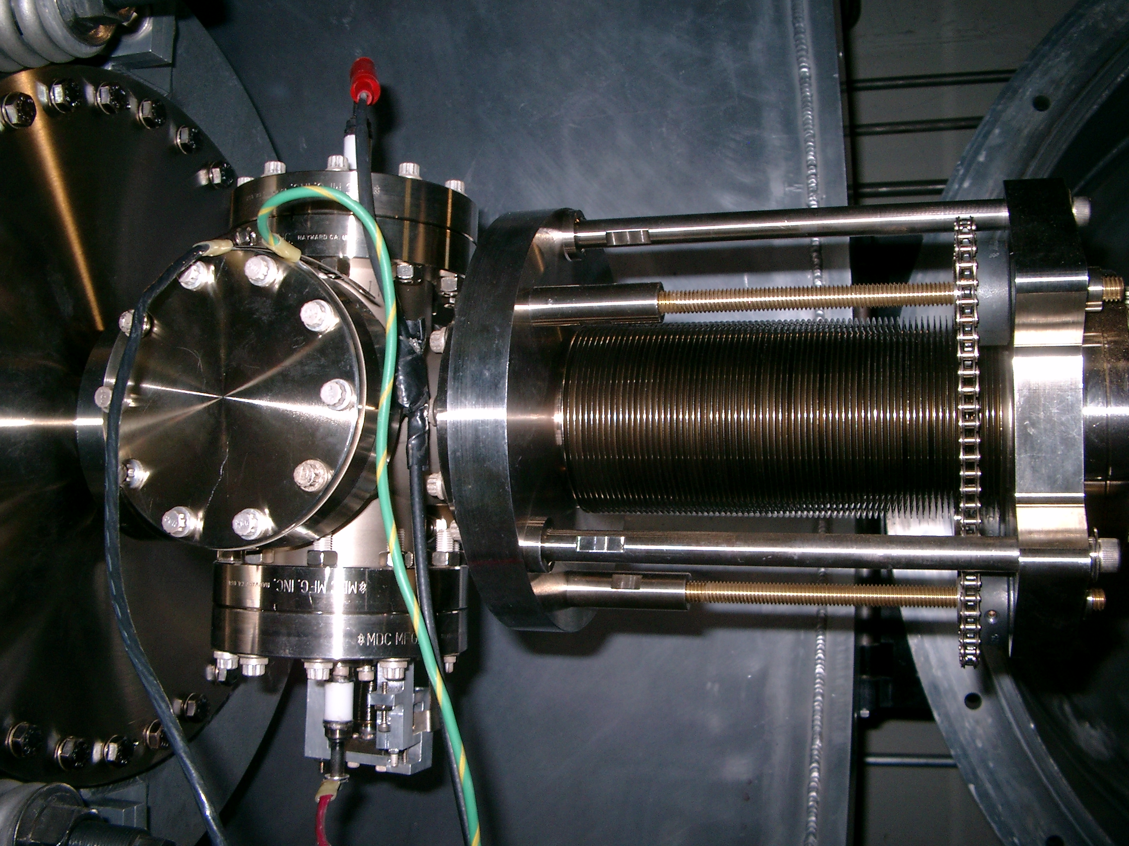
Fig. 4. Extended bellows meaning the cathode has been retracted inside the ball electrode. The picture shows the charge collector (top) connected to the connector box, the black ground cable (middle) connected to the Cs channels DC PS along with the ground green cable, and the hot (red) cable (bottom) connected to the Cs channels DC PS.

- OPTIONAL HEAT CLEAN
Before inserting the cathode heater, spread molybdenum grease on the end coil of the heater to prevent sicking to the inside of the cathode stalk. Make sure the heater and thermocouple is well seated against the end of the cahode stalk.

- Connect and switch on the Nitrogen flow and the power supply to the heater.
- Begin the heat clean by ramping up to 670 C in ~1.5 hours (increase time if vacuum becomes too poor). Remain at 670 C for a 4 hour soak period, monitoring the vacuum simulateously (it should reach a peak of ~8e-9Torr). Use the controller to ramp down to room remperature in 1 hour. In practice it takes longer than 1 hour to reach room temperature, usually over night.
- Leave the system for several hours to allow the pressure to recover sufficiently.
- Remove the heater from the cathode stalk and disconnect the Nitrogen and power supply. END OF HEAT CLEAN.
- Prepare the pico-ammeter. There is a small (2x1x3 inches) connector box with labels in each connector. CAUTION: Make sure the battery box bias is set to 0 V before making any connections. The box connectd directly to the ammeter. Connect the battery box to the connector box using the specially terminated cable. Connect the box to the to the charge collector feedthrough (i) in the gun using the coaxial cable with the red alligator clip on one end. Connect then the ammeter to the stripchart recorder. See Figure 5.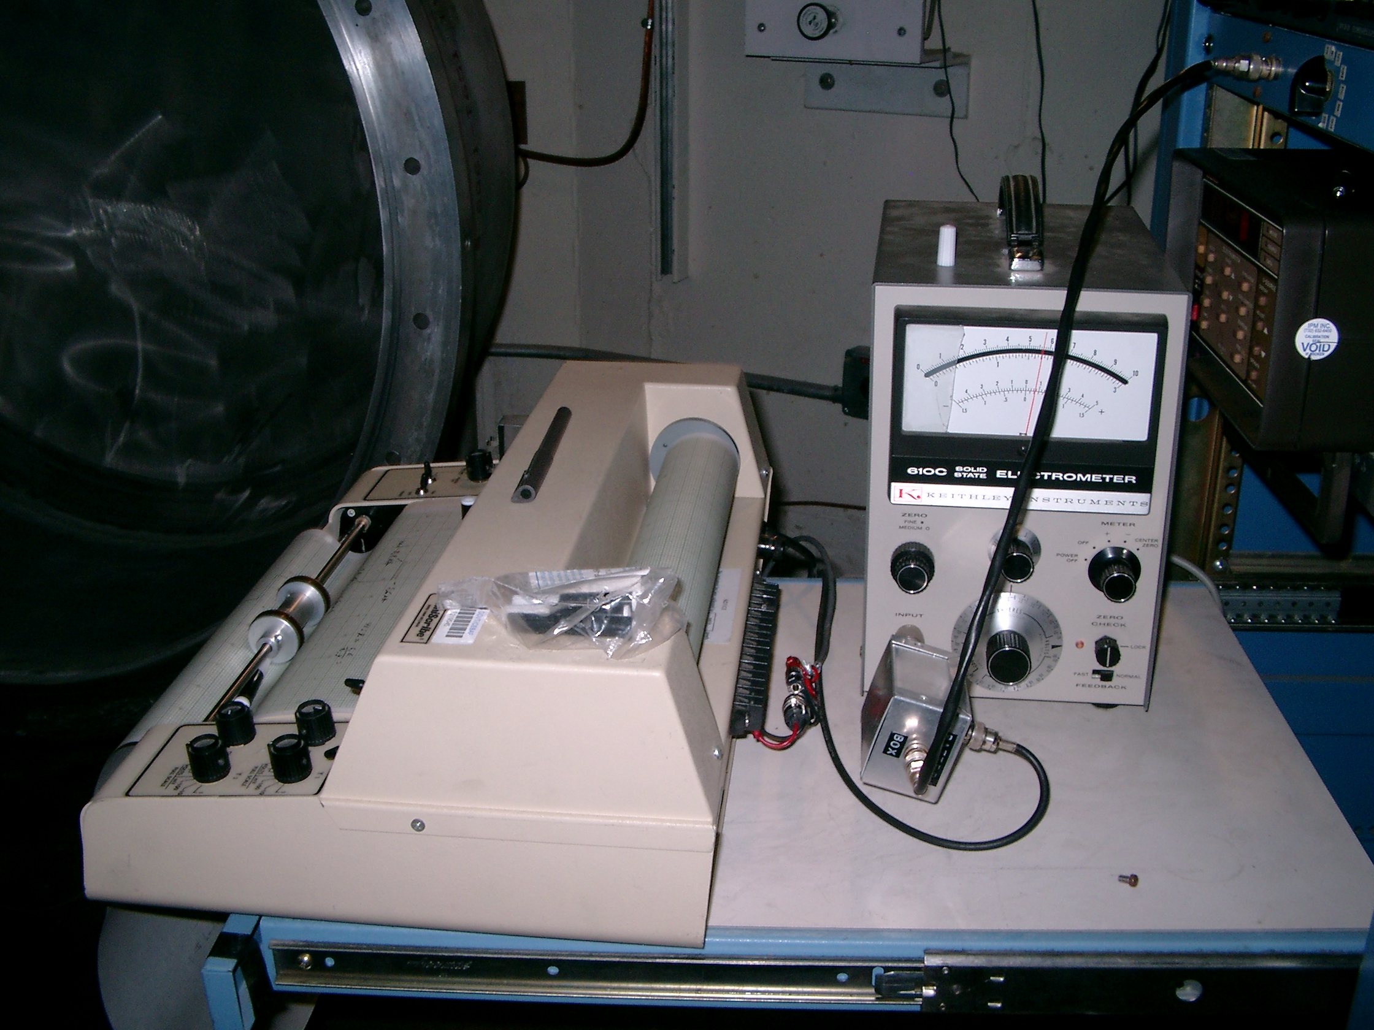
Fig. 5. Connector box connected to the pico-ammeter, battery (blue box in rack, top right) and charge collector connected also to box). Th stripchart recorder is also connected to the pico-ammeter.

- Connecting the DC power supply to the Cesium channels. CAUTION: Make sure the DC power supply is turned off before making any connections. Connect the ground (black) cable and the green cable (connected to the ground plate next to the wall) to the ground flange (c) with the hose clamp. Connect the hot (red) wire to the Cs channels feedthrough (j). See Figure 6.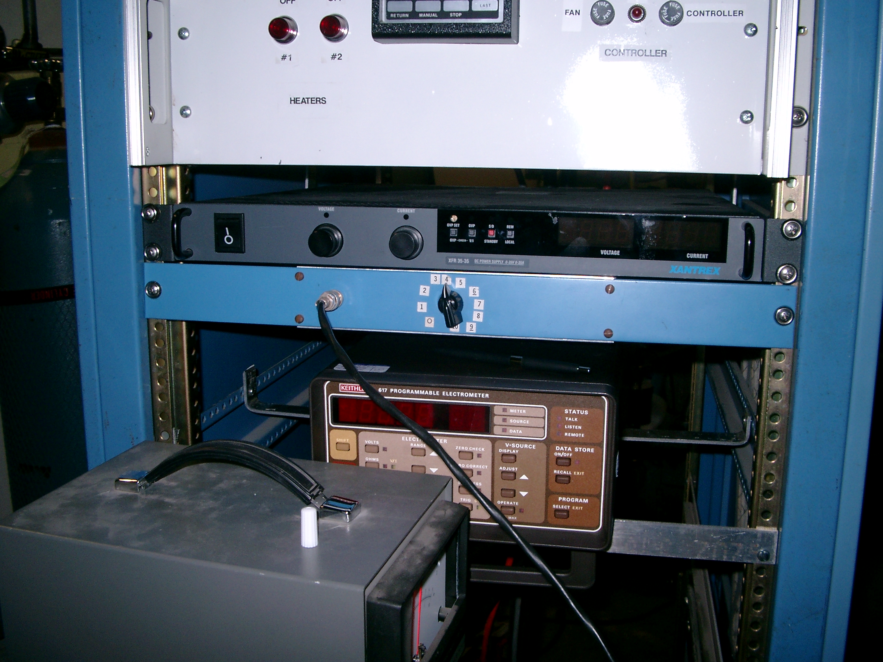
Fig. 6. The DC PS (black) to power the Cs channels is mounted in the rack cabinet on top of the battery box (shwon in blue). The PS cables run from the back.

- Make sure the Voltage setting is zero before turning on the DC power supply. Then set the voltage until the current is around 3.0 Amps to warm up the Cs. Channels for about 5 minutes. There may be a slight increase in vacuum during this time.
- Remove the cathode scanner mirror that directs the green HeNe beam through the viewport in the lightbox. The mirror is mounted in a rail by means of a screw. Loose the screw and remove the mirror mount from the rail. Remove the foil covering the viewport and install and turn on the lamp in such a way that the light is passing normal to the viewport. See Figures 7 and 8.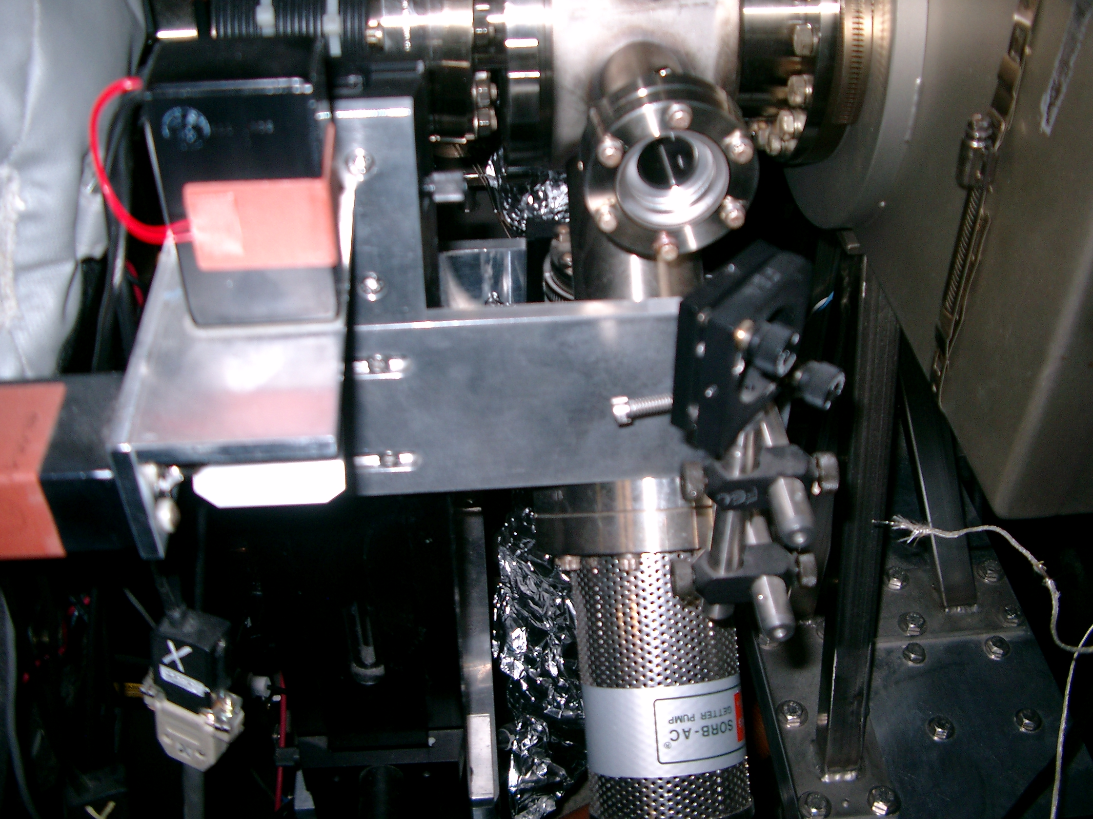
Fig. 7. Cathode scanner mirror assembly. The green HeNe laser reflects off the mirror on the right and enters through the viewport on the top of the picture.
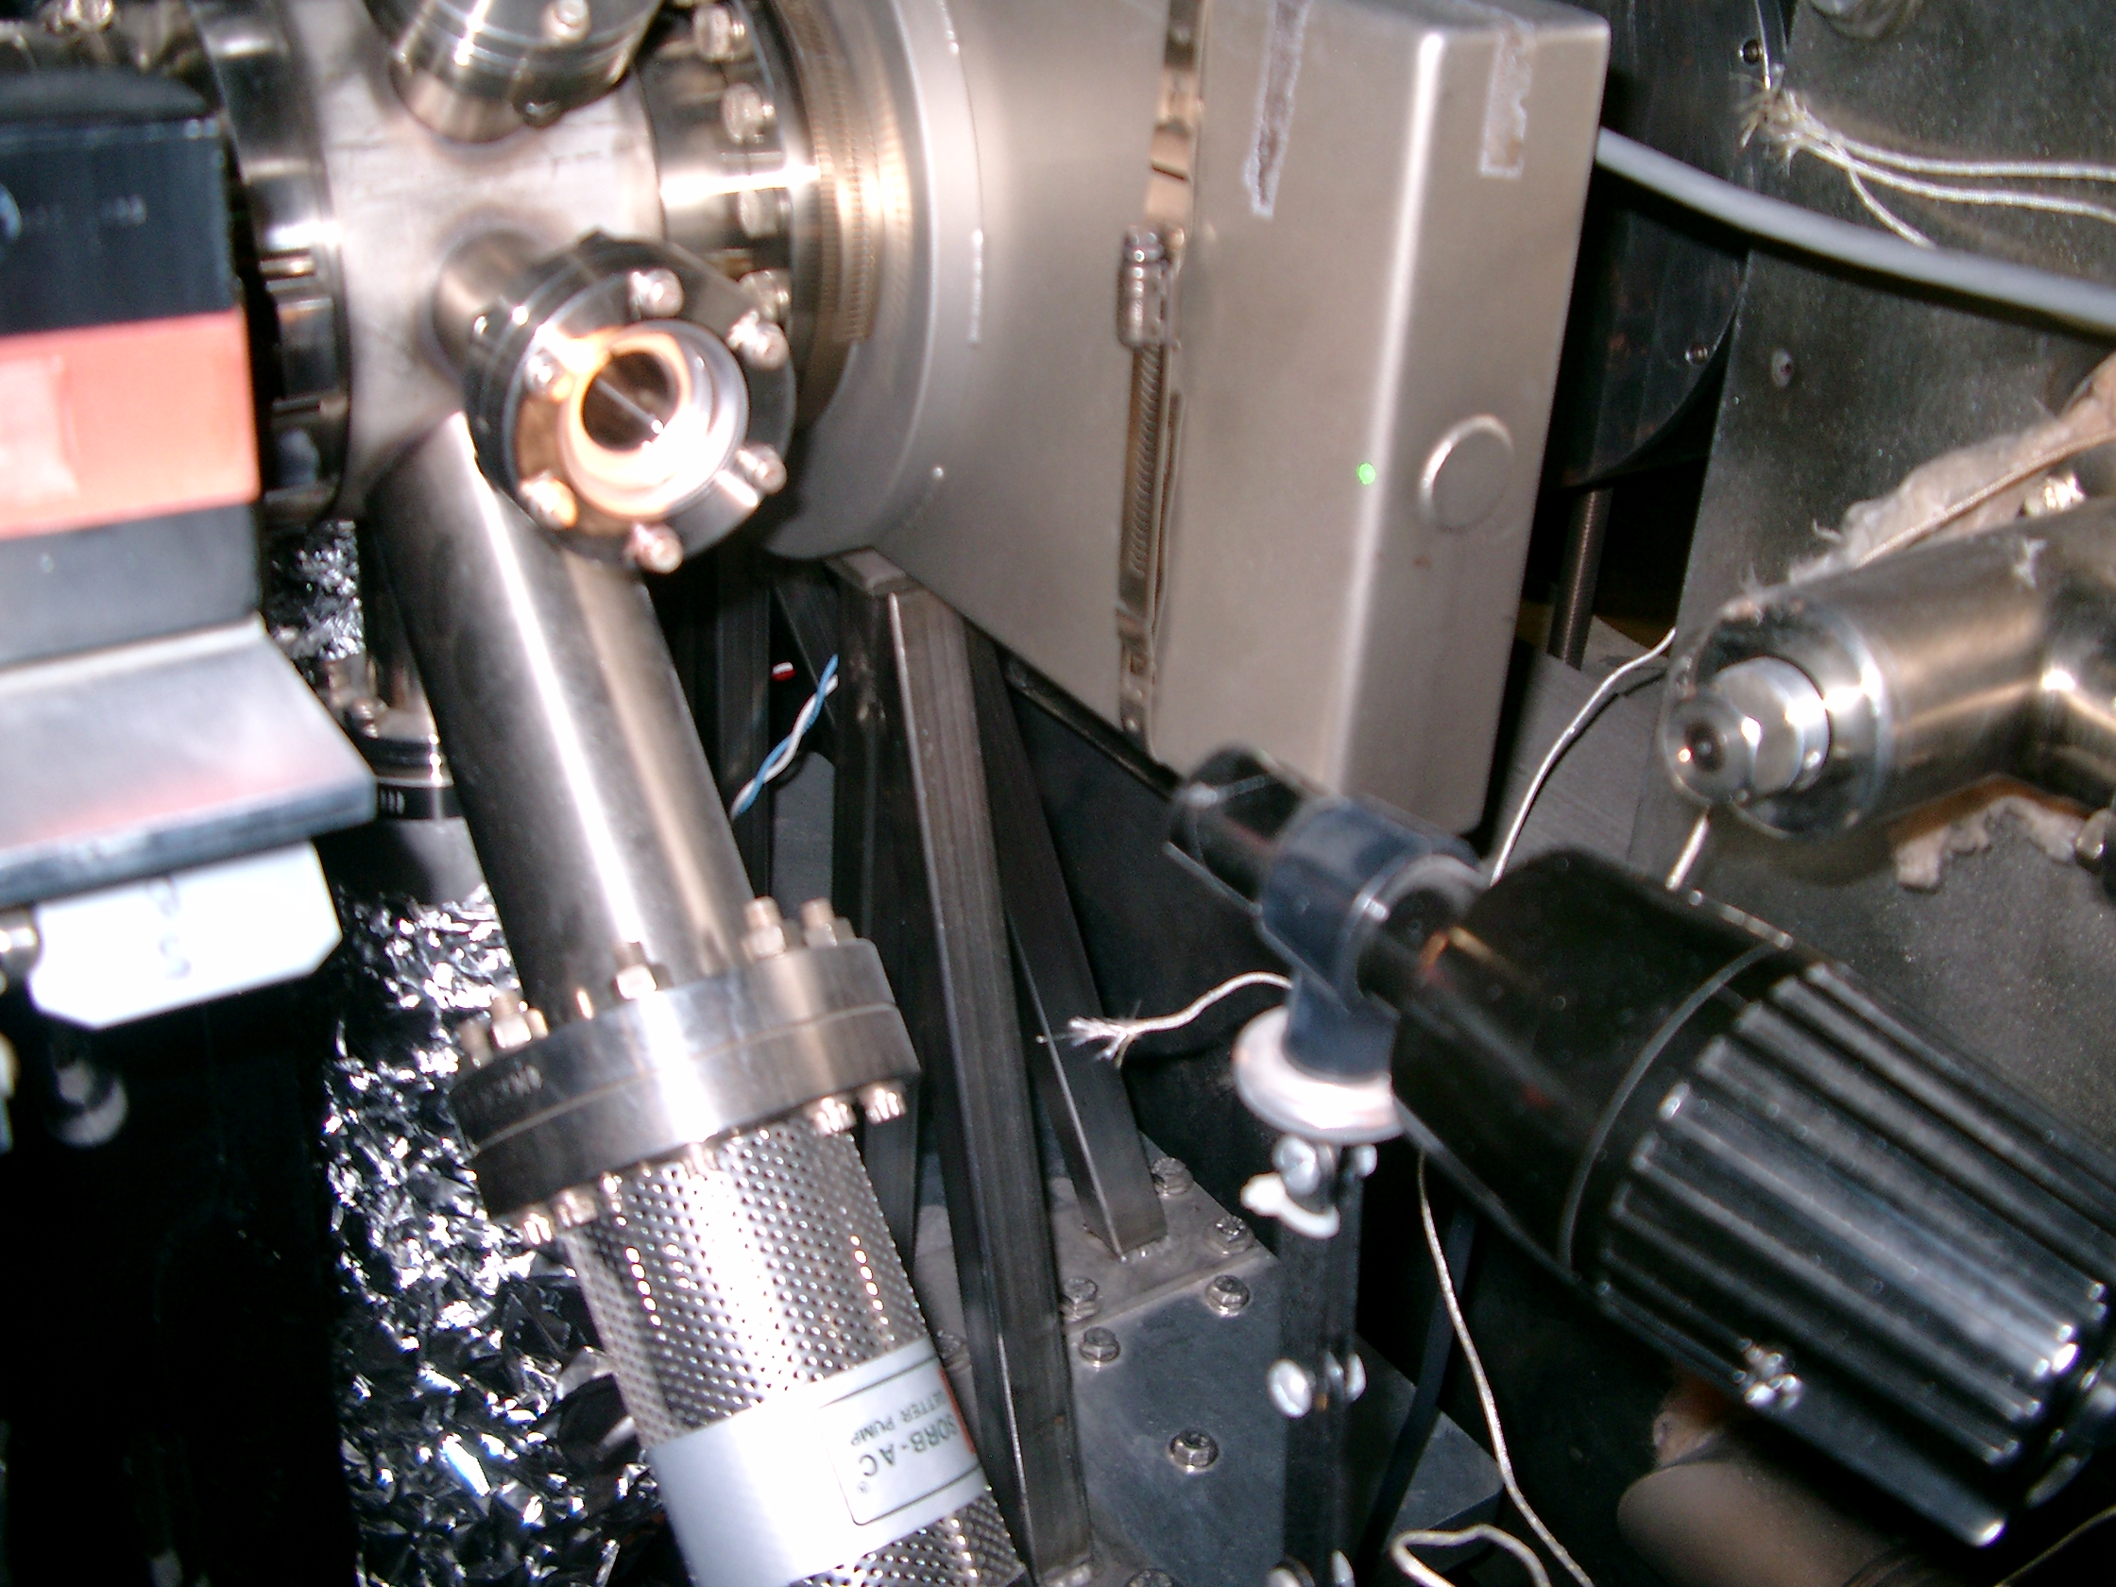
Fig. 8. Lamp placed in front of the viewport for illuminating the cathode during re-cesiation.

- Verify that the vacuum is in the ~5E-11 Torr range at VIP0F00 (gun) and VIP0F01 (light box), then open the gun gate valve VBV0F01 (to trick the interlock system into not closing the gate when the vacuum is too high).
- Turn on the pico-ammeter and set the battery box bias to 4 batteries (~120V). You should see some photocurrent in the pico-ammeter in the 10x10E-6 Amps scale. If necessary, adjust the light to maximize the photocurrent.
- At this point Cs is applied to the cathode. Increase the DC PS voltage until the current is 5.0 Amps. Observe the pico-ammeter and record the maximum photocurrent. When the photocurrent falls to 10% of its peak value, decrease the DC PS voltage until the current is again 3.0 Amps.
- Introduce NF3 (or O2) into the gun chamber to a pressure of ~ 8e-10Torr. The photocurrent should mostly recover.
- Once the photocurrent has plateaued and dropped by 10%, again increase the current in the Cs channels to 5.0Amps. The photo current will again increase (to a larger value than the previous Cs peak). Allow to over caesiate by 10% and reduce the current to 3.0A. The NF3 will then recover the photocurrent and the Cs is depositied as above. This procedure is repeated until the gain in photocurrent between Cs peaks is less than 10%.
- The final over caesiation is 20% rather than 10%. Switch off the Cs channel current at this point.
- Remove the NF3 (O2) supply once the photocurrent has plateaued.
- Set the battery box bias to zero volts and remove all connections from the gun.
- Re-position the cathode stalk by running the drive screw clockwise. Do it carefully and slowly until the distance is 3-in and 3/32 or until you see the gears disengage from the back flange. This is, if you keep turning the screw the gears move but not the flange. See Figure 3.
- Re-connect the blue wire as shown in Figure 3.
- Remove the lamp and re-position the scanner mirror in its rail mount as shown in Figure 7. Make sure to tight the screw that secures the mirror base to the rail.
- Before doing a cathode scan, connect the cathode scanner electronic box to the charge collector feedthrough (i) using the coaxial cable with the alligator clip on one end. Connect the other end of the coaxial cable to the back of the cathode scanner box. See Figures 9 and 10. Since the blue wire is now connected, the gun should be at the same potential. Run the cathode scanner and FLOG the resulting cathode scan.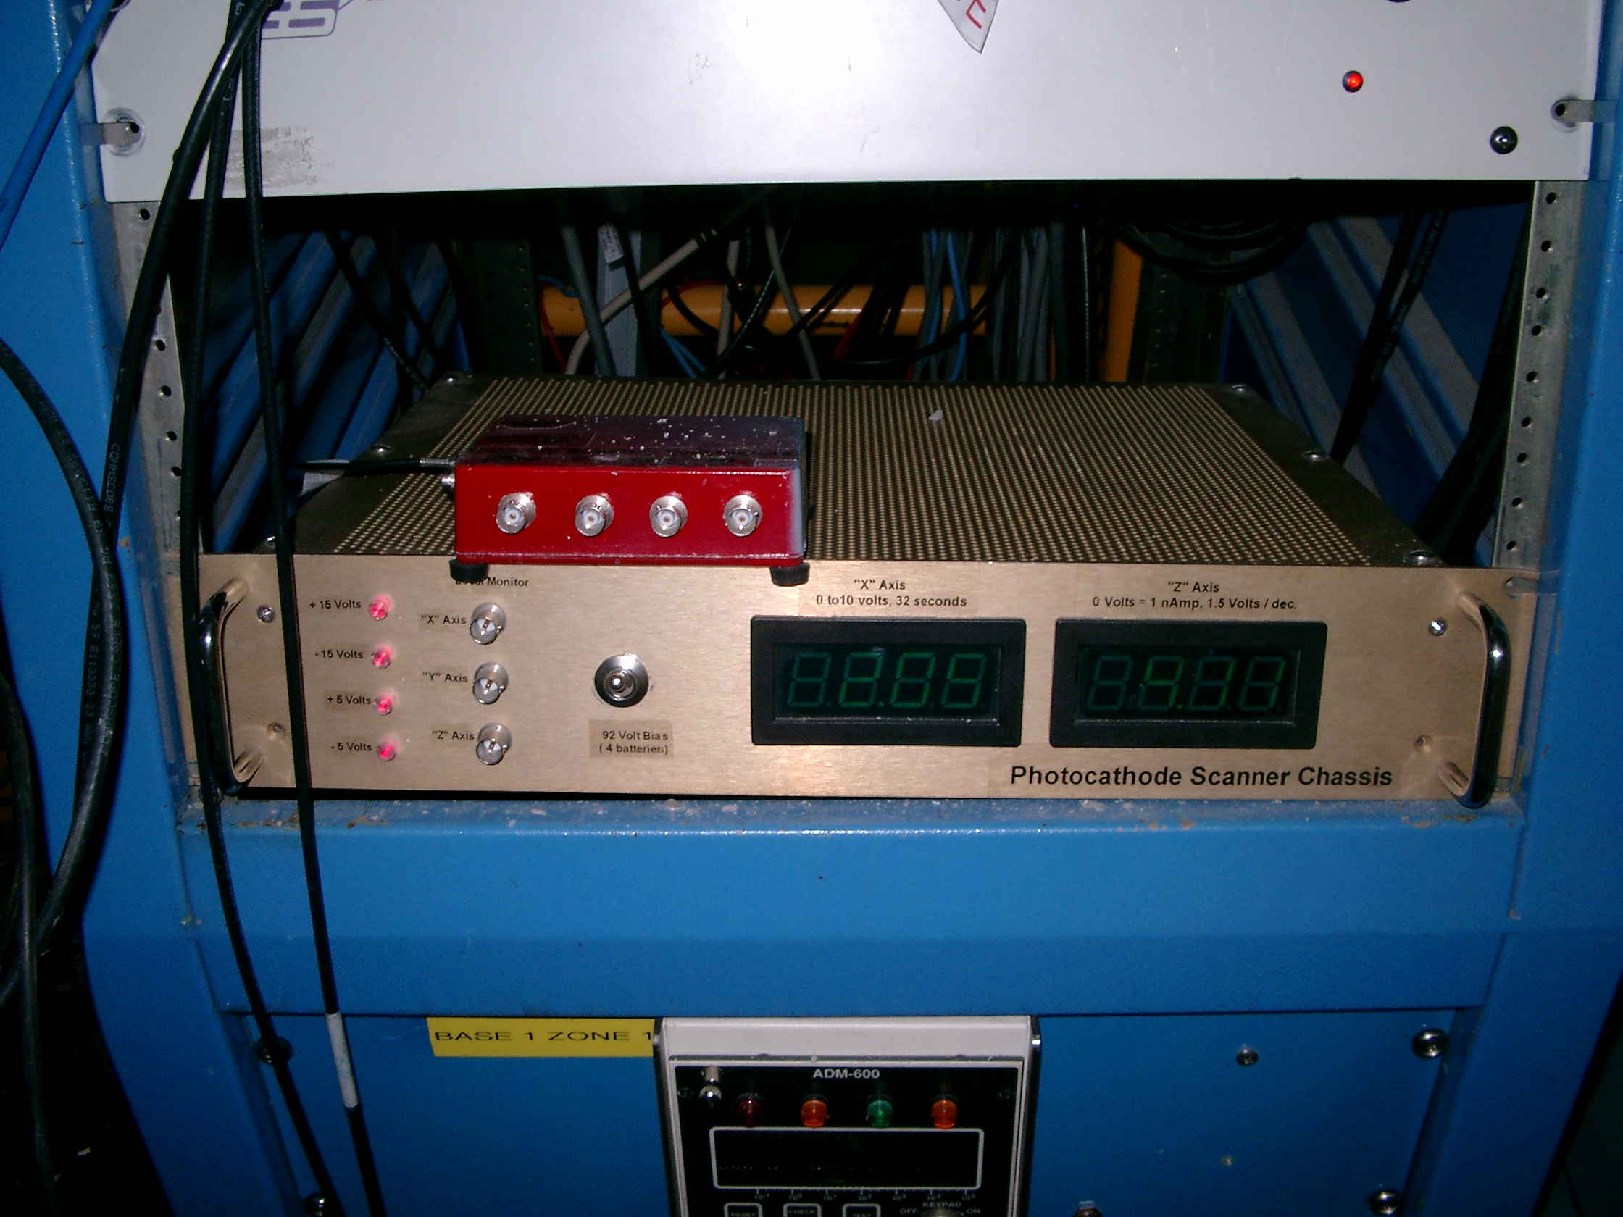
Fig. 9. Front view of the cathode scanner chassis.
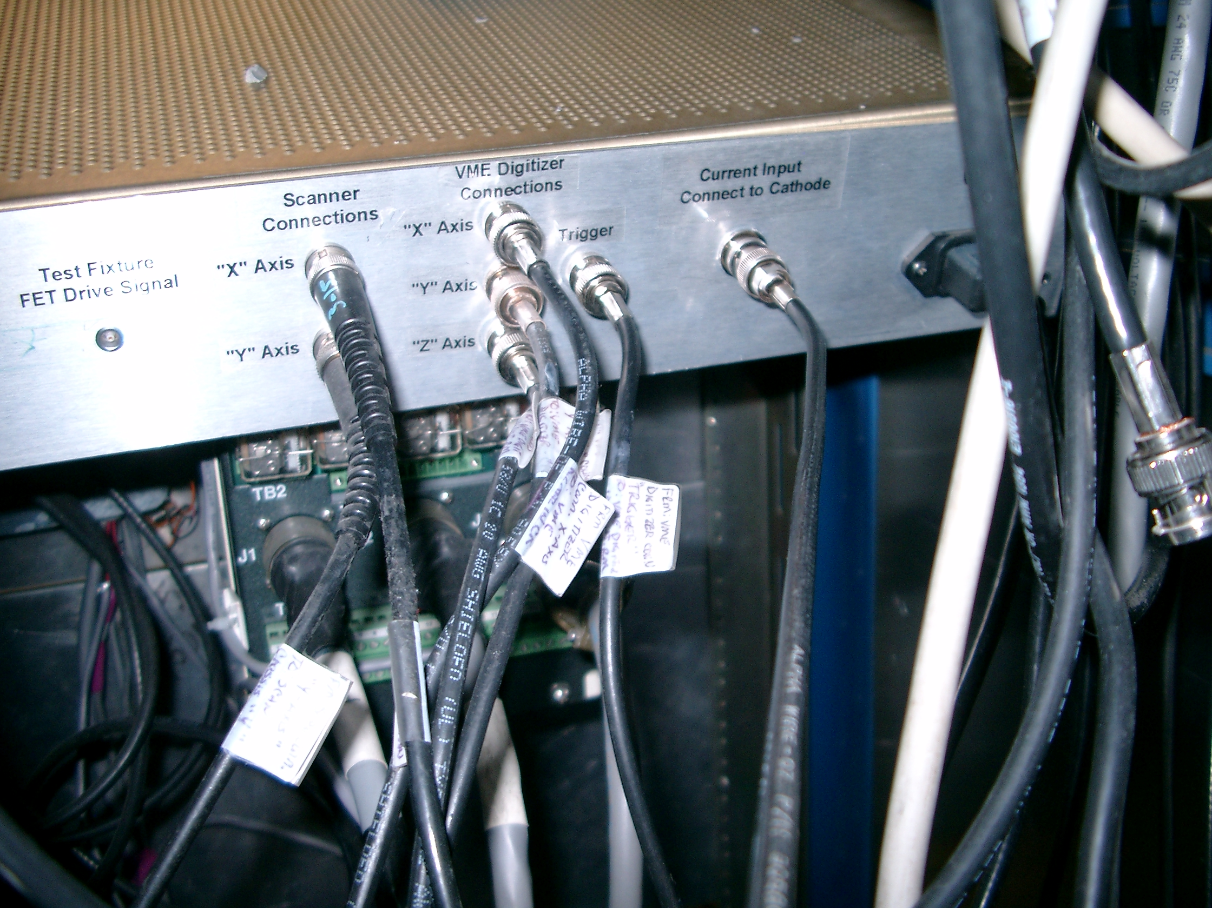
Fig. 10. Back end of the cathode scanner chassis with the coaxial cable (Current Input Connect to Cathode) connected to the gun.

- Remove the coaxial cable, close VBV0F01 and cover the lightbox viewport with aluminum foil. Re-install the corona shield (salad bowl) and clean it with isopropanol.
- Close the tank door and follow the instructions for back-filling the tank with SF6. The re-cesiation procedure is complete.

6 EMERGENCY PROCEDURES:

A Exposure to Sulfur Hexafluoride

Eye Call 911 for help, then medical services at X-7539.
Flush rapidly and continuously with eye wash station.
Advise Emergency personnel to continue irrigation.

Skin Irrigate rapidly with water.
See Emergency/Medical services.

B ODH Alarm in Injector Pit

Ensure nobody is laying on the floor of the Injector pit.
Leave the building.
After permission is given to re-enter the building, setup a fan to dissipate the gas.
APPENDIX A.

Check List For Tank Pressurization:

1. Were any bolts removed from either the HVPS or Gun Tanks (look, check log, ask, etc.)?

NO, pressurize tank. Yes, continue with checklist.

2. All bolts that were removed have been reinstalled and properly tightened.

Installer signature date

3. All bolts have been checked for security and tightness.

Checker (second person) signature date

4. Make log entry on status of bolts.

5. Continue with pressurization.

NOTE: An entry in the FEL system log stating the above information may be substituted for this checklist. The completed checklists are to be filed in the plastic folder located on the HVPS Tank.

500 kV Gun Power Supply
Operations and Maintenance Sign Off Sheet

I certify by my signature below that I have read and understand the following:
This SOP for bolting, filling, pumping out, and unbolting the HVPS and Gun tanks.
The Jefferson Lab EH&S Manual 6200, Electrical Safety.
The Jefferson Lab EH&S Manual 6110, Lock, Tag, Try (LTT).
The Glassman HVPS instruction and operations manual.
The SOP for cathode re-cesiation.
I further certify that I have had and am presently current with Jefferson Lab LTT, ODH level 1, and RadCon Worker or higher training and that I have had specific training on this particular procedure.

Carlos Hernandez will give the safety and maintenance training for this equipment.

As a result of my training, I am allowed to bolt, fill, pump out, unbolt the HVPS and Gun tanks, and work on the photocathode gun either only in a positively de-energized state (i.e. turned Off with my personal LTT).

Name (print) Signature Date Trained By
________________________________________________________________________________________________________________________________________________________________________________________________________________________________________________________________________________________________________________________________________________________________________________________________________________________________________________________________________________________________

