The Past – Summer SAD 2017 (March – November)

Hardware
- 4-LLRF
  - Production unit installed (spare in fabrication)
  - Each laser has identical knobs (amplitude, phase shifter, 250/499)
  - FSD latch if RF system is confused on 250/499 => called RF group
- Laserfreek app
  - Tool changes laser rep rate between 250 and 499
  - Sequences the amplifiers ON/OFF while changing laser/RF setpoints
- Repair tune mode generators
  - DC mode for RTP cells backed out
  - Replaced two cells => bad extinction and bad tail
- Repair laser chiller
  - Good news, but local chiller worked fine all summer
- Removed Gun3
  - ALL Gun3 hooks removed and tested
  - VBV3I02 (a.k.a. Gun3 valve behaves like normal valve)
  - Vacuum diagnostic chamber there => will go away w/ new Y chamber
- Chopper amplifier replaced
  - I believe replaced w/ 300W spare unit (might be wrong)
- Suitcase-photocathode swaps
  - Many swaps, but this is what remains in Gun2
    - #9 - SLSP-5756-4 in HV (recent 12 GeV photocathode) – 10/10/17 activation
    - #3 - SLSP-5247-4 in Prep on SM#1-1 (QWeak sibling)
    - #6 - SLSP-75104 in Prep on SM#2-1 (90% photocathode, wet bake)
    - #10 - SLSP-DBR-75105-1 in Prep on SM#2-2 (DBR, wet bake)
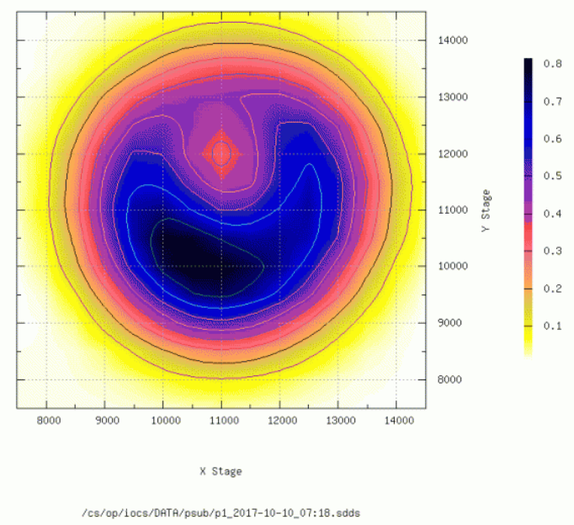
The Past – Summer SAD 2017 (March – November)

Beamware
- Tested Brock cavity as a phase detector (like Yao) upstream of chopper
  - Test looked promising => useful for UITF
- Radio-isotope run @ 4K
  - Setup 15.7 MeV w/ 0L02+0L03 @ 4K
  - Injector ran well, bodes well if Bubble @ 4K
- PQB – dependence on laser size and divergence
  - Study sensitivity of pos. diff. to laser size at PC and Photocathode
  - Learned sensitivities to path length and similarity of divergence to set spot sizes
  - Instigated improved control of laser size/divergence and PPLN settings
- PQB – study KD*P PC vs. RTP PC
  - Provide data to evaluate if RTP can be both a feedback for charge & position
  - Finally backed out, returned to standard KD*P configuration
  - Instigated using Elegant to re-normalize pos. diff. results
- Installed resonant ring polarimeter
  - Installed in 1D beam line, ready for testing
  - If ring is limiting we can back out in few days with accesses, or over holiday
- Quad-Solenoid emittance study
  - Took solenoid-harp and quad-harp emittance data at various spot size
  - On Daniel’s plate to fit with provided equations
- mA polarization @ Mott
  - Measured polarizations remains high ~85% from 1 uA to 1 mA
- mA lifetime @ CEBAF
  - Operated up to 2 mA @ 499MHz to FC1
  - Measured lifetime vs. laser spot size => demo. >400C @ 1mA
  - Compared UHV and RadMon => fast loss detectable ~nA level

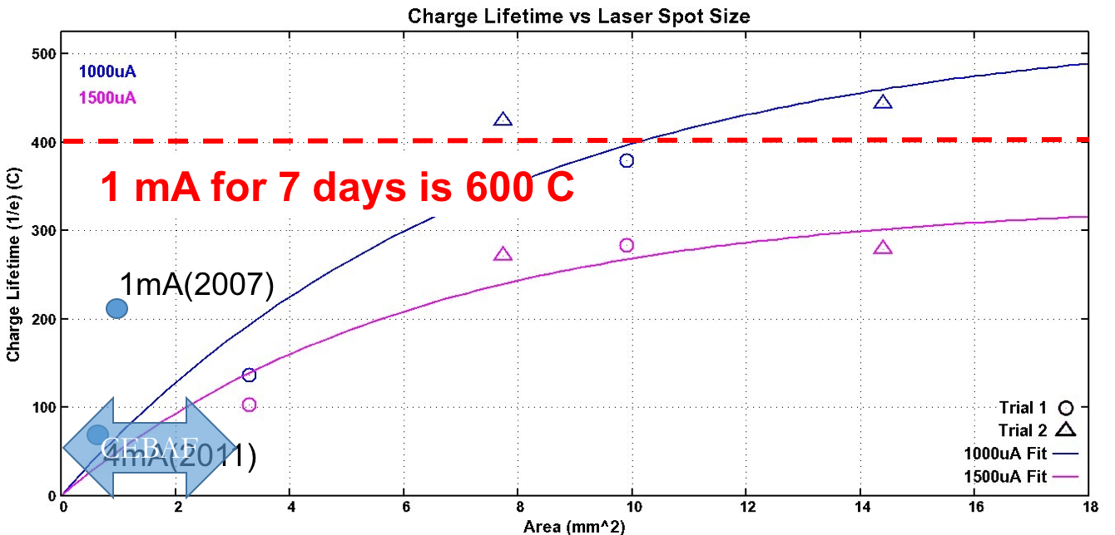
The Present – Winter Run 2017-2018 (Dec 4th – Mar 21st)

Dec 4th – Dec 21st : 4 Hall Operations for three weeks
Parameter | Hall A | Hall B | Hall C | Hall D
Program | E12-11-112 | Engineering | Commissioning | E12-06-102
Passes | 2 | 5 | 3,4 | 5.5
Current | 20 uA | 2-100 nA | 20,80 uA | Run: 150-200 nA  Tests: 5-600 nA
Polarization | No | Yes/Wien=TBD | No | No
Chopper/Slit | 499/A | 250/B | 499/C | 250/D

Jan 12th – 27th : 4 Halls Operations for two weeks
Parameter | Hall A | Hall B | Hall C | Hall D
Program | E12-10-103 | Engineering | E12-06-107 | E12-06-102
Passes | 5 | 5 | 4,5 | 5.5
Current | 20 uA | 100 nA | 80,65 uA | 200 nA
Polarization | No | Yes/Wien=TBD | No | No
Chopper/Slit | 250/A | 250/B | 499,250/C | 250/D

Jan 27th – Feb 4th : 3 Hall Operations for one week
Parameter | Hall A | Hall B | Hall C | Hall D
Program | E12-10-103 | Maintenance | E12-10-002  E12-10-008 | E12-06-102
Passes | 5 |  | 5 | 5.5
Current | 20 uA |  | 65 uA | 200 nA
Polarization | No |  | No | No
Chopper/Slit | 250/A |  | 250/C | 250/D

Feb 5th – Mar 22nd : 4 Hall Operations for six weeks
Parameter | Hall A | Hall B | Hall C | Hall D
Program | E12-10-103 | CLAS12 - Run Group A | E12-10-003  E12-10-017 | E12-06-102
Passes | 5 | 5 | 5 | 5.5
Current | 20 uA | 100 nA | 70 uA | 200 nA
Polarization | No | Yes/Wien=TBD | No | No
Chopper/Slit | 250/A | 250/B | 250/C | 250/D

The Present – Winter Run 2017-2018 (Dec 4th – Mar 22st)

WEEK of Nov 6th –
- Fri
  - Gun2 QE scan => same spot, new spot or heat/activate

WEEK of Nov 13th – 4 Beam Setup to ILD
- Mon-Tue to FC2
  - Wien Angle => looking at old 1050 setup, Yves is working B @ 5th pass
  - 4- bunch profile => benchmark ABCD @ 499 and 250
  - 4-laser phases => record ABCD phases @ 499 and 250 to save
  - 4-beam chopper
    - => determine atten/slit values for proposed currents
    - => measure bleed through
- Wed-Fri to ILD
  - Bunch length setup => status of tool and are there new settings ?
  - 0L-0R quad centering => update BPM offsets?
  - Injector match => important to test if new RF settings ?
  - high current setup => explore BD @ 250 & ABCD @ 250 ?
- What else ?
  - 750 MHz BPM detector
  - Managing expectations (halls have priorities)
  - Maybe put beam in the resonant cavity polarimeter on Tuesday…

WEEK of Nov 20th – Week of Thanksgiving – no setup planned

WEEK of Nov 27th – CEBAF setup
- CIS On-Call Support => Please send me your unavailability through March 22nd

WEEK of Dec 4th – Physics begins…

Must – SAD 2018 (Mar 23rd – September 30th)

200 kV Gun Installation (integrated time is 2-3 weeks)
- 200 kV HV chamber (R28 connector, excellent vacuum, no FE, reliable)
- NEG tube (two BPM’s + FH solenoid)
- 350 kV HVPS (SF6 tank, 350-R28 cable, resistor & short, ENG and software)

200 kV Injector Testing (integrated time is 3-4 weeks)
- Demonstrate HVPS safe and functional operation
- Demonstrate 200kV application to gun at CEBAF (no FE)
- Deliver 200keV beam from gun
- Evaluate existing beam line (magnets, diagnostics)
- Magnet currents increase by 28%
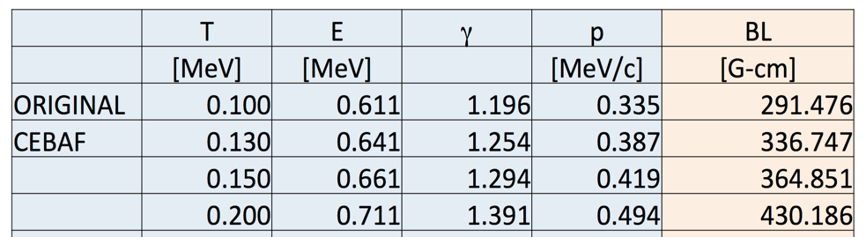
- Evaluate stability of new HVPS (may compare w/ present supply <150kV)
- Evaluate photocathode lifetime
- Assess range/performance of INJTWF (Wiens and solenoids)
- Assess chopper at higher power (Hovater)
- Assess chopping/dechopping with higher voltage beam
- Measure transmission/bunchlength vs. intensity/charge from 100-200kV
- Assess range of compatibility with existing ‘booster’ capture/quarter

Bubble Experiment (integrated time is 5 weeks)
- 1 week installation
- 2 week engineering run
- 2 week physics run

Laser Table Jobs (integrated time 2 weeks)
- STAC5 Upgrade
  - Replace 6 rotational steppers (attenA, attenB, attenC, attenD, RWP)
  - Replace 2 linear steppers + ADC (lensX, lensY, QE scan ADC)

Stretch – SAD 2018 (Mar 23rd – September 30th)

Rebuild Baked Beamline for 200 kV Operation
- MUST
  - repurpose as many components as possible
  - upgrade/fabricate those that cannot operate at 200kV
  - eliminate unnecessary or unused components (Brock cavity)
  - simplify setup where possible w/o loss of functionality (injsteer, PQB)
  - develop model to assess ME layout
  - coordinate w/ other groups that needs ~weeks for parallel upgrades !!!
- SHOULD
  - replace/fabricate components when obvious performance improvement
  - improve beamline vacuum

- Installation (10-12 wks)
- Disconnects and pull beam line out (1 wk)
- Break down and rebuild new beam line with survey as needed (2 wk)
- Install new beam line with 1A alignment (1 wk)
- Pumpdown, leak check, bake prep and bakeout (2-3 wks)
- Post bake leak check, hookups and HCO (2 wks)
- Beam line commissioning (2 wks)

- Components
- Fabricate new DS dipole magnet w/ AWG16 on DS fixture (need 3A)
- Existing transport solenoids should work (need to check MFG)
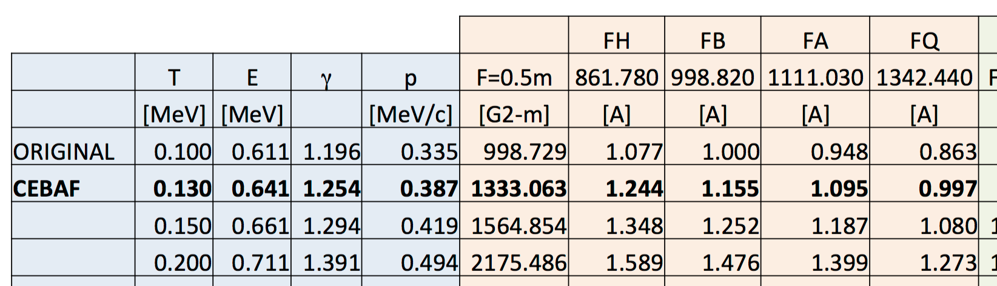
- Repurpose existing Wien filters
  - High voltage power supplies ordered
  - Existing feedthrough + barrel polished electrodes ready for UITF test
  - Modest vacuum chamber modifications are reasonable
  - Coil design needs to be improved (too many tight bends)

Must & Stretch – SAD 2018 (Mar 23rd – September 30th)

200kV Gun  Capable | MAR | 26 | Bubble Install
 | APR | 2 | Bubble Engineering
 |  | 9 | Bubble Engineering
 |  | 16 | Install 200kV Gun / HVPS
 |  | 23 | Install 200kV Gun / HVPS
 |  | 30 | Install 200kV Gun / HVPS
 | MAY | 7 | Slop
 |  | 14 | Commission @ 200keV
 |  | 21 | Commission @ 200keV
 |  | 28 | Commission @ 200keV
 | JUN | 4 | Slop
 |  | 11 | Restore FC2
 |  | 18 | Bubble Run @ 130 keV
 |  | 25 | Bubble Run @ 130 keV
Beamline  Upgrade | JUL | 2 | Slop
 |  | 9 | Disconnect and pull beamline
 |  | 16 | Breakdown and rebuild
 |  | 22 | Breakdown and rebuild
 |  | 30 | Slop
 | AUG | 6 | Install and 1A
 |  | 13 | Pumpdown, leak check, bakeout
 |  | 20 | Pumpdown, leak check, bakeout
 |  | 27 | Slop
 | SEP | 3 | Hook-ups and HCO
 |  | 10 | Hook-ups and HCO
 |  | 17 | Commission
 |  | 24 | Commission

