The CTF schedule and considerations for more UITF operations
March 10, 2022
In attendance: J. Creel, W. Seay, K. Baggett, J. Guo, R. Rimmer, M. Drury, A. Reilly, E. Daly, G. Ciovatti, J. Grames, M. Poelker, M. Spata, A. Seryei
Meeting notes:
The timescale as it relates to this discussion: now through the start of the next CEBAF SAD presently set to begin mid-March 2023. That’s when the booster CM leaves UITF and gets installed at CEBAF
The booster CM was tested at UITF in 2020 and 2021 and deemed acceptable for installation at CEBAF. There are still some residual concerns about puzzling modulation seen on the beam and if relevant groups wanted to identify the source of the modulation, I would support another “booster study” run. By that I mean, I volunteer to put beam into an MeV dump. But I do not detect much enthusiasm for more sleuthing. So the reason for today’s meeting relates to the following projects: 1) evaluate a Compton transmission polarimeter we promised BNL, 2) more water irradiation studies, and 3) EIC subharmonic kicker tests.
Discussed CTF priorities:
- CMTF CM testing has top priority (CEBAF CM testing not so flexible, SNS PPU CM testing offers from flexibility, at least by the time we get to SNS PPU-CM08)
- Expectation that VTA is always getting some LHe
- CLEO magnet testing
- UITF MeV operation
The CMTF has never been busier: 14 CMs to be tested in CY2022 and first couple months of CY2023, about one CM per month
Whit thinks CLEO magnet cool down will start mid-August and he expects tests to last 6 to 8 weeks. The first two weeks of cool down happens with LN2. After that, there’s a one week cool down period to 4K and that’s when there are potential conflicts with other CTF users. Jonathan recommends we focus only on VTA and CLEO ops during the week-long 4K cooldown.
Jonathan expressed cautious optimism that the CTF could cool the UITF booster CM and an SNS PPU CM inside the CMTF at the same time, and that he would be willing to support this work for ~ 6 to 8 week long duration. It means running the CTF harder than usual. He notes this would impact the VTA, there would be less LHe flow there.
Tony mentioned the end of the year is very important for CMTF tests of CEBAF CMs. That’s when the CMs will be ready for testing. He also mentioned the familiar absence of staff during the end of the year holiday period.
Ed suggested SNS PPU testing can slide into 2023, at least for the “spare” PPU CM. But of course JLab looks better if we deliver on time.
Mike Spata questioned the hard deadline for EIC kicker tests “end of calendar year 2022”, suggesting there would be no disadvantage scheduling them in 2023. But that begs the question, where would the beam come from once the booster is removed from UITF?
For two months – tentatively set for May/June – there will be no beam at UITF of any kind, while the gun group installs the CEBAF 200 kV gun needed for the upgrade.
Gigi’s experiment is the only one ready for beam now. The other two experiments – Compton transmission polarimeter and EIC kicker tests – are not ready for beam.
The Compton transmission polarimeter magnet should be delivered October/November and installation is quick. For EIC kicker tests, they need to finish building the kicker cavity and extend the beamline.
Poelker and the usual suspects volunteer to deliver the beam for Compton transmission polarimeter tests and water irradiation, but prefer these tests happen during the same cool down period. And provided the usual suspects are available.
I recommend that SRF Institute set the end date for UITF operations. By this I mean, SRF should schedule the booster removal from UITF and its installation at CEBAF together with all the other CM work for 2023 SAD. I had recommended “getting a jump” on things by removing the booster before the SAD, but SRF can say when it makes sense to the pull the booster from UITF, in the context of all the other work they will be doing.
In this primitive Gannt chart, I took the liberty of setting PPU CM tests to four weeks duration, and I moved them around to create a 2 month test period for UITF. I arbitrarily moved the PPU test dates without consulting anyone, so the UITF opportunity noted below might not be realistic but that’s when we think the Compton transmission polarimeter solenoid will be in-house. The indicated UITF test period would also support water irradiation runs. (SAD 2023 starts mid-March, the end of the chart)
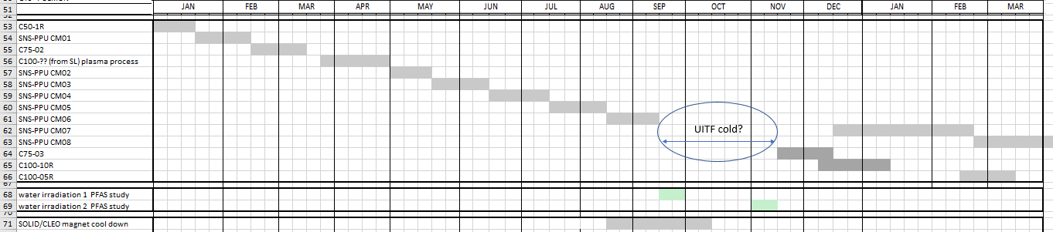
Jonathan mentioned CTF “upgrade” work likely happens to the right of this chart but expect the usual end-of-year maintenance will take place end of December, first week of January.
We agreed to reprise this meeting in a month or two, Poelker to set it up

