Commissioning of the Rogowski Coil BPM
Summary of the Rogowski coil
The Rogowski Coil is a beam position monitor designed to noninvasively detect an electron beam down to a fraction of a nanoamp. The Rogowski coil is composed of a torus coil divided into four sections. The radius of the torus is 40 mm and the radius of the coil tube is 5 mm. Let the torus lie in the xy-plane and the z-axis pass through the center of the torus as shown below.

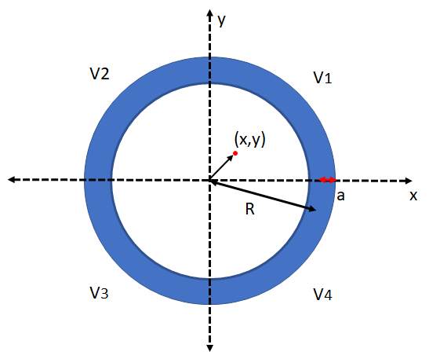
Figure 1: The cross section of the Rogowski coil. Each quadrant represents a separate coil segment. R represents the radius of the torus and a represents the radius of the coil tube.
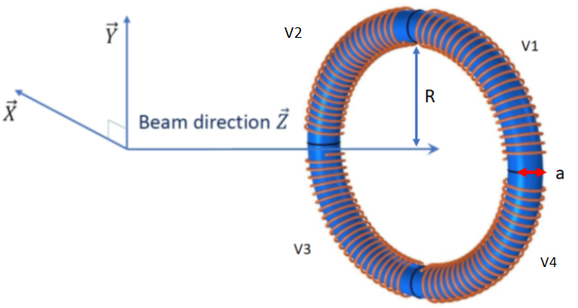
Figure 2: The structure of the Rogowski coil is shown in the cartesian coordinate axes. R represents the radius of the torus, a represents the radius of the coil tube, and the induced voltage in each coil segment is represented by V1-V4.
An electron beam passing through the torus parallel to the z-axis will generate a magnetic field that induces a voltage in each section of the torus coil. The electron beam can be modulated to a chosen frequency, which will cause the induced voltages in each coil segment to oscillate at that frequency. This frequency is the reference frequency used to lock onto the induced voltages using lock-in amplifiers (SR844). Then the induced voltage in each coil segment is measured and the relationship between the induced voltage in each coil section can be used to determine the electron beam’s position.
The Rogowski coil has been tested to validate this theory by passing a wire through the coil and sending an AC current through the wire at a certain frequency. The current simulated an electron beam passing through the Rogowski coil and the frequency of the AC current was used as the reference frequency. By adding a resistor in series to this wire the amount of current can be controlled and the Rogowski coil was tested to simulated currents as low as a 0.120 pA. A plot of the beam position measured by the Rogowski coil during this simulation is shown below.
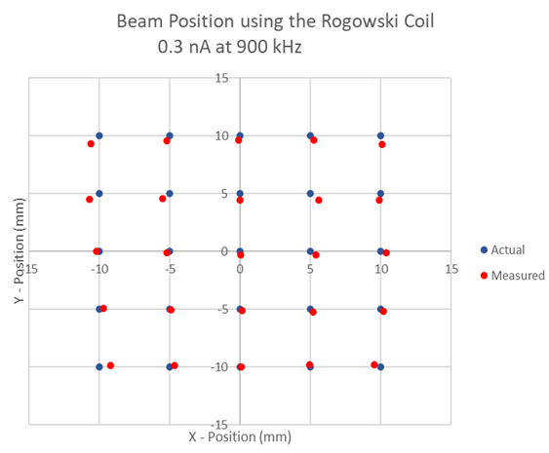
Figure 3: Plot of the beam position of a wire simulating an electron beam.
The Rogowski coil will be installed in the beamline of cave 1 of the UITF. The Rogowski coil will be installed in a section of the beamline after the cryomodule, and diff pumps (VDPM301A,B) where it can be tested using Correctors (MHBM401 H&V) , Viewer+ (ITVM401+), Faraday Cup+ (IFYM401+), and a BPM (IPMM501) located in the vicinity of the beamline. This location is shown in the image below of the quick reference sheet of the UITF beamline.
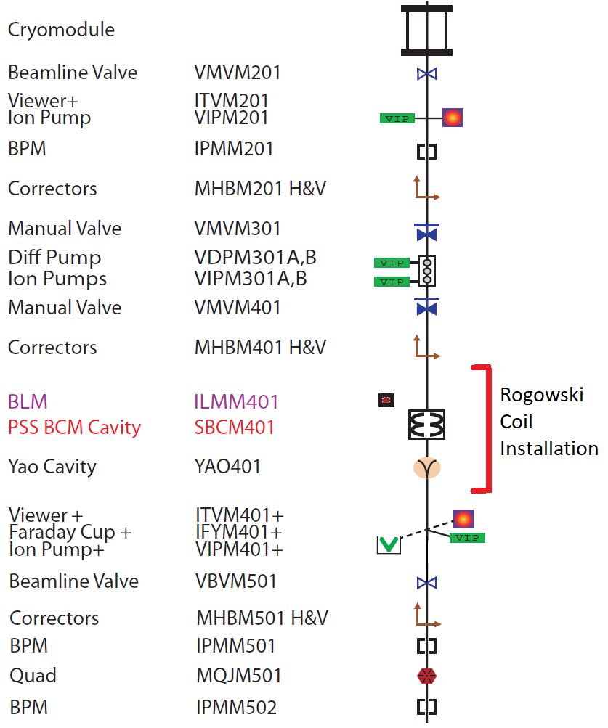
Figure 4: Section of the beamline the Rogowski coil will be installed. Image taken from the UITF quick reference drawing.
Once the Rogowski coil is installed in the beamline each coil segment is attached to its preamplifier (SR560) and lock-in amplifier (SR844). These electronics are located on an electronics rack that is located near the Rogowski coil and the electronics are controlled via a LabVIEW vi on a computer also on the electronics rack. This computer should be controlled via remote access in the control room of the UITF.
The Rogowski Coil LabView Program
The signal from each coil is passes through a preamplifier (SR560) before being sent to a lock-in amplifier (SR 844). The measurement from each lock-in amplifier is displayed and recorded by a LabView program. An image of the LabView program screen is shown below.

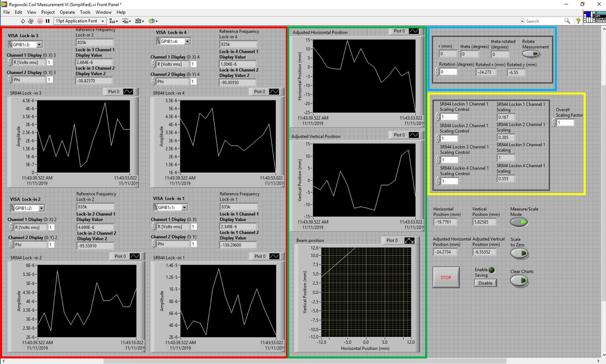
Figure 5: Image of the LabView vi used to control and monitor the Rogowski coil.
In the image above the signals from the four lock-in amplifiers are represented by the four plots (in the red box). Each plot displays the induced voltage with respect to time. Each plot also has controls above it that describe which lock-in amplifier is being controlled. The reference frequency, measured induced voltage, and phase are also displayed here. The orientation of the lock-in amplifiers has the lock-in amplifier labeled 1 in the bottom right corner and the numbering continues clockwise. This orientation mirrors the orientation of each coil segment in the Rogowski coil. The reference frequency is provided and controlled by the modulation to electron beam in cave 1. By default, the LabView program displays the induced voltage and phase, but these can be changed via the controls, if needed. The signals from the lock-in amplifiers are used to determine the beam position of the electron beam passing through it. With the origin of the coordinate grid being through the center of the Rogowski coil, the horizontal and vertical beam positions are determined using the following equations:
$$x=\frac{\left(V_{1}+V_{4}\right)-\left(V_{2}+V_{3}\right)}{c_{1}\sum_{1}^{4}{V_{i}}}$$
$$y=\frac{\left(V_{3}+V_{4}\right)-\left(V_{1}+V_{2}\right)}{c_{1}\sum_{1}^{4}{V_{i}}}$$
$$c_{1}=\frac{π\sqrt{R^{2}-a^{2}}}{2}$$
These calculations are done automatically by the LabView program and the results are shown in the green box. The adjusted horizontal and vertical beam positions are displayed in the top and middle plots. Together the coordinates of the electron beam are shown in the bottom plot. With respect to the coordinate grid used, during an experiment the bottom plot has the electron beam going into the page.
The horizontal beam position and vertical beam position are also displayed numerically in the bottom right corner of the program. The raw beam position measurements are simply labeled horizontal position and vertical position. The adjusted horizontal and vertical positions are the beam positions after any scaling or rotation has been applied.
The beam position can be rotated, if needed. A rotation could be needed if there is a misalignment with the Rogowski coil in the beamline. This is done by using the controls in the blue box. These controls display the current measurement in polar coordinates (r,θ). A rotation (in degrees) of the beam measurement can be inputted to rotate the measurement with respect to the coordinate axes. The rotated horizontal and vertical measurements are shown. To enable a rotation, press the button labeled “Rotate Measurement”. When a rotation is not active, the rotated measurements display will just display the unrotated beam position.
Due to imperfections in the Rogowski coil and its alignment, the beam position may need to be adjusted/scaled. This can be done by using the scaling controls shown in the yellow box. By default, the LabView program is set to manual controls upon initializing the program with each coil set to un-scaled. The scaling to each individual coil measurement can be inputted to improve the beam position measurement. The scaling of each coil measurement that is actively in use is shown to the right of the inputs. (The scaling is done by multiplying a measured signal by the inputted factor e.g. 1 represents no scaling and 1.1 represents an increase of 10%). When scaling the measurements is done the program should be set to measurement mode to prevent any unintended changes to the scaling. (Manual changes to the scaling will not register until the program exits measurement mode). An additional feature to automatically scale the coil measurements to center of the Rogowski coil is to press the “Scale to zero” button while in measurement mode. This will scale all four coil measurements to set the current beam measurement to the origin. If needed, the overall beam position can be scaled by changing the scaling factor labeled “Overall Scaling Factor”.
Additional controls are displayed in the bottom right section of the LabView program. The “STOP” button is used to stop the LabView program. The “Enable saving” button may be pressed to start saving measurements once the program has started. When presses the program will ask where to save the file. If the file has the same name as one that already exists, the new data will be appended to the already existing file. The clear chart button clears the data displayed in the plots.
Rogowski Coil Commissioning
The commissioning will involve testing the Rogowski coil as a beam position monitor and testing the sensitivity of the Rogowski coil to low-current electron beams.
The first step will involve the use of Correctors (MHBM401 H&V), Viewer+ (ITVM401+), Faraday Cup+ (IFYM401+, and a BPM (IPMM501). A 1 μA electron beam will be sent through the Rogowski coil and modulated to 860 kHz using a modulation unit, which will also pass this frequency as the reference frequency to the lock-in amplifiers on the Rogowski coil electronics rack. A brief period of tuning will be needed to calibrate the Rogowski coil to the electron beam passing through its center. Then the Correctors will be used to direct the electron beam to various positions through the Rogowski coil. The bpm located downstream will be used to determine the beam position of the electron beam and the measurements from the Rogowski coil will be recorded and compared. The beam position measurements from the Rogowski coil will be compared to those from the bpm. Depending on the comparison the reference frequency and Rogowski coil may need to be further tuned to determine and improve the accuracy of the Rogowski coil beam position measurements. A viewer and Faraday cup are also available to validate the position and current of the electron beam.
The second step in commissioning the Rogowski coil is to test its sensitivity to low-current electron beams. Once the initial beam position testing of the Rogowski coil has been completed the next test is to determine the lowest beam current the Rogowski coil can detect while still producing adequate beam position measurements. This test will involve the use of the same units as before. The electron beam initially at 1 μA will be set to a lower current and the same test as the first step will be repeated. The Correctors will steer the electron beam to various positions, the bpm will measure the position of the electron beam, and the Rogowski coil will have its beam position measurements compared to those from the bpm. The viewer and Faraday cup will be used to view the position and validate the current of the electron beam. These steps will be repeated until the lowest electron beam current the Rogowski coil is sensitive to is determined. If the current is decreased to a value undetectable by the other bpms on the beamline, the process may continue keeping in mind the accuracy of the Rogowski coil to determine if the Rogowski coil will still be accurate in further testing.

