Joe Matalevich
4-Feb-2014

Mott Dump Thermal Analysis

Background:
A new configuration dump plate is considered for the 5 MeV Mott polarimeter. The end plate configuration will consist of a beryllium plate (7.25” diameter, 0.25” thick) secured to a copper end cap (0.75” thick) which bolts to a stainless steel pipe flange with an o-ring seal. The seal material has operational temperature limits (204C for Viton; 240C for Kalrez). While these represent functional temperature limits, it is considered desirable for the copper end cap to remain below 100C. The component configuration is depicted below:

Cu plate
Be plate

A photo of the existing installation shows where the copper end cap will be installed.

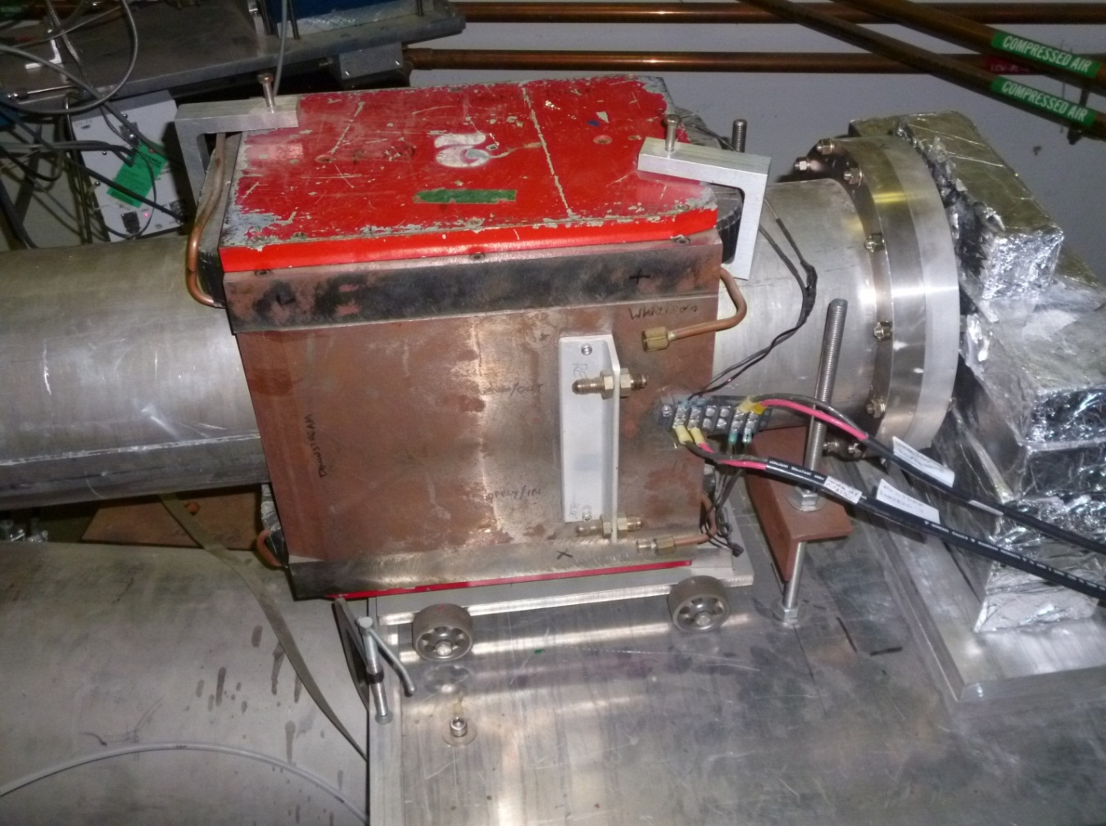
Stainless Steel Pipe Flange
To be replaced with Copper

Thermal Modeling
In order to predict the expected thermal profiles under various operating conditions several models were constructed. First a spreadsheet based calculation was performed to calculate the steady-state (SS) temperature as a function of deposited energy. An underlying assumption of this simplified calculation is that all deposited energy is uniformly distributed. In reality we would expect a temperature gradient with the highest temperature realized closest to the point where the beam is focused. This calculation is intended as an estimate with the calculated SS temperature expected to be on the lower end of actual results. Finite element modelling was performed in order to define the thermal gradients expected in the components.
As an input to the thermal models a simulation was done (by Marty McHugh) to predict the power densities deposited in the plates under various conditions. The results of which provided a spatial definition of the deposited energy profile. Several operating scenarios were evaluated (varying beam energy; with and without a 1um gold target) and the watts per unit volume of material were calculated over a three-dimensional grid of the beryllium and copper plates. A detailed summary of these results is included in Appendix A. A representative graph of the results is included below. The energy per unit volume is plotted vs distance from the center and also as a function of depth in the plate.

Several FEA models were created to evaluate the temperature profiles resulting from the deposited power. The first set of FEA models was utilized to determine the importance of the deposited energy profile. Since copper is such a good conductor of thermal energy it was anticipated that the distribution of thermal energy in the plates wouldn’t be a significant factor in the steady state temperature profile.
Three similar models were generated with the only difference being the location of the deposited power. The first model deposited all of the power (predicted by the simulation results) at a single point in the center of the beryllium plate. The second model deposited the same amount of total power, but distributed it over ten points located fairly close to the center. In the third model the same power was distributed over a wide area.
The resulting temperature distributions for each of the three cases predict the same SS temperature (within 1K) for the o-ring flange. Each model has locally higher temperatures in the beryllium where the energy is deposited but the copper temperature gradients are largely the same.
These three models were exercised under two cooling scenarios over a range from one to one thousand watts of deposited power. The cooling scenarios considered were: (1) air-cooling of the exposed copper (free convection) and (2) air-cooling with the addition of a water cooling tube on the copper.
Results show that the magnitude of deposited energy is important, but the distribution of that energy has minimal impact on the SS thermal gradient in the copper.
The calculations to determine the convection coefficients to be used in the FEA models for the air cooling and water cooling scenarios are summarized in Appendix B. The resulting temperature (as a function of deposited power) is summarized in the graph below:
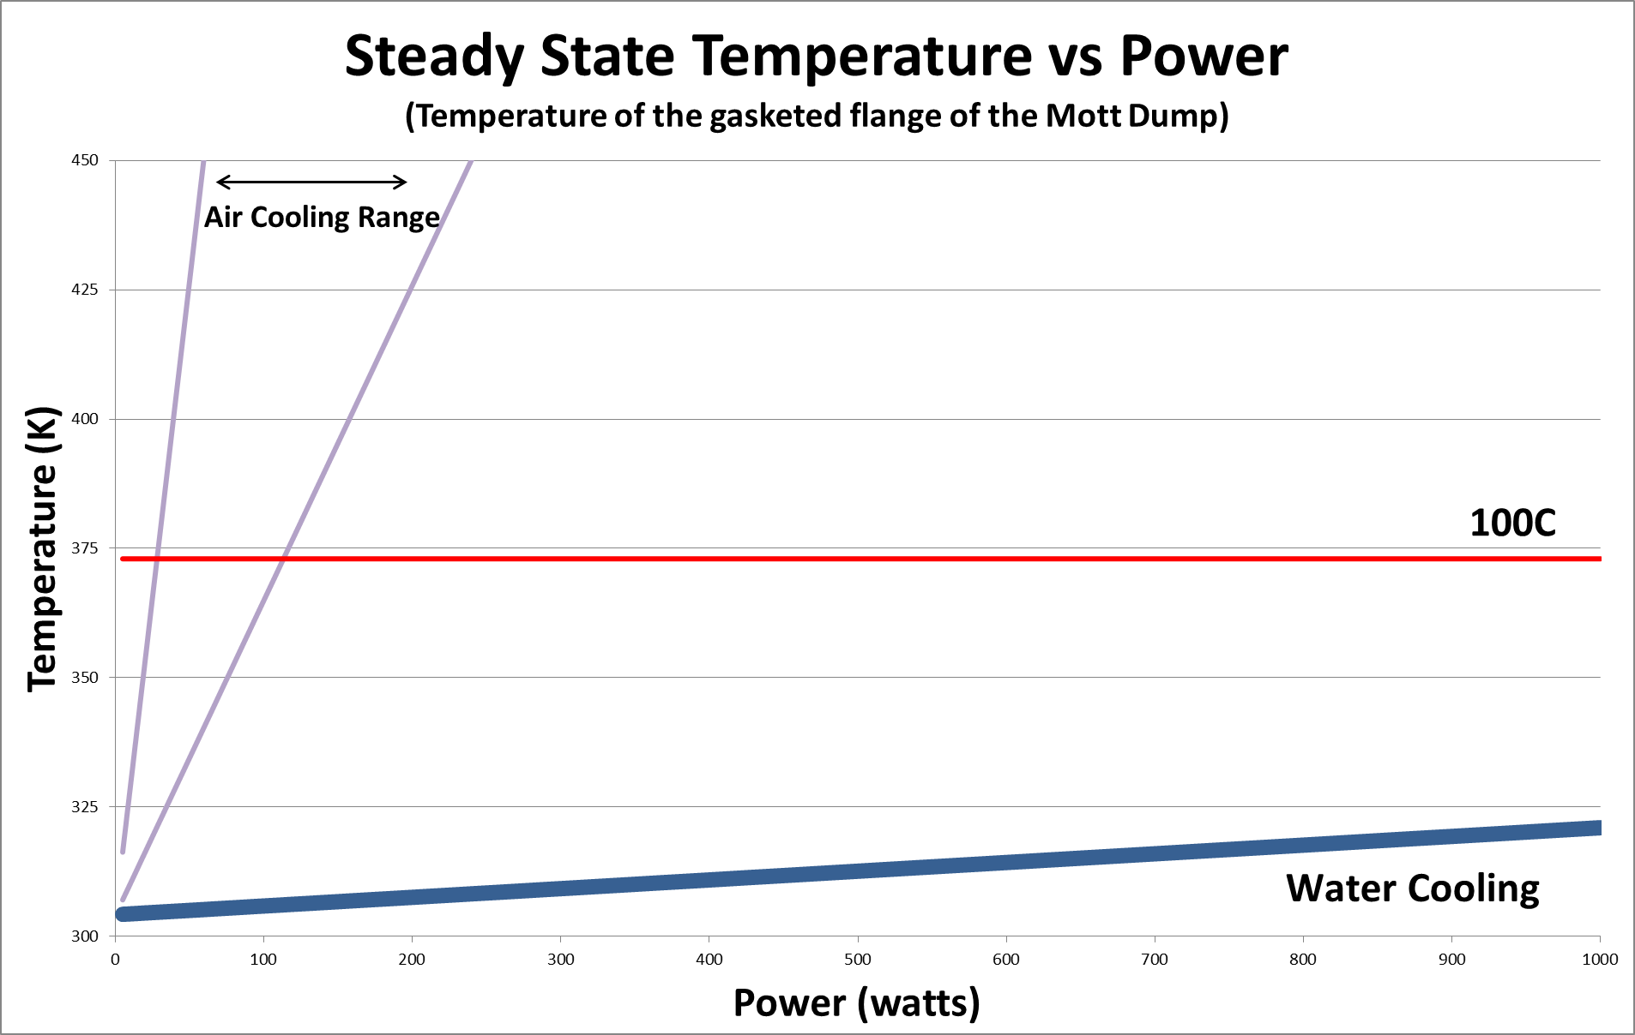
Results
It is evident from the graph that with air cooling alone only limited levels of deposited power (less than 34W) will yield a SS flange temperature less than the desired maximum of 100C. By utilizing a water cooling coil (1/4” tube with 38C water at 0.5 GPM) the SS temperature of the flange is expected to be near 50C at the maximum expected power of 1000W.

