Progress on a 499 MHz Alternating Bunch Deflection Meter and 249.5 MHz Resonant 1-D Beam Position Monitor 3/29/17

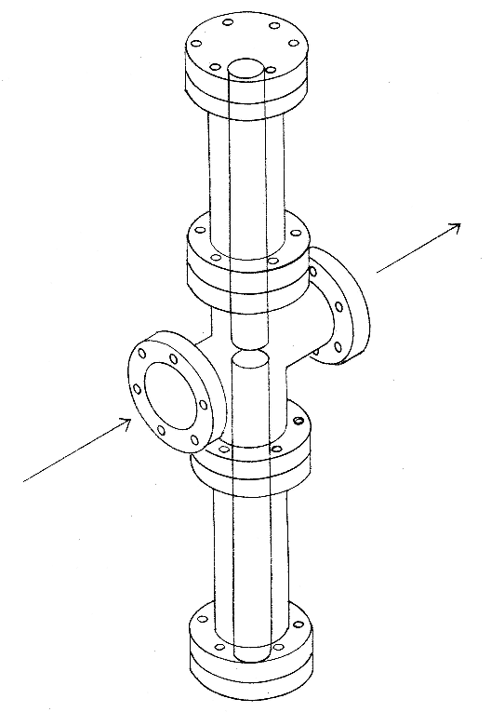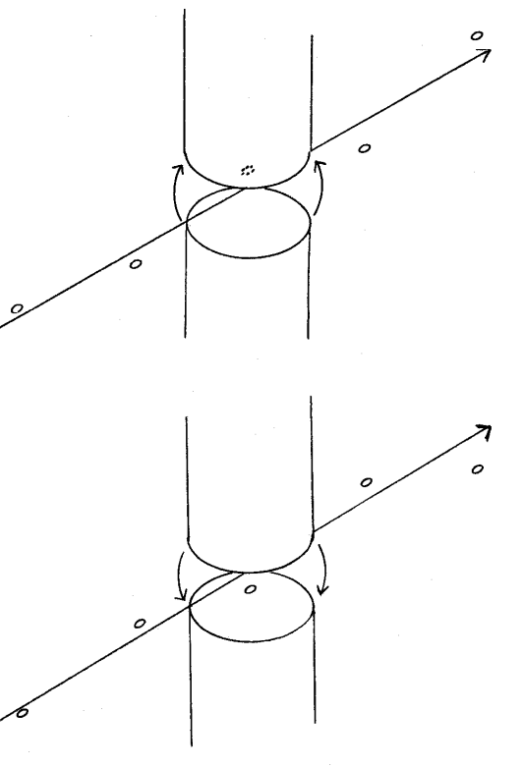
A Superfish model has been created confirming that the fundamental mode of the cavity is the same as shown in the upper left, being driven by bunches with alternating deflection.

A prototype has been constructed using off the shelf vacuum hardware.
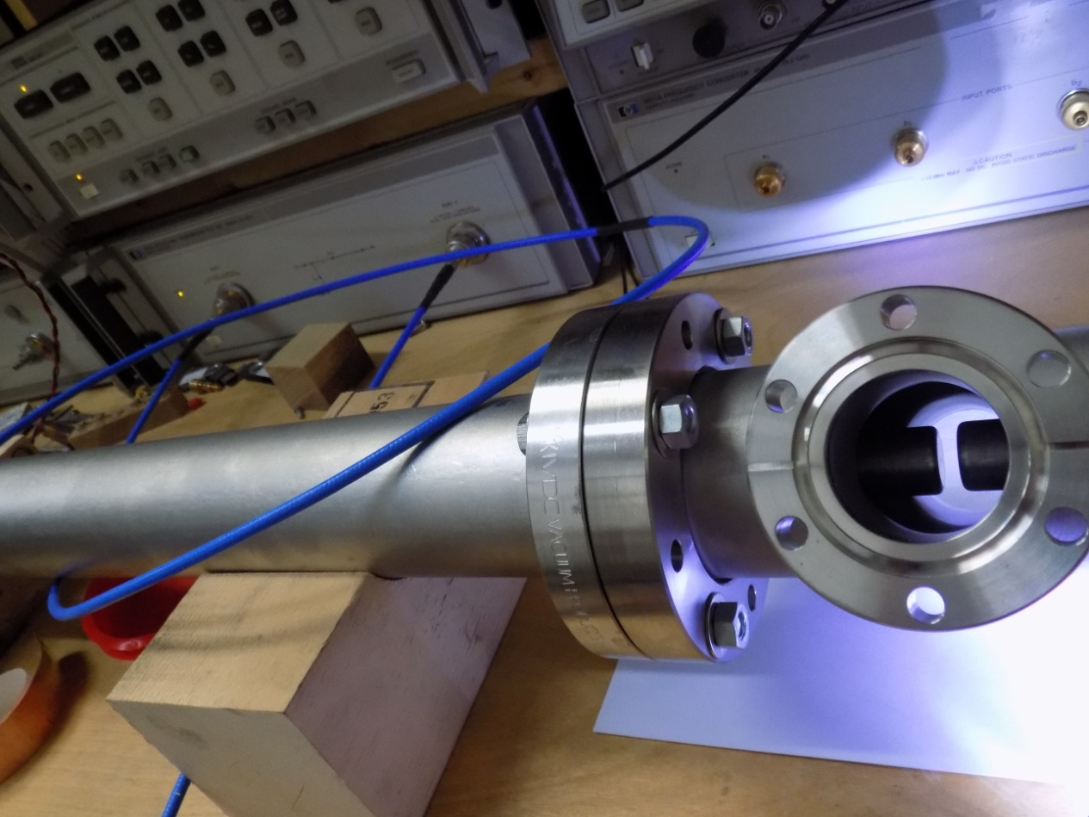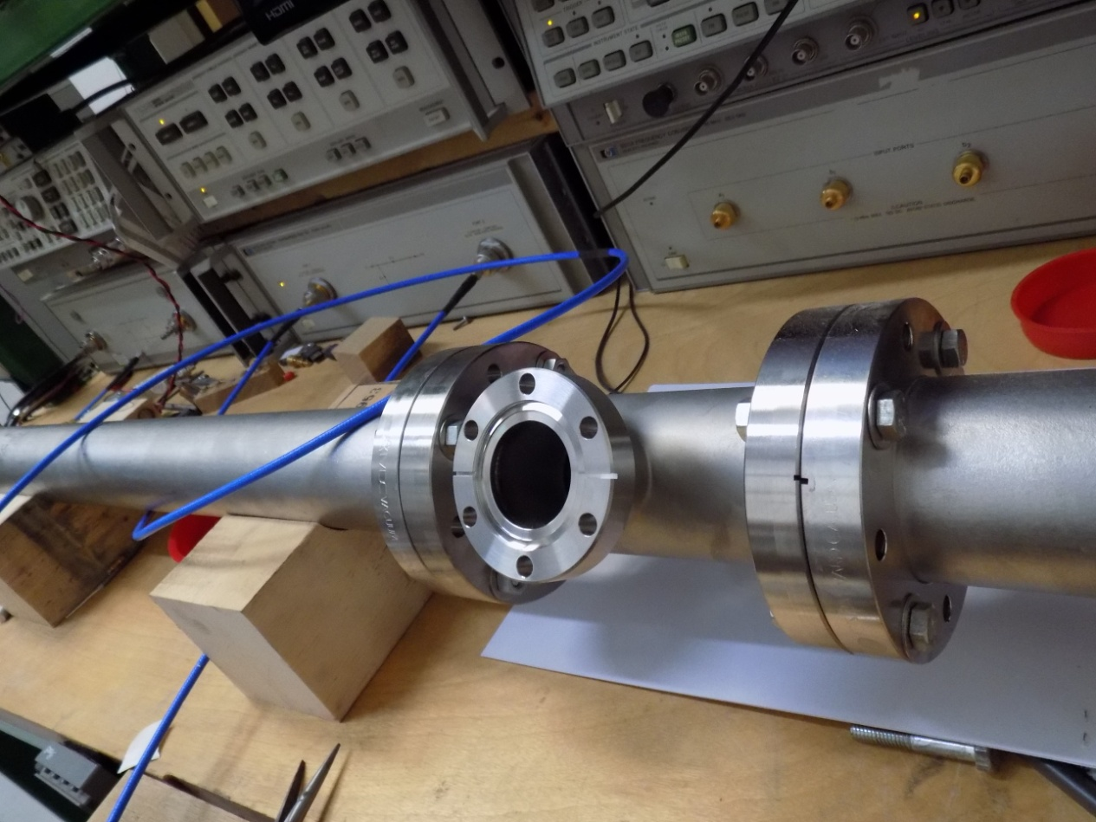
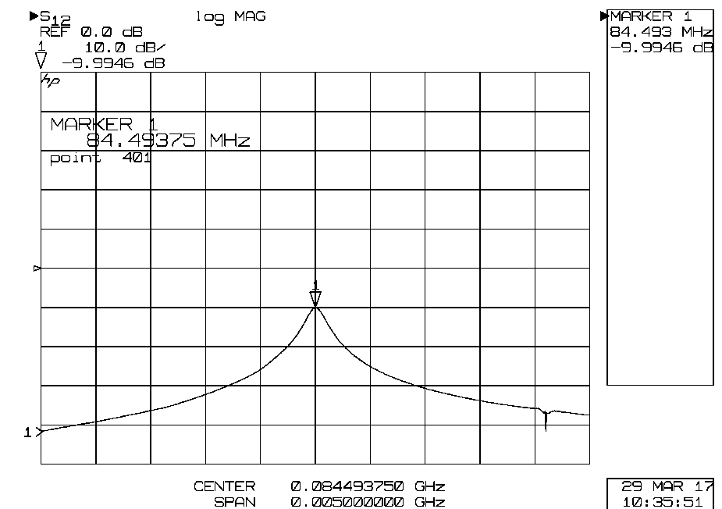

The nearly 6 foot long coaxial cavity is currently too long, however we plan to insert adjustable sliding shorts to tune the cavity to 124.9 MHz. Antenna development is also underway.

