Temperature Profile that was used on the fine Grained Nb Sample
Tom Elliot Weekend of July 31 through August 3-09
Step # (1) 150°C for 45 minutes. Ultimate Vacuum approximately 3X10-6 Torr
Step # (2) 300°C for 45 minutes. Ultimate Vacuum approximately 4X10-6 Torr
Step # (3) 450°C for 45 minutes. Ultimate Vacuum approximately 5X10-6 Torr
Step # (4) 600°C for 45 minutes. Ultimate Vacuum approximately 4X10-6 Torr
Step # (5) 700°C for 120 minutes. Ultimate Vacuum approximately 3X10-6 Torr
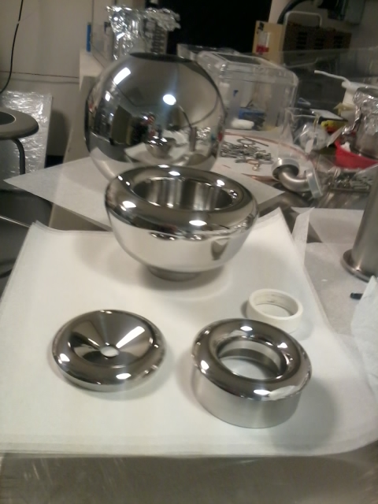
Ball and shed are very shiny after polishing, but after 950C vacuum degas they develop a haze, with the weld line clearly visible.
