200 kV
400 A gun solenoid
0.32 mm (rms) spot size
Xoff=0
Yoff=0
50000 particles
25 ps (uniform)
0.56 mm mrad /mm emittance
Viewer 1=1.47 m

Space charge grid: Nrad=70, Nlong_in=100

Charge (nC) | # of Active particles | # of lost particles
0.01 | 50000 | 0
0.05 | 49972 | 28
0.10 | 42108 | 7892
0.15 | 34561 | 15439
0.20 | 29225 | 20775
0.25 | 25513 | 24487

0.25 nC

25513 particles in distribution
-127.57 pC total charge
Position 1.47
5.44244e-05 MeV, beta*gamma 0.0, beta 0.0146
8.35459e-02 keV sig energy spread
27.43502 ps, sig time at cathode
sigx = 2.5336 mm, sigy = 2.5316 mm
sigxp = 240132.5190 mrad, sigyp = 185628.0044 mrad
sigz = 18.8119 mmnEnz = 21.3107 keV mm = 4867.5371 keV ps
Enxps = 13.8811 um, Enyps = 13.8720 um
Enxtr = 8878.8225 um, Enytr = 6858.3373 um
Exge = 951.0667 um, Eyge = 950.4416 um

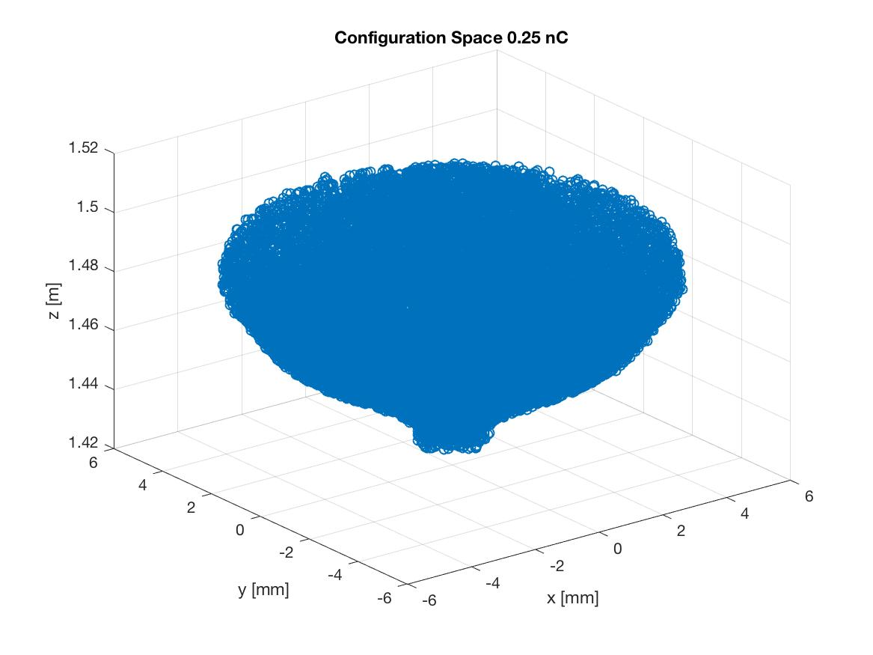

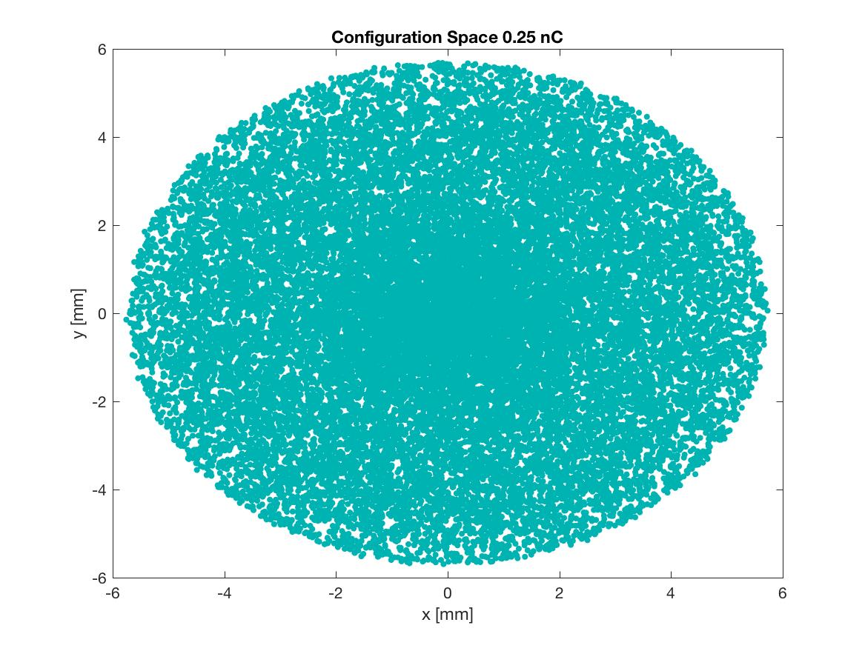
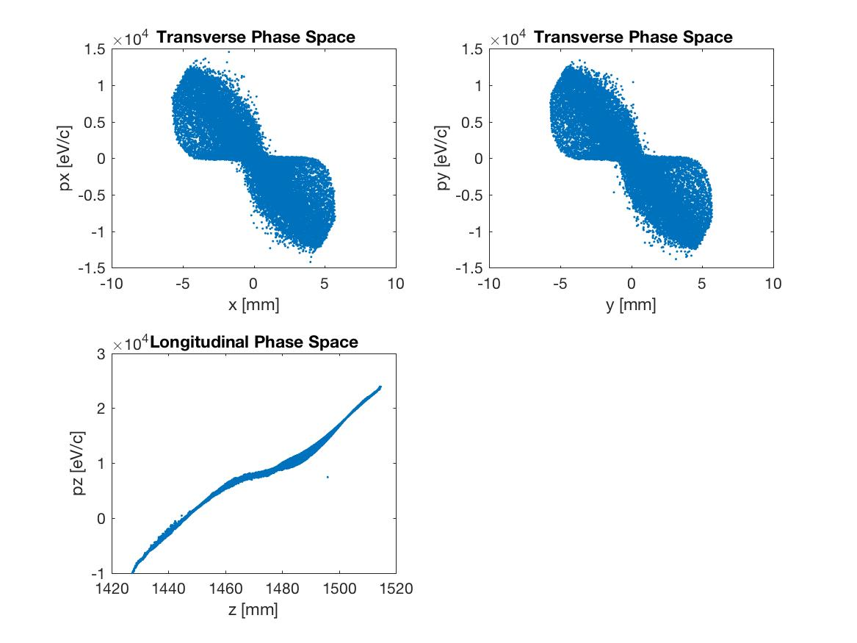
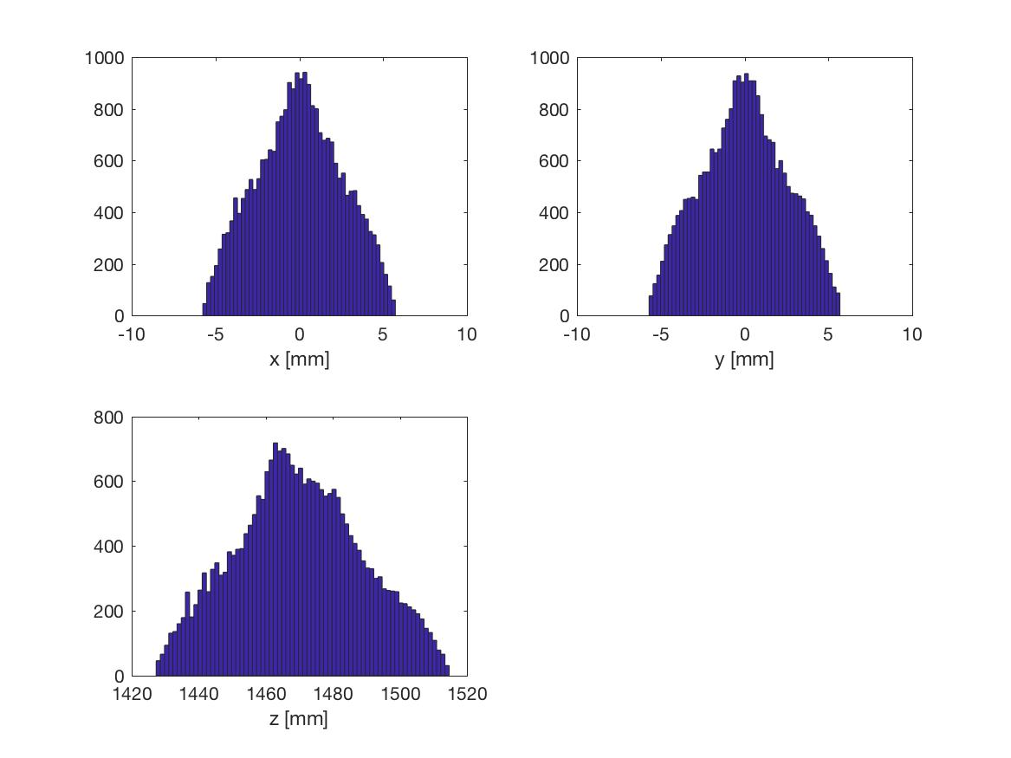

0.20 nC

29225 particles in distribution
-116.90 pC total charge
Position 1.47
5.65046e-05 MeV, beta*gamma 0.0, beta 0.0149
8.18884e-02 keV sig energy spread
26.88200 ps, sig time at cathode
sigx = 2.4433 mm, sigy = 2.4446 mm
sigxp = 30798.6191 mrad, sigyp = 37691.1021 mrad
sigz = 18.3079 mmnEnz = 18.8069 keV mm = 4215.8609 keV ps
Enxps = 13.2037 um, Enyps = 13.1960 um
Enxtr = 1118.6496 um, Enytr = 1369.8907 um
Exge = 887.8465 um, Eyge = 887.3243 um

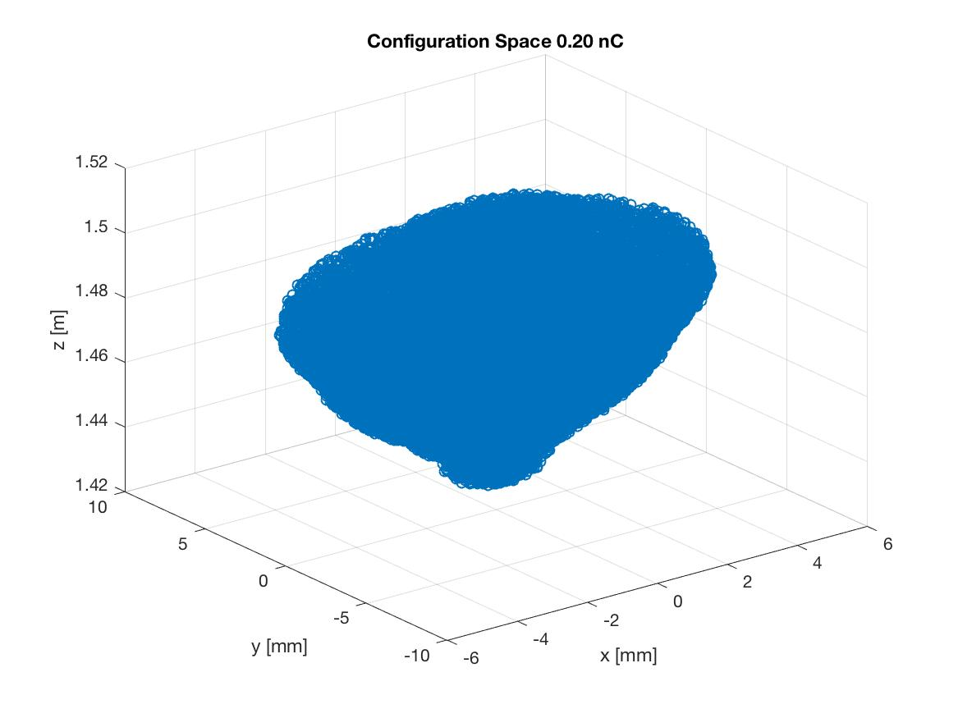
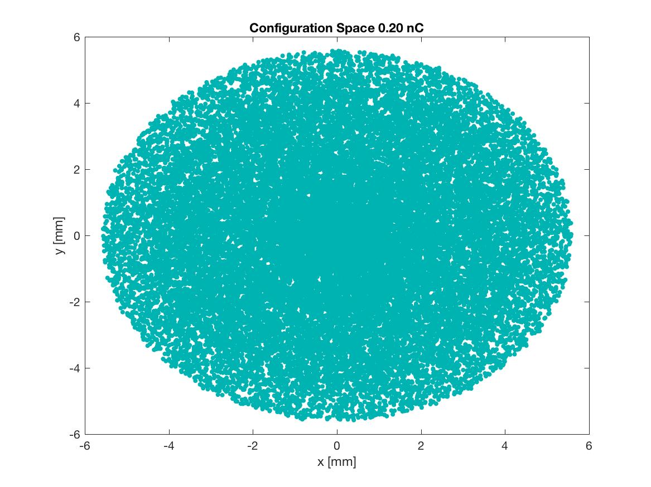

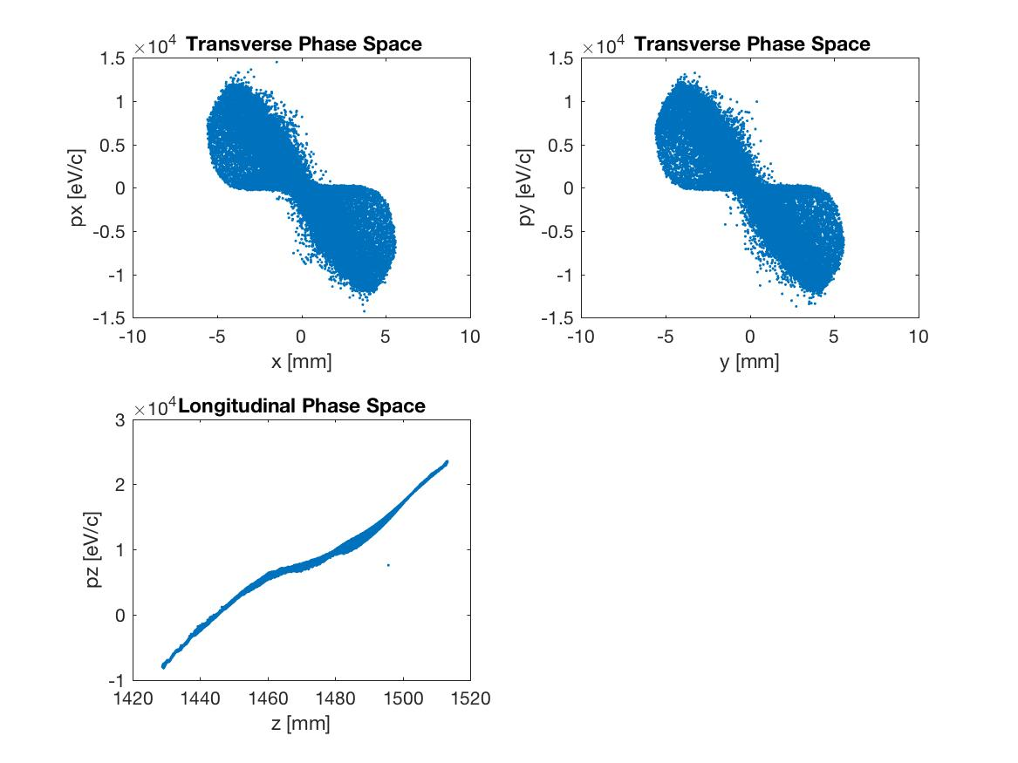

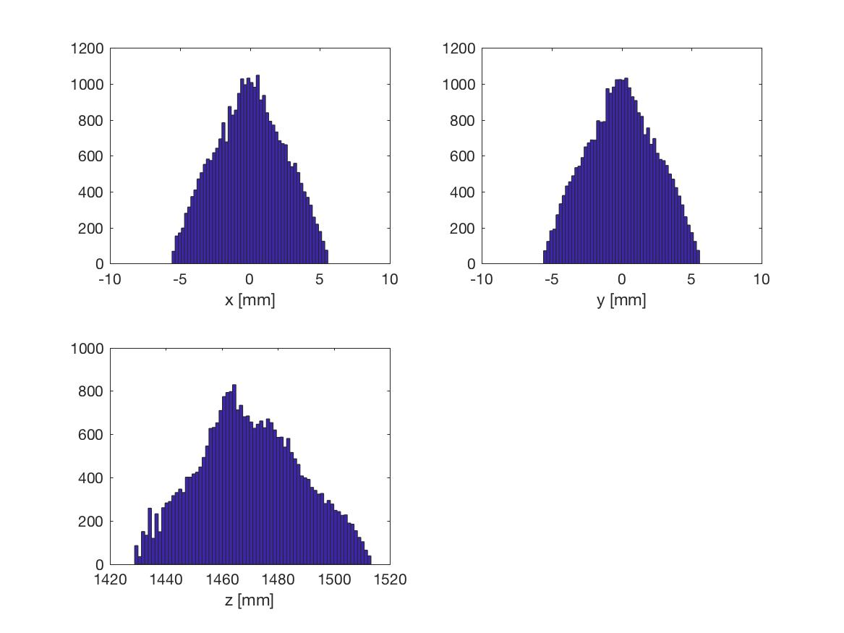

0.15 nC

34561 particles in distribution
-103.68 pC total charge
Position 1.47
2.00823e-05 MeV, beta*gamma 0.0, beta 0.0089
7.32450e-02 keV sig energy spread
26.27558 ps, sig time at cathode
sigx = 2.3603 mm, sigy = 2.3617 mm
sigxp = 77350.7830 mrad, sigyp = 76511.7097 mrad
sigz = 17.5644 mmnEnz = 16.0269 keV mm = 6026.0047 keV ps
Enxps = 12.1738 um, Enyps = 12.1942 um
Enxtr = -1618.3349 um, Enytr = -1601.5364 um
Exge = -1373.1260 um, Eyge = -1375.4269 um

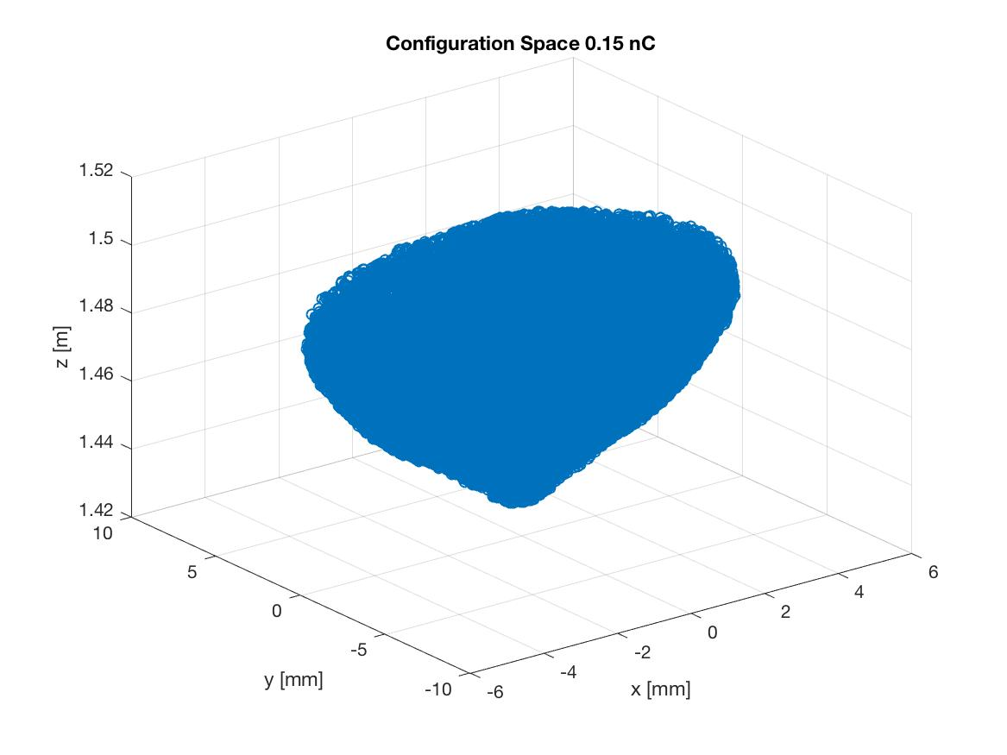
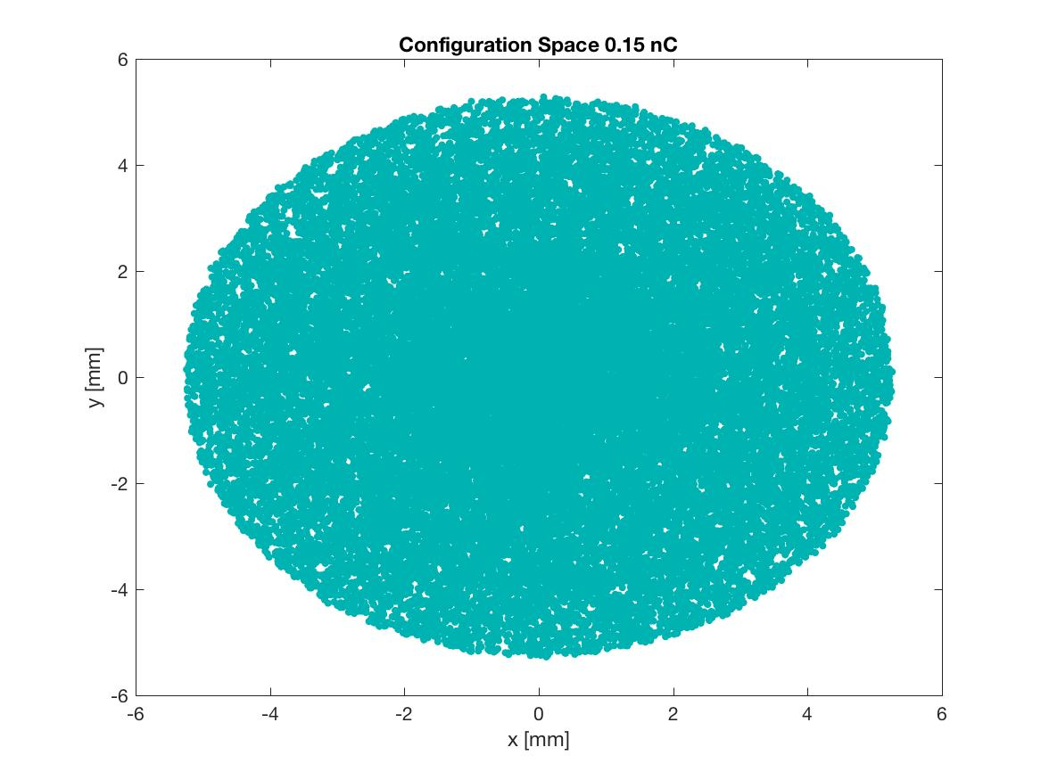

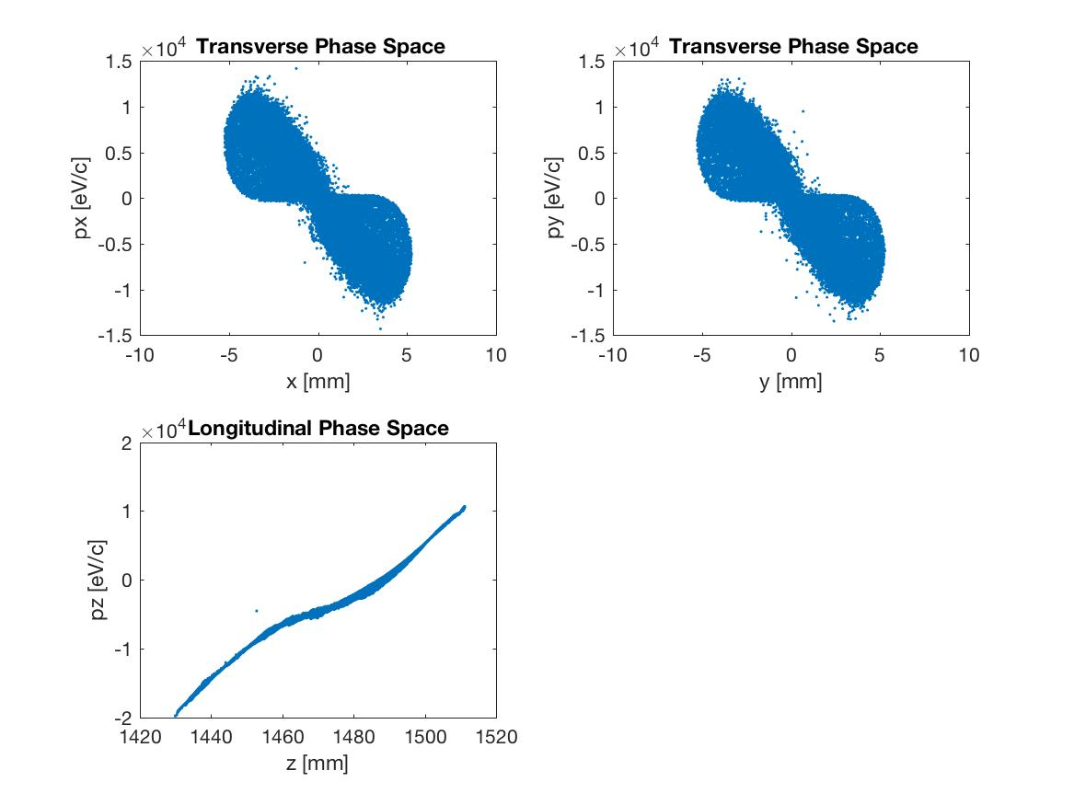
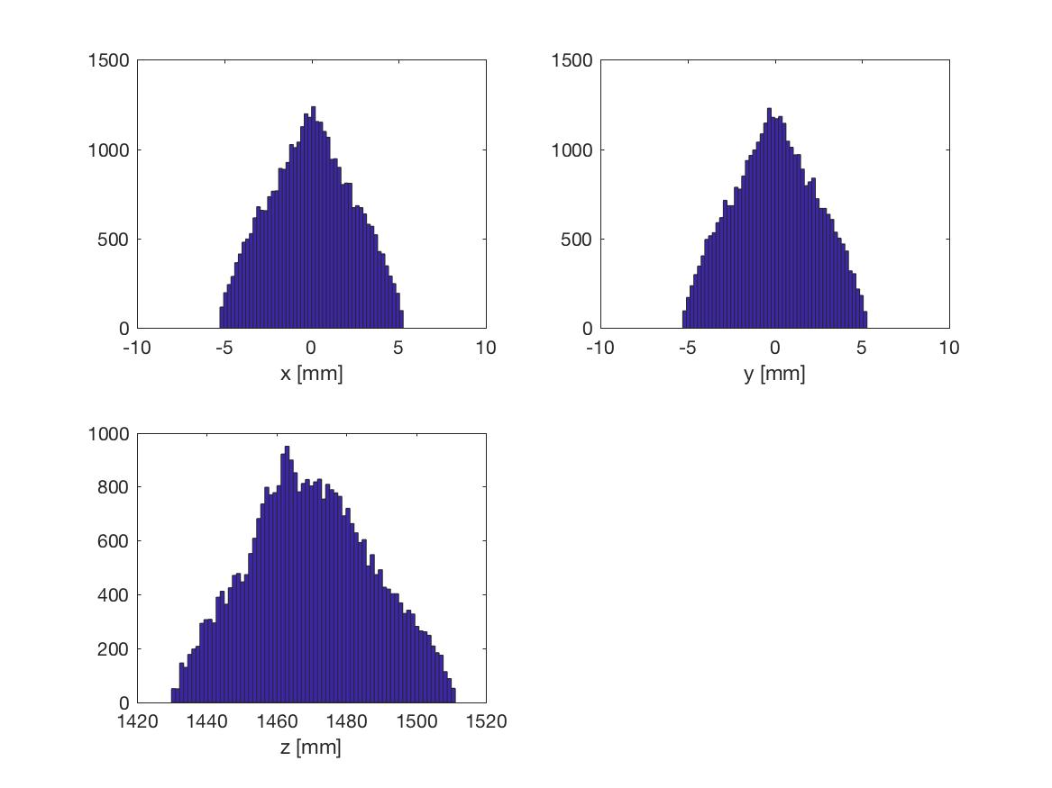

  - nC

42108 particles in distribution
-84.22 pC total charge
Position 1.47
6.73147e-06 MeV, beta*gamma 0.0, beta 0.0051
4.86747e-02 keV sig energy spread
25.60645 ps, sig time at cathode
sigx = 2.2058 mm, sigy = 2.2057 mm
sigxp = 147989.5200 mrad, sigyp = 103508.2548 mrad
sigz = 16.3821 mmnEnz = 12.1971 keV mm = 7921.0065 keV ps
Enxps = 10.5226 um, Enyps = 10.5522 um
Enxtr = -1675.4417 um, Enytr = -1171.8120 um
Exge = -2050.0407 um, Eyge = -2055.8120 um

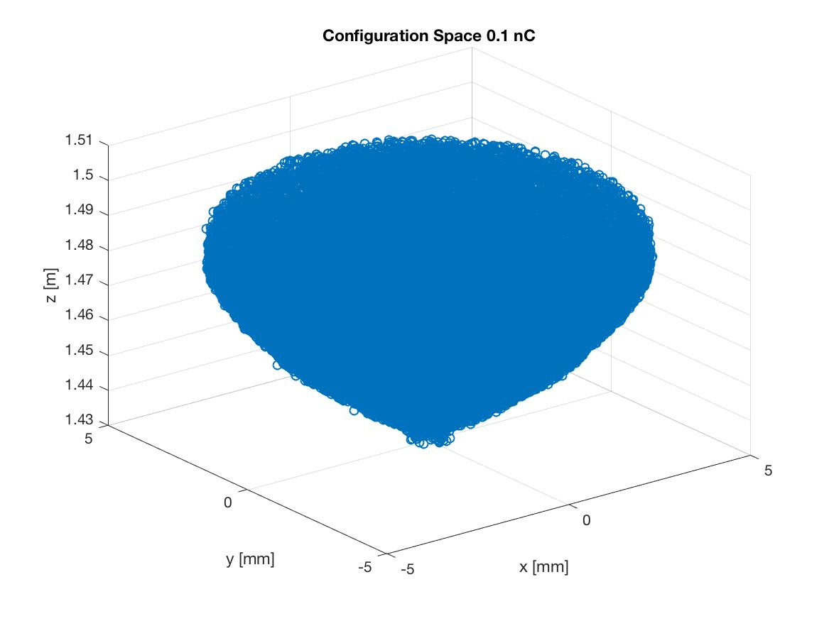
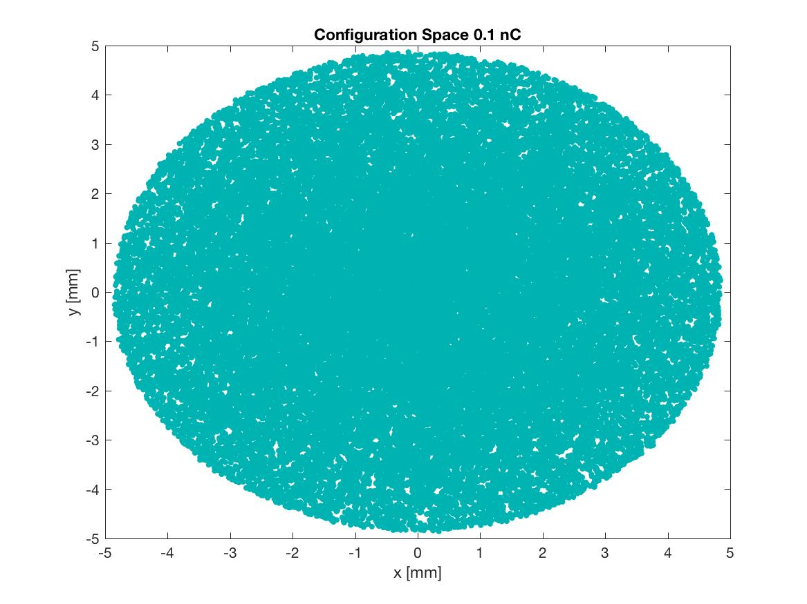
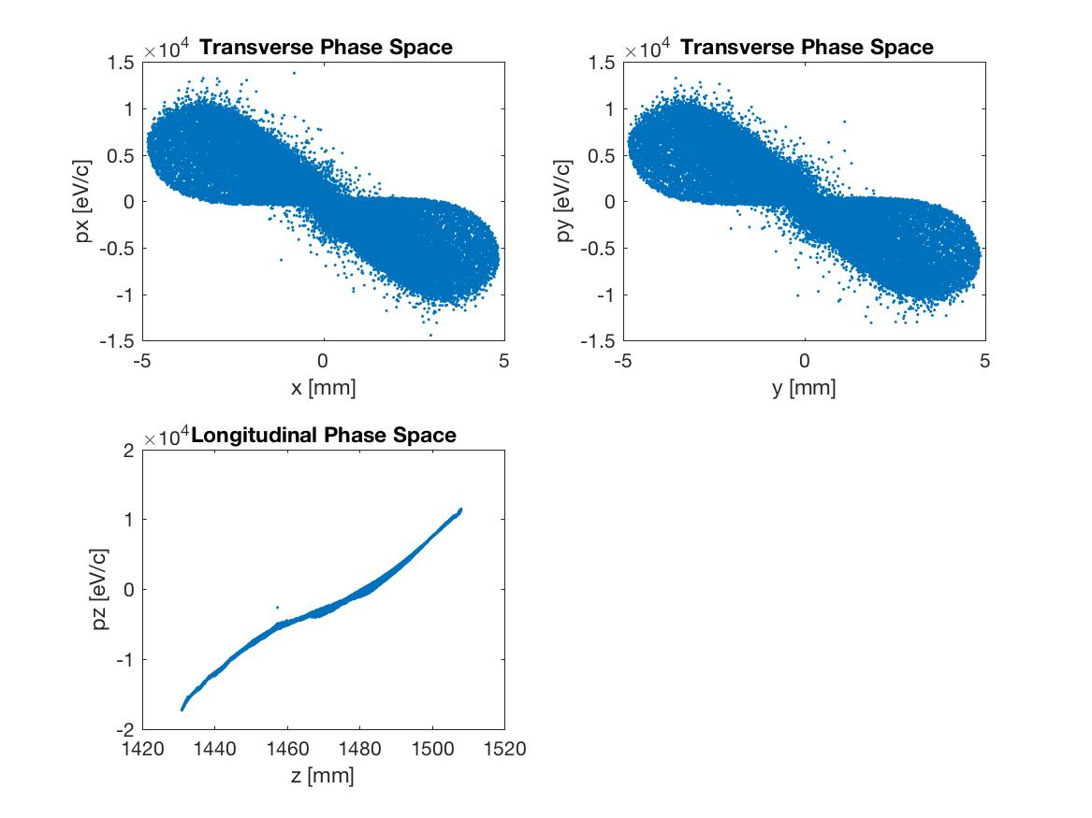
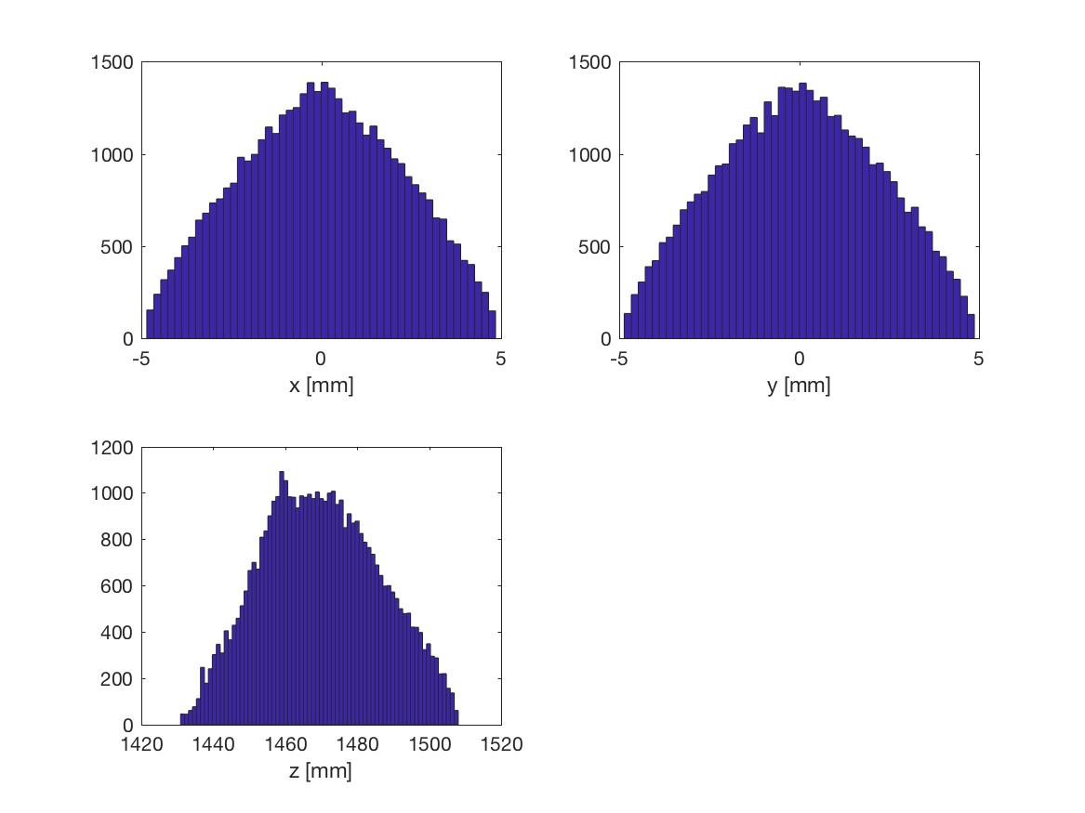

0.05 nC

49972 particles in distribution
-49.97 pC total charge
Position 1.47
2.07440e-01 MeV, beta*gamma 1.0, beta 0.7029
2.80473e+00 keV sig energy spread
24.99629 ps, sig time at cathode
sigx = 1.8566 mm, sigy = 1.8565 mm
sigxp = 7.4244 mrad, sigyp = 7.4232 mrad
sigz = 13.5067 mmnEnz = 5.7310 keV mm = 27.1767 keV ps
Enxps = 6.7144 um, Enyps = 6.7161 um
Enxtr = 6.7828 um, Enytr = 6.7845 um
Exge = 6.7941 um, Eyge = 6.7958 um
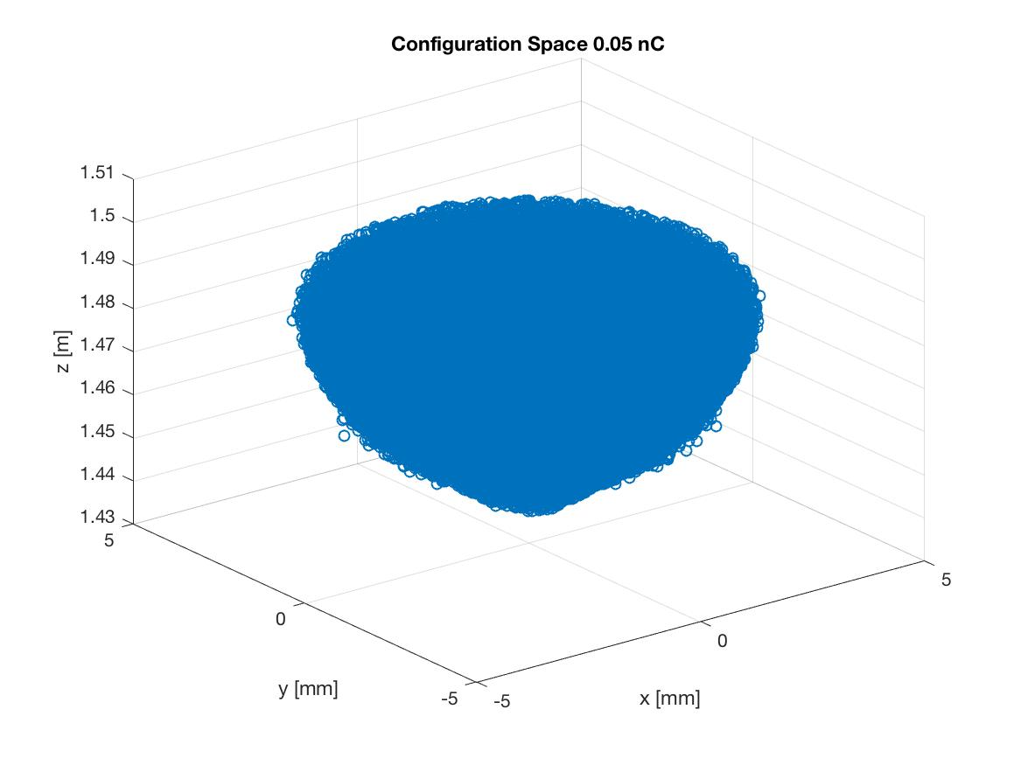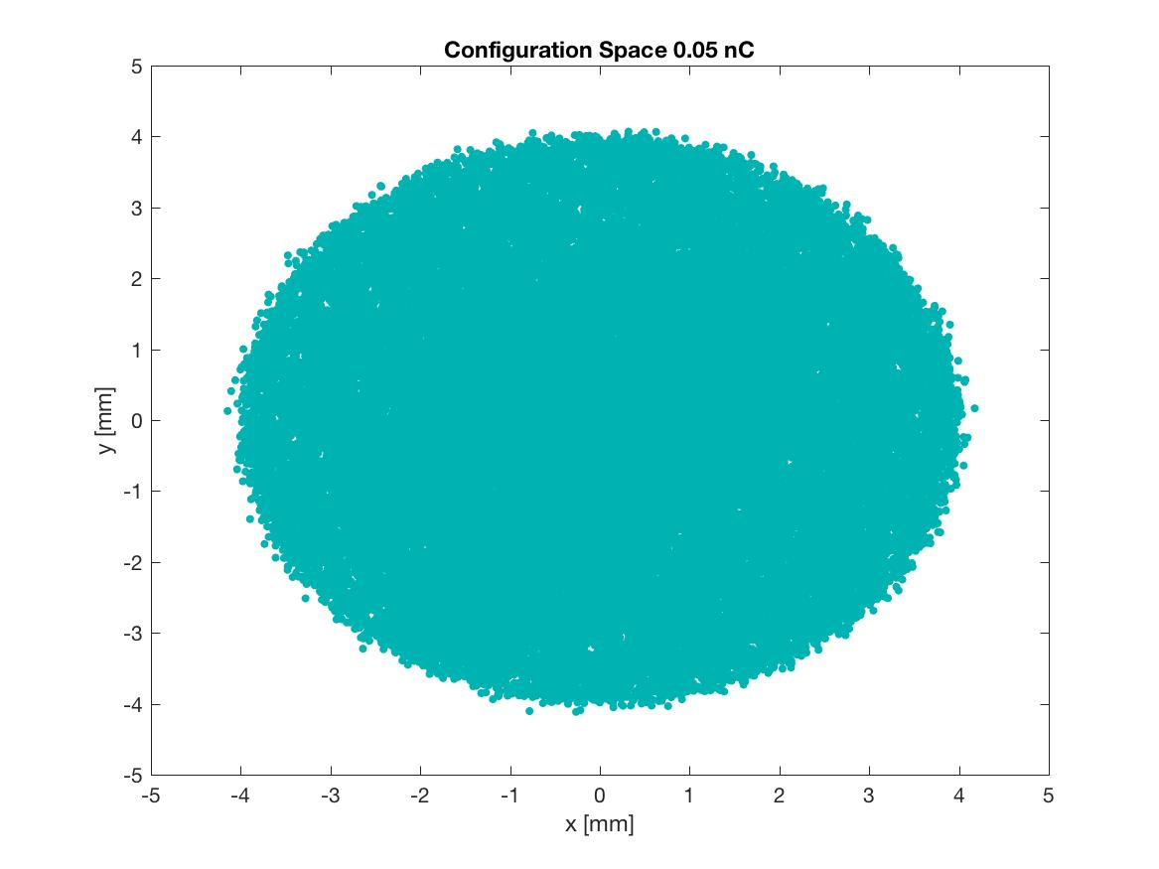
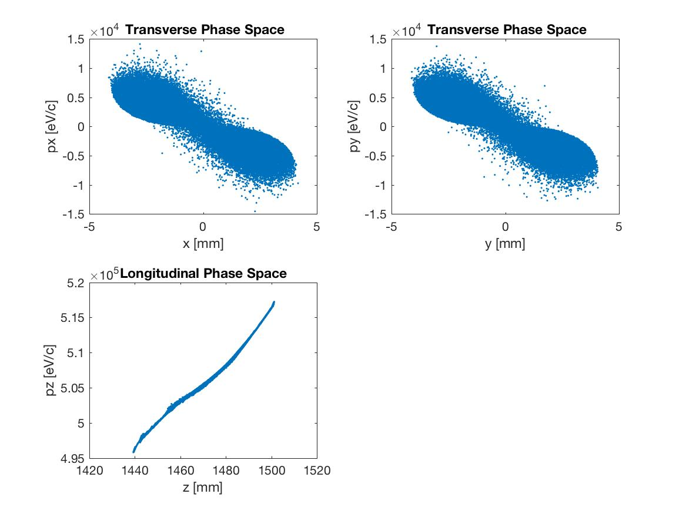
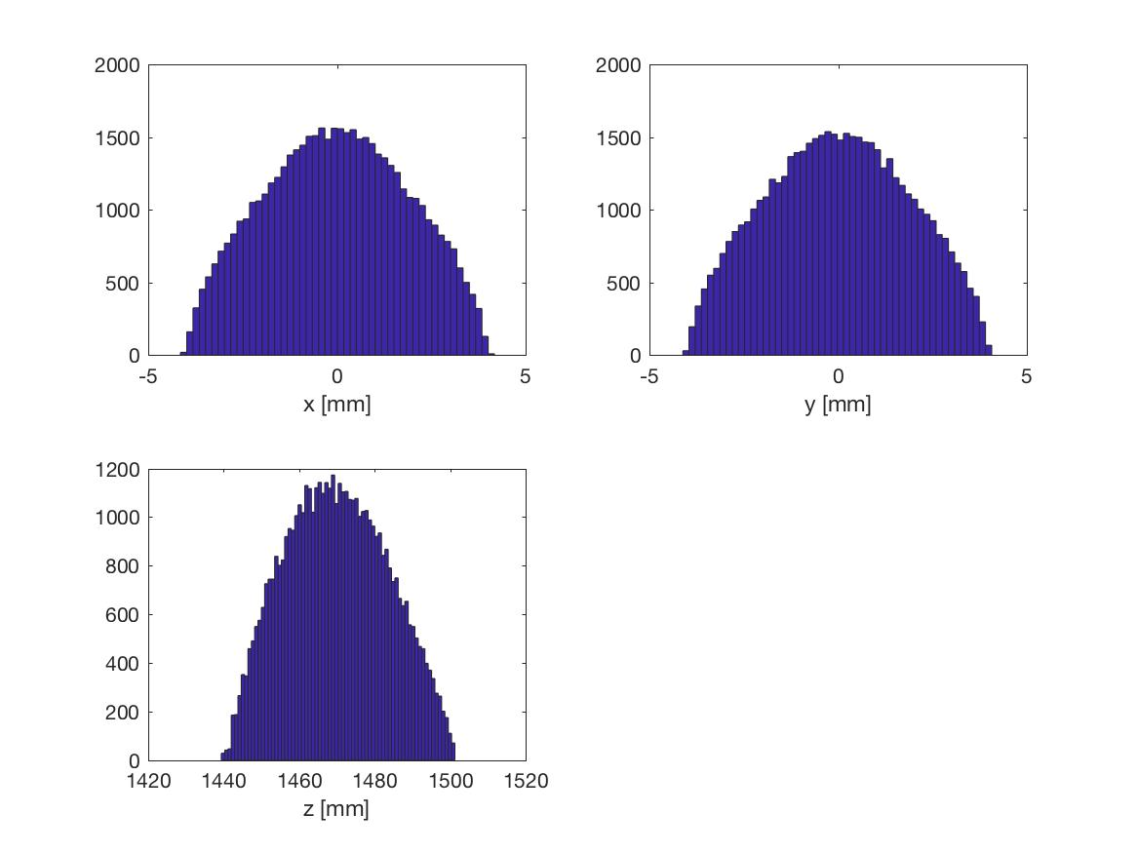

angle in radv1-v2= -2.930304e-01
angle in degreev1-v2= -1.679792e+01

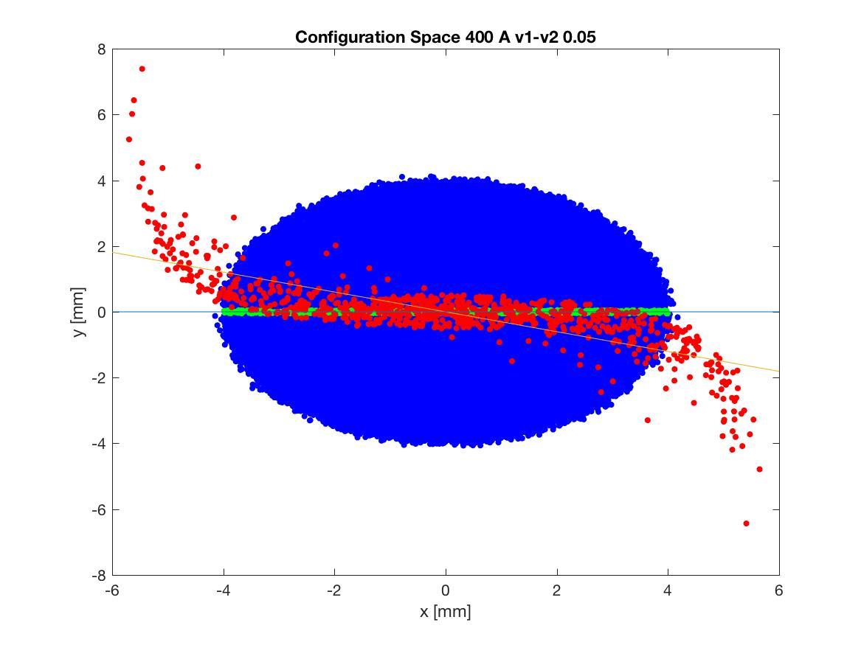

  - nC

50000 particles in distribution
-10.00 pC total charge
Position 1.47
2.07581e-01 MeV, beta*gamma 1.0, beta 0.7031
1.12912e+00 keV sig energy spread
25.00026 ps, sig time at cathode
sigx = 1.1355 mm, sigy = 1.1356 mm
sigxp = 6.3732 mrad, sigyp = 6.3706 mrad
sigz = 7.9001 mmnEnz = 2.6807 keV mm = 12.7097 keV ps
Enxps = 3.8255 um, Enyps = 3.8262 um
Enxtr = 3.8296 um, Enytr = 3.8303 um
Exge = 3.8693 um, Eyge = 3.8701 um

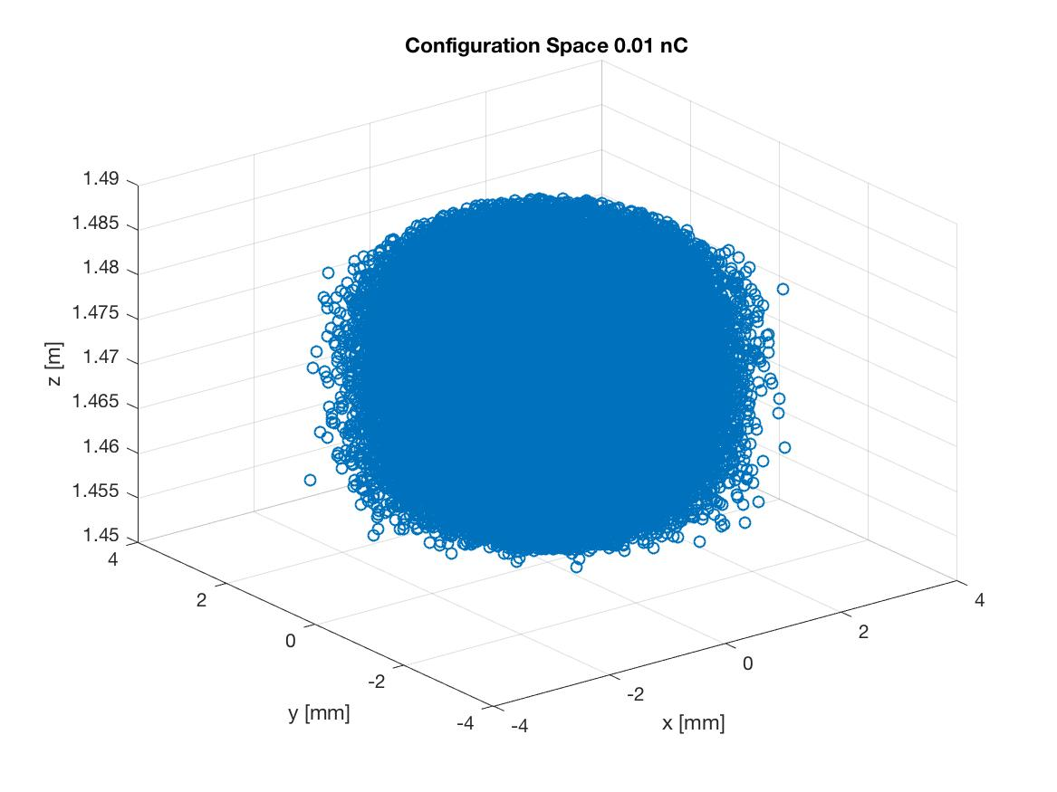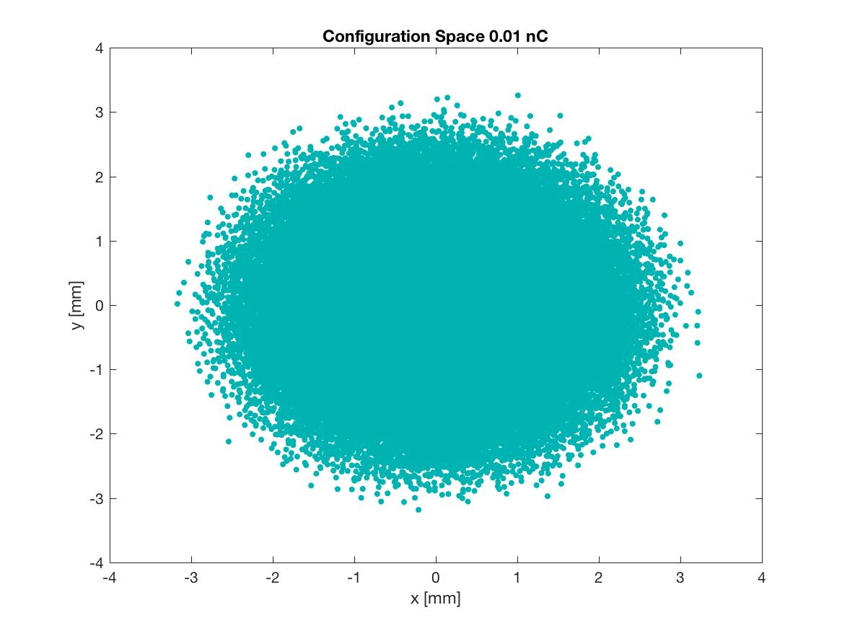

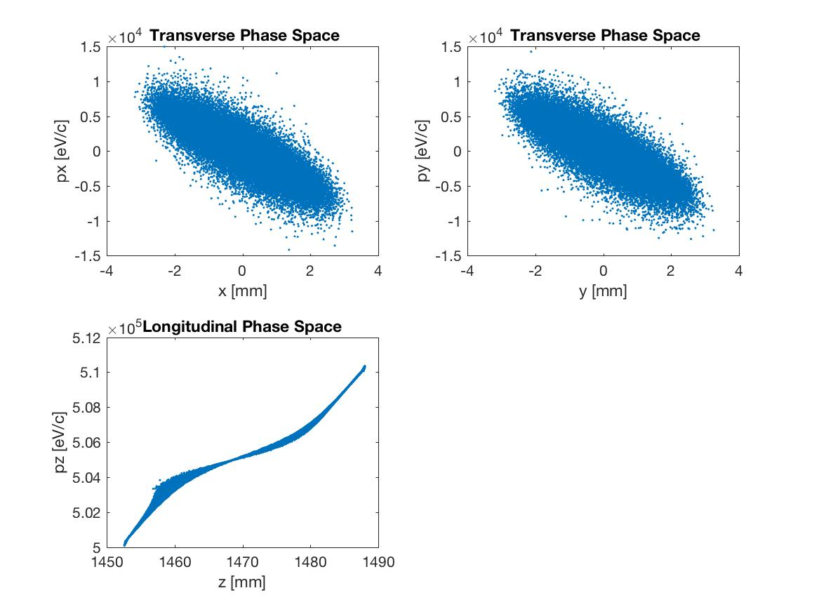
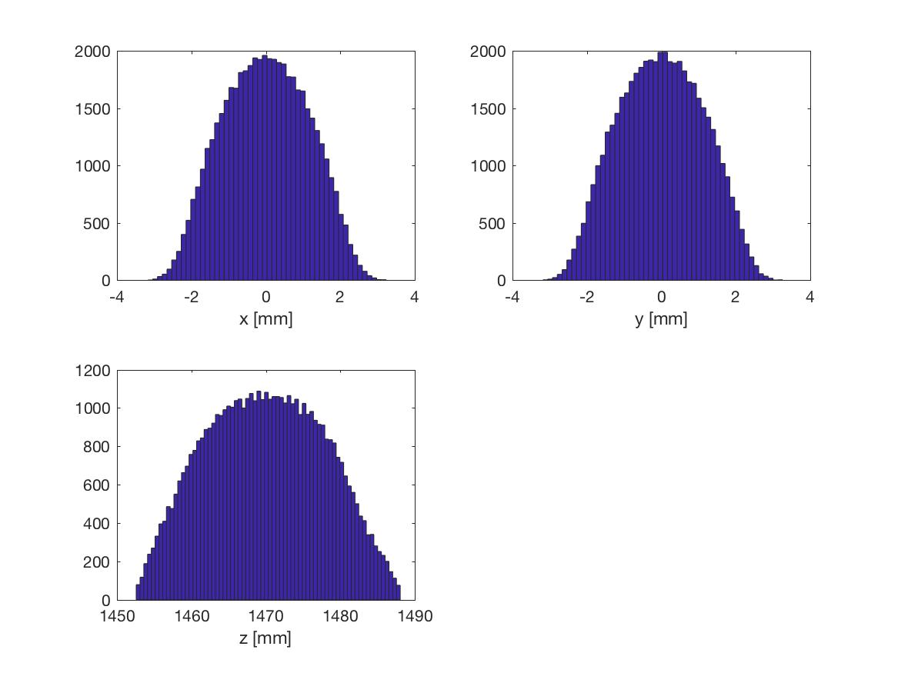
angle in radv1-v2= -7.729033e-01
angle in degreev1-v2= -4.430656e+01

