ODH Assessment

DATE: 3/2/2016

DIVISION: ___ Accelerator & Engineering Divisions_________________________________

LOCATION: ___Upgrade Injector Test Facility (UITF) at Building 58__**(Preliminary)**______

ASSESSMENT AUTHOR: ____Hari Areti & Will Oren_______________________

APPROVAL: __________________________________________________

Dave Kashy for the Engineering Division Head

cc:  
Building Manager  
EHS IH Group, MS 35  
EHS Documentation, MS 35

*ODH Risk Assessment, UITF*

*2016*

**Introduction**

**This assessment addresses the risk of oxygen deficiency hazard for the Upgrade Injector Test Facility (UITF). The assessment is conducted in accordance with the requirements specified in Appendix 6500-T3, “ODH Risk Assessment”. This assessment addresses the cryogens and gas (Helium, Nitrogen and Sulfur Hexafluoride-SF6) ODH hazards associated with the facility. These gases and cryogenic fluids are sources of gases which can dilute the normal oxygen content with health effects as outlined in Appendix 6500-T3, but according to the MSDS, the maximum exposure of SF6 is 1000ppm. Therefore, SF6 should not be considered as an asphyxiant. It is recommended that a separate assessment address SF6 as a toxic hazard other than what is covered here as an ODH hazard.**

**The following sections cover the modeling scope and methodology for a cryogen or gas dispersion release, a description of the work space, operational modes which affect the risk factors, failure rates of the components, and the resultant area classification.**

**UITF Configuration**

**The facility description is depicted in Figures 1 - 4, shown below where the entire complex is within the Test Lab, Bldg 58. The work areas covered in this analysis include the UITF enclosure which is composed of Cave 1 and Cave2, the adjacent Test Lab high bay area and the tops of Caves 1 and 2**

**Cave1 has a volume of 259 m3 and Cave 2 has a volume of 469 m3 for a grand total of 728 m3 for the combined space. These areas, while they have differing ceiling heights with a 1 m divider between them, will be treated as a combined space. The bottom of this divider is 3m (10’) from the floor.**

**Cave 1 has six 0.25 (10”) diameter ceiling penetrations, all of which can be used for cable routing. All six of these penetrations emerge under an expanded metal grating that spans the space between two sets of electronics racks on the top of the cave. None of these will be considered as possible vents for helium in this analysis. To prevent helium from venting through these penetrations and exposing workers in the racks to a possibly oxygen deficient environment these penetrations must be blocked so that helium cannot escape from the cave. Additionally, in Cave 1 there are two 0.76m (30”) diameter ventilation tubes, with active fans, on the east wall approximately 2.1m (7’) above the floor: one tube vents to the exterior of the building (capacity of 2.1m3/s – 4400CFM), and the other vents (capacity of 3.5m3/s – 7400CFM) to the high bay region. Because of the need to power the fans, these vents will not be used in this analysis which assumes that powered active controls may fail. In addition, there are three 0.15m (6”) diameter vent holes on the west wall near the ceiling which go to the High Bay area. Finally there are three 0.30m x 0.46m (12”x18”) penetrations that go through the ceiling terminating outside the access area to the electronics racks. It is assumed that one of these will be filled with waveguide but the other two can be used as vents.**

**The total area in Cave1 available for venting helium, includes the two 0.30m X 0.46m penetrations and one of the 0.15m diameter vent holes on the west side, is 0.30m2 (3.2ft2). The two remaining 0.15 diameter holes on the west side will be reserved for dedicated use to house vent lines coming from the ¼ cryomodule’s primary Circle Seal relief, the parallel plate relief and the burst disc. Since the two 0.30m X 0.46m penetrations will be used as vents, some kind of chimney ~8ft tall must be installed on the cave roof over each penetration to direct any vented helium above the heads of anyone in the area.**

**Within Cave2, there is a 5.6 m2 (60ft2) area at approximately 3.7 m (12’) under the raised part of ceiling available for venting into the high bay volume. This raised portion can be seen in Fig 4 below and corresponds to the planned longitudinal location of the HDice target.**

**The main entry/exit to UITF is through a labyrinth with chain-link fence gate, approximately 1.8m (6’) wide and 2.4m (8’) tall, which also provides an escape path for helium gas and/or a path for makeup air. The vent tubes, penetrations and chain-link fence gate allow lighter than air mixtures of ODH gases to leave the enclosure to the high bay.**

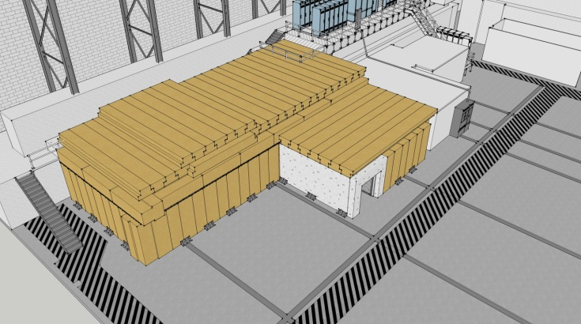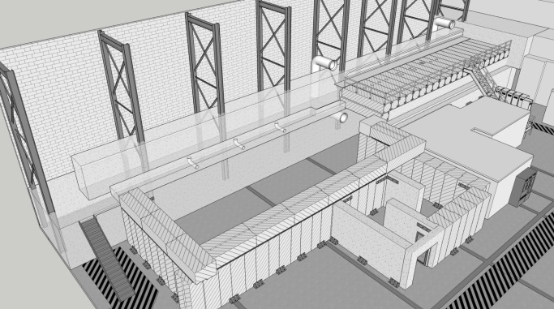

**Figures 1 &2: UITF with Ceiling in place and without ceiling on Cave 2**

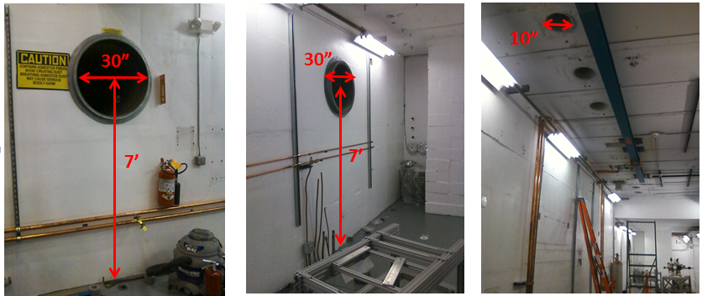

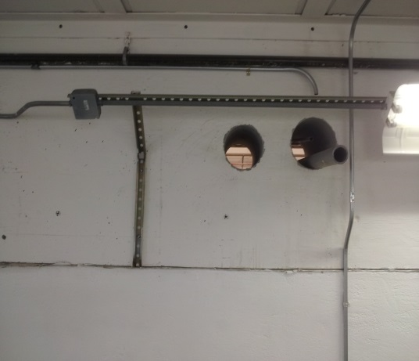

6” Vents, West Wall

Figure 3: Vents in Cave1

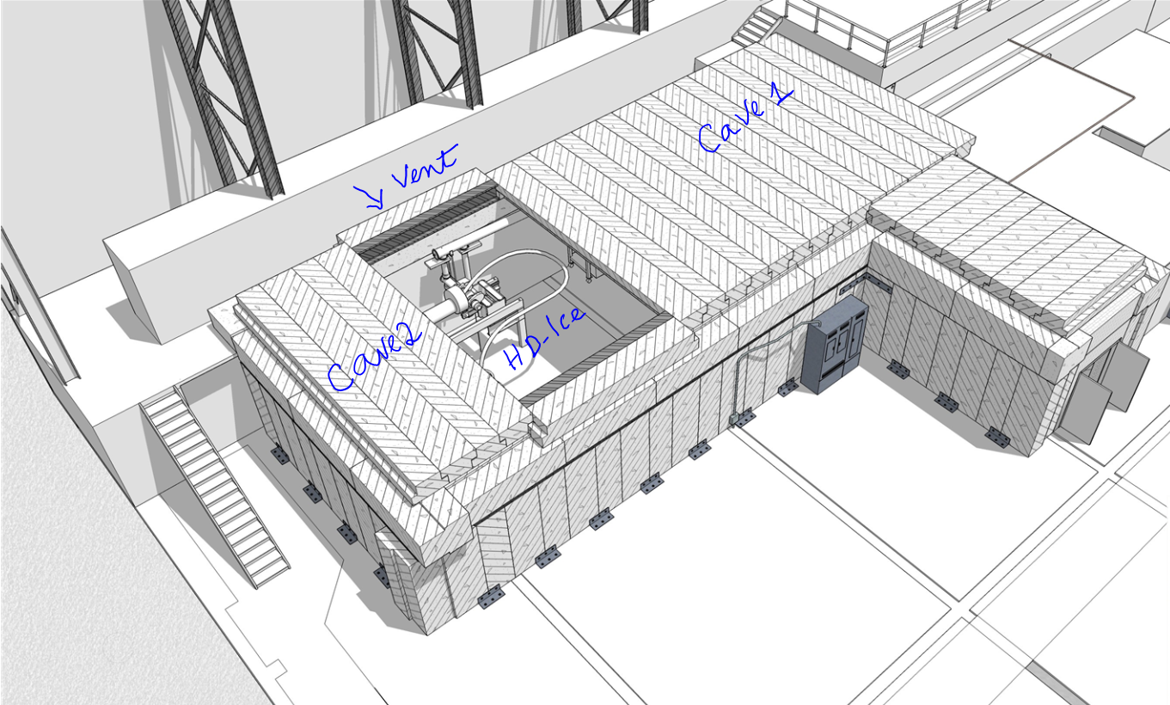



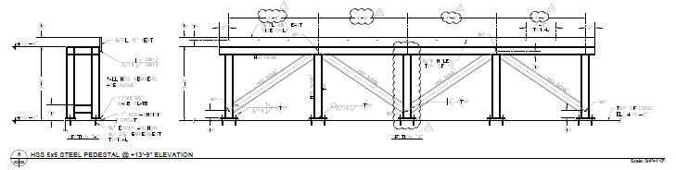

Figure 4. 5.6 m2 vent area at the ceiling in Cave2

**Model and Sources for Cryogen and Gas Dispersion Release**

**Helium spill tests within the JLab accelerator tunnel and the CHL vent stack test apparatus have shown that rising helium gas interacts with the surrounding air, mixing with it as it rises to predominately produce a mixture with 16.5-17% oxygen. Once combined with air, the helium does not readily separate out of the air/helium mixtures thus is not reversible. It will retain the same helium to air percentages as long as it does not further interact with additional sources of air (dilution) or high concentrations of helium (enrichment). Since the helium/air gas mixture is “lighter than air”, the mixture rises but at a substantially slower rate than pure helium gas since the mixture is heavier. When natural convection ventilation (in the form of vertical vent tubes) is provided, both oxygen and helium are purged from the enclosure area. The helium/air mixture will displace more of the confined space in a vertical downward direction from the ceiling if no additional sources of air are provided to replace the escaping helium/air mixture. Calculations indicate for ideal conditions, where the vented mixture is replaced by air, that we can expect a passive vent capacity of** 0.26kg(He)/m2/s. **(Reference: Internal memo – “Helium Vent Investigation, July 9, 2001, Dana Arenius)**

**The possible sources of ODH producing gases or cryogens in Cave 1 are based on a fully operational quarter-cryomodule with 400L of 2K liquid helium and the associated cryogenic distribution system at 4K located within the UITF accelerator enclosure. Liquid helium is supplied to the quarter-cryomodule from the Cryomodule Test Facility (CTF) refrigerator located adjacent to building 58. The UITF ODH sources of pressurized helium gas are a cryogen distribution 3.5 atm, 35K shield supply line, a 3.0 atm shield return process line, a 3 atm 4k supply line, a 4K .034/1 atm return line, a warm (300K) 3 atmosphere helium supply line and the component failures associated with the quarter-cryomodule. The cryogen transfer line relief valves are located outside the UITF enclosure either outdoors (supply and shield return lines), in the CTF (primary supply line) or inside the Testlab (shield supply) and do not contribute as a source for ODH for the UITF accelerator enclosure.**

**In addition to the quarter-cryomodule, this ODH assessment considers a fully functional HDIce target attached to an In-Beam-Cryostat of 50L LHe, 500L LHe buffer dewar, a 500L or 1000L LHe supply dewar and a 100L LN2 service dewar. The helium gas boil off from the HDIce target is captured and returned to the CTF refrigerator, using a return line at 1.08 atm attached to the exhaust port of vacuum pumps used to cool the helium within the HDIce target.**

**Additionally, gaseous nitrogen is available from a supply line originating at the LN2 dewar that services the Testlab. An ODH analysis documented in JLab Technote “JLAB-TN-07-075” for Room 127 (old cave room number) requires an orifice bore of 0.114in and an interlock from active fans to a solenoid cut off valve on the N2 supply line that limits the area to an ODH 0 state. These features have been installed in the N2 supply line system.**

**ODH Analysis**

**The Test Lab high bay volume is large, roughly** 40220 m3 (81.4m L x 40.5m W x 12.2m H - **1.4 million cubic feet,** 267‘ L × 133’ W × 40’ H**), the high bay is considered to be equivalent to the outdoors.** To justify the assumption that the high bay volume is large enough to be considered equivalent to the outdoors, consider 1,900 L of LHe released simultaneously from the quarter cryomodule (400L) and from the HDIce target (500L buffer dewar and a 1000L fill dewar). This amount of LHe would expand to 1481m3 (52,315 ft3of gas) with a resulting O2 concentration of 20.2% in the Test Lab high bay.

**This ODH analysis is based on the premise that the passive venting capacity built into the UITF cave is large enough that ODH gases from failure of any component in the supply circuits will never accumulate to the level where the O2 content will go below 18.5% outside the spill plume. If the O2 content never goes below 18.5% then the fatality factor will be 0 for all failure cases where the passive vent rate is greater than the failure flow rate. Of course O2 levels will be less than 18.5% in the vent plume but the layout of the equipment in the cave does not restrict access to the point where those qualified for ODH work cannot move away to a point where there is no ODH danger. The tables below quantify the flow rates upon failure of any of the circuits associated with the UITF cave with the HDice target and the ¼ cryomodule fully functional. (Note: an alternative analysis methodology is present by Hari Areti in Appendix A which confirms the conclusions from the table below)**

Equipment failure and passive vent rates

|  |  |  |  |  |
| --- | --- | --- | --- | --- |
| Item and Event | Spill Rate kg/sec | Passive Vent Rate kg/sec based on 5.9m2 vent area | Ratio (Spill Rate)/(Vent Rate) | If <1 “Ok”, If >/=1 “Issue” |
| Rupture 4K Supply | 0.02 | 1.50 | 0.013 | Ok |
| Blocked 4K Return | 0.02 | 1.50 | 0.013 | Ok |
| Rupture Shield Supply | .015 | 1.50 | 0.010 | Ok |
| Blocked Shield Return | .015 | 1.50 | 0.010 | Ok |
| ¼ CM Insul Vac Loss | 0.22 | 1.50 | 0.147 | Concern+ |
| ¼ CM Beam Line Vac Loss | 0.89 | 1.50 | 0.593 | Concern+ |
| Rupture 300K Helium Supply | 0.01 | 1.50 | 0.007 | Ok |
| Rupture HDice 50L IBC | NA* | 1.50 | NA | Ok |
| Rupture transfer line 500L Buffer Dewar | 0.06 | 1.50 | 0.040 | Ok |
| Rupture transfer line Supply Dewar | 0.25 | 1.50 | 0.167 | Ok |
| Rupture 500L Dewar | 63kg** | 1.50 | NA | Issue |
| Rupture 1000L Dewar | 125kg** | 1.50 | NA | Issue |
| Rupture HDice boil off return line | 0.0003 | 1.50 | <<1 | Ok |
| Rupture 100L LN2 Dewar | 81kg*** | 1.50 | NA | Ok |

Notes:

+ Because of the direction of discharge and distance to substantial passive venting these events remain a concern

*Instantaneous failure of 50L IBC results in a 19.9% O2 concentration in the cave with a fatality factor of 0.

** Instantaneous failure of dewar dumping entire contents results in O2 concentration for 500L of 8.8%, 1000L inerts the cave – Initial operations will be with a 500L supply dewar.

*** Instantaneous failure of dewar dumping entire contests results in O2 concentration of 18.8% resulting in a fatality factor of 0.

From the above table one sees that two concerns and two issues need to be addressed. While the passive venting is able to accommodate a full venting of the ¼ cryomodule, the direction of flow from the reliefs (close to head height) and the long distance to the majority of available venting in Cave 2 is a concern if an actual event were to occur. The venting of the entire helium inventory upon the loss of beam line vacuum in the ¼ cryomodule will take place in approximately 70secs with a large discharge plum. To ensure clear egress and clear flow of the spill out of the cave, the primary relief, the secondary parallel plate relief and the burst disk on the new ¼ CM must be diverted to the outside of the cave. Two of the penetrations on the west wall of Cave 1 have been reserved for that function. The two issues involve dewar failures and must be dealt with in a traditional ODH risk analysis taking into account fatality factors and failure rates.

The median failure rate for a dewar from the EH&S manual indicate 1 x 10-6/hr but with a fatality factor of 1 in this case. This results in a PiFi product of 10-6 and an ODH 1 rating from the presence of a 500L helium dewar or larger. However, for this analysis it is recognized that the most probable failure that would result in an instantaneous dumping of the entire dewar contents would involve the movement of such a dewar. This is taken into account in the analysis of ODH states for the following configurations.

**ODH Ratings and Operational Configuration**

**Mode 1:** The ODH rating of the UITF cave is **ODH 1** when a 500L helium dewar or larger is being moved into/out of the cave or the supply transfer line is being installed into the supply dewar with the roof fully installed.

**Mode 2:** The ODH rating of the UITF cave is **ODH 0** from the floor to an elevation of 9ft with the roof fully installed, the primary reliefs of the ¼ Cryomodule diverted outside the cave and the passive vent areas outlined above free and clear for the passage of helium gas. From 9ft up to the ceiling the ODH rating is **ODH 1**. Additionally, the access **labyrinth must have a chain-link fence gate allowing free passage of air.**

**Also, the two 0.30m x 0.46m (12”x18”) penetrations on the roof of Cave 1 must have chimneys installed to divert any vented helium above the heads of anyone working in the vicinity of the electronics racks. The six 0.25 (10”) diameter ceiling penetrations in Cave 1 must be sealed to prevent the passage of helium.**

**Mode 3: When the Cave 2 roof is partially removed for work on the HDice target the entire cave is rated as ODH 0 with all gas and cryogen sources available and the ¼ cryomodule reliefs diverted outside the cave.**

**Mode 4: When the cave roof is fully installed, during u-tube operations to connect or disconnect the ¼ Cryomodule the entire cave will be rated ODH 1.**

**Appendix A**

**Assessment: Cave2 – HDIce Area – Using ceiling vent and chain link entrance gate**

***Helium:***

Helium released in the cave tends to rise towards the ceiling. The ceiling vent is located close to the cryogenic dewars facilitating the venting of cryogenic gases into the high bay. The pressure increase in an enclosure due to release of cryogenic gas is given by ΔP = n RT/Vc  , where n is moles of the released gas, R is the gas constant, T is gas temperature in K and Vc is the volume into which the gas is released. N = m/M, where m is the mass of the released gas and M is its molecular weight. This equation could be rewritten as ΔP = mRT/MVc.Since m/Vc is the density of gas, rearranging the equation gives, ρ = M ΔP/RT or, ΔP/ρ = RT/M. Recognizing that ΔP/ρ is related to the volume flow, we find that volume flow of gas is given by

V= A C $\sqrt{\frac{2ΔP}{ρ}}$. Or, V = A C $\sqrt{\frac{RT}{M}}$.

There will be no ODH hazard in cave2 if the volume of the released gas is replaced by the air entering the cave from the openings. No ODH condition then is,

Ad Cd < Ac Cc , where

Ad is the area of the dewar’s transfer tube, ΔP is the pressure in the dewar and ρ is the density of liquid in the dewar, Ac is the area of the ceiling vent and Cd and Cc are discharge coefficients. Using the values for expansion factor of Helium (750) and the gas constant R = 0.0083 m3.Kpa.mol-1K-1,

< , where

B = (1/750)(Ac/Ad) (Cc/Cd) √R. Substituting values for gas constant R, B = 1.2 10-4 (Ac/Ad) (Cc/Cd). Note that for any gas mixture in this document $\sqrt{\frac{T}{M}}$ is never less than 1 - even when T is 5K, for Helium its value is 35 and, for air its value is 13.

If we make a reasonable assumption that Cc/Cd is 1, the condition for no ODH reduces to

< 1.2 10-4 (Ac/Ad)

|  |  |  |
| --- | --- | --- |
| Dewar |  | 1.2 10-4 (Ac/Ad) |
| 1000L LHe | 0.22 | 2.7 |
| 500L LHe | 0.22 | 10.6 |

The above table shows that the openings in UITF exclude ODH conditions in Cave2 due to transfer pipe ruptures of the Helium dewars, even without the $\sqrt{\frac{T}{M}}$ factor. Note that this analysis is valid even when the two caves are considered together. In the coupled cave case, T will be larger than if only Cave2 is considered because the gas released has to warm up a larger volume.

Rupture of the In-Beam-Cryostat will increase the pressure in the cave and move the gas towards the ceiling vent. This requires a different calculation, based on the gas law, and calculating the pressure increase in the cave. One can use this pressure increase in the formula for volume flow to find the flow rate of Helium through the ceiling vent. However, in this document we will not take credit for venting of this small amount of Helium. At 19.3% oxygen content due to In-Beam-Cryostat rupture, (if only Cave2 is considered), the fatality factor for this incidence is zero. If the entire UITF volume is used, the oxygen content is higher (19.9%) and again there is no ODH.

An earlier leak test has established a volume vent rate for Helium as 0.26kg/m2/s. (Ref. 1). The 2.8m2 ceiling vent of UITF can vent 0.7 kg/s. The 1.5m3/s of Helium spill from 1000L dewar is equivalent to 0.25kg/s of spill. Thus, both the calculations shown in this document and the data from spill test show no ODH due to Helium spill from dewars in Cave2. (The conditions for the test are different from those in UITF. There was a 10.7m chimney but the enclosure did not have a chain link fence type opening that UITF. Not having such an opening limits the flow of gas mixture through the chimney).

**Relevant Data:**

Percentage of Oxygen in ambient air = 21%

Oxygen level below which ODH exists = 19.5%

Cave2 ambient temperature = 300K

Cave2 Volume = 469m3

Ceiling vent area = 2.8m2

Pressure in liquid Helium dewars = 13.8KPa

Transfer pipe diameter of 1m3 dewar = 0.00635m

Transfer pipe diameter of 0.5m3 dear = 0.003175m

Expansion factor for 4K He = 750

Expansion factor liquid N2  = 700

Pressure in liquid Nitrogen dewar = 139KPa

Transfer Pipe diameter of Nitrogen dewar = 0.003175m

From Reference 1:

Rate of escape of Helium = 250g/s/m2

Volume of Helium venting through 1m2 vent= 0.002 m3/s

Volume Helium venting capacity of 2.8m2 vent in Cave2 = 0.0056 m3/s

**Formulas and constants Used:**

Volume flow of fluid V= A C $\sqrt{\frac{2ΔP}{ρ}}$, where A is the area of the opening, C is the discharge coefficient, ΔP is the pressure differential and ρ is the density of the fluid.

The value of C will be less than 1 due to friction. In this document, we assume C to be 1 for liquid Helium and liquid Nitrogen venting from the dewars which dilutes the oxygen content of ambient air more quickly.

Mass flow M = V* ρ

% Oxygen Content in a volume = (V – Vr)/V, where V is the volume of the cave and Vr is the volume of the released gas.

R = 0.0083m3.Kpa.mol-1K-1

Molecular Weight of Helium = 0.004kg/mol

Molecular Weight of Nitrogen = 0.028kg/mol

Molecular Weight of air = 0.029kg/mol

Density of Liquid Helium = 125kg/ m3

Density of Helium at 300K = 0.165kg/ m3

Density of Liquid Nitrogen = 810kg/m3

Density of Nitrogen at 300 K = 1.165kg/m3