JLab 5 MeV Mott Polarimeter – Data Analysis
Joe Grames, Riad Suleiman, Daniel Moser, Marcy Stutzman
May 2017
Rough draft

Abstract
This note describes the analysis code used to analyze individual Mott runs as well as further analysis performed outside of the code on multiple runs. Choices of cuts in the analysis code and accounting of systematic and statistical sources of error is then discussed. Finally, asymmetries and rates from Runs I and II for a given foil thickness are presented.

Analysis Code
The Mott DAQ produces a raw data file for each data run that is then decoded into a ROOT tree such that each scalar has a unique branch. The analysis consists of ROOT-interpretted C++ code that an individual run's ROOT tree is passed to.
There are three main sub-routines in the Mott analysis code that are executed sequentially – the first loop in which energy spectra are cut and fit in order to determine “good” elastic scatterings from the target foil, the second loop in which the determined “good” scatterings are broken down by helicity and asymmetries are calculated along with rates, and the scaler loop in which charge asymmetry is calculated.

Analysis Code – First Loop
From a run's ROOT tree, in the first loop sub-routine, “raw” data histograms are filled. Eight histograms corresponding to each of the 8 PMTs – Left, Right, Up, Down for Energy and dEnergy – are filled. These histograms are helicity-independent, that is, events with either helicity state are present. The energy for each of the events in these histograms is calculated by recording 50 sample raw detector signals from the DAQ's FADC. Then, taking the average of the first 10 of these samples, an average pedestal p is calculated. This pedestal is then subtracted from each of the next 40 samples, which are summed together, producing the event's energy in units of channels.
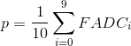
(1)
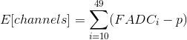
(2)

PMT histograms are binned 10Ch/Bin from 0 to 13000. Time-of-flight (ToF) histograms for each detector are also filled at this time. These histograms are binned 10 bins/ns, or 100 ps/bin (TDC resolution is 34ps/channel), from 40 to 80 ns. Additionally, for display, 2-dimensional Energy vs ToF, dE vs ToF, and Energy vs dE histograms are created. The energy axis follows the same binning as the 1D histograms, while ToF axis is expanded to the full 90 ns window and 2 bins/ns.
Figure 1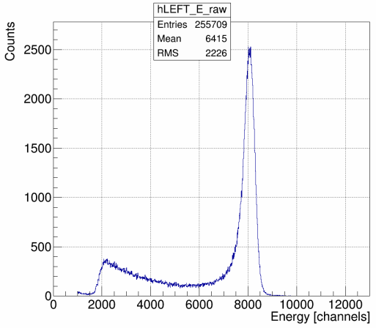: "Raw" Energy Spectra
Figure 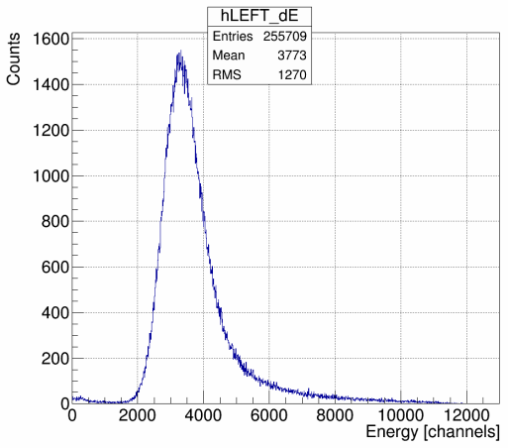2: dE Spectra

Figure 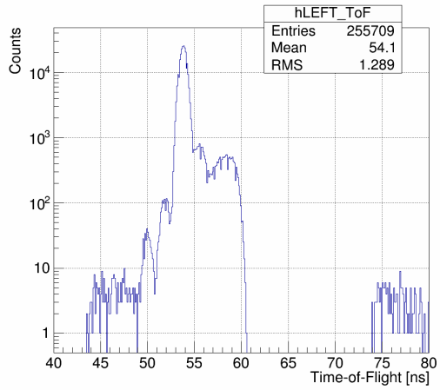3: Time-of-Flight Spectra, Vertical Log Scale
Figure 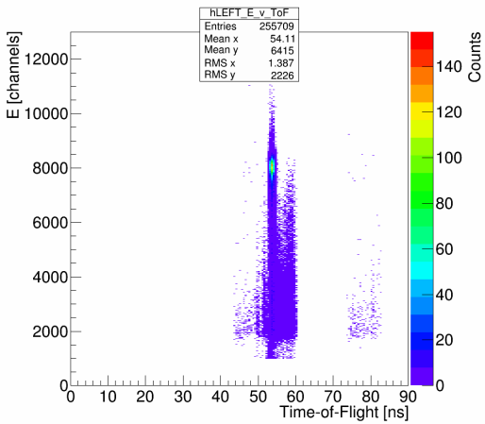4: Energy vs Time-of-Flight

Figure 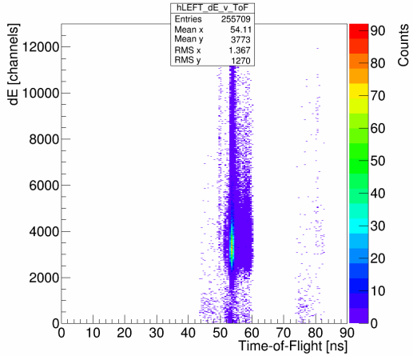5: dE vs Time-of-Flight
Figure 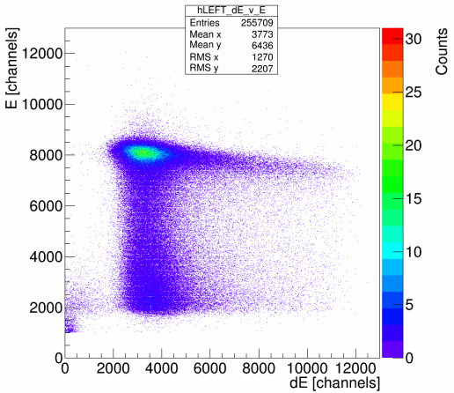6: Energy vs dE

Figures 1 through 6 are sample spectra from the Left detector of Mott Run 8545 – Run II, 31MHz beam repitition rate, vertically linearly polarized electrons, scattering off of a 350 nm gold foil. Corresponding spectra for the other three detectors are similar. Figure 1 shows a typical E-detector “raw”, or uncut, spectra. Figure 2 shows a typical dE-detector spectra. Figures 3 shows a typical Time-of-Flight spectra with a log-scale y-axis. Run 8545 was performed with a hardware timing veto wired into the FADC, and so from roughly 61 to 74 ns there appears to be no data. Without this veto, a second peak corresponding to scatterings from the dump would be present. The peak around 54 ns is scatterings from the target foil. Figure 4 shows “raw” energy spectra vs ToF, Figure 5 dE vs ToF, and Figure 6 E vs dE.
After filling histograms, when running at a suitable beam repitition rate, each detector's Time-of-Flight spectra's target peak is fit with a Gaussian. To do this, the maximum bin between 49 and 55 ns is found and used as the seed value for the mean of the Gaussian fit. The amplitude seed value is 1000 counts, and the sigma seed value is 1 ns, both chosen heuristically. The fit is restricted to the 49 to 55 ns range. The default ROOT TH1 class fitter is used – a Chi^2 function minimized using Minuit and the MIGRAD minimizer. Figure 7 shows run 8545, Left detector Time-of-Flight spectra fit with a Gaussian in light red. From this fit, the time-window that “good” Mott scattering events from the target foil occur within is determined as from (mean – 2 sigma) to (mean + 2 sigma). The choice of this +/- 2 sigma window about the mean is explained in detail in section Time-of-Flight Cuts.
Next, the uncut, “raw” energy spectra are Time-of-Flight cut – for each Left, Right, Up, Down detector, a new energy histogram is filled, but only if the event occurs within our specified time-window. Figure 8 shows run 8545's Left E-detector's uncut spectra in gray, and Time-of-Flight cut spectra in blue. Note the reduction in number of events, from 255709 (as can be found on figures 1-7) to 221413 – we've cut away ~13% of all events.
Figure 7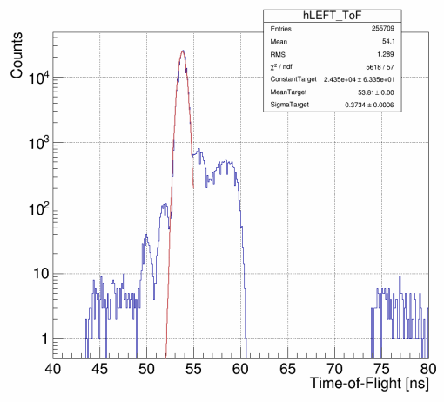: Time-of-Flight Spectra, Target Peak Fit with Gaussian
Figure 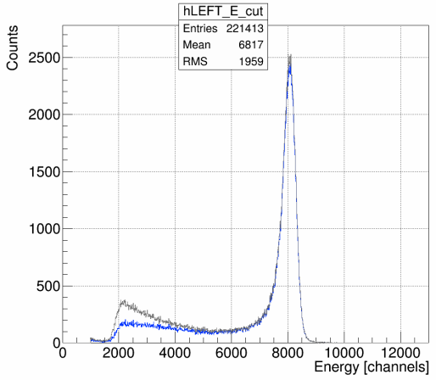8: Energy Spectra, Time-of-Flight Cut in Blue
When making Mott measurements with beam repitition rates of 249.5 MHz or 499 MHz, typical CEBAF repitition rates, the beam bunches are temporally spaced too close together to resolve a target scattering peak in the Time-of-Flight spectra. In this case, a flag can be passed to the analysis code to forgo the fit and subsequent cut.
Next, ToF-cut energy spectra (or simply “raw” energy spectra if no ToF-cuts are possible or wanted) are horizontally normalized such that their peaks each line up at a specified energy channel “center,” chosen to be 8000. This is implemented by calculating a 'squeeze fraction' equal to the center of the bin that the maximum count value occurs at divided by the channel to center on. Then, any bin edge or bin center can be calculated simply as:
NewBin = (MaxCountBinCenter / center) * OldBin
thereby squeezing/centering our four different detector energy spectra about a chosen channel. Figure 9 shows unnormalized horizontally ToF-cut energy spectra from run 8545 in gray, and horizontally normalized ToF-cut energy spectra in blue. Figure 10 then shows the horizontally normalized, ToF-cut energy spectra of each of the four detectors atop one another.
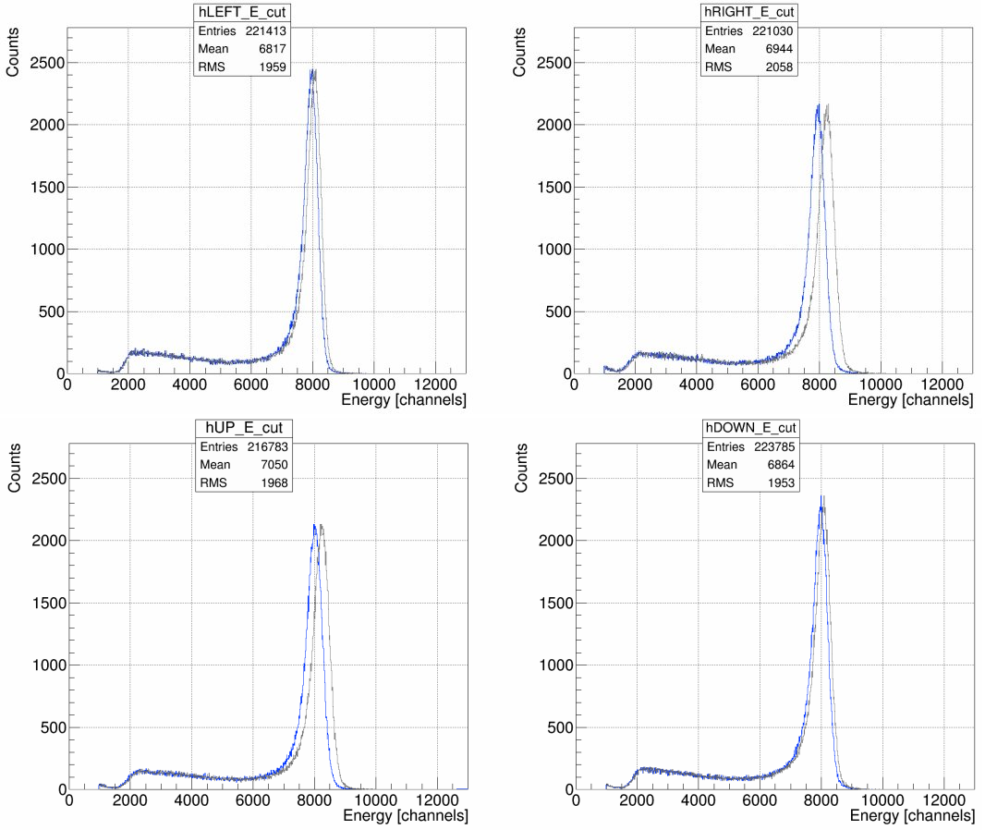
Figure 9: Horizontally Normalizing, from gray to blue, ToF-Cut Energy Spectra

In Figure 10, because both helicity-states are present in each of the four detectors, an asymmetry in Left/Right or Up/Down detectors is not apparent.
Figure 10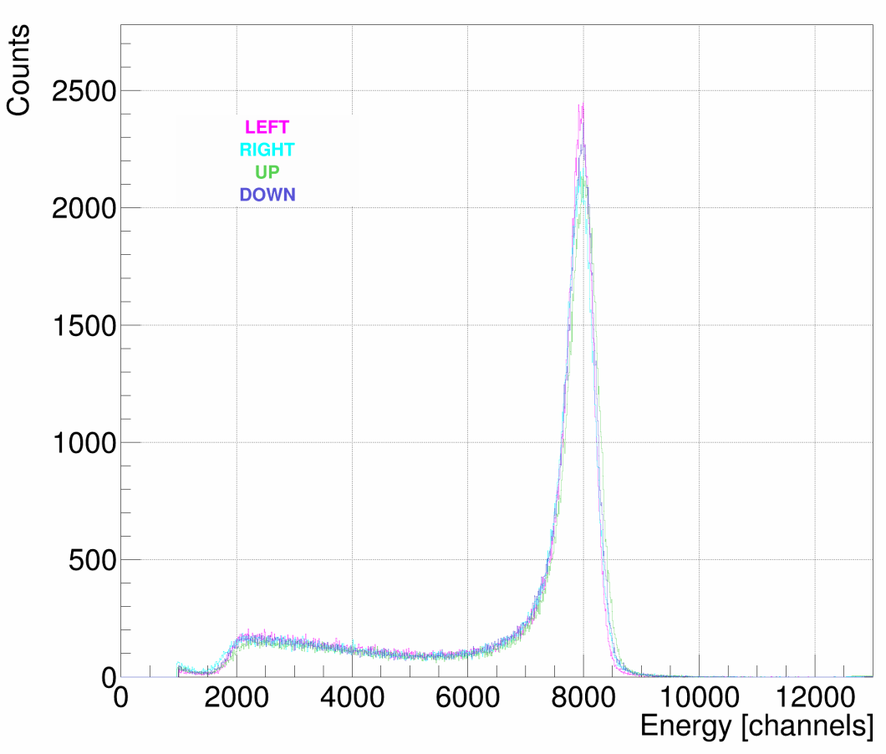: Horizontally Normalized ToF-Cut Energy Spectra
Figure 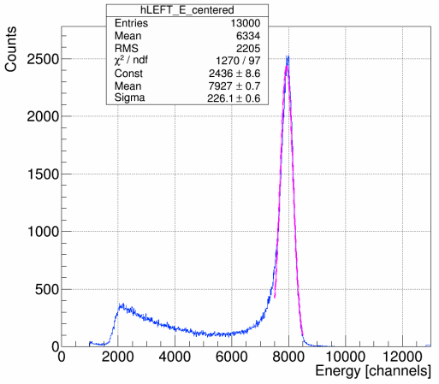11: Energy Spectra Horizontally Normalized, ToF-Cut, Fit with Gaussian
Next, each of the four detectors' horizontally normalized, potentially ToF-cut, energy spectra is fit with a Gaussian. The mean is given the “center” bin used to horizontally normalize about as its seed value, meanwhile the amplitude and sigma are each given a seed value heuristically determined to be 300. The fit is restricted to +/-500 channels about the “center” bin. Again, the default ROOT TH1 fitter is used. Figure 11 shows run 8545's Left detector energy spectra, ToF-cut, horizontally normalized about channel 8000, fit with a Gaussian in magenta. From the returned fit parameters, a “good” elastic scatterings off the target foil energy window is determined as from (mean – (½)*sigma) to (mean + 2*sigma). The choice of this -0.5 to +2 sigma about the mean energy window is explained in detail in section Energy Cuts.
Just prior to the end of the first loop subroutine, fit parameters and associated uncertainties from both fits along with 'squeeze fractions' are written to a formatted output file. The Time-of-Flight and Energy windows determined by the fits, windows that define our “good” Mott scatterings off the target foil, are passed to the second loop along with the calculated 'squeeze fractions' to horizontally normalize energy spectra.
Figure 1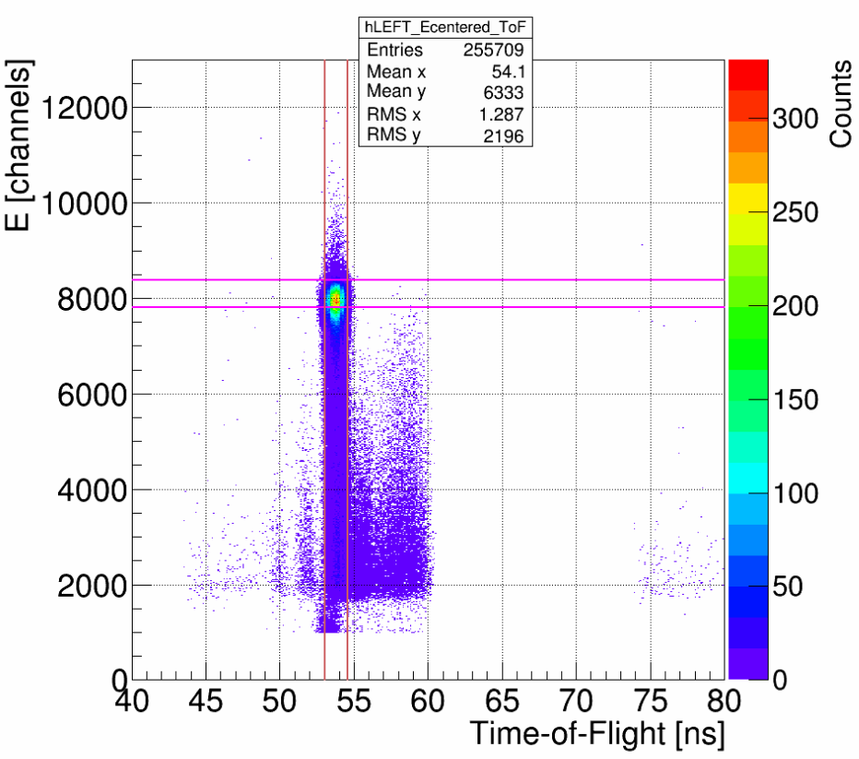2: Energy vs Time-of-Flight with Cuts

Figures 12 and 13 show run 8545's Left detector Energy vs Time-of-Flight plot with the determined Time-of-Flight window/cut shown by the vertical light red lines and the Energy window/cut shown by the horizontal magenta lines. Figure 13 is a contour rather than scatter plot. These figures differ from Figure 4 in that the energy data is horizontally normalized about the chosen center bin. They are also generated in the second loop rather than the first, although it could be done in either loop.
Figure 1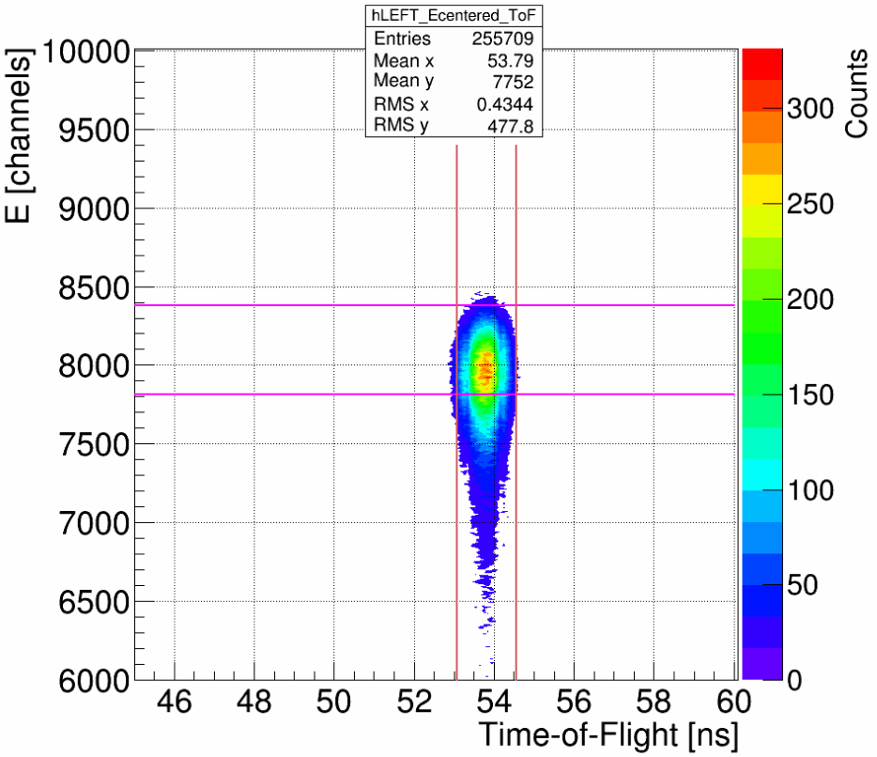3: Energy vs Time-of-Flight with Cuts, Contour Plot

General Technique – Second Loop, Calculating Asymmetries
In the second loop subroutine, from a given run's ROOT tree, eight new energy spectra histograms are filled – four E-detectors, and now breaking down scatterings by positive or negative helicity state. These histograms are binned exactly like previous E and dE-detector histograms – 0 to 13000 channels, 10 Channels/bin. Only scatterings that make it within our energy window determined in the first loop, and within our time-of-flight window if one is employed, are added. Using the 'squeeze fractions' passed from the first loop, these “good” elastic scatterings from the target foil are added directly to their horizontally normalized bin.
Continuing the use of Run 8545 from Run II, we have vertically linearly polarized incident electron beam scattering off a 350nm gold foil, and so we expect to observe physics asymmetry in the Left and Right E-detectors. Figures 14 shows these E-detectors, broken down by helicity.
Figure 14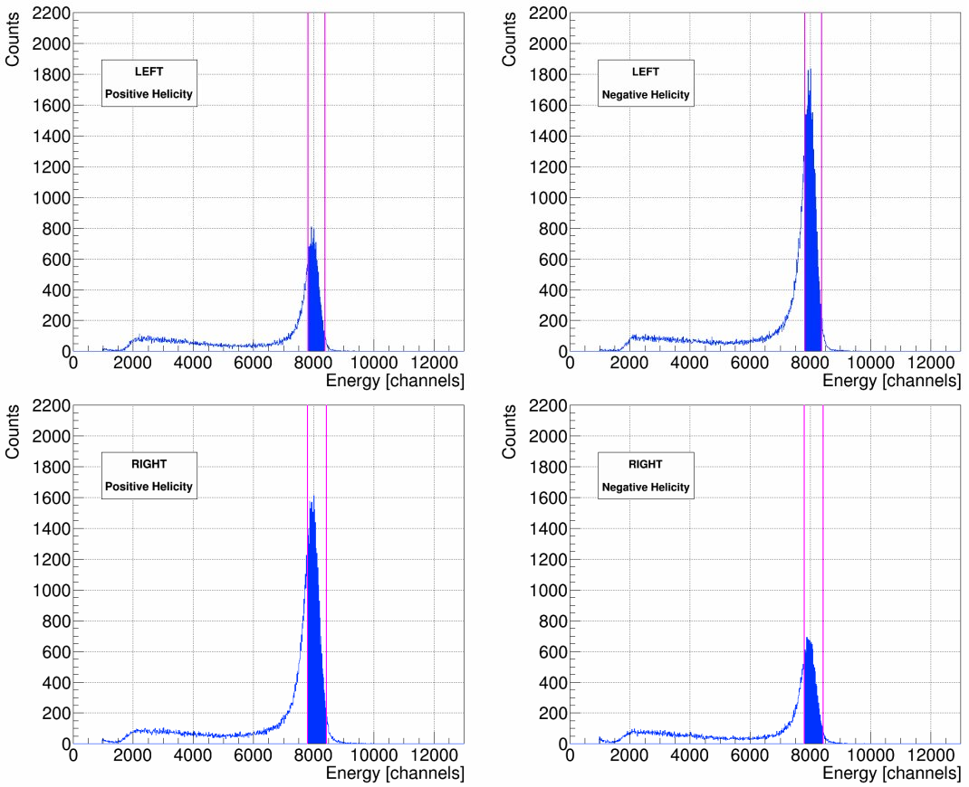: Left and Right Energy Spectra, Positive and Negative Helicity

The difference in maximum height between positive and negative helicity in one detector, as well as between Left and Right detectors for a given helicity, indicate the presence of asymmetry. These spectra are horizontally normalized and Time-of-Flight cut. Magenta lines are used to show our energy-cut window. Filled in blue represent the “good” elastic scatterings we will use in our asymmetry calculations, the scatterings that fall within both our Time-of-Flight and Energy cuts. For contrast, Figure 15 shows the Up/Down E-Detectors helicity spectra from Run 8545– all four are approximately the same height, indicating little to no asymmetry in this plane.
Figure 1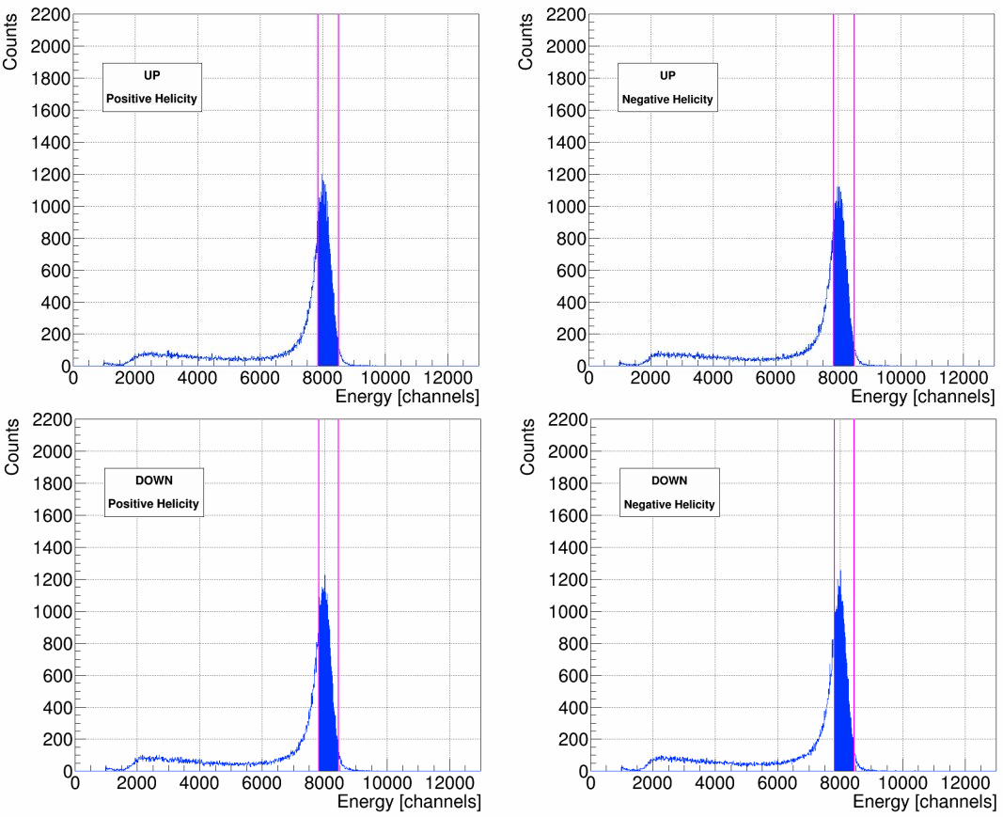5: Up and Down Energy Spectra, Positive and Negative Helicity
With our “good” elastic Mott scatterings determined, we can now calculate asymmetries using the cross-ratio method. The cross-ratio method is advantageous for our purposes in that the physics asymmetry is indepenedent – cancels to all orders – of relative detector efficiencies and solid angles, of relative integrated charge, and of target thickness variation. The differences in beam polarization in the two helicity states, however, only cancel to first order. Reference [1], G. G. Ohlsen, Jr. and P. W. Keaton, Nuclear Instruments Methods 109 (1973), “Techniques for Measurement of Spin-½ and Spin-1 Polarization Tensors,” discusses in detail the advantages and limitations of the cross-ratio method, and the effects of misalignments, false asymmetries, and spin-angle uncertainty. Derivations of asymmetry calculations used in the analysis, equations 3 the physics or Mott asymmetry measured A, equation 5 the detector instrumental asymmetry Instr1, and equation 7 the beam instrumental asymmetry Instr2, are also presented.
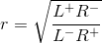
Letting L+ = number of positive helicity “good” elastic Mott scatterings counted in the Left E-detector, L- = number of negative helicity “good” elastic Mott scatterings counted in the Left E-detector, and so forth for R+/- , U+/- , and D+/- . Then, considering only the Left-Right plane for the moment, the cross-ratio method gives us for physics/Mott asymmetry A–

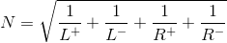

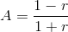
(3)
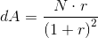
(4)

For detector instrumental asymmetry Instr1 (note the different definition or “r” ) –
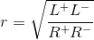

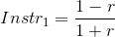
(5)
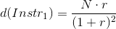
(6)

For detector instrumental asymmetry Instr2 (again, note the different definition or “r” ) –
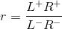

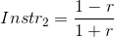
(7)
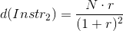
(8)

For the Up-Down plane, simply replace all L's with U's and R's with D's in the above equations.

Analysis Code – Second Loop, Calculating Rates
In the second loop subroutine, all events recorded in a given run's ROOT tree are gone through in order to build the helicity-dependent energy spectra. At this time, outside of our cuts, we sum several scalers to be used in rate calculations – the BCM VtoF scaler is used to calculate current I, after being cross-calibrated against BCM 0L02; the detector trigger scaler Ntriggers and the accepted triggers scaler Naccepted to be used in calculating the DAQ deadtime correction; and the 121 kHz clock scaler to be used to calculate the run time T. We also sum scalers that give us detector-specific dE rates in order to calculate electronics deadtimes (when N_rings == 1 which means when.... Riad?). Inside of our cuts, during this pass through the raw scalers, we record the number N of “good” scatterings from the target foil per detector, helicity-independent. From these quantities, the rate and uncertainty for a given detector can be calculated as –
(9)

(10)

Ntriggers / Naccepted is our DAQ deadtime correction, common to all four detectors. This quantity is typically unity until the third decimal place, even when scattering off of the thinnest foils. The error contribution from this quantity is expressed by (Ntriggers)-1 and (Naccepted)-1. These quantities are usually on the order of millions and so their error contribution is typically less than 10-5. (1 – dRLRUD)-1 is our detector-dependent electronics deadtime correction. dRLRUD is calculated by multiplying our dE-rate in Hz from the DAQ for a given detector by the coincidence window of 100ns. This resulting quantity is typically on the order of 10-4 to 10-3 and so the correction (1 – dRLRUD)-1 is typically unity until the third or fourth decimal place. (Riad: Why do we not need to make a correction to our asymmetry calculation due to detector dependent electronics deadtimes?) The error contribution from this quantity is at most 10-10, and so we do not include it.
Run time T is calculated from our 121 kHz clock –
RunTime T [s] = clock_scaler / clock_rate (Hz) (11)
Our 121 kHz clock rate was measured to be 121340.0 Hz, with a drift of as much as 100 Hz. From this, we determined dT = 100 / 121340 = 8.241E-04.
Electron beam current I, on the order of microamps, is calculated from a BCM scaler that is cross-calibrated against BCM 0L02. This is done by plotting BCM scaler values versus BCM 0L02's readback and fitting the data with a line from which a slope/gain m and intercept/offset b, along with uncertainties, is determined. Then, beam current I and uncertainty dI can be calculated as –
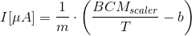
Do these units make sense?(12)
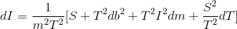
(13)

This was done for both Runs I and II respectively, using all times Mott data was being acquired (ie anytime the Mott Run Number PV was non-zero, indicating the DAQ as recording) as data sets. This cross-calibration against BCM 0L02 means our current is known only as well as BCM 0L02 knows it. No absolute calibration of BCM 0L02 was done in either Run I or II, and so we do not speak of absolute rates when we talk about them, rather we are speaking of relative rates.
Since in practice we take multiple runs on the same foil and then average them together, averaging rates and asymmetries, and in order to not treat our beam current quantity in the rates calculation as a statistical one – that is, one whose uncertainty decreases the more data we take, or more runs we include in our averaging – the analysis code reports rates in units of Hz, calculated by
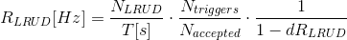
(14)

and then dRLRUD becomes –
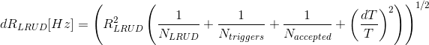
(15)

Current I and uncertainty dI are then used outside of the analysis code to calculate rate in Hz/uA.

Analysis Code – Scaler Loop
… … … … needs signficant review and revise
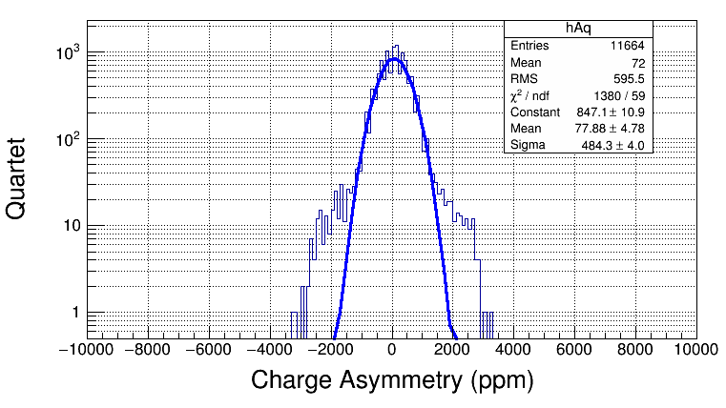
In the scaler loop subroutine of the analysis code, scalers for BCM current, Helicity Ring Control, and Pattern Synchronization Ring Control (? correct, = PatSyncRingCtrl) are summed if nRings == 1. Why? Then some accounting for delayed helicity signal is performed, before a charge asymmetry histogram is filled. This histogram ranges from -10000 to 10000 parts per million of charge asymmetry, with 200 bins of 100ppm/bin. The calculation is....

