6,7. Extrapolation of Asymmetry Data to Determine A_{o}
[including 10 graphs/figures and 5 data tables]
A. Extrapolation Functions
The ultimate goal of a Mott asymmetry measurement is to provide an absolute value of the incident electron polarization, P_{e}. This is obtained by knowing the theoretical Sherman function S: P_{e} = A_{o}/S. Since S is calculated assuming elastic single-collision conditions, A_{o} corresponds to the Mott asymmetry taken when such conditions can be achieved experimentally. In principle, this requires that elastic scattering be guaranteed by energy filtering, and that a vanishingly thin target be used to eliminate the possibility of plural scattering. In practice one extrapolates measured asymmetries to zero target thickness, while providing the best possible energy discrimination against inelastically-scattered electrons [1]. At incident electron energies below ~200 keV, “retarding field” Mott polarimeters allow the precise extrapolation of asymmetries to zero energy loss in conjunction with target thickness extrapolations [2]. (Energy extrapolation alone is not sufficient to guarantee single-scattering conditions; see reference [3], Figure 9.) At higher energies such as ours, where semiconductor or scintillator-based electron detection is used, energy discrimination becomes more difficult. In these cases, careful target thickness extrapolation procedures are mandatory.
In our experiment, we measured Mott asymmetries, A(t), as a function of Au target foil thickness, t, ranging from 0.0550 μm to 1μm. At 5 MeV in this foil thickness range, A(t) is a monotonically decreasing function of t, losing about 20% of its value as t increases from 0 μm (A_{o}) to 1 μm. The function A(t) has a weak curvature with a positive second derivative. Historically, and because of the lack of any compelling theoretical guidance, a variety of functional forms have been used to fit A(t), and thus determine A_{o} [3,4]. These have all been of the form
$A^{q}\left(t\right)=A_{o}(1-at)$, (i)
$A\left(t\right)=A_{o}\frac{(1-at)}{\left(1+bt\right)} ,$ (ii)
or $A\left(t\right)=a+be^{-ct},$ (iii)
where q = 1, -1, or -2, and a, b, c, and A_{o} are fitting parameters. In form (iii), a+b = A_{o} or, if b is set to zero, A_{o} = a. The latter case has often given reasonable fits to asymmetry data for relatively thin foils, but implies the unphysical result that A(∞) = 0. Form (iii) has been used only for incident energies below 200 keV, where, for the thickest targets, A(t) has a non-zero asymptotic value [3].
As we will see below, the precision with which A_{o} can be determined is limited primarily by the uncertainty in the target thicknesses. These uncertainties are typically 5-8% of the t values themselves. An attractive alternative to thickness extrapolations is to consider A vs. the count rate summed from both detectors, R(t). Uncertainties in the count rates are due mostly drift between stability runs, believed to be due to instability in the measured beam current, to which the rates must be normalized. These uncertainties are typically much smaller on a percentage basis than the uncertainties in t. In this work, we will thus also consider R -dependent extrapolation functions.
The GEANT4 simulations discussed in Section X.X give us some confidence that a fitting form of type (ii) is the most appropriate function with which to extrapolate our A(t) data to A_{o}. Having said this, we prefer a more conservative approach espoused in reference [4]. In that work, the A(t) data were fit to four functions of types (i) and (ii). It was shown that the spread in the (correlated) fit values of A_{o} was somewhat larger than the statistical uncertainty in the A_{o} values given by a specific fitting form. As a result, the uncertainty in the weighted mean of the four intercepts (their quoted final value of A_{o}) was assigned to be such that ±2σ error bars encompassed all four intercepts.
To this end, we have applied a more general procedure to assess the precision of our final A_{o} values. Our A(t) data were fit using the method of Padé approximates [5]. Padé approximates (PAs) are a class of rational fractions which are typically well-behaved and converge more rapidly than Taylor series approximations to a set of data for extrapolation. The PAs, A_{n,m}, take the form
$A_{n,m}\left(t\right)=\frac{P_{m}(t)}{Q_{n}(t)}=\frac{A_{o}(a_{n}t^{n}+a_{n-1}t^{n-1}+…+a_{2}t^{2}+a_{1}t+a_{0})}{(b_{m}t^{m}+b_{m-1}t^{m-1}+…+{ b}_{2}t^{2}+b_{1}t+b_{0})}$ (iv)
for m ≥ 0 and n ≥ 1. The form of Eq. (i) thus corresponds to a A_{1,0} PA for q = 1, an A_{0,1} for q = -1, and an A_{0,2} PA for q = -2; equations (ii) corresponds to a PA of A_{1,1}. Finally, equation (iii) is essentially a PA of arbitrarily high order s of the form A_{s,0}.
We began our analysis by using the A_{1,0} form to fit a given A(t) data set, and then increase both n and m until application of an F test indicates that higher orders of n and/or m are not justified [6]. As we will show below, the only PA forms that were not excluded for the A(t) data were the A_{1,0}, A_{0,1}, A_{1,1}, and A_{2,0} forms. This procedure was repeated for fits to the A(R) data sets. In this case, only the (2,0), (1,1), and (0,2) forms were not excluded. Finally, R(t) was also investigated and and the (1,0), (2,0) and (1,1) forms were not excluded. All fits that passed the F-test were then also subjected to a reduced chi-squared analysis as well [6].
Table 1 shows the results of the Pade analysis for the fits of the A(t) data for Run 1 to the various forms A_{n,m}. For each PA, the intercept(with uncertainty), the F-test result and the reduced χ2 value are shown.
A(t)Run1  Pade(n,m) | (0,m) | (1,m) | (2,m) | (3,m)
(n,0) |  | 43.82(14),n/a,2.6 | 44.05(13),7.7,1.4 | 44.26(17),2.8,1.1
(n,1) | 44.04(10),8,1.3 | 44.09(14),6.3,1.8 | 44.35(38),-2.2,5.4
(n,2) | 44.09(14),0.3,1.5 | 43.98(33),-0.41,2.5

Table 1 shows the results of the Pade analysis of the run 1 asymmetry vs. thickness data. The forms in red are excluded by the F-test of the data: this means that adding another term may improve the fit of the function to the data, but not significantly enough to justify the additional term. In fact, in some cases, adding another term to the fitting function is detrimental to the goodness of the fit, characterized by the reduced χ2 goodness of fit parameter.
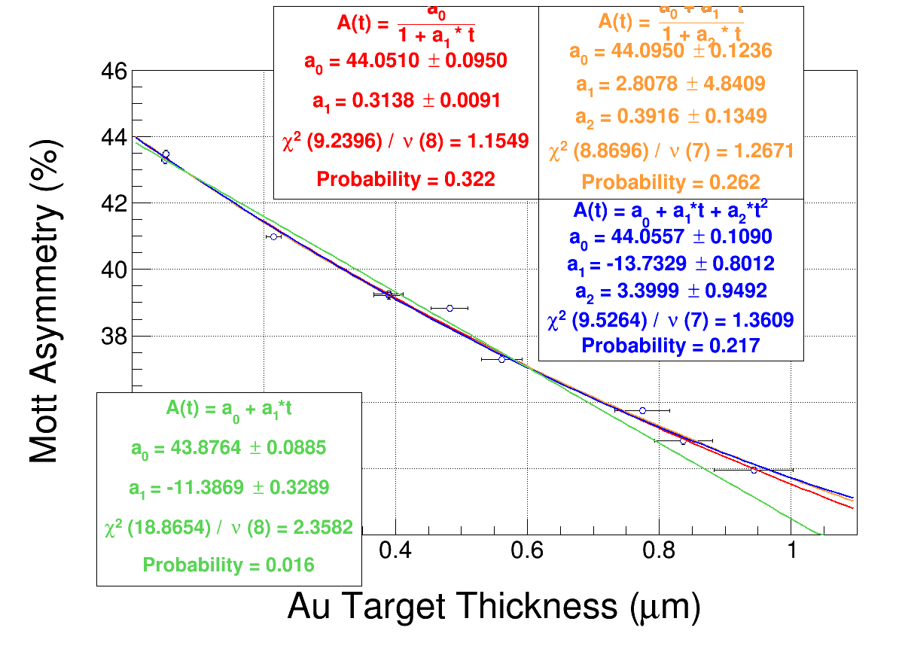
Further reduction of the allowed fits to the data can be made using other methods. For example, the A_{1,0} fit to the A(t) data both looks to be a poor fit to the data, and the reduced χ2 value of 2.6 indicates that this is unlikely to be a good fit to the data (with a 1.5% chance of exceeding χ2, Bevington table C-4)
For the second run, the results of the PA analysis are shown in Table 2. Similarly to in Run 1, the A₁₀ function was also removed for its poor fit and reduced χ².
Table 2 shows the results of the Pade analysis for the fits of the A(t) data for Run 2to the various forms A_{n,m}. For each PA, the intercept(with uncertainty), the F-test result and the reduced χ2 value are shown.
A(t)Run2  Pade(n,m) | (0,m) | (1,m) | (2,m) | (3,m)
(n,0) |  | 43.84(16),n/a,2.7 | 44.12(14),10,1.3 | 44.35(17),3.4,0.96
(n,1) | 44.08(11),9.4,1.3 | 44.18(15),8.5,1.6 | 44.43(39),-2.0,4.6
(n,2) | 44.17(15),0.84,1.4 | 44.14(65),-0.04,2.0

Similarly, a PA was carried out for the asymmetry vs. rate data, where the theory is not sufficient to provide guidance regarding a preferred functional form. The results of the PA analysis for runs 1 and 2 are shown in tables 3 and 4. Again, the linear fit, while not able to be eliminated using the F-test method, was eliminated due to the poor reduced χ2 value. It is evident that the A_{2,0} function fits the data somewhat less well than the others and appears to have pathological curvature for rates larger than the largest measured. However, as this function is being used to extrapolate only toward rate approaching zero, the A_{2,0} function can be valid.
For asymmetry vs thickness, using the three PA not excluded by the F-test or poor reduced χ2 values, the results are shown in Figure xx. The values of the extrapolation are Ao(t)=44.07(13) for run 1 and Ao(t)=44.13(16) for run 2.

Figure 1 shows the values of Ao for three different PA forms that are not excluded, as well as the A10 form which has been rejected due to a poor reduce χ2 value and outlier value compared to the other PAs. Run 1 is shown on top and run 2 below the center line.

Table 3: Asymmetry as a function of rate, Run 1, with the allowed PA in black and those eliminated by the F-test in red. . For each PA, the intercept(with uncertainty), the F-test result and the reduced χ2 value are shown.

A(R)Run1  Pade(n,m) | (0,m) | (1,m) | (2,m) | (3,m)
(n,0) |  | 43.42(24),n/a,15.2 | 43.98(10),84, 1.33 | 44.08(11),2.4, 1.11
(n,1) | 43.77(15),16.8, 5.1 | 44.08(09),90,1.28 | 44.15(15),0.32,1.48
(n,2) | 44.05(09),25, 1.16 | 44.04(12),-0.49,1.83 | 44.00(35),-0.92,1.93
(n,3) | 43.98(10),-1.23, 1.84

Table 4: Asymmetry vs. Rate for run 2, with PA not excluded by the F-test in black and excluded functions in red. . For each PA, the intercept(with uncertainty), the F-test result and the reduced χ2 value are shown.

A(R)Run2  Pade(n,m) | (0,m) | (1,m) | (2,m) | (3,m)
(x,0) |  | 43.48(28),n/a,12.6 | 44.06(12),65,1.40 | 44.20(12),3.6, 1.02
(x,1) | 43.81(19),12,5.3 | 44.20(11),76, 1.25 | 44.00(17),-1.27, 2.28
(x,2) | 44.15(11),25,1.19 | 44.35(24),0.54, 1.38 | 43.96(84),-1.16, 3.22
(x,3) | 44.06(13),-1.4,1.99
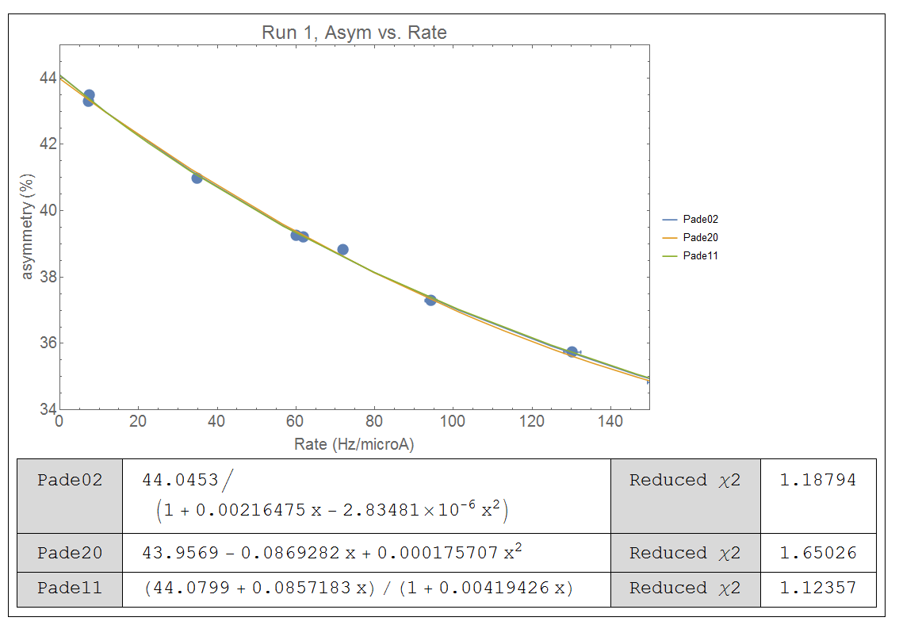
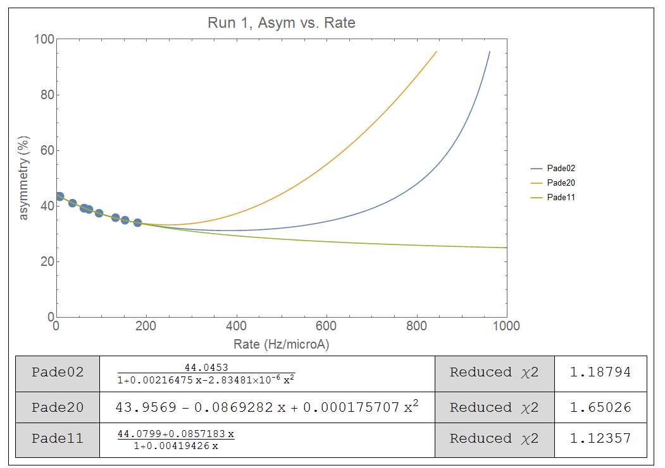

Values:
 | Run 1 | Run 2
With Pade (2,0) | 44.03(16) | 44.09(11)
Without Pade (2,0) | 44.06(09) | 44.15(20)

Similarly, a PA analysis of the rate vs. thickness was undertaken, with the results shown in Tables 5 and 6 for runs 1 and 2 respectively. The R(t) fits were forced to yield R(0)=0, so the A_{0,m} fits were not investigated. The linear fit, A_{1,0}, was excluded again due to poor adherence to the data and a poor reduced χ2 value.

Table 5. Rate vs. thickness for Run 1. For each PA, the F-test result and the reduced χ2 value are shown.

R(t) Run1  Pade(n,m) | (1,m) | (2,m) | (3,m)
(n,0) | n/a,2.7 | 17.2,0.89 | 1.77, 0.71
(n,1) | 14.0,1.13 | 1.08,1.11
(n,2) | 0.76,1.18

Table 6: R(t) run 2.For each PA, the F-test result and the reduced χ2 value are shown.
R(t) Run 2  Pade(n,m) | (1,m) | (2,m) | (3,m)
(n,0) | n/a,3.4 | 21,0.98 | 2.9,0.69
(n,1) | 18,1.19 | 1.18,1.15
(n,2) | 1.07,1.17

