TIME-RESOLVED IMAGING FOR THE APS LINAC BEAMS http://aps.anl.gov/News/Conferences/1998/LINAC98/papers/TU4059.pdf
Common Name | Chromox | YAG
Material | Al2O3:Cr | Y3Al5O12:Ce
Thickness | 0.25 mm | 0.50 mm
Beam energy | 600 MeV | 600 MeV
Spatial Resolution @ 30mA peak current  (43.2 nA) | 200 um | 30 um
Spatial Resolution @  200 mA peak current  (288 nA) | 200 um | 100 um
Time Response | 300 ms | 80 ns (80%)  300 ns (20%)
Intensity (a.u.) | ~1 | ~1
Blurring threshold |  | 0.2-0.3 pC/um^2

RESOLUTION STUDIES OF INORGANIC SCINTILLATION SCREENS FOR HIGH ENERGY AND HIGH BRILLIANCE ELECTRON BEAMS https://accelconf.web.cern.ch/accelconf/IPAC10/papers/mopd088.pdf
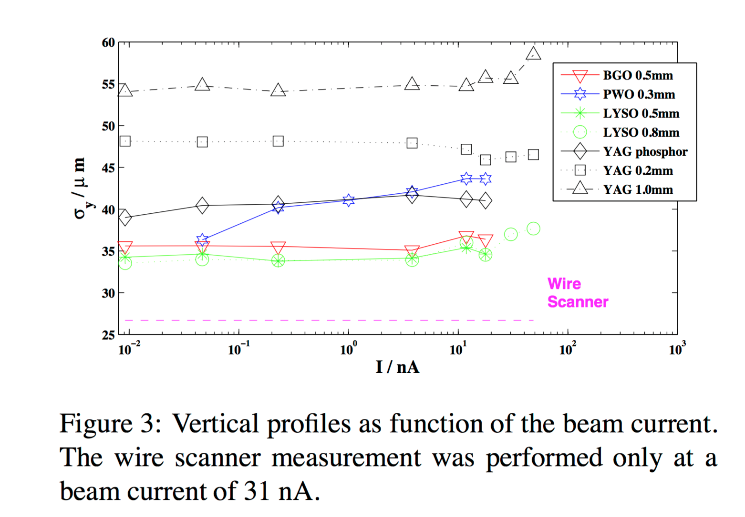

INVESTIGATION OF THE LIGHT YIELD OF LUMINESCENT SCREENS FOR HIGH ENERGY AND HIGH BRILLIANT ELECTRON BEAMS https://accelconf.web.cern.ch/accelconf/d09/papers/tupd39.pdf
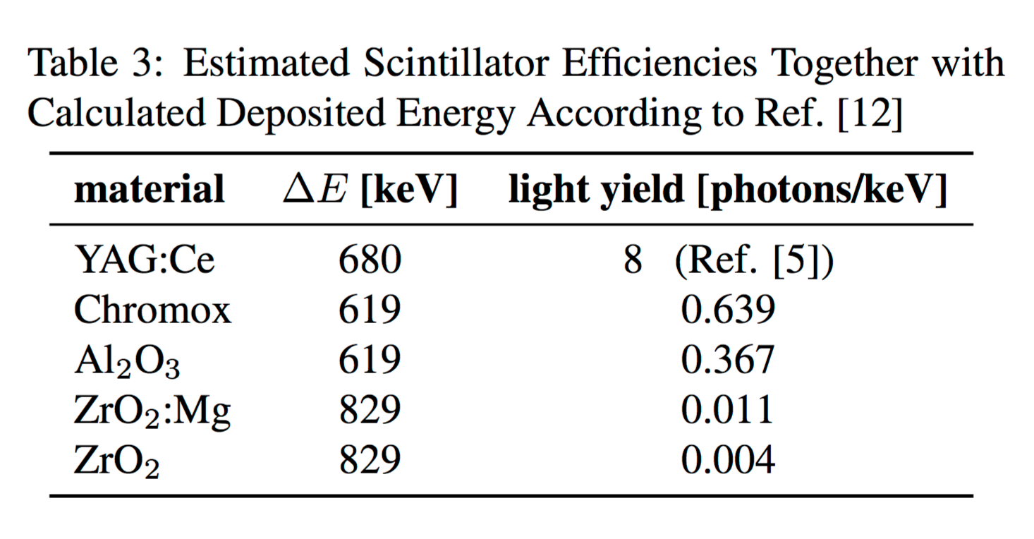

YAG:Ce SCREEN MONITOR USING A GATED CCD CAMERA
http://www.slac.stanford.edu/econf/C140914/papers/tupd08.pdf

- Blurring threshold ~ 0.25 pC/um^2
- Resolution vs. thickness
- Crystal vs. Ceramic (powered)

LIMITATIONS ON THE RESOLUTION OF YAG:CE BEAM PROFILE MONITOR FOR HIGH BRIGHTNESS ELECTRON BEAM
https://www.bnl.gov/atf/pubs/YAGmon.pdf

- Thorough article describing the physical effects limiting beam size measurements using YAG:Ce. Distinguished between multiple scattering, bremsstrahlung and charge field effets.

