RTP Installation Meeting) – Oct 12, 2019

- We have about 2 weeks in January for laser work, but sharing w/ PSS after Jan 7.

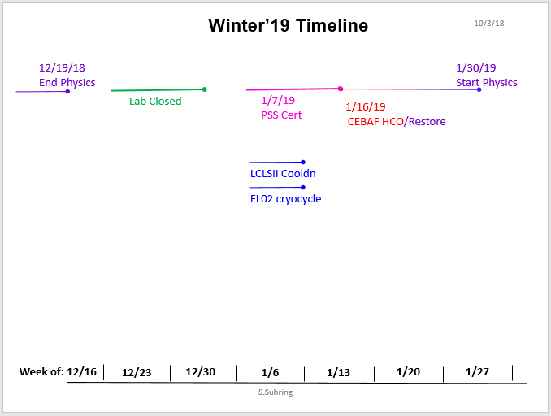

- Items for UVA RTP installation
  - UVA RTP Pockels cell in UVA mount, on existing translation stage
    - This is the plan
  - UVA PS (four + and four -), installed in rack
    - John come up with a plan for (8) PS-Switch (8) Switch-RTP
    - Rack mount these, be creative
    - John to stuff DAC isolator
  - JLAB DAC (four + and four -), EDM screen
    - New DAC is ready
    - Repurposed DAC cable (8), need controls
    - John purchase R1B relay, for switching 115VAC re-use ON/OFF
    - Consider names for (8) DAC for EDM screen
    - Caryn will specify equations for EDM screen
  - Modify laser cover (LSOP?), pull cables
    - John will submit to shop
  - Convey channel names to Halls (for recording if they want)
    - Riad will communicate/update changes to Halls
    - Riad will work to define new alarms for the RTP, to Daniel

- Configuration/Alignment
  - Grounding, of orthogonal plates?
    - Making to go to the floated ground of the switches
  - Which switches are we going to use (electrical, optical=falcon,dragon?)
    - Plan A = Dragon, Plan B = UVA test electrical (slow down?), then decide
  - Remote PC on/off
    - See above, fan out same 24V on/off
  - Laser alignment procedure
    - Write down UVA procedure
    - Hands-on training

- Performance
  - Assess 4-laser spot sizes at RTP cell and Photocathode, test 50cm, 40cm lenses
  - (thermal) stability studies at UVA
    - Doing burn in studies now
  - plan for tracking stability and tests during SPRING 2019 run (pre-PREX/CREX
    - Mott measurements
    - maximize (+/- 2000ppm/hr) or minimize (+/- 200ppm/hr)
    - Caryn’s plan
      - QPD pickoff to test transition times on fast photodiode
      - Measure charge asymmetry, test Aq feedback, working w/ Hall A
      - Have a KDP Backout Plan
      - Need one shift to in-line for RTP checkout
    - Translation
      - John figure out if we can remote desktop to USB to UVA stage
      - Worst case no remote translation Spring run, assess for later

- KDP Backout Plan
  - Store cell in existing mount
    - Mark location show can shove it back in
  - Retain KDP DAC channels/cables tied off
  - Retain EDM interface

- JLAB RTP System
  - Raicol large(r?$?$? => voltage increase) aperture crystal, metalized (spare when makes sense)
    - 12x12 (attach Caryn’s quote for UVA), metalized contact plates
    - Good experience, pleased w/ specs
  - RTP Mount
    - Caryn provide 3D CAD model, John will see about printing (vendor) + list of all thorlabs/Newport components
    - We can also re-assess mount design…
  - HVPS
    - Go w/ UVA design, John figure out plan for forward support
    - Let’s be sure to stay forward compatible to 2kHz

