Beam Magnet Corrector/Kicker Assembly (metric)

Beam Line Mount (block comprises 2 diagonal halves)

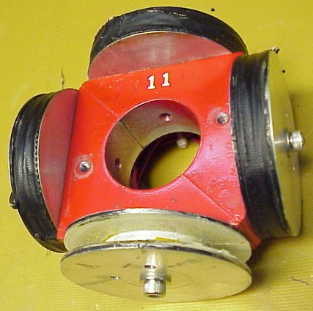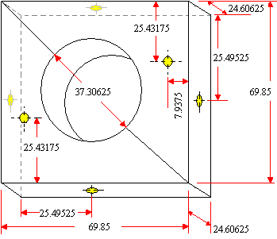

Magnet Coil (4 each)

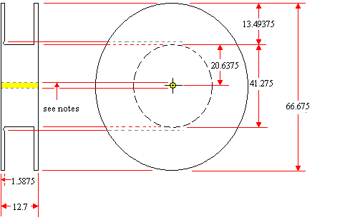
Notes:
- All units of measurement are in millimeters except screw holes.
- Holes (in yellow) are threaded for size 10-32 x ½” Allen head screws.
- All materials must be non-magnetic.
- Winding wire diameter is around 0.35mm (measured by caliper)
- Winding OD is 52.31mm (measured by caliper)

