Polarized Electrons for Polarized Positrons (PEPPo)
Snowmass Workshop on Polarized Positrons, J. Grames (3/8/22)

Important topics in nuclear, hadronic, and electroweak physics including nuclear femtography, meson and baryon spectroscopy, quarks and gluons in nuclei, precision tests of the standard model, and dark sector searches may be explored at CEBAF, especially when considering potential upgrades in luminosity, polarized and unpolarized positron beams and doubling of the beam energy to 24 GeV [1, 2].

For a positron program, Polarized Electrons for Polarized Positrons (PEPPo) represents a pathway to generate the highly spin-polarized positron beams required. The technique is based on the electro-magnetic shower of electron beams in matter and the two-step process of polarized bremsstrahlung followed by polarized pair creation [3, 4]. Both steps can occur in a single high-Z conversion target, or be accomplished using a separate radiator and converter, if desired. Notably, this technique can be applied at any electron accelerator where spin polarized electron beams are produced, whether at a university or national lab.

The transfer efficiency of spin polarization from the electron beam to the positron beam, defined as ε_{P} = P(e+)/P(e-), can be very efficient, approaching unity as the momenta of the collected positrons approaches the initial electron beam momentum. The technique was first demonstrated at CEBAF [5] where an 8.2 MeV/c electron beam with polarization 85.2% produced positrons with polarization >82% (Fig. 1). Collecting the positrons at half the electron beam momentum serves to maximize figure of merit defined as IP², with positrons receiving >60% of the electron beam polarization.

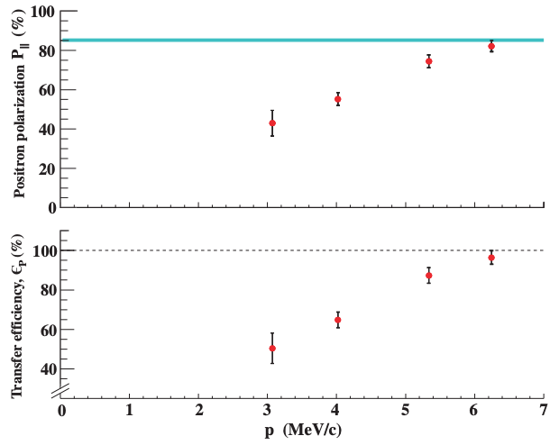

Figure 1. Positron polarization and transfer efficiency as reported in [5].

In contrast to positron polarization, the positron yield N(e+)/N(e-) falls precipitously with increasing positron momenta, due to the characteristic bremsstrahlung power spectrum. While this is not a deciding factor for unpolarized positron sources which select a low-momentum fraction of positrons from the conversion target, a PEPPo-driven polarized positron source must select the high-momentum fraction to provide polarization. Limitations in electron spin polarization and beam intensity likely explain why a PEPPo-based positron source has not been constructed to date. However, this landscape has changed significantly in the last 10 years. Electron beam polarization is now routinely ~ 90% and with average beam currents at mA level [6,7].

Today, strained-layer superlattice (SSL) photocathodes composed of quantum well multi-layer heterostructures provide very high spin polarization >85% and with yields ~ 6 mA/W of laser light. And SSL photocathodes fabricated with an integrated diffracted Bragg reflector - to more efficiently absorb optical power - have demonstrated yields ~ 30 mA/W [8]. One may now reasonably imagine providing 100 kW of highly spin polarized electron beam at energies in the range of 10-100 MeV. In this context, a recent Jefferson Lab LDRD project [9] explored the possibility of generating > 100 nA positron beams with polarization >60% for experiments at Jefferson Lab’s Hall B [10], using a 1 mA spin polarized electron beam at 100 MeV. The results were encouraging and are now under further consideration as a potential future upgrade for CEBAF.

In summary, PEPPo demonstrated a compact and efficient technique to produce highly spin polarized positrons, suitable for small to large-scale accelerator facilities. Advances in GaAs photocathodes capable of producing a high degree of spin polarization and milliampere intensities makes this technique viable. It is recommended to P5 to support R&D in the areas of high current polarized electron sources, ~100 kW high power targets and magnets for efficient collection of positrons over energies 10-100 MeV.

[1] J. Arrington et al. “Physics with CEBAF at 12 GeV and Future Opportunities”, (to be published by Progress in Particle and Nuclear Physics) (2022); https://arxiv.org/abs/2112.00060

[2] A. Accardi et al. “An experimental program with high duty-cycle polarized and unpolarized positron beams at Jefferson Lab” (2020); https://arxiv.org/abs/2007.15081

[3] E. G. Bessonov and A. A. Mikhailichenko, in EPAC96 (JACoW, 1996) THP071L

[4] P. Potylitsin, Nucl. Inst. Meth. A 398, 395 (1997).

[5] D. Abbott et al. (PEPPo Collaboration) Phys. Rev. Lett. 116 (2016) 214801

[6] J. Grames et al. "Milliampere beam studies using high polarization photocathodes at the CEBAF Photoinjector", International Workshop on Polarized Sources, Targets and Polarimeters (PSTP 2017), Oct 15 - 20, 2017, Daejeon, South Korea

[7] R. Suleiman et al. “High current polarized electron source”, AIP Conference Proceedings 1970, 050007 (2018); https://doi.org/10.1063/1.5040226

[8] W. Liu et al., "Record-level quantum efficiency from a high polarization strained GaAs/GaAsP superlattice photocathode with distributed Bragg reflector", Appl. Phys. Lett. 109, 252104 (2016)

[9] J. Grames (LDRD Positron Team), “Positrons for Our Future” LDRD Final Report 2021-LDRD-LD2104 (2021)

[10] V. Burkert et al. “Beam charge asymmetries for deeply virtual Compton scattering off the proton” Eur. Phys. J. A (2021) 57: 186

