A brief update of the analysis:

- Fig. 1 shows the expected rate of the 18O(g,a)14C reaction (solid line) as function of the energy together with the rate for cosmic ray induced events. This rate is independent of the beam energy but is plotted at the energy of the electron beam we had when this background was measured (although we didn’t have beam on target). The good news is that because of the overhead shielding the rates are on average 4x10⁻³ /sec or one count every 4 minutes.

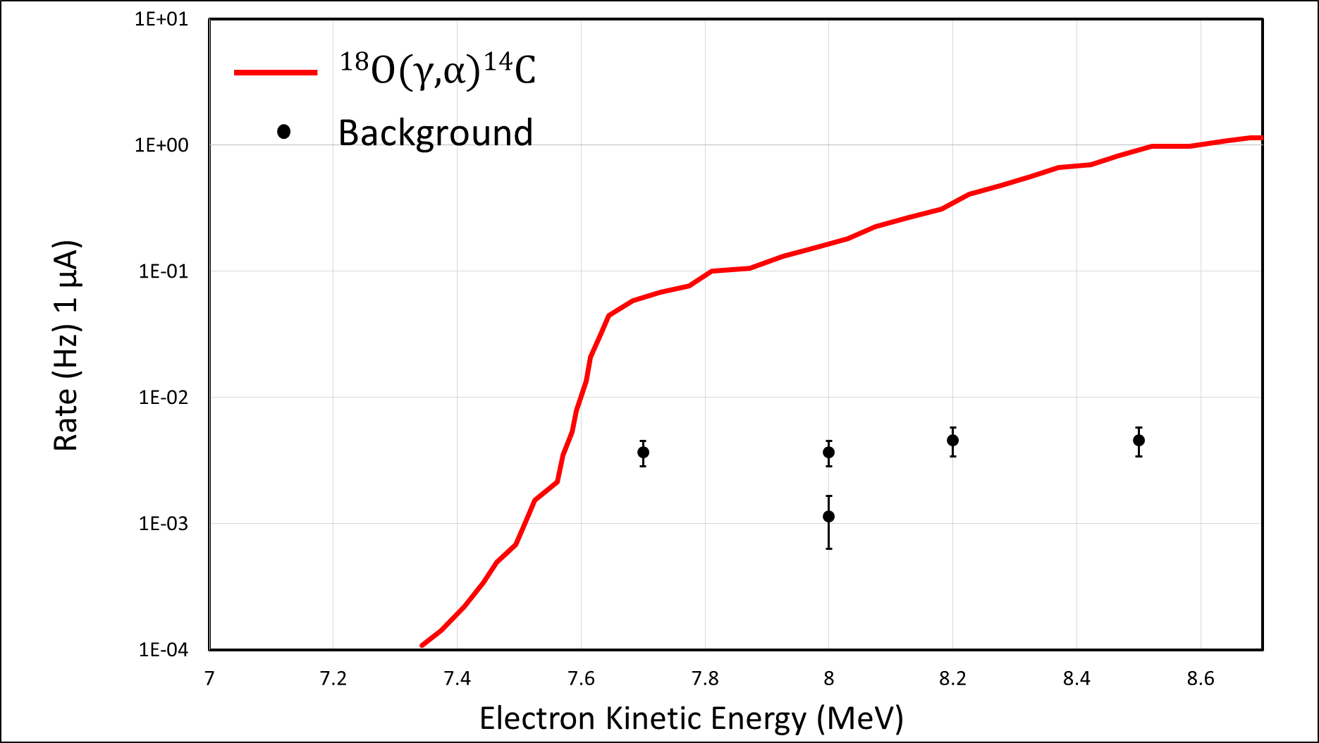
Fig. 1

- Fig. 2 shows the rates in the fiducial volume normalized to a current of 1 microA beam measured between 7.7 and 8.5 MeV. Cosmics are subtracted. Not subtracted yet are beam induced background events inside the fiducial volume. This is tricky since it seems to depend on the way the beam was tuned (see below). The time the data were taken and the current used are included as well. Not clear why the data point at 7.7 MeV (the first one taken during the experiment) is now high. It was low during the online analysis (see old plot on the website).

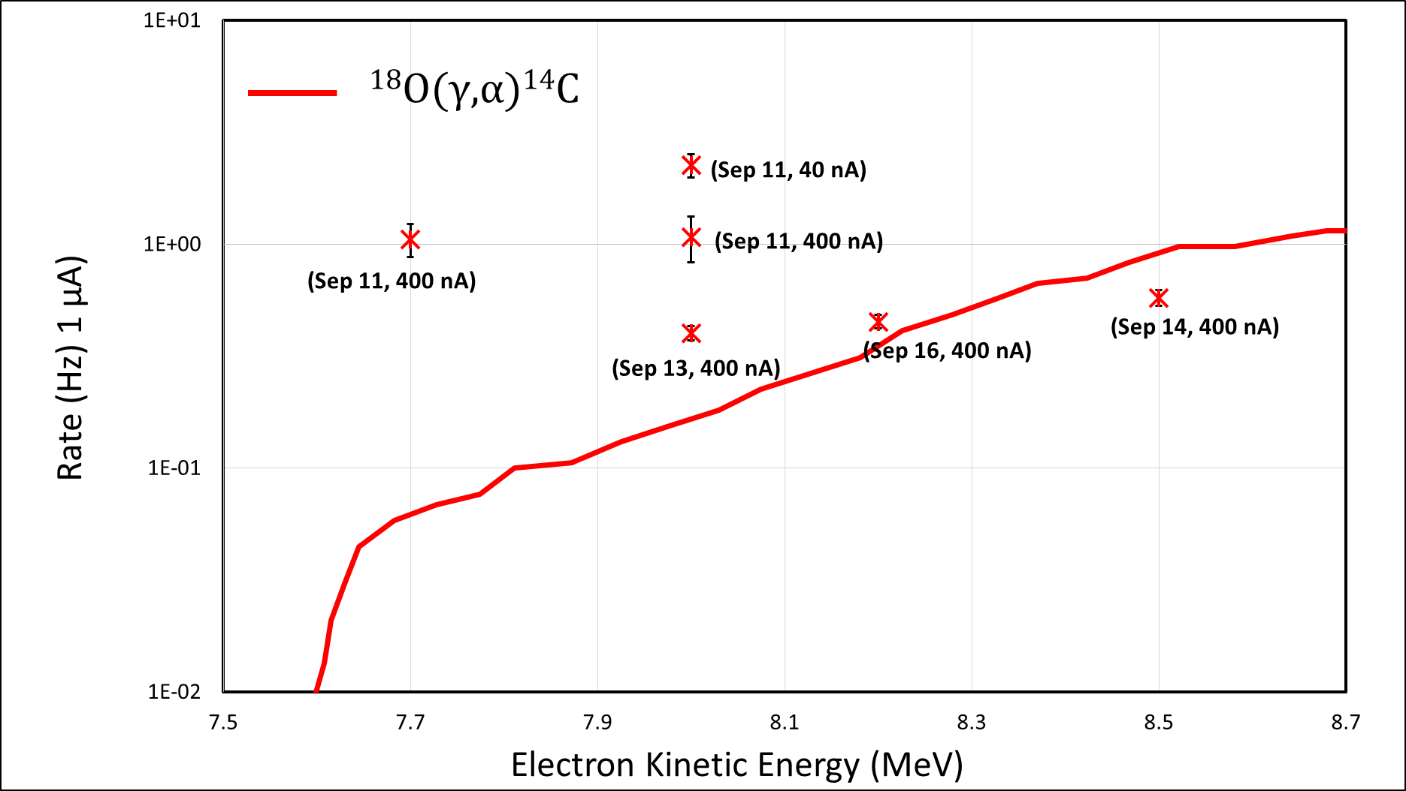
Fig. 2

- Restricting the analysis to points taken with 400 nA we see two groups. The data taken on Sept-11 are all a factor of ~3 higher than the data taken later (Sept 13,14,16). Between these two data sets we checked the beam orientation and shifted the beam spot towards West or North. The events for the un-shifted and shifted conditions are shown in Figs. 3 and 4. One sees that the events are more localized for the conditions when the beam spot was optimized.

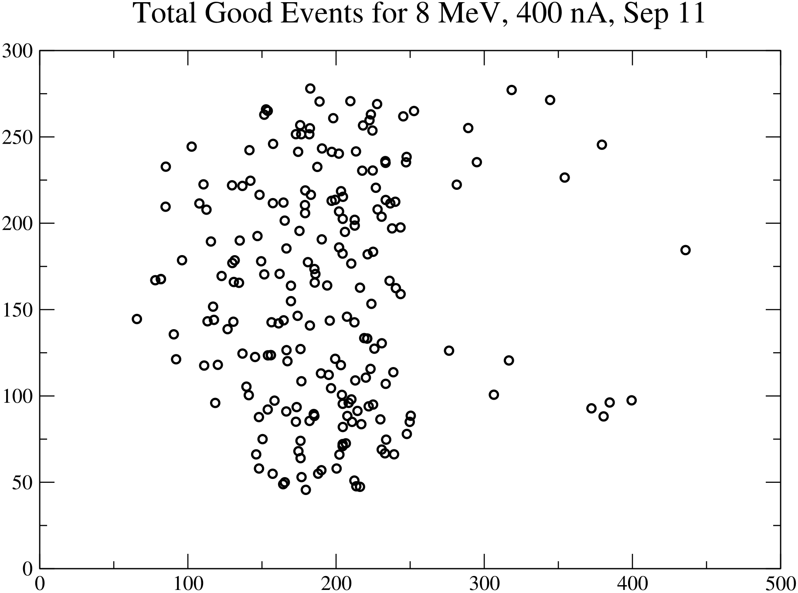
Fig. 3

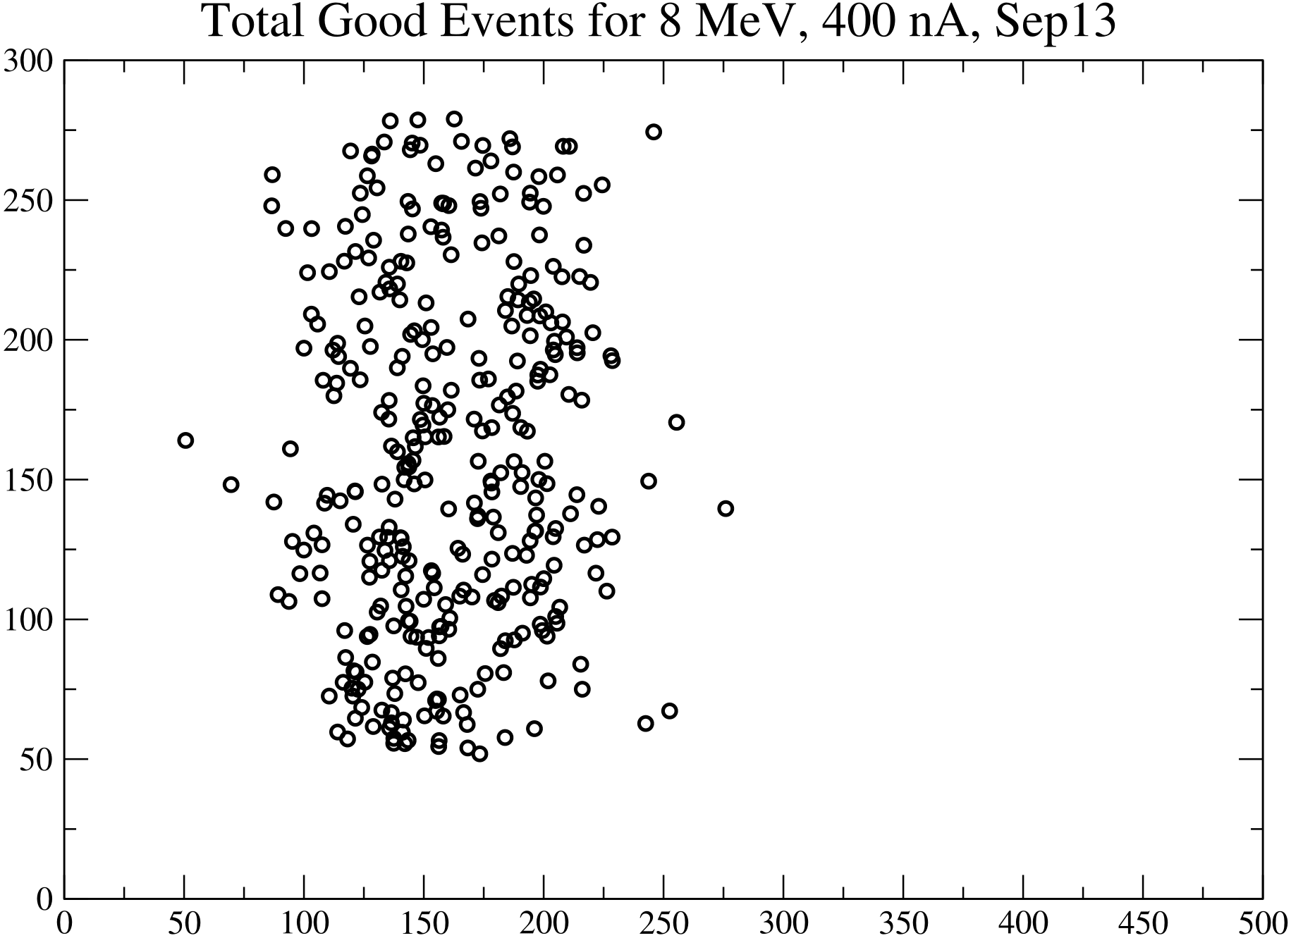
Fig. 4

- So we think that the later data are better than the earlier ones, although the reason why the Sept.11 data are higher cannot be explained. Perhaps the pressure was slightly lower and so we were at that time sensitive to 14N(g,p) as well or we had more background with the un-shifted beam which agrees with the difference in the localization plots shown in Figs. 3 and 4.

- The highest data point in Fig. 2 is from Sept 11 when we reduced the beam to 40 nA. The uncertainties are largest for this point. The reason why it is so high could be: a) the beam intensity was higher than 40 nA, b) with the lower rate we were more sensitive to background, c) this point was done with the non-centered beam (Sept.11) or d) we were sensitive to 14N(p,g).

- Still to be done: Analysis of the three measurements at 6.5 MeV and 4 MeV beam energy. For the 4 MeV point we had vacuum problems and the background-corrected number of events is not available. Also some of the later runs might be influenced by the chemical problems we encountered during the second week.

