Viewer dimensions

Viewer frame
Visible surface: print not yet released: 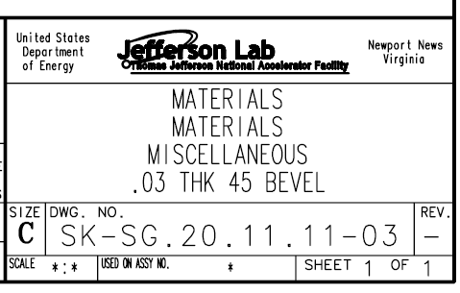
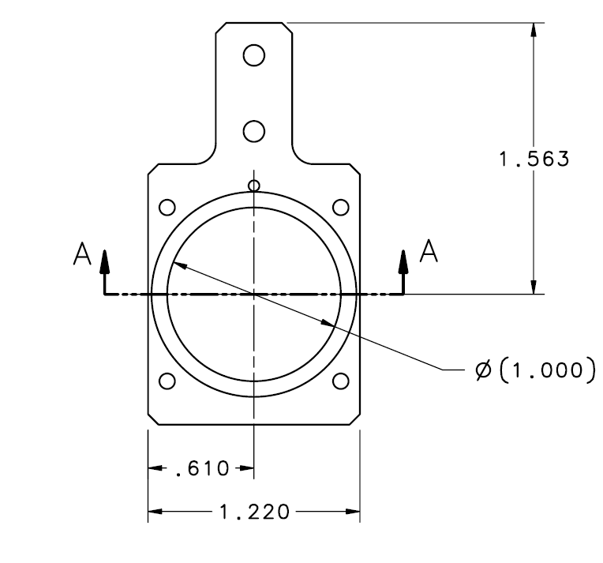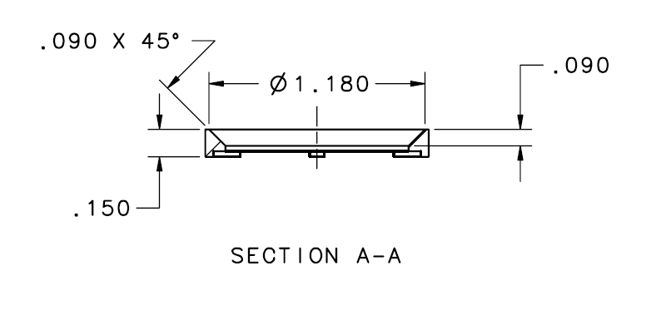

Chromox screens
Diameter: 28.45 mm, Thickness: 0.25 mm (partially obscured by frames)
2I01 hole dimension: 6 mm diameter
Other viewers with holes (UITF): 3 mm hole

Yag screens
Diameter: 28.5 mm, Thickness 0.25 mm (partially obscured by frames), 20 nm ITO coating on reverse for charge bleedoff
Marking pattern: 250 micron circles on the corners of 5 mm and 10 mm squares

Chopper viewers
Yag: 57.1 mm diameter, 0.25 mm thick, 20 nm ITO coating on reverse
Chromox: same dimensions

