A 500 KV INVERTED GEOEMTRY FEEDTHROUGH FOR A HIGH VOLTAGE DC ELECTRON GUN *
C. Hernandez-Garcia†, G. Palacios-Serrano, J. Grames, and M. Poelker, Thomas Jefferson National Accelerator Facility, Newport News, VA, USA

Abstract
The Continuous Electron Beam Accelerator Facility (CEBAF) injector at Jefferson Lab (JLab) utilizes an inverted-geometry ceramic insulator photogun operating at 130 kV direct current to generate spin-polarized electron beams for high-energy nuclear physics experiments. A second photogun delivers 180 keV beam for commissioning a SRF booster in a testbed accelerator, and a larger version delivers 300 keV magnetized beam in a test stand beam line. This contribution reports on the development of an unprecedented inverted-insulator with cable connector for reliably applying 500 kV dc to a future polarized beam photogun, to be designed for operating at 350kV without field emission. Such a photogun design could then be used for generating a polarized electron beam to drive a spin-polarized positron source as a demonstrator for high energy nuclear physics at JLab. There are no commercial cable connectors that fit the large inverted insulators required for that voltage range. Our proposed concept is based on a modified epoxy receptacle with intervening SF₆ layer and a test electrode in a vacuum vessel.

INTRODUCTION
In 2010 JLab embarked on a R&D program to test and implement conical ceramic insulators (known as inverted geometry) in high voltage direct current (dc) photoemission electron guns (photoguns thereafter) [1], as an alternative to large cylindrical ceramic insulators for electrically isolating the cathode electrode [2-4]. In the inverted-insulator design, the cathode electrode in vacuum electrically connects to the high voltage power supply using a commercial high voltage cable, while the insulator serves as the electrode support structure. In comparison with large bore cylindrical insulator photoguns, the inverted insulator design has less metal biased at high voltage contributing to field emission, smaller vacuum chamber resulting in better achievable vacuum, and no exposed high voltage components; thus, a sulphur hexafluoride (SF₆) tank is not required to suppress corona discharge. The success of the CEBAF photogun [1], which utilizes an inverted insulator and cable commercially available from the X-ray industry rated for 225 kV, motivated an R&D program to develop (in collaboration with industry) a larger insulator compatible with commercial 300 kV cable connectors [5,6]. In these designs, the rubber cable termination conforms to the conical insulator shape. By applying a thin layer of silicone grease to the cable termination, and sufficient compression, a snug fit without trapped air bubbles is ensured for robust operation without electrical breakdown.
The inverted insulator R&D program resulted in the construction and operation of a 200 kV photogun delivering polarized beams at a testbed accelerator [7], and a 300 kV photogun designed for generating magnetized beams in a testbed beam line [8,9], both using multi-alkali photocathodes. Figure 1 shows a picture of the insulators and electrodes used in these photoguns, compared to the proposed 500 kV insulator [10].
At even higher operating voltages, inverted insulator photoguns are appealing for a variety of applications: mA-level continuous wave (CW) electron beam-driven production of polarized positrons [11], production of highly polarized electron beams for the Electron Ion Collider [12] and for the proposed International Linear Collider [13]. A photogun design capable of meeting the stringent requirements of such applications must produce polarized electron beams without field emission at the operating voltage and maintain $1×{10}^{-12}$ Torr dynamic vacuum conditions with photocathode lifetime comparable to that in the CEBAF photogun [14], but at nearly 3 orders of magnitude higher CW beam current. These initiatives provide the motivation for this work - to develop an inverted insulator compatible with a commercial cable for applying 500 kV dc to a future polarized beam photogun providing sufficient margin for high voltage conditioning. The resulting photogun must operate reliably and field-emission-free at 350 kV dc. Such an insulator/cable termination design does not exist.
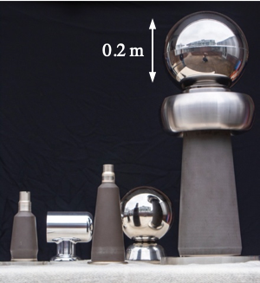
Figure 1: Inverted geometry insulators and electrodes utilized in JLab photoguns. From left to right: 200 kV R28, 300 kV R30, and the 500 kV assembly currently under testing.

THE 500 KV INSULATOR CONCEPT
Ideally, the envisioned 500 kV insulator would be of shape and size to mate with commercial high voltage cable terminations rated to 350 kV, which are longer than the 300 kV-rated R30 terminations. Although such an insulator does not exists, back in 2010 JLab in collaboration with SCT [15] developed doped alumina inverted insulators approximately twice as long as the R30s for a proposed 500 kV dc photogun [16], but their taper and aperture do not fit the 350 kV rated commercial cable terminations. Developing a custom insulator in collaboration with industry is beyond the scope of the proposal funding this work, thus an alternative was devised for coupling the 350 kV to the large doped inverted insulators readily available [6,16]. The concept is based on an epoxy receptacle that accepts the 350 kV cable, but tapered to fit the 500 kV insulator leaving a ~ 0.01 m gap filled with SF₆ pressurized to 0.69 Bar above atmospheric pressure (1.69 Bar absolute, 10 pounds per square inch gauge, PSIG thereafter).

* Work supported by U.S. Department of Energy, Office of Science, Office of Nuclear Physics under contract DE-AC05-06OR23177
† chgarcia@jlab.org.
The motivation for using SF₆ instead of silicon grease as an intervening layer is twofold. First, the epoxy receptcle is smaller in diameter than the ground side (open to air) of the insulator, thus the gap is too large to be filled with silicon grease as the large volume may trap air pockets. Second, the receptacle is rigid in contrast to the rubber cable termination which conforms tightly to the ceramic conical shape (Fig. 2).
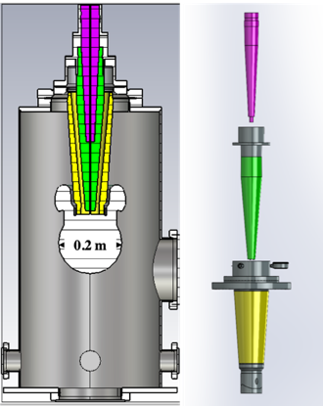
Figure 2: Left: Cross section of the model used for electrostatic simulations in CST EM Studio. Right:, SolidWorks exploded view of the cable plug (purple), tapered receptacle (green) and insulator (yellow) assembly (Right).
The size of the spherical electrode was chosen to fit through the opening of the test chamber, and as large as possible to reduce the gradient. The triple point junction shielding profile and size was optimized using the electrostatic solver CST EM studio with the goal to keep the maximum electric field ~10 MV/m at 500 kV. Design and operation of various dc photoguns has shown that if the electric field is kept at that value for the maximum operating voltage, field emission processing is more manageable. From the electrostatic field map shown in Fig. 3, it is clear that the test chamber walls are too close to the electrode, precluding the choice of larger electrodes. However, the purpose of this work is to test the insulator/cable plug concept to 500 kV. Once this is demonstrated, a future photogun would be designed with larger vacuum chamber to reduce the cathode electrode electric field at the operational voltage.
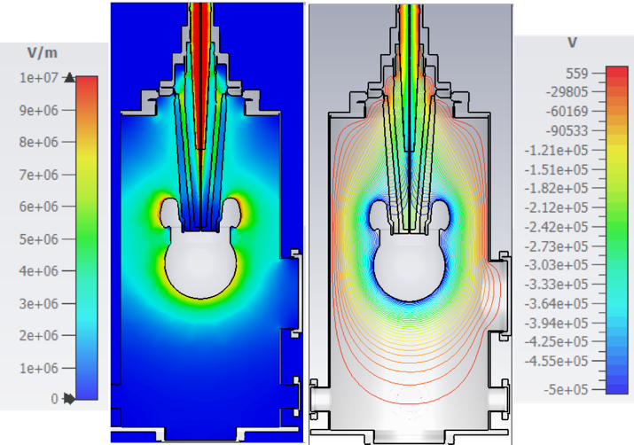
Figure 3: CST EM electrostatic simulation of the testing apparatus at 500 kV. Left: Electric field map. Right: Equipotential lines.

EXPERIMENTAL METHODS

Components Preparation and Assembly
The testing apparatus consists of two separate volumes: the main test chamber (237 L) and the SF6 reservoir on top of the insulator that provides the intervening volume between the insulator and the epoxy receptacle (2 L). The ceramic insulator was first welded to an 0.2 m (8 inch) ConFlat© flange and leak tested.
The spherical and triple point junction shield electrodes were polished in a barrel tumbler using first plastic cones in a diluted soap solution, followed by tumbling in dry crushed corncob [17]. Once polished, the electrodes were cleaned using lint-free wipes soaked in diluted de-greaser, followed by rinsing with deionized water and finally wiped off with iso-propanol. The ceramic insulator and flange were also wiped off with iso-propanol. Then the spherical electrode and triple-point junction shield were attached to the ceramic insulator as shown in Fig. 4.
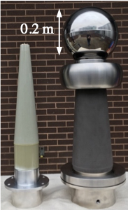
Figure 4: Picture of the tapered epoxy receptacle (left) next to the 500 kV doped alumina insulator with triple point junction shield and spherical electrode (0.2 m diameter).
The electrode-insulator assembly was then installed into the test chamber using an overhead crane due to its share weight (~30 kg). Since both the receptacle and the insulator are rigid components, the SF₆ reservoir that mechanically connects the insulator with the receptacle was designed to leave about 0.02 m gap between the bottom of the insulator and the tip of the receptacle to ensure proper sealing. Thus, the electrical connection between these two components is accomplished using a spring for good electrical contact (Fig. 5).
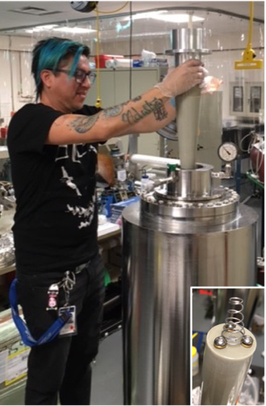
Figure 5: Postdoctoral fellow Gabriel Palacios-Serrano installing the modified epoxy receptacle to the SF6 reservoir assembly on top of the testing chamber. Inset: Close-up view of the spring attached to the end of the epoxy receptacle.
The assembled apparatus was then transported to the Gun Test Stand where both the main vessel and the reservoir were evacuated and back filled with SF₆ to 10 PSIG.

High Voltage Testing
The power supply is a Cockcroft-Walton generator inside a vessel filled with SF₆ gas to 10 PSIG. A 300 Mega-Ohm resistor was connected to the high voltage end of the power supply. The resistor is coaxial to a cylindrical appendage of the power supply vessel. The opposite end of this resistor connects to an unmodified 350 kV rated epoxy receptacle (350 kV GEN receptacle extended length, wide band Essex X-Ray & Medical Equipment, LTD. [5]) and is mounted on a flange to the appendage thus sealing the SF₆ environment. The high voltage 350 kV rated termination on Essex cable C2236 connects to the epoxy receptacle on one end, and to the modified receptacle in the high voltage testing apparatus on the other. The power supply features a voltage shutdown on pre-set over current limit.
The power supply was set to shut the voltage off on over-current at 0.2 mA. Voltage was applied incrementally at a rate of 5 kV/min in steps of 25 kV up to 150 kV, then at a rate of 1 kV/min in steps of 5 kV. A couple of over-current trips were observed at ~ 190 kV. After the third over-current power supply trip, the would shut off on over-current at voltages as low as 15 kV. Suspecting cable dam-age, the cable terminations were removed at both ends, as well as the receptacle. No damage was found in any of these components. To isolate the insulator form the receptacle, the spring making the electrical connection was removed. Voltage was applied without issues up to 50 kV.
Upon closer inspection, the insulator showed an electrical breakdown track on the side facing the epoxy receptacle. Sanding off the track markings resulted in slightly higher voltage before the power supply tripped off again on over-current at 22 kV. The unexpectedly low voltage at which electrical breakdown occurs on the insulator might be caused by too low SF₆ pressure in the intervening layer. This aspect is one of the core research points of the re-search project. The plan is to inspect the insulator on the test chamber side and if found without traces of arcing, repeat the experiment but at higher SF₆ pressure in the intervening layer with a brand new insulator. A pressure analysis is underway prior to attempting higher pressures.

CONCLUSION
JLab develops and implements inverted geometry ceramic insulators for 100-300 kV dc high voltage photoguns. These photoguns have delivered spin-polarized beams for CEBAF over a decade, and un-polarized mA-level beam in test injectors. Initiatives for production of spin-polarized positrons require mA-level polarized electron beam drivers. A photogun capable of operating at higher bias voltage for providing such beams does not currently exist. JLab is developing a custom inverted insulator connected to a commercial high voltage cable by means of a modified epoxy receptacle and intervening SF₆ gas layer, with the intent to bias a future photogun to 500 kV for achieving 350 kV operations without field emission. Preliminary tests shows electric breakdown on the insulator surface at 190 kV. This is surprisingly low breakdown voltage. Future tests will focus on increasing the SF₆ gas intervening layer pressure and on designing a custom insulator that conforms to the shape and size of commercial high voltage cable plugs, thus eliminating the SF₆ gas intervening layer.

ACKNOLEDGEMENTS
Funding for the postdoctoral fellow is provided by the Office of Science Funding Opportunity LAB 20-2310 with award PAMS-254442. The authors wish to thank D. “Bubba” Bullard for polishing the electrodes, T. DeSalvo and M. Weihl for assisting with the crane during the apparatus assembly, and B. Johnson for transporting the test apparatus to the gun test stand.

REFERENCES
[1] P. Adderley et al., “Load-locked dc high voltage GaAs photogun with an inverted-geometry ceramic insulator”, Phys. Rev. ST Accel. Beams vol. 13, p. 010101, 2010. doi:10.1103/PhysRevSTAB.13.010101
[2] N. Nishimori et al., “Experimental investigation of an optimum configuration for a high-voltage photoemission gun for operation at ≥ 500 kV”, Phys. Rev. ST Accel. Beams vol. 17, p. 053401, 2014. doi: 10.1103/PhysRevSTAB.17.053401
[3] J. Maxson et al., “Design, conditioning, and performance of a high volt-age, high brightness dc photoelectron gun with variable gap”, Rev. Sci. Instrum. vol. 85, p. 093306, 2014. doi: https://doi.org/10.1063/1.4895641
[4] C. Hernandez-Garcia et al., “A high average current DC GaAs photocathode gun for ERLs and FELs,” in Proc. 21st Particle Accelerator Conf. (PAC’05), Knoxville, TN, USA, May. 2005, pp. 3117-3119. doi: 10.1109/PAC.2005.1591383
[5] Dielectric Sciences, Inc., https://www.dielectricsciences.com
[6] A. Hernandez-Garcia, M. Poelker, and J. Hansknecht, “High voltage studies of inverted-geometry ceramic insulators for a 350 kV dc polarized electron gun”, in IEEE Transactions on Dielectrics and Electrical Insulation vol. 23, p. 418, 2016. doi: 10.1109/TDEI.2015.005126
[7] R. R. Mammei et al., “Charge lifetime measurements at high average current using a K2CsSb photocathode inside a dc high voltage photogun”, Phys. Rev. ST Accel. Beams vol. 16, p. 033401, 2013. doi: 10.1103/PhysRevSTAB.16.033401
[8] C. Hernandez-Garcia et al., “Compact -300 kV dc inverted insulator photogun with biased anode and alkali-antimonide photocathode”, Phys. Rev. Accel. Beams vol. 22, p. 113401, 2019. doi: 10.1103/PhysRevAccelBeams.22.113401
[9] S. A. K. Wijethunga et al., “Space charge effect in low energy magnetized electron beam”, in Proc. 12th Int. Particle Accelerator Conf. (IPAC2021), Campinas, SP, Brazil, May 2021. doi: 10.18429/JACoW-IPAC2021-WEPAB093
[10] C. Hernandez-Garcia et al., “Inverted Geometry Ceramic Insulators in High Voltage DC Electron Guns for Accelerators”, in Proc. Of the 2021 IEEE Conf. on Elec. Insul. And Diel. Phenomena (CEIDP), Vancouver, BC, Canada, Dec. 12-15, 2021. doi: 10.1109/CEIDP50766.2021.9705333
[11] D. Abbott et. al., “Production of Highly Polarized Positrons Using Polarized Electrons at MeV Energies”, Phys. Rev. Lett., vol. 116, p. 214801, 2016. doi: 10.1103/PhysRevLett.116.214801
[12] E. Wang et al., “High voltage dc gun for high intensity polarized electron source”, Phys. Rev. Accel. Beams vol. 25, p. 033401, 2022. doi: 10.1103/PhysRevAccelBeams.25.033401
[13] V. Shiltsev, and F. Zimmermann, “Modern and future colliders”, Rev. Mod. Phys, vol. 93, p. 015006, 2021. doi: 10.1103/RevModPhys.93.015006
[14] J. T. Yoskowitz et al., “Improving the operational lifetime of the CEBAF photo-gun by anode biasing”, in Proc. 12th Int. Particle Accelerator Conf. (IPAC2021), Campinas, SP, Brazil, May 2021. doi: 10.18429/JACoW-IPAC2021-WEPAB104
[15] SCT, http://www.sct-ceramics.com
[16] J. . E. Hannon, P. Evtushenko, and C. Hernandez-Garcia, “Electrostatic modeling of the Jefferson Laboratory inverted ceramic gun”, in Proc. 1st Int. Particle Accelerator Conf. (IPAC’10)., Kyoto, Japan, May 2010, paper TUPE075, pp. 2305-2307.
[17] C. Hernandez-Garcia et al., “High voltage performance of a dc photoemission electron gun with centrifugal barrel-polished electrodes”, Rev. Sci. Instrum. vol. 88, p. 093303, 2017. doi: https://doi.org/10.1163/1.4994794

