UITF, what’s the plan?
8/4/2021 (Poelker/McCaughan)

Before the end of the calendar year, we would like to:
- Provide 100 nA beam through a thin vacuum window, to demonstrate decomposition of 1,4-dioxane in wastewater
  - Need to follow prescribed commissioning plan that includes radiation shielding check out, BLM checkout, BCM checkout and fast valve checkout, ~ 1 week
  - Optics measurements, ~ 1 week
  - At least ~ 1 week of irradiation studies
- Continue to study the “booster” aka QCM. (Past studies indicate the booster is “good”, but would like more results, we could easily chew up a month of time)
  - Yan to compare beam deflection and x/y coupling, booster and 1/4CM (mostly done but now we have better viewer downstream of booster, so want to repeat)
  - Optics studies - Emittance measurements and “back propagation” method using qsUtility to compare measurement and simulation, and to estimate energy spread. Plus GPT simulation: compare predicted beam size to beam size measured at viewers, harps
  - Energy spread vs off-crest operation, buncher amplitude
  - Minimum gun voltage to make acceptable MeV beam
  - Bunchlength studies – aka, yao time of flight studies
  - Stability studies: microphonics, jitter, LLRF3.0 development?

Recognizing that:
- CEBAF takes priority, labor resources in demand, UITF is “best effort”
- CMTF schedule is busy
- Cool down, warm up, cool down, warm up, etc., does this take a toll?
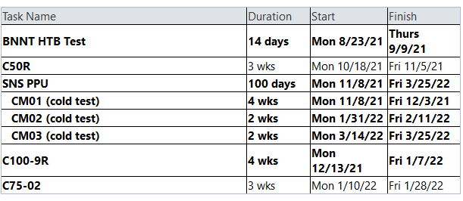

What needs to happen to perform the water irradiation measurements?

Hot Check Out:
- Cool down the booster
- I&C stuff: viewers, video only channel, BPMs, harp at M703
- new valve
- test the fast valve
- steering magnets reconfigured, moved from elevated line
- PEPPo solenoid
- UED updated with proper naming convention
- Gun happy at 180 kV
- Photocathode fabricated
- laser aligned
- Stack lead brick at FCup3 and FCup4
- Re-attach water lines FCup3, re-cable other items in this area

Commissioning:
- Deliver VL MeV beam to spectrometer, set energy
- Deliver VL MeV beam to FCup4
- Work with RadCon to validate shielding for 100 nA CW beam
- Work with SSG to check out BLM function along new beamline
- Setup Chopper
- Set buncher amplitude using spectrum analyzer on Brock cavity
- Xi Li: optics measurements, with Chopper ON/OFF
- Set raster amplitude
- Dose water

