A High Precision Mott Polarimeter at 5 MeV

J. M. Grames¹, C. K. Sinclair^{1,}*, R. Sulieman¹, M. Poelker¹, X. Roca-Maza⁴, M. Stutzman¹, A. Mamun⁵, M. McHugh², D. Moser¹, J. Hansknecht¹, and T. J. Gay³

¹Thomas Jefferson National Accelerator Facility
Newport News, VA 23606
²Physics Department, George Washington University
Washington, DC
³Physics Department, University of Nebraska
Lincoln. NE
⁴INFN, Milan, Italy
Department of Mechanical and Aerospace Engineering, Old Dominion University
Norfolk, VA

We report on the design and performance of a Mott polarimeter optimized for a nominal 5 MeV electron beam energy. Using beam with a 31 MHz time structure from the electron injector of the CEBAF accelerator, and incorporating time-of-flight in the electron detection, we can cleanly isolate those detected electrons that originate from the scattering foil. This significant background elimination results in measured scattering asymmetries which are exceptionally stable over a very broad range of beam conditions, beam currents, and foil thicknesses. In two separate series of measurements from two different photocathode electron sources, we have measured the Mott scattering asymmetries produced by an approximately 86% transversely polarized electron beam incident on ten different gold foils with areal densities between 96 μg/cm² and 1.93 mg/cm². The statistical uncertainty of the measured asymmetry from each target foil is below 0.25%. We confirmed that within this statistical precision, the measured asymmetry was unaffected by +/- 2 (3?) mm shifts in the beam position on the target, and by beam current changes and deadtime effects over a wide range of beam currents. A detailed simulation of the complete polarimeter using GEANT4 has confirmed that double scattering in the target foil is the sole source of the dependence of the measured asymmetry on foil thickness, and gives a result for the asymmetry versus foil thickness in excellent agreement with our measurements. Future measurements at different beam energies and with different Z target foils will seek to bound uncertainties from small effects such as radiative corrections. With a high precision measurement of the beam polarization using a different polarimeter, which is clearly possible at the CEBAF accelerator, simultaneous measurements with this polarimeter will allow a high precision comparison of our measured asymmetries with theoretical calculations of the Mott analyzing power.

*Present address: P.O. Box 8713, Medford, OR 97501

Content that must be included in the Mott polarimeter paper (not necessarily in correct order).

-1. Abstract (Sinclair) (Draft completed)

- Introduction (Sinclair) (Draft completed)

- The physical construction of the polarimeter (Sinclair, Grames) (Draft completed)

  - The scattering chamber, optimized for 5 MeV (i.e. 172.6º scattering angle)
  - Internal collimation
  - Target ladder and foils
  - OTR viewport
  - Beam dump, including long channel and dump magnet
  - The detector packages (four ports)
  - Shielding
  - vacuum

- Detector electronics, including TOF details (Sulieman)

- The polarized source and injector (only basic descriptions, but including details relevant to polarization and its measurement) (Sinclair, Poelker)

  - The gun, cathode, (including laser spot size at cathode and QE map?), and 130 kV operation (vs. original design at 100 kV?)
  - Wien filters and solenoids
  - The laser system, including details of 31.1875 (and 62.375) MHz operation and the IHWP
  - Chopping, bunching, capture, and quarter cryomodule
  - Beam monitoring and transport to polarimeter and spectrometer (including BPMs), and measured beam properties (emittance, E, dE, spot size at foil)
  - Beam current measurements (F. cups, BCM)

- Setup of polarization with Wien and solenoids, data collection, online analysis, and final offline analysis, including complete details of E counter spectra and TOF, event selection, etc. (Poelker, Sulieman, Moser)

- Systematic studies (deadtime, PITA, IHWP, position change, sign of dump dipole, ultimate elimination of dump dipole, polarization stability measurements during run) (Sinclair, Grames)

- Details of foils used and their thickness measurements by Lebow, FESEM, and singles rates (Stutzman, Mamun, Gay)

- Experimental results – measured asymmetry versus measured foil thickness and hyperbolic fit to data (Moser)

- GEANT4 model of the polarimeter and its performance, including generation of a fit to the data from first principles (McHugh)

- Calculated Sherman function and its uncertainties, and comparison with model and experimental data (Roca-Maza, Sinclair)

- Mention the spin dance and intercomparison of very different polarimeters (coupled with essentially zero polarization degradation in transport thru CEBAF) (Grames, Sinclair)

- Summary and Conclusions (Grames, Sinclair, Gay)

- Future plans (measurement with different Z foils, and at different energies, allowing some bounds to be placed on systematic uncertainties of the Sherman function calculations; precision polarimetry with a different polarimeter to allow extraction of the Sherman function from our results) (Sinclair, Poelker, Grames, Gay)

- Acknowledgments (All) (Draft completed)

- References (Sinclair) (In process with draft writing)

INTRODUCTION

Soon after the publication of Dirac’s revolutionary equation for the electron, Mott calculated the elastic scattering of electrons by the Coulomb field of the nucleus in this new formalism (M-1). His motivation was to determine whether the anticipated polarization of the scattered electron, produced by spin-orbit coupling and in principle measurable in a double scattering experiment, could be used to determine the magnetic moment of the free electron, with its then unusual g-factor of 2. It was understood at the time that the uncertainty principle precluded a direct measurement of the electron magnetic moment.

Mott’s solutions for the spin-flip and non-spin-flip scattering amplitudes are conditionally convergent series in which pairs of terms very nearly cancel, requiring the calculation of a very large number of terms to obtain reasonably precise values for the scattering cross section and scattered beam polarization. Although various mathematical transformations were employed to reduce the complexity of the calculations, they remained tedious. Before the advent of digital computers calculated values for the cross section and polarization were restricted to a limited range of electron energies at a 90º scattering angle. The first extensive computer calculations of the cross section were done by Doggett and Spencer, and by Sherman, who also calculated the scattered beam polarization, which is transverse to the plane of scattering (D-1, S-1). Since that time, the analyzing power of Mott scattering has been known as the Sherman function.

Several early attempts to demonstrate electron polarization in a double scattering experiment gave negative or inconclusive results prior to the first successful measurement by Shull et al. (S-2). As Mott scattering was the only known method for producing polarized electrons at the time, experiments using them were uncommon. One early application was a measurement of the free electron g-factor with 0.5% precision, satisfying Mott’s original motivation, (though not in the way he envisioned) (L-1). Following the experimental demonstrations of parity violation in the weak interactions in 1957, Mott polarimeters were developed in a number of laboratories to measure the longitudinal polarization of beta decay electrons. This led to a much improved understanding of the experimental technique, and to several well-designed polarimeters, capable of achieving percent level precision in polarization measurement. Good examples of such polarimeters are given by Greenberg et al., who measured the asymmetry of 194 keV electrons from ⁶⁰Co beta decay with about 6% uncertainty in 1960, and Brosi et al., who measured 616 keV electrons from ³²P beta decay with about 1% uncertainty in 1962 (G-1, B-1).

The development of polarized electron sources for accelerators began in the late 1960s, and required polarimetry to quantify and improve their performance. Mott scattering at modest energies, typically 60 to 120 keV, was universally employed for these studies. The early polarized sources delivered average currents in the μA range, and peak currents of many mA. These average and instantaneous beam currents are much too large for Mott polarimetry at such low energies, requiring that they be greatly reduced – to the point where it is effectively impossible to monitor the average beam position or current with meaningful precision during a polarization measurement, to say nothing of observing any possible dependence of these beam properties on the beam polarization. Even the very thinnest gold scattering foils are “thick” in the sense that plural scattering is a significant problem. Inelastic scattering also presents difficulties, particularly given the relatively poor energy resolution of the detectors used, although careful electrostatic design of a polarimeter can reduce the uncertainty associated with inelastic scattering. Screening of the nuclear potential by the atomic electrons is large at these low energies, and adds uncertainty to the calculated analyzing power. The result of these difficulties is that the uncertainty in the polarization measured by Mott scattering at these low energies is a few percent at best.

Mott scattering for precision electron transverse polarization measurement is not experimentally easy, as a quick examination of the cross section and analyzing power reveals. High Z scattering foils must be used to provide a large spin-orbit effect. The analyzing power is largest at large scattering angles, while the cross section drops very dramatically from small to large angles – facts which become ever more pronounced as the electron energy increases. As a result, for every scattering event providing useful polarization information, a very much larger number of electrons scattered at smaller angles are also generated. Unfortunately one can detect only the scattered electron. It is essentially impossible to assure that a detected electron arises from a single large angle scattering, or from more scatterings from the far more prolific smaller angle scattering events coupled with additional scattering from the apparatus walls, target supports, etc. Since each scattering is primarily elastic or near-elastic, the electron energy is not a very useful discriminant against these latter cases, particularly when the energy resolution of typical detectors is incorporated. Thus a typical Mott scattering asymmetry measurement generally includes an uncertain and potentially significant contamination from the detection of electrons which did not arise from a single large angle elastic scattering in the target foil, and which has a very different scattering asymmetry.

With the high average current available from contemporary polarized sources in use at accelerators, it becomes practical to study Mott polarimetry at beam energies in the MeV range. Beam from these accelerators has RF time structure, offering the possibility of time-of-flight discrimination against electrons that do not originate from the primary scattering foil. The RF time structure and higher average current of the beam make precision monitoring of the beam position and current possible. The detailed beam profile incident on the scattering foil is made visible by optical transition radiation (OTR), which can be measured continuously for each polarization state during a polarization measurement. The scattering foils can be thicker than those used at lower energies without overwhelming plural scattering problems. Screening effects are very small at few MeV energies, while the energy is still low enough that nuclear size effects are also quite small (Z-1, U-1). Both of these effects can be calculated with ample precision at the beam energies in question, and contribute very little to the uncertainty in the calculated Sherman function. Radiative corrections, though believed to be small, are difficult to calculate, and are the largest contribution to the theoretical uncertainty in the Sherman function in this energy range. By measuring the Mott asymmetry from foils of several different Zs, and at several different energies, it may be practical to place bounds on this theoretical uncertainty. All of these considerations led us to develop a Mott polarimeter capable of high statistical precision measurements for the injector of the CEBAF accelerator, which operates at a nominal 5 MeV beam energy. (More recently, this energy has been increased to 6.2 MeV.)

Mott polarimetry at energies above 1 MeV was first employed in a search for possible time-reversal violation in the beta decay of ⁸Li (A-1, S-3). The success of this experiment led some of its participants, with collaborators at the MAMI accelerator at Mainz, to make detailed measurements of the analyzing power of ²⁰⁸Pb foils at 14 MeV (C-1, S-4). Their measurements were the first to convincingly show the reduction in analyzing power from the nuclear size effect, in agreement with the calculations of Ungincius et al. (U-1). These measurements are consistent, within their approximately 3% statistical uncertainty, with the thickness dependence of the analyzing power resulting entirely from a second scattering with no net polarization dependence. These double scattering events must belong to one to two categories, viz. (a) a first (second) scattering very close to 90º, followed by a second (first) scattering making the remainder of the total large scattering angle, or (b) a first (second) relatively large angle scattering followed by a second (first) small angle scattering completing the net large scattering angle. The very thin target foils, and the strong dependence of the differential cross section on angle, effectively restricts events from other than these two classes from meaningful contributions at few MeV energies.

The 5 MeV polarimeter we developed has been in operation for twenty years, and has proven to be a reliable monitor of beam polarization at the exit of the injector. The beam polarization is not degraded during multiple acceleration passes through the CEBAF accelerator, and remains completely in the horizontal plane between the polarized injector and the experimental targets, making polarization measurement in the injector very relevant to the full energy physics measurements. Since its original development, significant improvements to the shielding, detectors, electronics, time-of-flight system, and beam dump have been made, resulting in the current version of the polarimeter presented below. A very early result reported asymmetry measurements from foils of three different Zs in reasonable agreement with expectations, as well as OTR measurements showing that the beam profile was independent of the beam polarization to a high degree (P-1). Detailed measurements of a beam with constant polarization and three different beam energies (2.75 MeV, 5.0 MeV, and 8.2 MeV) made with this polarimeter following the addition of time-of-flight rejection of background have been presented, along with fits to the asymmetry versus target foil thickness at each energy using a semi-empirical model based on Wegener’s study of the double scattering problem (S-5, W-1). The entire data set is fit very well with this model, as shown in figure 1, and is consistent with the polarization at all three beam energies being the same within about 0.3%. It is worth noting that foil thicknesses spanning a factor of 100, from 0.05 μm to 5 μm were used in these measurements. Using an unpolarized beam, it was determined that the instrumental asymmetry of the polarimeter was (4 +/- 6) x 10⁻⁴.

One other polarimeter operating in the MeV range at an accelerator has been reported (T-1). This device was operated between 1 and 3.5 MeV at the MAMI accelerator. It employed two double focusing spectrometer magnets followed by scintillation counters, with a fixed scattering angle of 164º, the angle of maximum analyzing power at 2 MeV. They achieved a reproducibility < 1% in their asymmetry measurements, and believe they reach an absolute accuracy for the measured polarization of about 1%.

The primary motivation of this work has been to reduce the statistical uncertainty of the measured beam polarization of polarized electron beams used for parity violation studies. At the present time, the predominant uncertainty in the measured asymmetry in electron scattering parity violation studies comes from the lack of knowledge of the beam polarization. Consequently, a meaningful reduction in the electron beam polarization uncertainty will directly impact the physics interpretation of high energy parity violation measurements. The statistical and systematic uncertainties associated with electron beam polarization measurement are discussed below.

THE PHYSICAL DESIGN OF THE POLARIMETER

The polarimeter vacuum chamber is comprised of two segments – a section containing the target foils, collimators, and detector ports, and a long drift section ending in a beryllium and copper beam dump structure. The polarimeter is connected directly to a beam port at 12.5º off the main accelerator beam line, with no intervening vacuum windows. Beam is steered to the polarimeter by a well-measured dipole magnet (B-2). This magnet can also steer the beam to an analysis port at 25º to the main beam line. When not in use, the polarimeter is isolated with a beam line vacuum valve. Vacuum in the chamber is maintained with a 30 l/s DI ion pump, which maintains a nominal pressure below ~ 10⁻⁶ Pa. The internal surfaces of the chamber have an aluminum sleeve to reduce both backscattered electrons and the photon background in the detectors.

The main chamber, shown in figure 2, has four detector ports, each centered on a scattering angle of 172.6º, and separated by 90º in azimuth, two in the horizontal plane, and two in the vertical plane, allowing simultaneous measurement of both components of the transverse polarization. The scattering angle is at the nominal maximum analyzing power for 5 MeV electrons. Four internal knife-edge collimators with 4.87 mm diameter apertures are precisely machined in an aluminum plate, centered on an aperture to pass the incident beam. This collimator plate is mounted on a large diameter copper plate. The solid angle of each detection channel is 0.24 msr. The collimator plate was positioned so the four apertures were centered on the 172.6º scattering angle lines between the center of the scattering foil and the detector packages by precision survey techniques. The copper plate covers nearly all of the cross section of the scattering chamber. Scattered electrons that pass the collimators exit into the detectors through 200 (or 125 μm?) μm aluminum windows, immediately followed by 9.7 mm diameter apertures in a 12.7 mm thick aluminum plate centered on the 172.6º scattering angle.

The target ladder is mounted on a bellows sealed translation mechanism with a stepping motor drive providing 600 mm of travel. It has 16 target foil mounting positions, one of which is intentionally left open, and another which contains a chromox beam viewscreen, leaving 14 positions available for scattering foils. For the work reported here, a total of 14 gold foils were installed. The target ladder assembly is thoroughly described in a Technical Note (G-3). Details of the target foils used are discussed in a later section. Finally, a port with an optical window is located on the side of the chamber behind the target foil plane, allowing the target foil to be viewed by a polished stainless steel mirror. Backward propagating OTR provides a visible image, viewed by a CCD camera, of the beam incident on the scattering foil. OTR provides an accurate, non-saturating image of the beam profile at the target foil for each polarization state.

A 2.5 meter section of 20 cm diameter stainless steel vacuum tube, lined with an aluminum sleeve and terminating in a beam dump, follows the scattering chamber. The dump is a 6.35 mm thick piece of Be metal 20 (less than 20?) cm in diameter, which is screwed into a water-cooled re-entrant copper flange structure. The use of Be, with its low Z and excellent thermal conductivity, greatly reduces the backscattered electron flux from the dump, as well as the general photon flux from the dump. Operation with 75 μA of beam current (more?) is easily achieved with this dump.

Figure 3 provides the details of one of the four identical detector packages. Each package contains two plastic scintillation counters behind a lead and aluminum collimator. The first “ΔE” counter is a 1 mm thick, 25.4 mm square plastic scintillator, while the second “E” counter is a 76.2 mm diameter by 62.6 mm long plastic scintillator. The ΔE scintillator is optically connected to a 25.4 mm diameter phototube (Hamamatsu R6427) by an acrylic lightguide glued to both the scintillator and the phototube, while the E scintillator is directly glued to the face of a 76.2 mm phototube (Hamamatsu R6091). The surfaces of the E scintillator were painted with a diffuse reflector to improve the optical photon transport to the photomultiplier cathode. The entire four detector package was enclosed in at least 10 cm thick lead shielding constructed from standard 51 x 102 x 203 mm lead blocks.

Detector electronics, including TOF details (Suleiman)

The Mott detectors consist of four sets of plastic scintillator detectors: two horizontal (Left and Right) and two vertical (Up and Down). The four sets are identical and each set is made up of two detectors: DE and E detectors. The DE detector is made of EJ-212 plastic scintillator of the size 1 mm x 1 inch x 1 inch. The detector is glued to an Acrylic Light Guide (0.125 inch x 1 inch wide x 2 inch long). The light guide is glued to 1-inch photomultiplier tube (PMT) (Hamamatsu R6427 in an H7415 Assembly). The E detector is made of EJ-200 plastic scintillator cylinder of the size 3 inch diameter x 2.5 inch long painted with EJ-510 with one end clear which was glued to a 3-inch PMT (Hamamatsu R6091 in an H6559 Assembly). DE-E detector set (shown in Figure 1) is designed to eliminate signal from gammas where the detection efficiency in the thin DE detector is very small. For electrons, about 10 keV is deposited in the DE detector while the rest of its energy is deposited in the E detector. The PMTs HV were adjusted such that signals of ΔE and E are about -200 mV. The DE PMT HV was about -1300 V while the E PMT was operated at -1200 V. Figure 2 shows an E raw signal (top) and a DE raw signal (bottom).
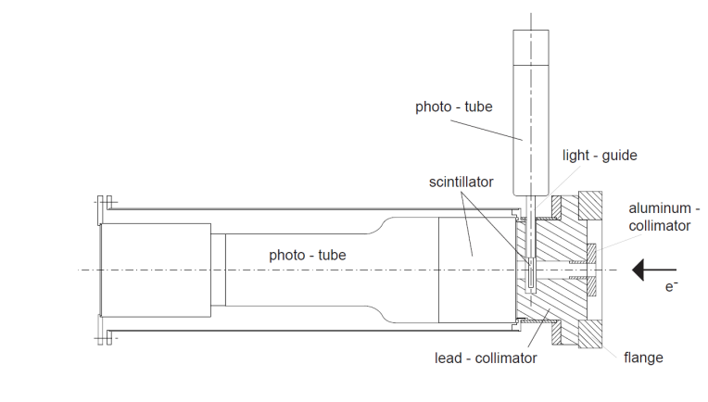
Figure 1: Mott detector assembly.
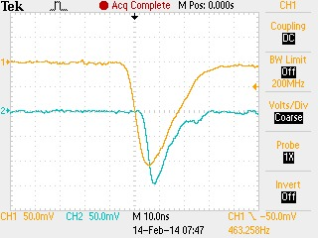
Figure 2: E and DE raw detector signals

Figure 3 shows the electronic logic diagram from the PMT all the way to the Data Acquisition readout. The DE detector signal is delayed by 48 ns using a cable delay then sent to a linear fan-out Philips Scientific NIM module 748. A copy of the detector signal is readout by a Flash Analog to Digital Converter (FADC). Another copy is sent to 715 Constant Fraction Timing Discriminator. A third copy is sent to 705 Octal Discriminator that generated a veto signal with thresholds of -450 mV (more than twice the size of signal from individual Mott electron). This veto signal is then used to eliminate any pileup events in the DE detector which turns out to be very negligible. There are two outputs from the 715 Timing Discriminator: one output goes to a Struck SIS3801 scaler, the second output goes to Philips Scientific Logic NIM Module 754 to perform a coincidence between the DE and E detectors.

The E detector signal is sent to a linear fan-out where one copy is sent to FADC while the other copy is sent to a Timing Discriminator. The timing discriminator has two outputs: one to the scaler and the other to the logic AND module to generate the coincidence signal from a set of DE-E detectors. The coincidence signals are then sent to a scaler and to Philips Scientific Logic NIM Module 754 to perform an OR with the other three detector sets.

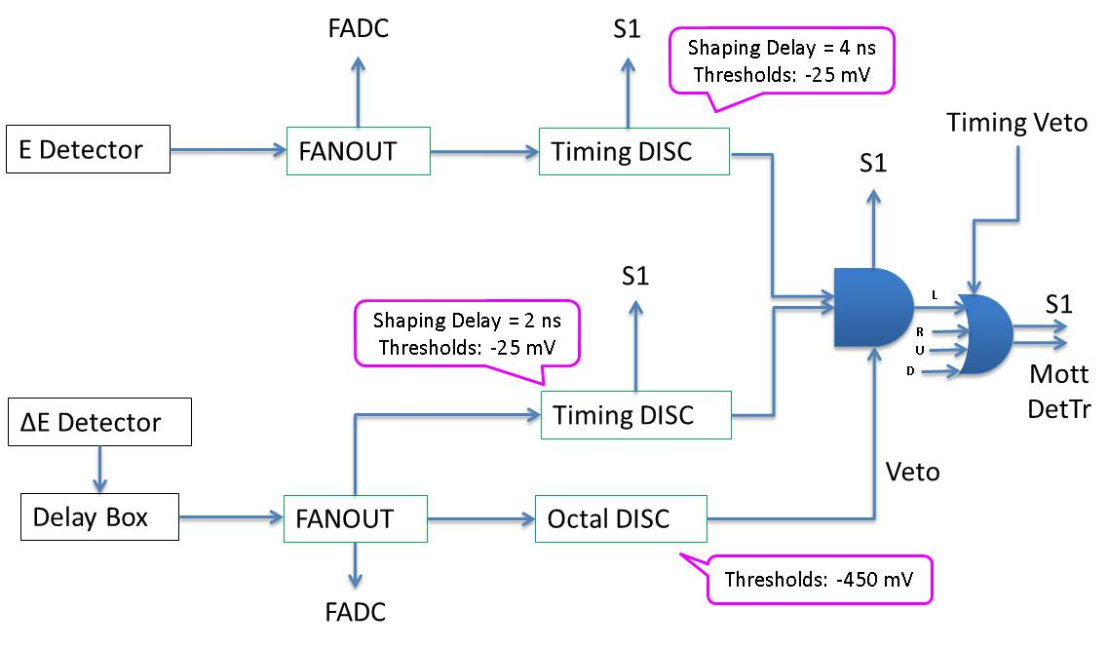
Figure 3: Path of DE and E signals from one set of detectors. The four sets of detectors have identical paths and are combined with an OR logic module.
The four sets of detector are then combined with an OR logic NIM module 754. There are two outputs from this module: one goes to a scaler to count the number of Mott events in the four detector sets and one labeled as Mott Detector Trigger and used as an input the Data Acquisition trigger system. The timing veto to eliminate the dump events was implemented using this module.

The Data Acquisition system (DAQ) is VME based and used MVME6100/VxWorks from Motorola during Run I. Before Run II, the DAQ was upgraded to use Intel/Linux VME Single Board Computer (SBC) model VX915 from Concurrent Technologies. In addition to the control board, the VME crate (CAEN VME64X VME8200) has the following boards: Trigger Interface and Distribution (TID) Module made by Jefferson Lab Data Acquisition Group, an FADC and its Distribution Board, also made at Jefferson Lab, CAEN v775 Time to Digital Convertor (TDC), and two Struck SIS3801 scalers (S1 and S2).

The TID is responsible for providing a low-jitter system clock and fixed latency trigger signals for the Front-end readout boards in the VME data acquisition crate. We have two trigger signals: a Mott signal (shown is Figure 3) that is used to collect (the random) Mott events and Helicity trigger signal that runs at a fixed rate and can be used to read the scalers counts per helicity window (to measure the helicity correlated charge asymmetry, for example).

The FADC is a 250 MS/s (Samples/second) 12-bit ADC that is used to sample the detector signals similar to a digital oscilloscope. It has 16 channels input. The eight channels used for the Mott detectors PMT signals have -500 mV full-range. Figure 4 shows an example of the 4 ns samples for few Mott events in the E detectors. For every Mott event in any of the four detector sets, 50 samples from each of the 16 FADC channels for all the four detector sets were part of the readout.

The TDC has a full scale of 134 ns and a bin resolution of 34 ps/channel. The TDC is operated in Common Start Mode where the start comes from the 31 MHz laser system and the stop is a copy of the Mott Detector Trigger signal that is delayed by 322 ns.

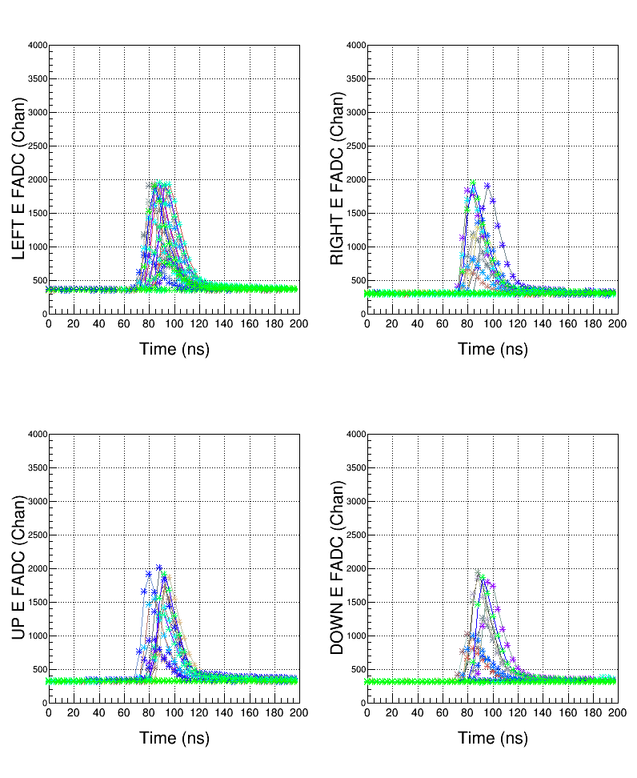
Figure 4: FADC raw 50 samples (every 4 ns) of E detector signals for few Mott events in each detector set.

The two Struck SIS3801 scalers

The Helicity signals

We used CEBAF Online Data Acquisition (CODA) software to collect all the information pertain to an event and write it to a file. Each file (Run) has few hundreds of thousands of events. Off-line, analysis software goes though all the events and for each event, the data from the FADC and the TDC are carefully examined.

How is the energy calculated from FADC? For each Mott event, 48 samples of the detector raw signal were written to the data file. In the analysis, the first 10 samples are used to calculate the average pedestal (p) (p $=\frac{1}{10}\sum_{s=0}^{9}{ADC_Sample_s}$) and the energy (in units of channels) is calculated by summing the samples from 10 to 49, $E=\sum_{s=10}^{49}{(ADC_Sample_s -p)}$.

How is the time-of-flight calculated from the TDC?

THE POLARIZED ELECTRON INJECTOR

The polarized electron injector for CEBAF is comprised of several subsystems, viz. a HVDC electron gun with a photoemission cathode; a laser system for illumination of the photocathode; a group of static electromagnetic elements to orient the spin of the electron beam; several RF cavities to temporally shape the individual electron bunches and accelerate them to full energy; and a number of conventional steering and focusing magnets and beam diagnostic elements to establish and maintain the desired beam conditions. The plan view of the injector, from the electron gun to downstream of the Mott polarimeter, is shown in figure 3.

The DC electron gun operates at 130 kV, and has a load lock to allow the exchange of photocathodes without breaking the ultrahigh vacuum in the gun (A-2). The photocathode is a strained multilayer GaAs-Ga_{x}As_{1-x}P structure which reliably delivers ~ 86% longitudinally polarized electrons when illuminated by 100% circularly polarized light of slightly above bandgap photon energy (M-2). Illumination of the photocathode is normally done with a system of three RF gain-switched lasers, each operated at a 499 MHz rate (H-1). These lasers, in conjunction with a 499 MHz RF chopping system in the injector and 499 MHz RF separators following the individual acceleration passes through the 1497 MHz CEBAF accelerator, support the delivery of independent current and energy beams to three experimental halls (ref??). For the work reported here, only a single 499 MHz laser was used. This laser was operated on the 16th sub-harmonic of 499 MHz, producing a train of electron bunches at a 31.1875 MHz, and thus a time separation of 32.1673 ns between electron bunches. Producing an optical pulse train at this low frequency was accomplished by a digital laser gain-switching technique, which produced clean optical pulses free from secondary pulses (F-1). The fundamental laser wavelength was 1560 nm, which was frequency doubled to 780 nm, providing maximum electron polarization from the photocathode. The linear polarization of the doubled laser beam is converted to circular polarization with a Pockels cell. A high quality zero-order mica waveplate before the Pockels cell allowed the sense of the circular polarization to be reversed while leaving the Pockels cell voltages unchanged.

Illumination of the photocathode with circularly polarized light produces longitudinally polarized electrons. Any residual transverse polarization of the optical beam does not result in transverse polarization of the electron beam. Polarized electron experiments generally require longitudinally polarized electrons. There is a very large polarization precession in the horizontal plane of the CEBAF accelerator between the polarized electron source and the experimental targets, requiring that the orientation of the polarization of the beam exiting the electron injector be properly oriented to give a maximum longitudinal polarization at the experiment. This is done with a pair of Wien filters and solenoids in the injector, with one solenoid following each Wien filter. A Wien filter employs crossed electric and magnetic fields, perpendicular to each other and to the beam velocity. The fields are chosen to give a zero net deflection to the beam while rotating the spin in the plane of the electric field. Our Wien filters are described in detail in section III of Grames et al. (G-2). They are capable of providing a 90º spin rotation at the 130 keV beam energy.

Magnetic solenoids with their magnetic field axis colinear with the beam velocity both rotate the transverse component of electron spin passing through them (leaving any longitudinal component undisturbed), and focus the beam. Such solenoids are very appropriate as focusing elements in a low energy electron beam. The spin rotation is proportional to the magnetic field integral of the solenoid, while the focusing is proportional to the integral of the square of the field through the solenoid. Thus it is possible to design a compound solenoid with a pair of equal and opposing, magnetically separated, excitation coils (a so-called “counter-wound” configuration) which produces a net beam focusing from the net square of the field integral, but no net spin rotation from the net zero field integral. All solenoids in the CEBAF injector are of the counter-wound type except for the two solenoids following the Wien filters. This assures that the spin orientation established in the Wien filter section is maintained through the subsequent accelerator. The two Wien filters and associated solenoids are able to orient the electron spin for all CEBAF experiments, as well as providing a means for important systematic spin orientation changes for systematic error cancellations. For the present measurements, the first Wien filter oriented the electron spin vertical, and its following solenoid rotated the spin to the horizontal plane. The second Wien filter and associated solenoid gave no further spin orientation. This provided an electron beam maximally polarized in the horizontal plane at the Mott polarimeter target foil, and thus nominally gave a maximum “up-down” asymmetry and a zero left-right” asymmetry in the polarimeter detectors.

THE GOLD FOILS AND THEIR THICKNESS MEASUREMENT

Although 14 gold foils were installed in the target ladder, three of these were not used for the measurements reported here as they had non-standard mountings with clear foil area. Two 1.0 μm foils were installed, but only one of these was used for these measurements. All foils were manufactured by the Lebow Corporation. While Lebow does not measure the thickness of the foils delivered, they are guaranteed to be within 10% of the specified thickness, and uniform to 2% over the active area of the foil. Foils of a given thickness manufactured in a single batch (called “siblings”) are guaranteed to have the same thickness to within 5%.

To obtain more accurate foil thickness values, we conducted a series of foil thickness measurements using Field Emission Secondary Electron Microscopy (FESEM). By using a very high brightness field emission electron source, it is possible to obtain images of the foils with nanometer level precision on the thickness. For these measurements, sibling foils were mounted on a silicon substrate which was subsequently cleaved to expose a cross section of the foil. Although we believe this foil preparation process does not significantly alter the apparent foil thickness, we have not conducted detailed studies to verify this. A typical FESEM picture showing a gold foil on a silicon substrate is shown in Figure X. The analysis of the foil thickness was done with ImageJ software. The results of the foil thickness measurements, along with the statistical and systematic uncertainties, are described in a JLab Technical Note (S-6), and are summarized in Table 1 below.

ACKNOWLEDGMENTS

Authored by Jefferson Science Associates under U.S. DOE Contract No. DE-AC05-84ER40150. The U.S. Government retains a non-exclusive, paid-up, irrevocable, world-wide license to publish or reproduce this manuscript for U.S. Government purposes.

We would also like to acknowledge the important early contributions of M. Steigerwald, P. M. Hartmann, P. Rutt, and J. S. Price, D Mack, K. Assamagan, and B. Wojtsekhowski. D. Machie, P. Adderley, A. Day, and J. Clark provided much technical support for the design, installation, and many changes over the years.

REFERENCES

A-1 M. Allet et al., Search for Time-Reversal Violation in the Beta Decay of ⁸Li, Phys. Rev. Lett. 68, 572 (1992).

A-2 P. A. Adderley et al., Load-locked dc high voltage GaAs Photogun with a inverted ceramic insulator, Phys. Rev. ST Accel. Beams 13, 010101 (2010).

B-1 A.R. Brosi et al., A Precision Measurement of the Longitudinal Polarization of Betas Following ³²P Decay, Nucl. Phys. 33, 353 (1962).

B-2 J. Benesch, A detailed examination of the MDL field map and the TOSCA model of this “5 MeV” dipole, JLAB TN 15-017.

C-1 D. Conti et al., Mott Scattering of Multi-MeV Electrons from Heavy Nuclei, in Polarized Gas Targets and Polarized Beams, AIP Conference Proceedings No. 421, R. J. Holt and M. A. Miller, eds., AIP, Woodbury, NY 11797, p. 326.

D-1 J. A. Doggett and L. V. Spencer, Elastic Scattering of Electrons and Positrons by Point Nuclei, Phys. Rev. 103, 1597 (1956).

F-1 A. Fragemann, V. Pasiskevicius, and F. Laurell, Optical parametric amplificatdion of a gain-switched picosecond laser diode, Opt. Express 13, 6483 (2005).

G-1 J. S. Greenberg, D. P. Malone, R. L. Gluckstern and V. W. Hughes, Mott-Scattering Analysis of Longitudinal Polarization of Electrons from Co⁶⁰, Phys. Rev. 120,1393 (1960).

G-2 J. M. Grames et al., Unique electron polarimeter analyzing power comparison and precision spin-based energy measurement, Phys. Rev. ST-Accel. Beams 7, 042802 (2004).

G-3 J. Grames, Fall 2014 Mott Target Replacement and Laddder Position Re-calibration, JLAB TN 14-026.

H-1 J. Hansknecht and M. Poelker, Synchronous photoinjection using a frequency-doubled gain-switched fiber-coupled seed laser and ErYb-doped fiber amplifier, Phys. Rev. ST-Accel. Beams 9, 063501 (2006).

L-1 W. H. Louisell, R. W. Pidd, and H. R. Crane, An Experimental Measurement of the Gyromagnetic Ratio of the Free Electron, Phys. Rev. 94, 7 (1954).

M-1 N. F. Mott, The Scattering of Fast Electrons by Atomic Nuclei, Proc. Roy. Soc. A124, 425 (1929).

M-2 T. Maruyama et al., Systematic study of polarized electron emission from strained GaAs/GaAsP superlattice photocathodes, Appl. Phys. Lett. 85, 2640 (2004).

P-1 J. S. Price et al., 5 MeV Mott Polarimeter Development at Jefferson Laboratory, in Polarized Gas Targets and Polarized Beams, AIP Conference Proceedings No. 421, R. J. Holt and M. A. Miller, eds., AIP, Woodbury, NY 11797, p. 446

S-1 N. Sherman, Coulomb Scattering of Relativistic Electrons by Point Nuclei, Phys. Rev. 103, 1601 (1956).

S-2 C. G. Shull, C. T. Chase, and F. E. Myers, Electron Polarization, Phys. Rev. 63, 29 (1943).

S-3 J. Sromicki et al., Study of time reversal violation in β decay of polarized ⁸Li, Phys. Rev. C, 53, 932 (1996).

S-4 J. Sromicki et al., Polarization in Mott Scattering of Multi-MeV Electrons in Heavy Nuclei, Phys. Rev. Lett. 82, 57 (1999).

S-5 M. Steigerwald, MeV Mott Polarimetry at Jefferson Lab, AIP Conference Proceedings No. 570, K. Hatanaka et al., eds., AIP, Woodbury, NY, 11791, p. 935

S-6 M. Stutzman, Gold Foil Thickness Measurement, JLAB TN-16-0XX.

T-1 V. Tioukine, K Aulenbacher, and E. Riehn, A Mott polarimeter operating at MeV electron beam energies, Rev. Sci. Instr. 82, 033303 (2011).

U-1 P. Ungincius, H. Uberall, and G. H. Rawitscher, Nuclear Size Effects in the Polaraization of Elastically Scattered Electrons, Nucl. Phys. A158, 418 (1970).

W-1 H. Wegener, Mott-Streuung an Streufolien endlicher Dicke, Zeitschrift f. Physik A 151, 252 (1958).

Z-1 E. Zeitler and H. Olsen, Screening Effects in Elastic Electron Scattering, Phys. Rev. 136, 1546 (1964).

