6-20-2016 Monday meeting with Joe
- Measure the thing with green light to see the Kerr effect .06 degrees
- Slides for next week appendix 2 in loppachler
  - Theory
  - Setup
  - What so far
  - What next
- IR Laser

Magnets coming July 14th
Fresnel Reflection coefficients- Reflectivity vs angle
Alignment of laser with cross polarizers
Loppachler look their angle
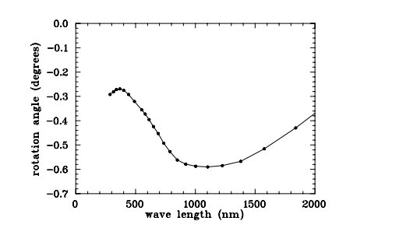
South pole north pole rotate analyzer later to see which way the light was rotated
Next Tuesday
.35/2.2 * 4 = .06??

