CEBAF Gun HV processing guidelines
March 8, 2021
C. Hernandez-Garcia

Gun background and pre-conditions:
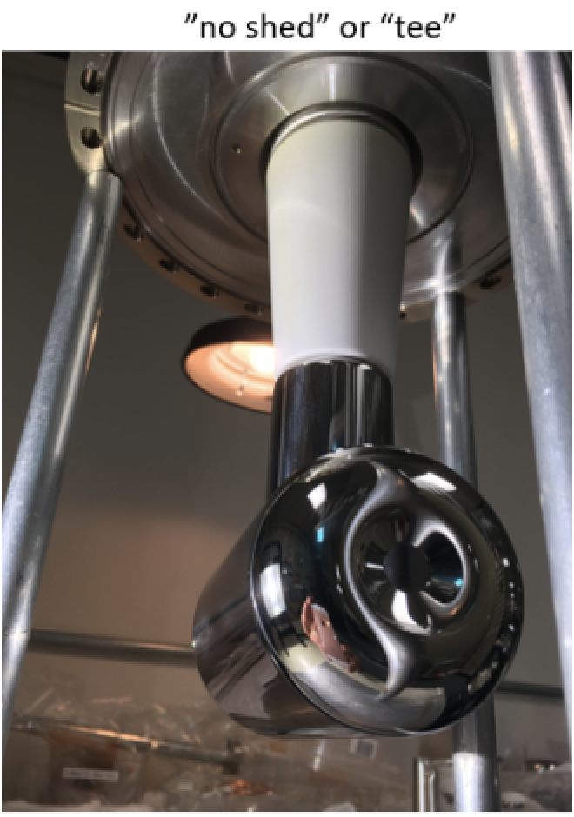
The gun has the Tee electrode on white R28 insulator. This electrode delivered 130 kV beam for the physics program. On September 24 2020 the gun voltage was increased from 130 kV to 200 kV with no signs of field emission https://logbooks.jlab.org/entry/3853206

Then it was vented for replacing the anode HV feedthrough and installing new NEG coated tube. The gun was baked in mid-February.

The gun 100 Mega-Ohm resistor tank was plugged in Tuesday March 9.
https://logbooks.jlab.org/entry/3869014

Remaining tasks prior to HV conditioning IN VACUUM
- Back fill the gun HVPS SF6 tank from 58 psig to nominal 60 psig. Seems to be very slow leak that started back in September when the HV cable was removed.
- Back fill resistor SF6 tank from 8 psig to nominal 10 psig. We did a leak check and found the 14 psig relief valve weeps. Carlos will check with D. Meekins.
- Install DecaRad system. Ensure its functionality in EPICS. Then install 5 decaRad probes around the gun. #1 behind the anode flange. #2 between the gun 10" top CF flange and HV chamber body, righthand side. #3, between the gun 10" top CF flange and the HV chamber body, left-hand side. #4 under the HV chamber body. #5 between the prep chamber gate valve and the gun HV chamber body.
- Connect the anode to the pico-ammeter

NOTE: the following tasks must be completed if Kr processing is needed.
- Disconnect the turbo pump cart from the Kr line and connect it to the bake ion pump exhaust right angle valve. Establish vacuum and bake the hose between the right angle valve and the turbo pump cart. Once bake is complete (150 C for 24 hours), keep the turbo pump on. This exhaust line will be used in case krypton is needed during high voltage processing, and thus, must be kept clean and under vacuum to prevent back streaming to the gun.
- Carlos asked T. Dela Cruz for a TV camera and channel to monitor Kr set point pressure in turbo pump cart gauge.

https://logbooks.jlab.org/entry/3869025

Guidelines for ramping the gun voltage from 0 to 130 kV.

E. Forman developed an EDM screen that has the Gun HVPS controls, DecaRad, LivePlit launcher and a sketch showing the location of DecRad probes and Kr plumbing. Although the intention is to start under vacuum conditions, I suggest using this screen.

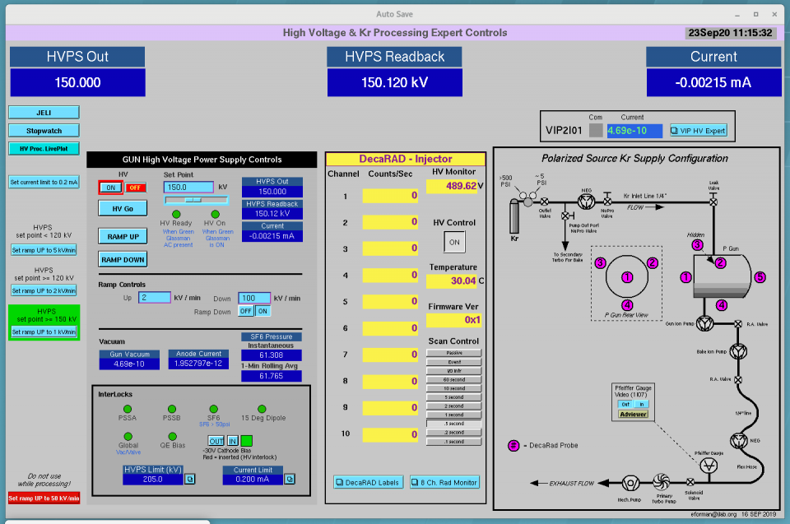

- Open EDM Kr processing screen JMenu -> Injector -> Kr HV Processing
- Set HV Op limit to 135 kV and HVPS current limit to 0.2 mA by clicking on the buttons to the right of the HVPS Limit read back box. This will open a second screen where the limits can be entered. This second screen has also an Expert Limit button that opens another screen for setting up the “Drive High”. I have setup this Drive High to 137 kV. But if desired to increase the voltage higher than that, please do so and document in POLOG. Close the HV and Current limit screen when thee values have been entered.
- Launch the LivePlot from the EDM r processing screen.
- Monitor DecaRad signals, Gun2 vacuum VIP2I00, anode current and HVPS current as a function of HVPS voltage using LivePlot
- Set the HV ramp up rate to 10 kV/min.
- Ramp the voltage in 10 kV steps up to 100 kV soaking for a couple of minutes at each step while monitoring read backs. It is important to let the vacuum stabilize before increasing the voltage again.
- Set the HV ramp up rate to 5 kV/min
- Ramp the voltage in 5 kV steps up to 130 kV soaking for a few minutes. It is important to let vacuum stabilize before increasing the voltage again.
- Soak for a few minutes to obtain a baseline for all the monitored signals and capture the LivePlot and Kr processing screen in POLOG.

This concludes guidelines for ramping the voltage to 130 kV. If this sis the desired voltage, I suggest soaking for a few hours.

If higher voltage is desired:

- Set the ramp rate to 2 kV/min
- Increase the voltage by 5 kV and soak for about 5 minute before increasing the voltage again by 5kV, or until vacuum has stabilized.
- Continue increasing voltage up to 200kV, keeping track of field emission, anode current, HVPS current and gun vacuum levels.

Additional Notes:

- While ramping the voltage, it is expected to see vacuum bursts.
- We hope there will be no field emission based on the performance of this electrode and the fact it was not touched during the gun vacuum work. But if there is field emission, please look for the onset voltage and log it.

