Progress Report:
We have begun constructing a 15,219.579 MHz receiver for the waveguide slot coupled TE011 cylindrical cavity polarimeters, operating at the 31.5th harmonic of 499.0026 MHz. The cavities were designed to measure a high frequency harmonic of the waveform induced by a passing polarized bunch, applying the concept of high frequency isolation. This is the idea that the bipolar pulse induced by a longitudinally polarized bunch has more high frequency content than the Gaussian bunch charge, so by observing a high harmonic the magnetic signature might not be masked by the passing charge. These cavities were described in our 8/23/17 progress report. The components for this receiver are below sitting in their housing. These components and sub-assemblies have been tested using the HP 8970S 18 GHz Noise Figure Meter, as well as network and spectrum analyzers. As soon as the assembly is finished, we can begin testing the complete assembly. 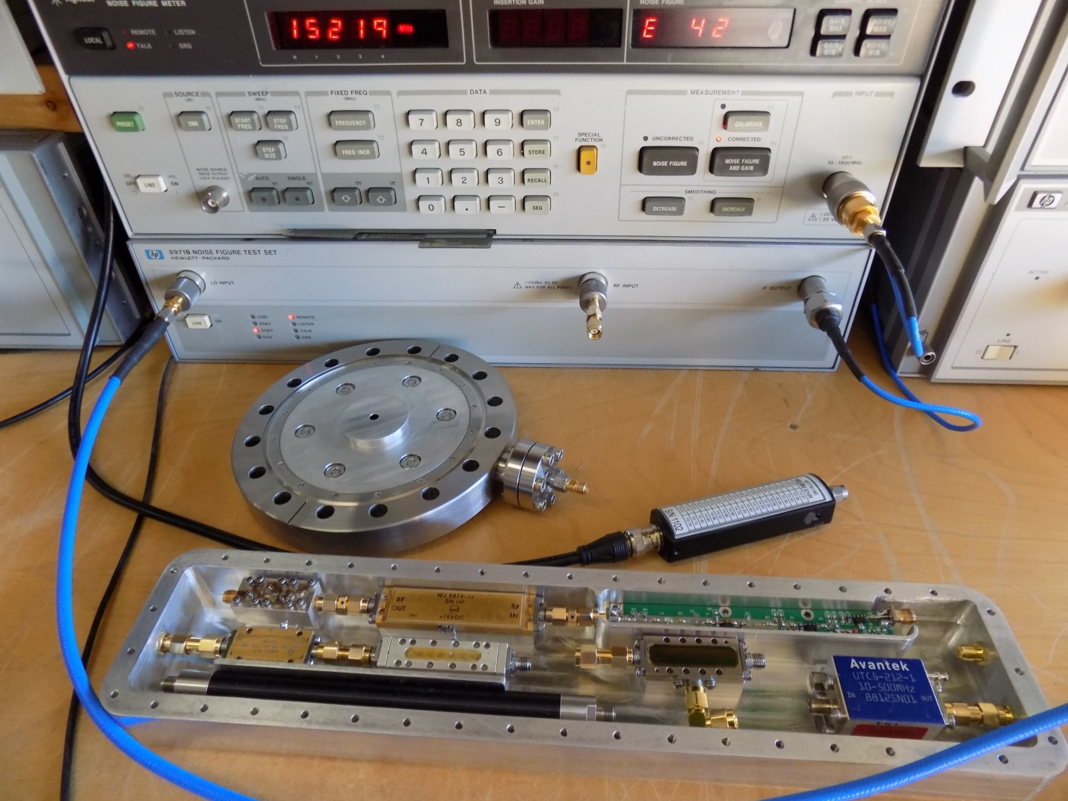

The TE011 cylindrical cavity is iris coupled to WR-62 waveguide that within the 6” conflat vacuum assembly. The Coaxial UHV feed trough has a loop coupler oriented to be matched to the waveguide, transmitting detected 15.219 GHz to the receiver.
This receiver could also be called a Harmonic Frequency Converter, similar to the HP 11970 series. In this configuration a 1497 MHz signal will be multiplied by 10 creating a 14,970 MHz local oscillator, which is mixed with the detected 15,219 MHz signal creating a 249 MHz output signal that will then be transmitted over cable to a 249.5 MHz I/Q demodulator
The input of the receiver is a Miteq amplifier, the gold rectangle on the left hand side. It has 40 dB of gain at 15,219 MHz and a noise figure of 1.6 dB. The RF filter follows this amplifier and has the bassband below:
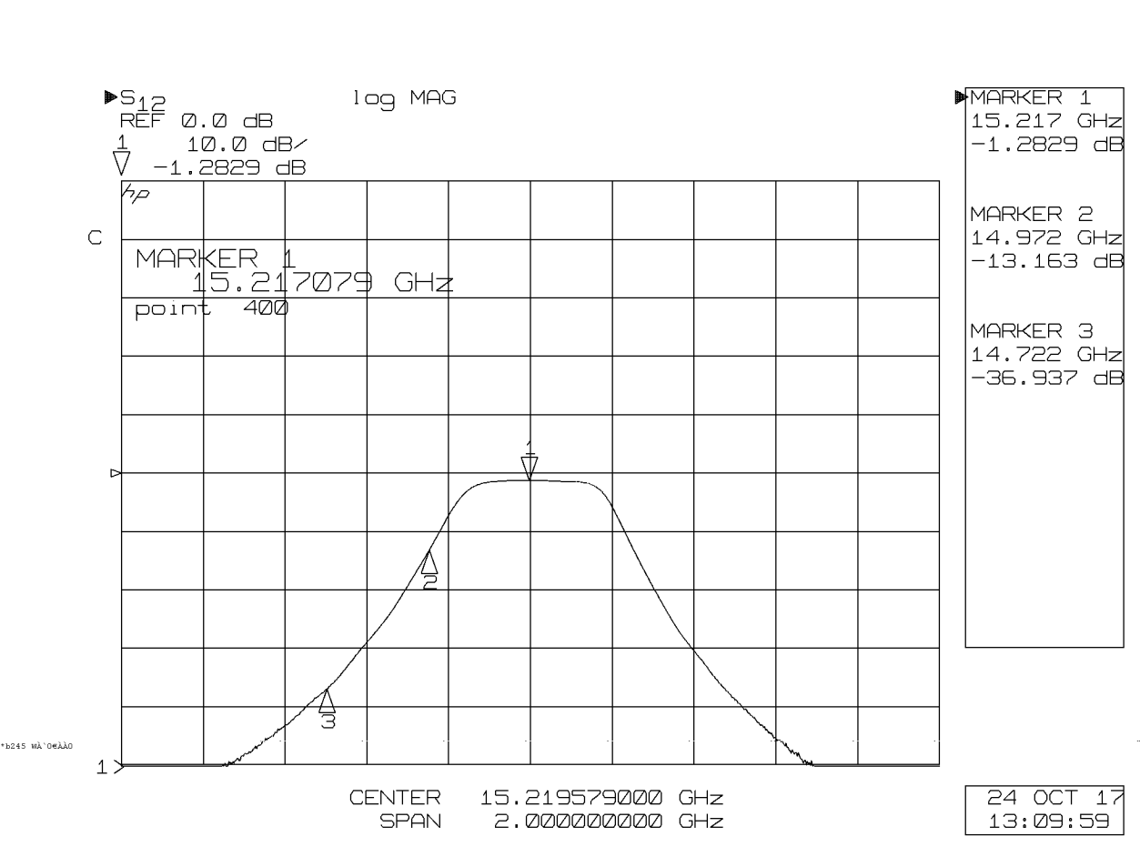
The markers sit at the detected frequency (1), the local oscillator frequency (2) and at a potentially interfering charge harmonic (3). The RF input filter does not provide sufficient isolation alone, however the iris coupling to the cavity, and transverse waveguide should additional charge signal isolation. We are pursuing narrower filters.
The local oscillator is generated from Jlab’s 1497 MHz RF clock that enters the assembly on the right hand side of the assembly and passes through a 1497 MHz band pass filter to remove any potential contamination of 249.5 MHz. This filter is the long black rod on the bottom left, K@L 1499/R222 with the pass band below.
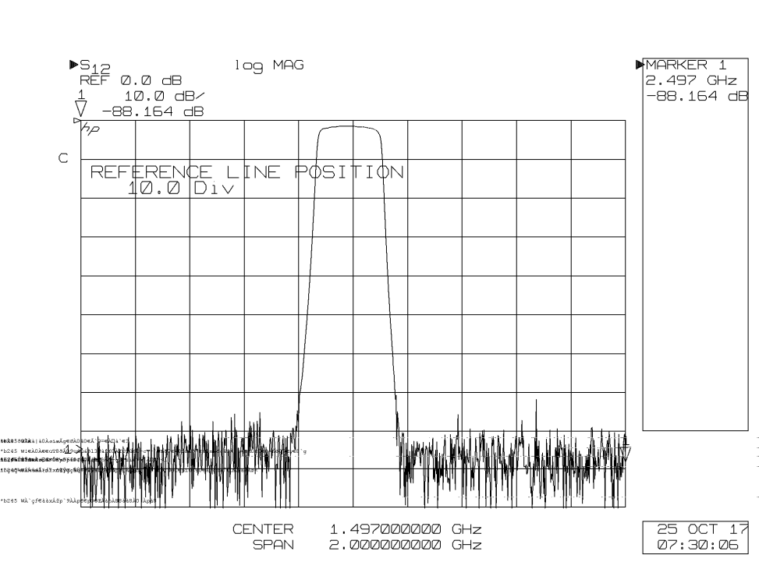
The filtered 1497 MHz then enters the green multiplier board on the upper right, where it is amplified to +27 dBm and drives a Metalix step recovery diode. The harmonic is amplified and filtered to +10 dBm and connected to the local oscillator port of a Miteq mixer, the DB0118, that has 8db of conversion loss, converting the signal to 249.5 MHz. A small Crytek coaxial 300 MHz Low pass filter connected to the mixers IF port has the passband below:
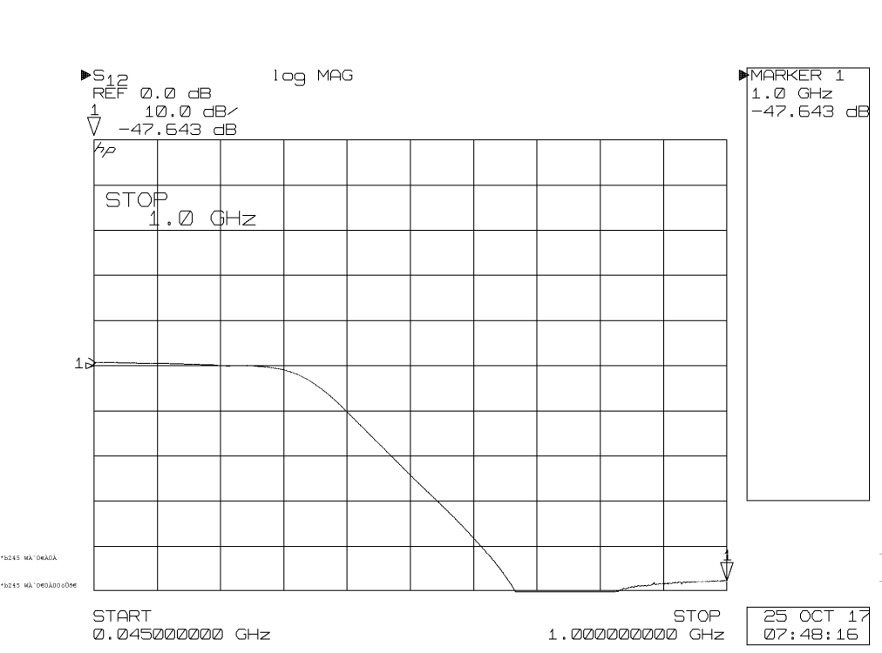
The output of the Crytek LPF then goes to the Aventek 500 MHz Amplifier UTC5-212 that has +47 db of Gain.
The output of the assembly is 249.5 MHz that is then transmitted to the I/Q demodulator located away from the beamline. It is anticipated that the Assembly will have a noise figure lower than 2dB, and more than 70 dB of gain.
We are pursuing approaches to improve the input filtering by using several filters in series, or producing a cavity filter with a narrower passband.

