Appendix A: Detailed JLab report

Report Period of Performance:
FY23 – Q2: 01/01/2023 – 03/31/2023

Co-Principal Investigator:
Riad Suleiman, with Joe Grames and Matt Poelker (Jefferson Lab), and Eric Voutier (IJCLab, Orsay, France) and Greg Blume (graduate student – ODU).

Work-scope Highlights:
Jefferson Lab’s contribution to this project is to provide a Compton Transmission Polarimeter, which will be used to measure beam polarization when SRF photogun employs a GaAs photocathode. IJCLab is contributing to Jefferson Lab’s effort.

Q2 FY23 Brief summary of activity issues, concerns, successes:

Activity successes:
- Graduate student (Greg) has finished data analysis and completed GEANT4 simulation.
- For second polarimeter and DAQ: Radiator #2 needs to be fabricated – this polarimeter will stay at Jefferson Lab
- Working on documentations and writing a paper for publication
- Greg is presenting a poster to IPAC'23. His expenses are covered by the conference.

Issues and concerns: Now under 1-year NCE that ends 9/23. We are working on a plan before the end of the NCE.

Milestones
- Polarimeter is ready and calibration is completed. Now waiting on BNL to give us the green light to move and install the polarimeter at their facility (expected in Fall 2023).

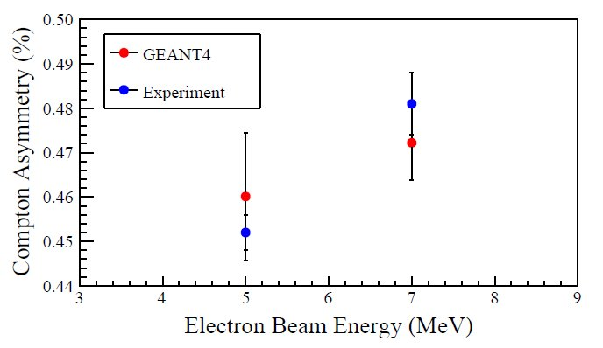

FIG. 1. Comparison of simulated GEANT4 asymmetries to experimental results.

Budget

Summary of total expenditures:

ID # | Item/Task | Baseline  Total Cost  (AY$) | Costed &  Committed  (AY$) | Estimate  To Complete  (AY$) | Estimated  Total Cost  (AY$)
COMTRA | Compton Trans Polarimeter | $400,200 | $353,704 | $46,496 | $400,200
Totals: |  | $400,200 | $353,704 | $46,496 | $400,200

Summary of expenditures by fiscal year (FY):
FOA Funding | FY 2020 | FY 2021 | Total
a) Funds allocated | $200,100 | $200,100 | $400,200
b) Actual costs to date | $200,100 | $139,653 | $339,753
c) Uncosted commitments | $0 | $13,951 | $13,951
d) Uncommitted funds  (d=a-b-c) | $0 | $46,496 | $46,496

