Accelerator Experiment Safety Assessment Document (ESAD)
(See ES&H Manual Chapter 3130 Appendix T1
Accelerator Science Experiment Safety Assessment Document –Instructions)

 |  | Accelerator Experiment ID: |  |  |  |  |  |  |  |  | UE-21-001 |  |  |  |  |  |  |  |  |  |  |  | (Assigned by appropriate leadership)
 |  | This form documents your experiment. The Experiment Lead Scientist completes ALL numbered questions (write “not applicable” or “none” where appropriate). If your experiment changes before the form expires, you must notify the accelerator Experiment Facility Leader. Most changes are easily accommodated and should not result in significant delay.
 |  | 1. Location: |  |  | UITF |  |  |  |  |  |  |  | 2. Expected Start Date: |  |  |  |  |  |  |  | August 1st 2021
 |  | (Once approved, this form is valid for two years.)
 |  | 3. Experiment Title: |  |  |  | E-beam Irradiation
 |  | 4. Document Owner(s)  (Lead Scientist): |  |  |  |  |  | Gianluigi Ciovati |  |  |  |  |  |  |  |  |  |  |  | 4a. Contact Information: |  |  |  |  | gciovati@jlab.org
5. List all Experimenters who will be working at the facility:
 |  | First & Last Name (Print) |  |  |  |  |  |  |  | Affiliation: |  |  |  |  |  | Phone: |  |  |  |  |  |  |  |  | E-Mail:
 |  | Xi Li |  |  |  |  |  |  |  |  | ODU |  |  |  |  |  |  | 757-269-5554 |  |  |  |  |  |  |  |  |  | xiliodu@jlab.org
 |  | Gianluigi Ciovati |  |  |  |  |  |  |  |  | JLab |  |  |  |  |  |  | 757-269-5945 |  |  |  |  |  |  |  |  |  | gciovati@jlab.org
 |  | Hannes Vennekate |  |  |  |  |  |  |  |  | JLab |  |  |  |  |  |  | 757-269-7607 |  |  |  |  |  |  |  |  |  | hannesv@jlab.org
6. Name of People who completed this form:
 |  | First & Last Name (Print) |  |  |  |  |  |  |  | Affiliation: |  |  |  |  |  |  | Phone: |  |  |  |  |  |  |  | E-Mail:
 |  | Gianluigi Ciovati |  |  |  |  |  |  |  |  | JLAB |  |  |  |  |  |  |  | 757-269-5945 |  |  |  |  |  |  |  |  |  | gciovati@jlab.org
Document History:
 | Revision: |  |  | Reason for revision or update: |  |  |  |  |  |  |  |  |  |  |  |  |  |  |  |  |  |  |  | Serial number of superseded document
Distribution: Original: MCC Control Room, Copies: Lead Scientist, author(s), LERF Control room or UITF Control room, Division Safety Officer, ESH&Q Document Control, ESH&Q Liaison, Area Safety Warden
After expiration: Forward original and log sheet of trained personnel to ESH&Q Document Control.

- Experiment Overview

Provide a brief description of your planned activities. Include the approximate duration of the program.
The experiment consists of the electron-beam irradiation of up to five water samples, each up to 75 ml volume, which have a concentration of up to 10-100 μg/L of 1,4-dioxane. The beam current is 100 nA and the energy 8 MeV. The beamline optics are designed to either have a defocused Gaussian beam with sigma ~8.3 mm or a rastered beam with sigma ~0.3 mm incident on the front side of the sample holder. The sample holders are mounted on a linear rail driven by a remote controlled stepper motor, allowing remote positioning of each sample holder in front of the beam exit window. Different doses will be given to the samples, in the range 1-20 kGy, corresponding to an irradiation time of ~2-44 min.
The experiment is currently funded until Sept. 30th 2021 and we would like to complete at least 4 sets of experiments. We estimate each set of experiments to require ~8 h of beam time. This estimate does not include the installation and commissioning time.

Does this experiment involve modification to the installed beam delivery system? | X | YES |  | NO
If YES describe the Modifications.
The experiment requires installation of a beamline section (“irradiation beamline”) replacing the current straight end “MeV beamline section” that terminates in a beam dump. The new straight section is approximately 6 m long and terminates with a thin-foil titanium window. A carousel with five sample holders is mounted at ~4 cm from the window. The sample holders are mounted on a linear rail driven by a stepper motor controlled in the UITF control room.
A solenoid is mounted ~5 m from the Ti window and the power supply used to energize the magnet is also remotely controlled from the UITF control room. A pair of raster coils are located at ~4 m from the Ti window. A pneumatic gate valve is installed at the beamline front-end, allowing vacuum isolation between the MeV beamline section and the irradiation beamline section. The valve operation is integrated in the UITF control room.
A six-way cross is mounted at the end of the beamline with spool pieces terminating in the Ti window on one side, a spool piece with a vacuum gauge linked to the control of a “fast” gate valve on another side, a spool piece with an ion pump on a 3rd side, a reducer with a NEG cartridge on a 4th side and a Faraday Cup (FC) on the 5th side. Two beam-viewers assemblies, two Beam Position Monitors (BPM) and two Haimson coils are also installed along the beamline.
The fast-valve is added after a manual gate valve currently installed after the differential pumping station in the “MeV section”, at ~12 m from the Ti window. The fast-valve control is integrated in the UITF control room.
A Beam Current Monitor is installed ~2 m downstream of the Booster cryomodule.

- Task Hazard Analysis

Instructions: Answer the following questions. When answers indicate a hazard may exist – document the resolution(s) and hazard mitigation techniques.
General Conditions | Keywords | Yes | No | Mitigation
Will chemicals be used?  Note: such use must meet the appropriate SDS requirements including Personal Protective Equipment (PPE). | acids, flammable gases and solvents, heavy metals (lead, etc.), respirator, gloves, aprons, face shield, safety glasses, working with flammables | X |  | The water samples will have a concentration of up to 100 microg/L of 1,4-dioxane. Pouring of the water samples into the samples holders and into the VOA vials will be done over an absorbing pad to contain any spill. The volume of the water samples is < 75 mL.
Will you create dust, welding arcs, heat, excessive noise, ionizing or non-ionizing radiation, radioactive materials? | welding, grinding, painting, x-rays, respirator, gloves, RF, lasers, chemicals, epoxies | X |  | The e-beam is directed to a thick aluminum sample holder filled with water. RadCon has a RSAD for the UITF vault. Local shielding on the north and west sides of the targets and at the Faraday Cups locations will be installed using 2” thick Pb bricks.
Are there any fire or explosive hazards associated with the work? | painting, welding, grinding, brazing, mixing chemicals, battery charging |  | X
Could the work create headaches, breathing problems, or dizziness from odors, etc.? | Motor exhaust, painting, ozone, solvents, acids, bases, chemicals, portable heaters |  | X
Will compressed or liquefied gasses be used? | cryogenics, nitrogen, helium, argon, carbon monoxide |  | X
Does the task require work in areas or with materials subject to temperature extremes? | welding, soldering, brazing, cryogenics, resistive heating |  | X
Does the work involve the use of hoists or robotics? | manlifts, subcontractors, rentals, slings, rigging |  | X
Will powered hand tools be used? | drills, saws, PPE, GFCI, power activated tools |  | X
Does the work involve the risk of electrical shock or other forms of hazardous energy? | LOTO, compressed gases, power supplies, pressure, cryogenics | X |  | The solenoid will be powered at ~120 A, ~17 V DC. Protection in the terminals area will be installed. A Class 2 power supply is used to power the magnet. The power supply will be interlocked to be OFF when the UITF Cave is in the Open state.  Each of the two raster coils is powered by a Class 2 amplifier. A plexiglass cover will be installed over the output terminals of the solenoid power supply and raster coils amplifiers.
Does the task involve lifting, pulling, pushing, or carrying heavy objects, or repetitive motion? | posture, back injury, twisting |  | X
Does the task involve work with pressurized or vacuum vessels? | resistive heaters, GFCI, pressure relief, tanks, containers |  | X
Does the task require any permits? | welding, grinding, open flame soldering |  | X
Does the task require specialized training? | Respirator |  | X
Will waste products require special handling or disposal requirements? | chemicals, by products, discharges to sanitary sewer or air | X |  | Most of the irradiated water samples will be returned to HRSD for analysis, HRSD has authorized to discharge any leftover in a sanitary sewer drain
Any other hazards we may have overlooked with this list? |  |  | X

- Experimental Details

List all materials (and quantities) to be used in your experiment. List Target Material first and include all chemicals, gases, sample materials, etc.
The target cell is made of an Aluminum block with a 60-75 mL cylindrical volume bored in, filled with the water sample to be treated. The Al block is sealed with a cork gasket covered by a 0.005” thick Stainless Steel foil, held by an Al ring. A cork cone is used as a cap. A drawing of the sample holder is attached.
The water samples to be irradiated consists of 10 μg/L or 100 μg/L 1,4-dioxane in either a deionized water or secondary effluent wastewater.

Describe any airborne contaminants that may be produced. Include the expected composition/decomposition, the method of exhaust, fixture description, and expected interaction with the optical beam.
Ozone, produced in the space between the Ti beam exit window and the sample holders. It is exhausted through the UITF vault HVAC system. The anticipated ozone concentration is
calculated to be 0.004 ppb, well below the 100 ppb occupational exposure limit.

Describe the beam stop construction and its ability to handle power.
Over 90% of the 0.8 W beam power is absorbed by the water sample. Given the maximum estimated dose of 20 kGy, the estimated temperature rise of the water is ~0.7 °C.

List Personal Protective Equipment Required.
Butyl gloves and safety glasses when handling the water samples, both before and after irradiation.

Additional Precautions (e.g. posting requirements, process restrictions, equipment limitations, laser beam containment, interlocks)
The following interlocks will be active during the experiments, besides the standard UITF interlocks:
- Beam current monitor: shuts off beam within 2 sec if the current exceeds 150 nA
- Pressure gauge at end of beam line: shuts off beam and closes the fast-valve and pneumatic valve if the pressure is > 1e-5 mbar
- Temperature and waterflow sensors for the water-cooled defocusing solenoid: shuts off the power supply and the beam in case of low water flow and/or overheating.
- Current monitors are installed around the power cables energizing the raster coils and they are used to trigger an FSD if the current exceeds the programmed value.
A labeled double polyethylene cover is installed to cover the beam exit window when the beamline is not in use to prevent accidental breaking of the window. It is suggested to wear hearing protection when working in the UITF Cave with the window uncovered, such as when inserting or retrieving the sample holders.
An orifice (Cu gasket with 16 mm diameter hole in the center) will be installed at the 2.75”-to-4.5” reducer Conflat flange, to slow the pressure front, in case of downstream loss of beamline vacuum.

- Additional Laser Usage

Describe any additional lasers to be used in the experiment. Use of additional Class 3b and above lasers will require a separate, additional Laser Operational Safety Procedure (LOSP).
None

- Outline Experiment Procedure

Layout of equipment and room (e.g. a brief description of any special requirements, overhead floor plan.)
A 3D layout of the irradiation beamline section is shown below:
FC
Sample carousel
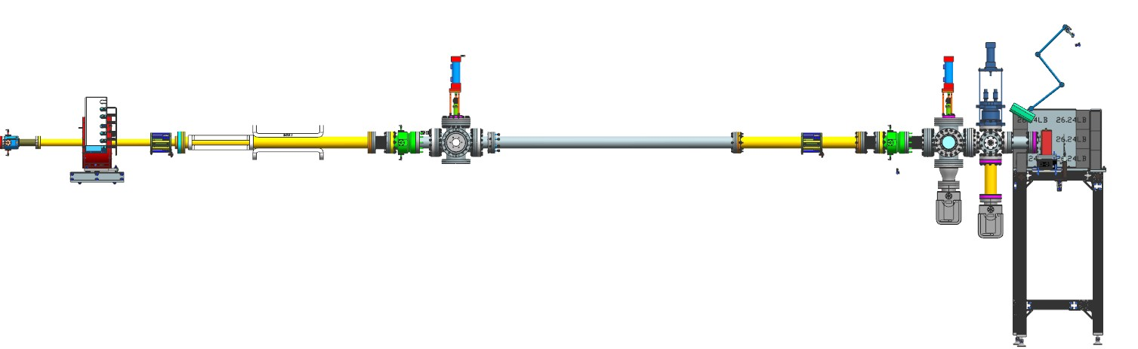
Orifice
Steerer
Viewer
Steerer
BPM
Cross with gauge and Ti window
Viewer
BPM
Raster coils
Solenoid
Pneumatic valve

Figure 1: 3D layout of the irradiation beamline section at UITF.
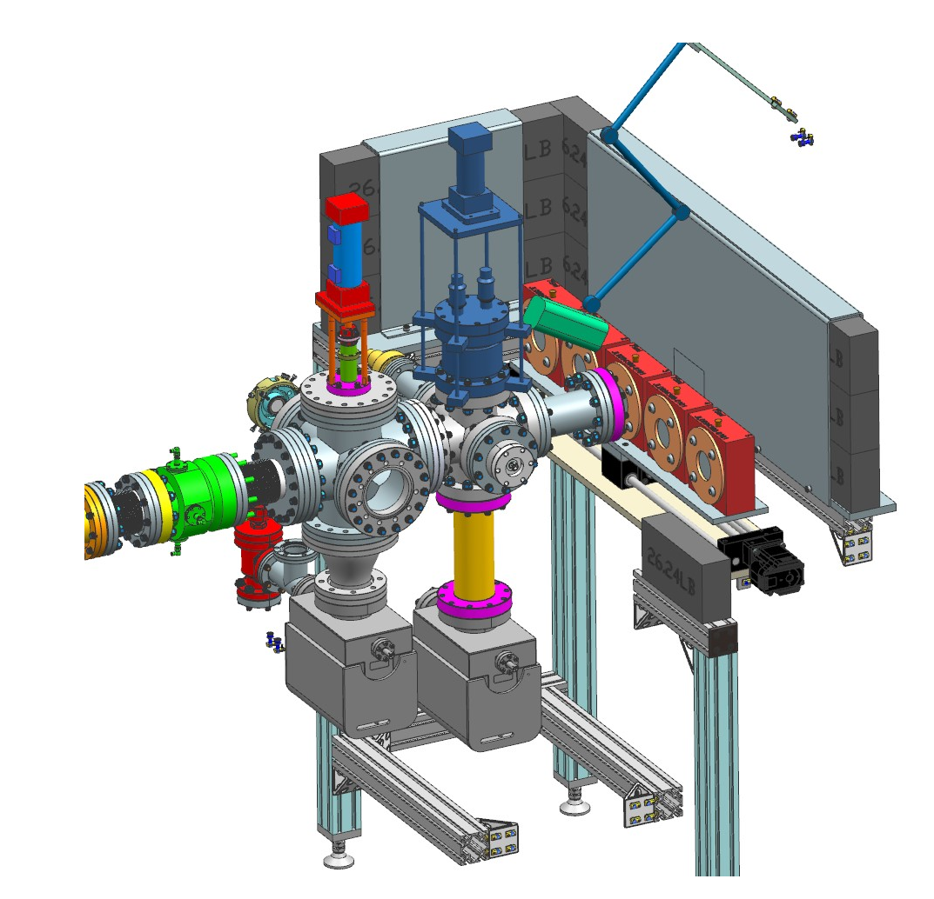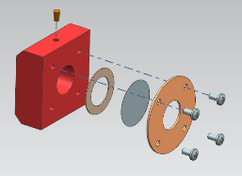
FC
Ion pumps
Sample carousel
Cork
Aluminum
SS foil
Beam viewer
BPM

Figure 2: Detailed view of the end of the beamline (left) and exploded view of the sample holder (right)

General Experiment Procedures Please be concise. Provide sufficient information to illustrate what will be done, who will do it, and where procedures will occur. You may refer to the LOSP for the particular lab, its hardware, and procedures. However a specific Test Plan will be filed on a separate form after technical and safety approval and scheduling have been assigned.
The PI or graduate student fills five sample holders with the water sample and mounts them on the linear rail. The accelerator operator sweeps, locks-up the UITF vault and sets the PSS to RUN. The accelerator operator also performs the following steps, using the UITF OSP as guidance:
- the pneumatic valve at the entrance of the irradiation beamline is opened
- a pulsed beam of up to 25 nA average current (“beam tune” mode) is accelerated to 8 MeV and the settings of the solenoid magnet, steerers and quadrupoles are set to obtain a ~50 mm diameter beam. Alternatively, the settings of the steerers, quadrupoles and raster coils are determined to obtain a ~50 mm diameter beam at the window.
- the current is increased to 100 nA in “CW mode” and the first sample is irradiated for a prescribed amount of time, depending on the dose. The expected dose range is 1-20 kGy, corresponding to an irradiation time of 2-44 min
- The beam is shut-off and the second sample holder on the linear rail is moved in front of the irradiation window.
- Steps 4-5 are repeated until all five samples are irradiated
- Beam is turned off and the PSS is set to OPEN
- The PI or graduate student retrieve the sample holders and pour the content of each into 40 mL Volatile Organic Analysis (VOA) vials, which are sent for analysis at HRSD. Any leftover water sample is poured in a sanitary drain.

Residual Hazards (Contaminants, Disposal, Safe Disassembly, …)
None

Any Other Safety Considerations
None

- Regulatory Requirements

Regulatory Requirements
 |  | Yes | X | No | Does the proposed experiment utilize viruses, viable bacteria, or material presenting a biological hazard at the lab facility? Certain biological hazards require notification to agencies outside Jefferson Lab.
 |  | Yes | X | No | Does the proposed experiment require any radioactive materials or radiation producing equipment?
 | X | Yes |  | No | Does the proposed experiment require any industrial chemicals to be brought or shipped to Jefferson Lab? All chemicals must include a SDS for each material shipped.
 |  | Yes | X | No | Does the proposed experiment create any chemical hazards?

- Environmental Management Information
(See EMP-04 Project/Activity/Experiment Environmental Review)

Is this a Water-Based Project? |  | X | YES |  | NO
If YES provide details:
Source of the Water and estimated quantity. | HRSD provides four 0.5 L bottles of water with up to 100 μg/L 1,4-dioxane. The water matrix is either DI water or secondary effluent wastewater. 5 samples holders with 75 mL maximum volume will be filled from each bottle. HRSD has provided the SDSs for the water samples.
How is water to be discharged or disposed of: | After irradiation the water will be poured in 40 mL VOA vials and returned to HRSD for analysis.
Sanitary Sewer | HRSD has confirmed that it is acceptable to dispose any leftover from the water samples in a conventional sanitary drain.
Special Sanitary Sewer Discharge
Surface Water

Will the Experiment Generate Waste? |  | X | YES |  | NO
If YES list all wastes including anticipated quantities and disposal approach for each type.
Anticipated Air Emissions | Ozone, up to 54 μg per test run
Other Waste Water
Hazardous Waste
Solid Waste
(landfill or recycling)
Power/Natural Resource Consumption Expected | ~2 kWh per test run

- Decommissioning/Shutdown Procedure (if necessary):

How will you ensure the lab is left in a safe and clean state after the experiment? Provide guidelines or process steps which outline closeout actions. Think about what needs to be done and plan enough time to do it:
 |  | Hazardous material to be removed from the lab. |  | User provided equipment to be removed. |  |  | Lab to be left in a clean and orderly state.
Two plastic caps are placed over the flange with Ti window, as a protection. The pneumatic valve connecting the irradiation beamline to the rest of the MeV beamline will be closed.
The sample holders will be thoroughly rinsed with tap water after each use.

(When form is complete, submit it to DSO for review and approvals)
This part to be completed by Jefferson Lab
SUPPLEMENTAL TECHNICAL VALIDATIONS
Subject Matter Expert Review and Acceptance
 | Hazard Reviewed (per ES&H Manual 2410-T1): |  |  |  | Print Signature |  |  | Date:
 | APPROVALS
 |  |  |  |  | Print Signature |  |  | Date:
 | Division Safety Officer
 | Accelerator Experiment Facility Leader:
 | Laser System Supervisor:

- Revision Summary

Revision 2.0 – 09/24/19 – Formerly titled FEL Experiment Safety Approval Form Instructions; rewritten to reflect current laboratory operations
Revision 1.0 – 11/23/10 – Updated to reflect current laboratory operations

 | ISSUING AUTHORITY | TECHNICAL POINT-OF-CONTACT | APPROVAL DATE | REVIEW DATE | REV.
 | ESH&Q Division | Harry Fanning | 09/25/19 | 09/25/22 | 2.0
This document is controlled as an on line file. It may be printed but the print copy is not a controlled document. It is the user’s responsibility to ensure that the document is the same revision as the current on line file. This copy was printed on 7/14/2021.

