During the power outage:
The UHV ion pumps and the Gamma pumps for the booster are power via the diesel generator/emergency power loop. During the power outage, verify the ions pumps are ON and operating at acceptable (low) currents.
Close the valves if you can, especially if the CTF has tripped OFF and the booster begins to warm

Recovering UITF following a power outage:
Recovering the Master Oscillator:
Walk upstairs to rack (ITF19) and see if the RF MO chassis green LED lights are ON. If not, power cycle the chassis from the back.
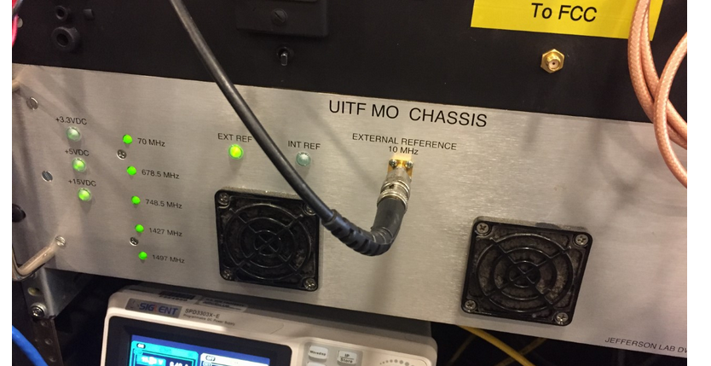
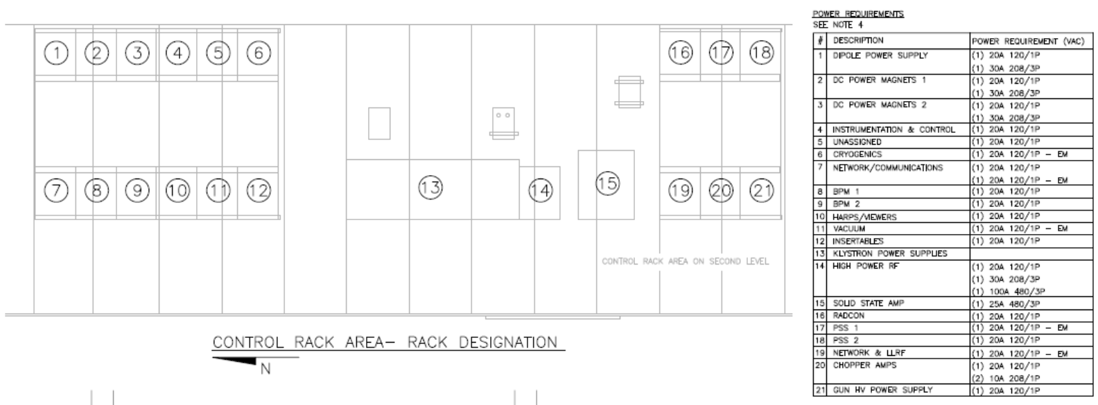
Contact Software on-call – Ask them to restart the servers for the Alarm Handler and the Generic Lock Server. You can then use the Alarm Handler to determine which IOCs are down. You should proceed to restore all of the IOCs and the control system before further recovering the other hardware to prevent unnecessary errors
When the BPM receivers lose power – they lose their 10 MHz PLL clock. Hard reboot (power cycle) all of the receivers to recover them. (Good BPM gains / thresholds should be determined and a file created to load to machine for operation)
Restoring the UITF laser:
- turn ON the PPLN frequency doubler oven by holding the "enable" button for a couple seconds, watch temp of PPLN crystal walk up to desired value ~ 151 C (actual temp will read ~ 148.9 C). There is no EPICS control of this device.
- turn ON the laser RF, you might need to power cycle the RF distribution box above cave1. All is well if you see something close to -6.6 dBm input signal level on the front of the laser fiber amplifier chassis
- then turn ON the fiber amplifier pump, there is no EPICS control of this device.
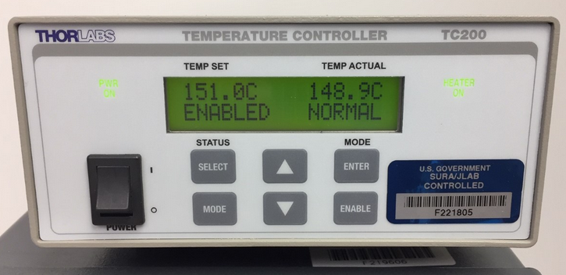
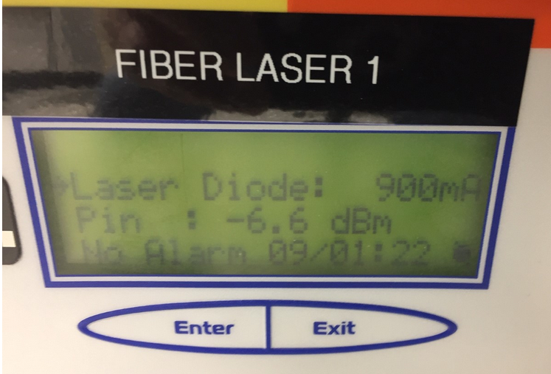
You must open each individual picoammeter epics screen and turn OFF “zero-check”
Note stepper motor “request setpoint” and “readback” – the values should agree, but likely will not. Readback position will likely read zero. Home reset each stepper motor and then set to desired position. [Laser X/Ystages, Chopper Aperture Slit, and water sample holder]
Home reset the laser attenuator.
Turn ON the two decarad chassis inside the UITF enclosure: one near the gun and one near the water irradiation line.
CARMs: some of the CARM boxes may indicate rad alarm flashing light, press and hold the reset button. One CARM box in the control room, two CARM boxes upstairs above cave1
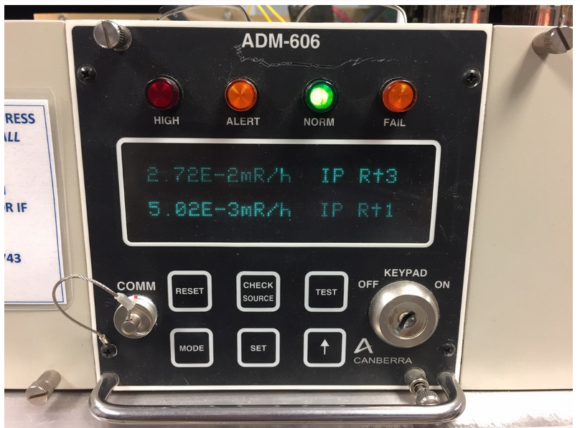
Check that the buncher heater is ON. The buncher heater is not remotely controlled, there is no epics screen to see status. You must visit the buncher inside Cave1 to see if the heater is ON and temp regulating near 164 F.
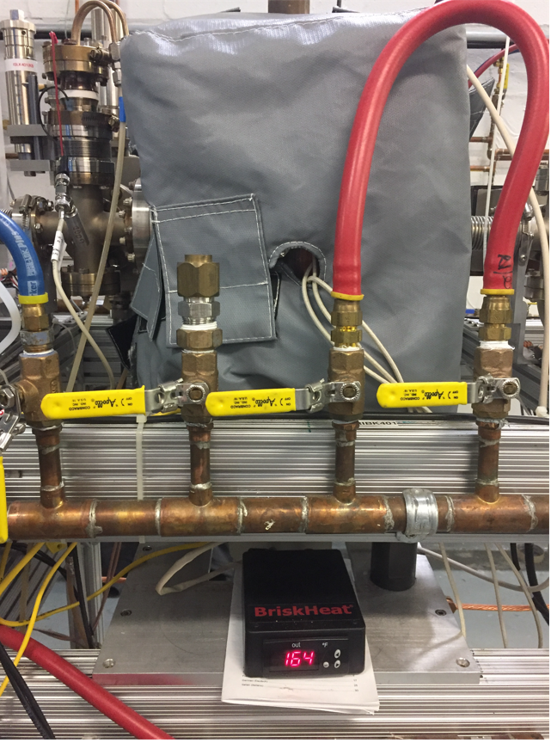

MPS: Verify BLM high voltage is ON for all channels. Verify appropriate set points for biases, thresholds, & voltages are loaded to all BLMs [Create BLM UED script like at CEBAF]

Lock up the cave
Operations: Execute cold start-up procedure to recover machine.
Load a recent file from save/restore program….
Verify laser power is appropriate to task
Losing the Master Oscillator/10 MHz reference means there can be 180 degree phase shifts. Deliver beam to spectrometers and check buncher zero crossing, and booster cresting. All of the RF phases will likely have changed with the lost references, and so finding booster zero crossing, as well as appropriate 2-cell, 7-cell, and Booster gang phases will need to be repeated.
Restore booster IOCs, call Rama and Tomasz if there are suspicions something is wrong, i.e., if you are not sure that all important parameters have been properly restored. This may manifest as energy being lower than expected when measured in the MeV spectrometer after phasing.
Turn ON the magnet racks and box supplies and cycle them at the set points from the All-save file. DC Power can help if necessary.

