Ring Coupled Cavity Polarimeter:

The drawing of the beam pipe below is intended to help visualize the primary fields of a bunched polarized electron beam traveling down a beam pipe. The electron bunches are depicted as tiny bar magnets to show their magnetic dipole field due to spin alignment. The electrostatic field $E_{q}$, and the magnetic field from the beams current $B_{I}$ are coupled to the conductive walls of the beam tube, so they excite resonant structures built into the beam tube. The dipole field of the bunches spin$,{ B}_{S}$is more localized to the bunch and drops off radially as $1/{R^{3}}$ making it less interactive with the beam pipe and resonant structures built into it.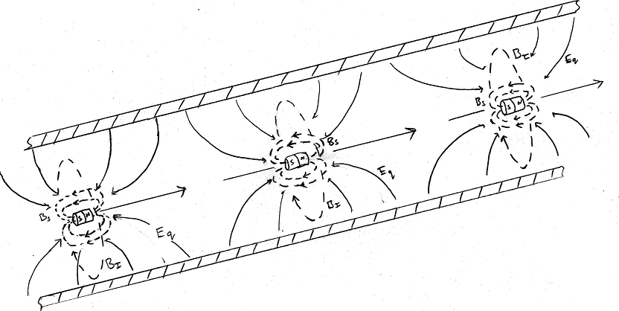
A small metal ring could be used to extract energy from the beams polarization field as the bunches pass through it, inducing ring current $I_{R}$.
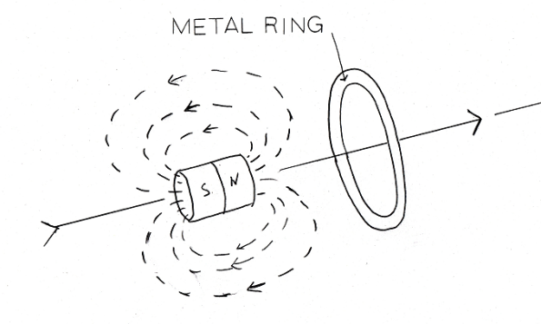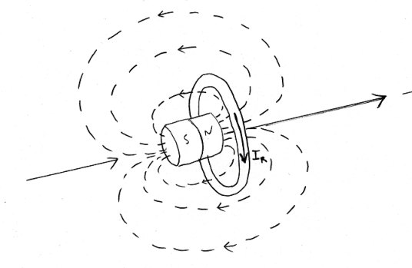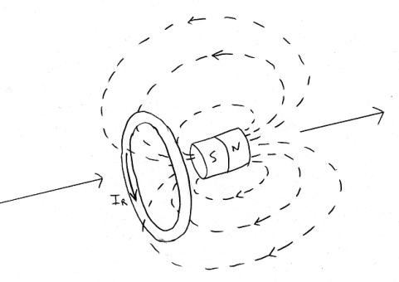

If the small metal ring were placed within a resonant cavity, the ring could serve a dual purpose; as a coupler to extract energy from the beams polarization field, and as a drive antenna for an axially symmetric transverse electric resonant cavity mode. The ${TE}_{011}$ is shown below. The relative phase of the cavity mode can be compared to the accelerators clock, when the polarity of the beam flips, so do the DC I and Q voltages. The ring could be suspended with radial metal spokes without disrupting axially symmetric TE modes.
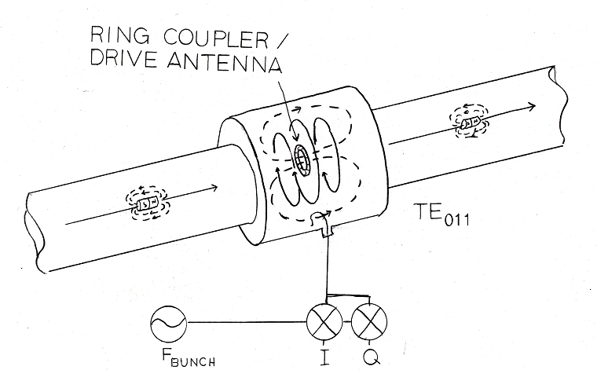

Acknowledgements: Poelker, Derbenev, Talman etc…

