Progress Report:
Split-Cylinder Resonant Electron Polarimeter:
We scaled the split ring resonator shown last meeting by a factor of .5454 to convert its resonance frequency from 1497 MHz to 2.7445 GHz. We machined the devices components in brass so that they could be easily soldered and parts were made for a single resonator and a four resonator split ring assembly. The jig in the lower left held the pins square while they were soldered to the split rings.
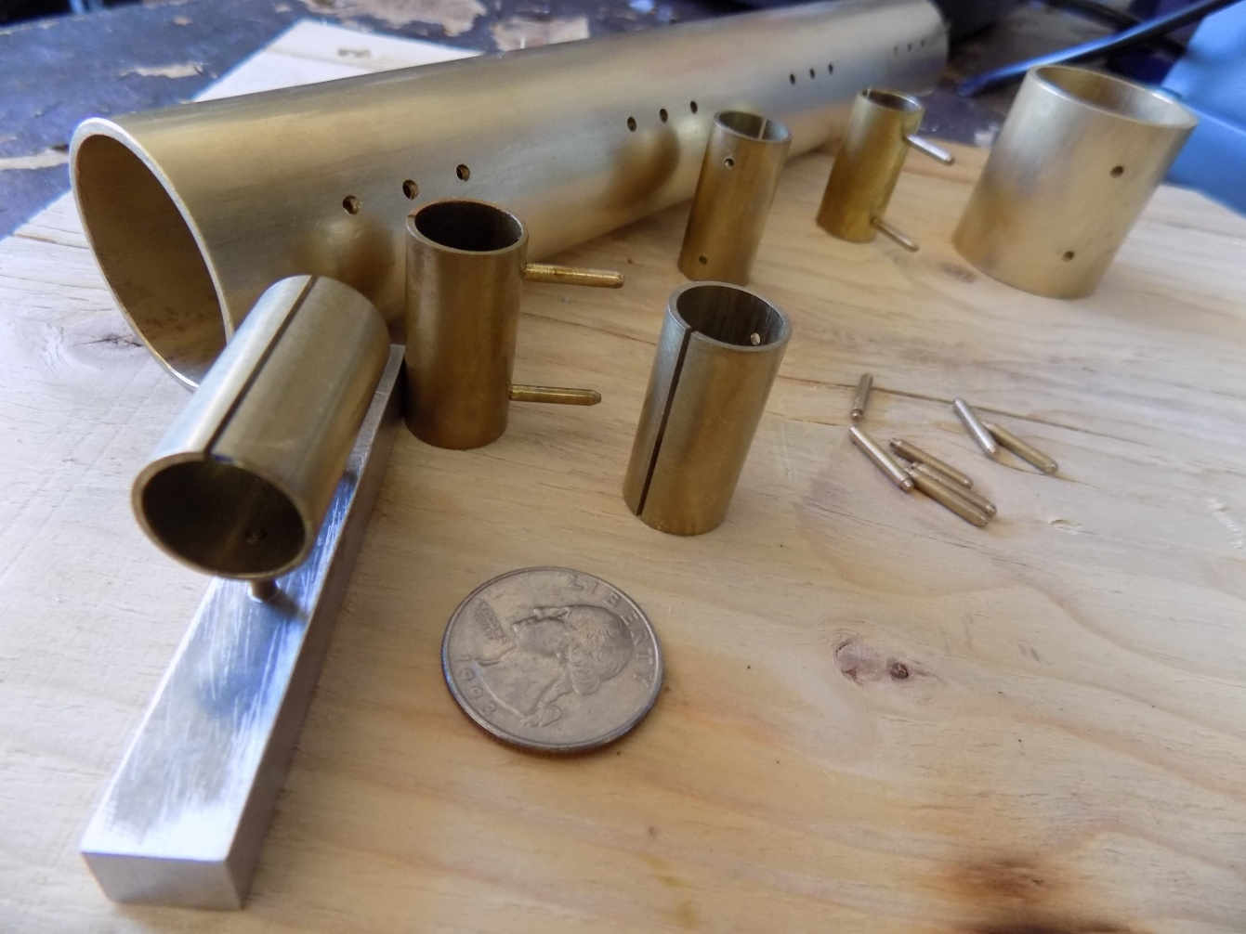
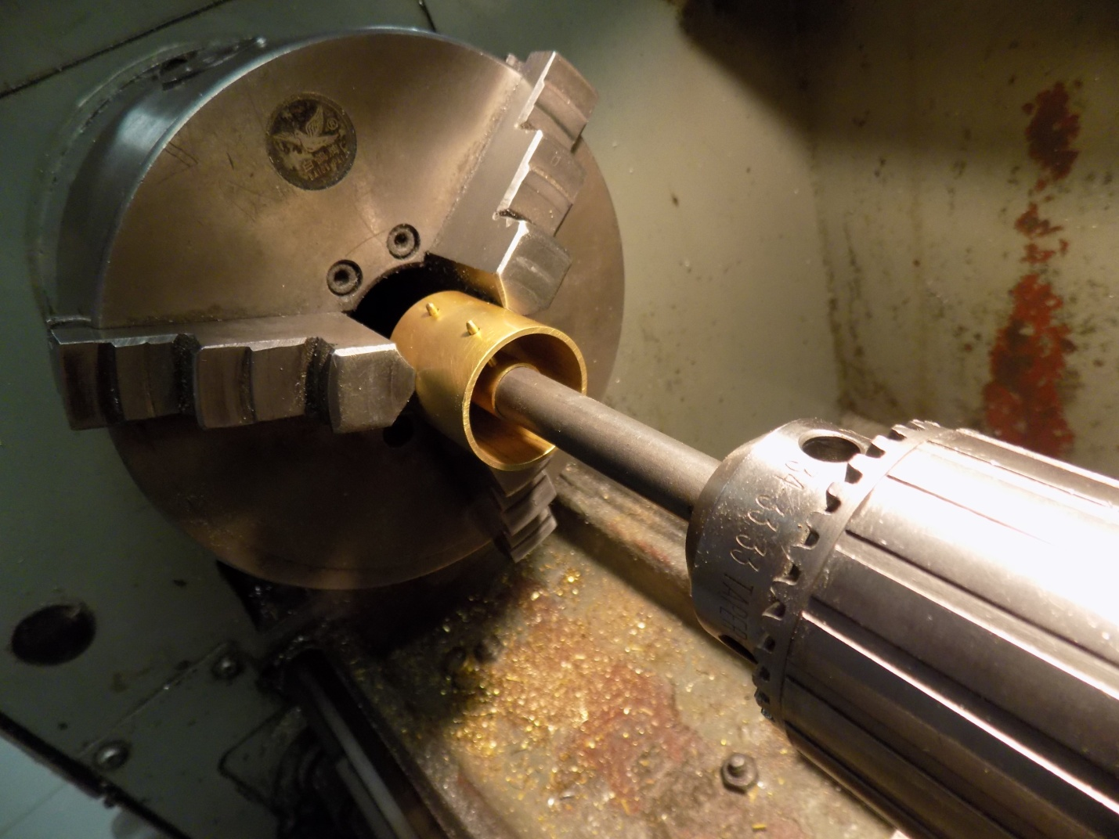
The single resonator components were then fixtured and soldered in a lathe because it has two co-axial chucks. The four resonator assembly was similarly fixtured after putting it together like a ship in a bottle.

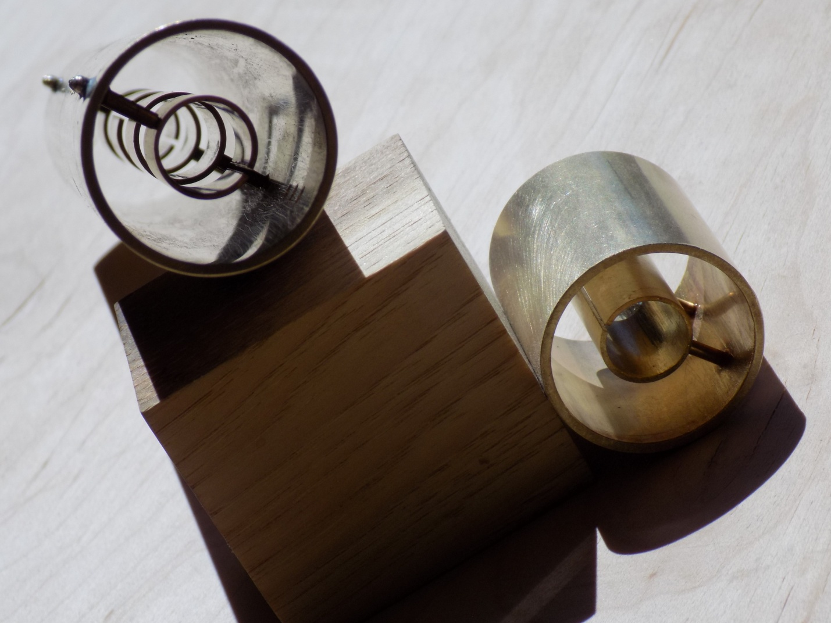

The assembly technique works well, the components remained coaxial. The single resonator has been RF tested, and to our surprise it resonates at 2.5 GHz rather than the target of 2.7445 GHz. Although we missed the frequency, RF testing these prototypes will tell us a lot about coupling to the resonance as well as the coupling between resonators in the four split ring prototype.

Ring Coupled Cavity Polarimeter @ 2.7445 GHz:
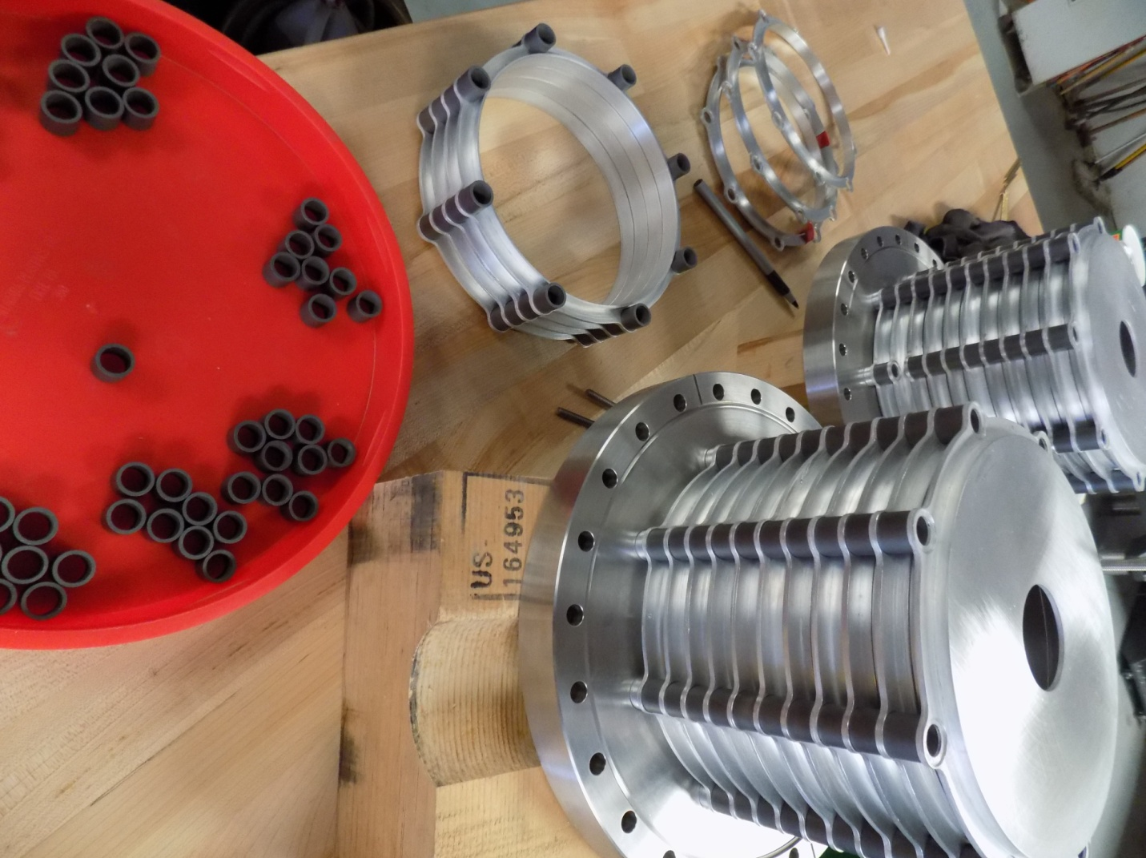
The Cavities have been tuned to their target frequency 2.774 GHz by precision grinding the Silicon Carbide spacers that separate the cavities segments.

Receivers: The 2.774 GHz and 15,219 GHz receivers are almost complete, they need machined housings and noise figure testing.

