Summer SAD Injector – 2018 (Updated June 1, 2018)

- Perform Bubble Experiment Engineering Run
  - Vacuum work - install harp and ceramic break on 5D beam line
  - Bubble chamber – reinstall target chamber as before
  - Beam Run – approximately one week of 24/7 running (up to 100uA)
- Install 350 kV HVPS
  - Assemble HVPS/SF6 tank near Gun2
  - Install HVPS controls/software
  - Modify and integrate PSS controls
  - Certify operation of HVPS
  - Demonstrate capability to switch between new/old supplies
- Install 200 kV Gun
  - Protect photocathode supply in Gun2
  - Vent Gun2 to install/align the 200kV electrode from UITF
  - Bake Gun2, leak free
  - High voltage condition Gun2, vacuum and/or gas conditioning
  - Make photocathode, check laser alignment
  - Restore and run beam at 130keV (new gun and HVPS)
  - Increase voltage to test injector settings needed w/ 200keV beam
- Reliable Polarized Source
  - Demonstrate “new gun” ready for operations
  - Gun back-out possible
  - HVPS back-out possible

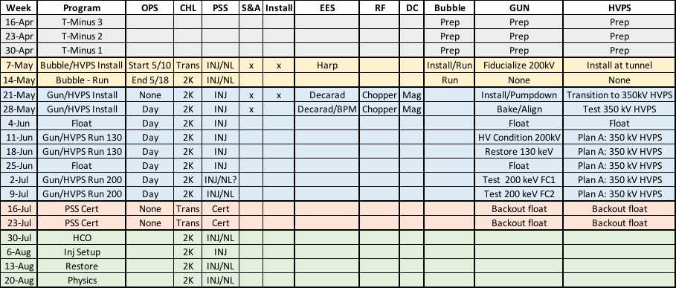

May 6 – May 19: First two weeks of SAD are highly integrated

- Sun/6
  - Beam off at 6am, then surveys
  - Attach turbo pump to 5D over board valve, clean-up overnight
- Mon/7
  - Bubble
    - Secure 5D vacuum valve
    - Unstack lead hut (RCG)
    - Vent 5D, install harp + ceramic break, verify isolation
    - S&A set harp rotation
    - Pump down + leak check vacuum OK
    - Install move crates tunnel, work w/ Brad begin install
    - S&A work w/ Brad set Bubble chamber
    - Install Bubble laser shutter
- Tue/8
  - Bubble
    - Final leak check Bubble line
    - Tony (re)allocate harp cable, make-up + HCO harp
    - Connect dump picoammeter
    - Install work w/ Brad to roughly set Bubble chamber
    - When ready S&A check 5D radiator/collimator set Bubble
  - Gun
    - Install move Suitcase, mate to Load and start bake
- Wed/9
  - Bubble
    - S&A complete alignment of Bubble chamber
    - ACE support for network controls
    - Brad continues Bubble assembly and training
  - Gun/HVPS
    - Install move/assemble SF6 + HV stack w/ John in tunnel
    - End suitcase bake
- Thu/10
  - Bubble
    - Complete Bubble assembly and training
    - Complete Bubble HCO checklists
- Thu/10 1600 – Fri/18 0800
  - 24/7 Ops and INJ/NL begins…(CA/RA by exp’t as needed)
  - Turn on Extractor Gauge
- Sat/19
  - Open House

Week of May 21st (#1)

Monday
  - Check laser retro-reflection
  - Admin Lockout gun from HV system
  - PSS Lockout 150kV Glassman
  - Secure gun valve
  - Magnet racks off, remove correctors from NEG tube
  - Move photocathodes to Suitcase
  - Remove HV cable, oil tank, computer cart away from gun
  - Crane OUT (optic table, clean table)
  - Crane IN (SF6 tank)
  - Allow S&A to setup
Tuesday
  - S&A have right of way measure (HV, electrode, NEG)
  - Stage turbo to vent HV chamber
Wednesday
  - Vent gun, remove electrode, cover 10” flange
  - Electrode to S&A lab to for measurement
  - Remove NEG tube, blank until ready for install
  - Remove RGA, replace w/ right angled valve (ready for plumbing)
Thursday
  - Check 200kV vs. 130kV puck cage => choose best one
  - SF6 tank could be staged
Friday
  - Install fiducialized 200kV electrode to Gun2, set/align
  - Install NEG tube w/ M20 BPM’s
  - Check all electrical isolations
  - Start Gun2 pumpdown, to leak check by Monday
  - RF condition choppers for 200kV operation

May 28 – June 1 : Bake Gun + Complete HVPS Installation

- Gun
  - Setup bake (HV chamber, NEG tube, right angled valve)
  - Careful bake: up – soak – down – activate – down

- HVPS/PSS
  - Facilities/PSS install conduit and AC contactors, cabling
  - Install 350kV Glassman control unit
  - Install 350kV Glassman interface chassis
  - Install 350kV Glassman control software
  - Install DAC iocin3, software/cabling
  - Move Keithley readbacks to 350kV
  - PSS/Software install VME comparator card
  - Complete assembly/cabling, HCO w/o PSS permissive
  - Continue HVPS assembly (add resistor + charge SF6)

June 4 – June 8: Operation HVPS + HV Condition Gun

- Gun
  - Careful bake: up – soak – down – activate NEG– down
  - Add krypton leak valve + plumbing, bake line
  - Leak check w/ PREP RGA
  - Lasers ON (A=pre-amp, D=atten)
  - Test magnets/PS for 200kV limits
  - Open gun valve, check retroreflection w/ C laser
  - Terminate BPM’s w/ 50ohm loads
  - Return Decarad, anode monitoring
  - Lock-out laser shutter

- HVPS/PSS
  - Complete HCO of PSS/HVPS (interlocks, controls, software)
  - Operate PSS/HVPS on itself (no gun connection)
  - PSS Cert/Review/OK for connection to gun
  - Connect gun to HVPS
  - HV condition w/o Kr first (assess x-ray/vacuum/anode)
  - Kr condition, eliminate FE at 200kV

- Remove Brock cavity 500kV line
  - Attach turbo, prep for venting
  - Prep to remove Brock cavity (ATLIS, notes, nipple, drawing)
  - Vent 1D, remove Brock cavity, replace
  - Pump down

June 11 – June 15 : Restore Gun Operation!

- Gun
- Hook-up two new BPM’s, perform HCO
- Reconnect cables, magnets
- Move Suitcase photocathodes to Prep
- Remove bulk GaAs to Suitcase for holding
- Make photocathode, install gun, LV to measure QE, check retro-reflection
- Remove SF6 w/ DILO, replace resistor for short, fill SF6

- 130 keV Beam
- standard operation INJ SEG mode
- Use 130kV beam and test PSS kicker in “200kV location”
- Restore beam to FC2 w/ new gun @ 130 keV
- Once satisfied, test transition between 350/150 HVPS ???

June 18 – June 22: Bakout Option / Float !!!

June 25 – July 29: 200 keV operation

- Configured and scale injector for 200keV beam
- Operate gun at 200kV, setup/test injector for beam to FC1 (chopper OFF)
- Perform PSS kicker and PSS dipole (INJ SEG) testing/certification
  - If desired move PSS kicker to a new “200kV location”
- Use Wien or spectrometer to measure energy stability
- Turn on chopper, measure deflection v. power, perform chopper setup
- Benchmark beam v. charge (transmission, emittance)
- Decide on possible setup to FC2 (chopper ON/OFF, capture ON/OFF)

July 2 – July 13: Complete 130/200 keV Beam Studies

INJ SEG
- Magnet capabilities/optics
- Chopping/dechopping
- Longitudinal bunch length
- Lifetime
- Transverse emittance
- Wien reach

INJ/NL
- FC2 setup
- Mott/transmission polarimeter

