Appendix A: Detailed JLab report

Report Period of Performance:
FY23 – Q1: 09/01/2022 – 12/31/2022

Co-Principal Investigator:
Riad Suleiman, with Joe Grames and Matt Poelker (Jefferson Lab), and Eric Voutier (IJCLab, Orsay, France) and Greg Blume (graduate student – ODU).

Work-scope Highlights:
Jefferson Lab’s contribution to this project is to provide a Compton Transmission Polarimeter, which will be used to measure beam polarization when SRF photogun employs a GaAs photocathode. IJCLab is contributing to Jefferson Lab’s effort.

Q1 FY23 Brief summary of activity issues, concerns, successes:

Activity successes:
- Polarimeter has been calibrated at Jefferson Lab
- Graduate student (Greg) finished data analysis. Now working to complete GEANT4 simulation to compare to data.
- For second polarimeter and DAQ: Radiator #2 needs to be fabricated – this polarimeter will stay at Jefferson Lab
- Working on documentations and writing a paper for publication
- Greg submitted an abstract to IPAC'23

Issues and concerns: Now under 1-year NCE that ends 9/23. Plan to submit an NCE request for another year for BNL install.

Milestones
- Polarimeter is ready. Now waiting on BNL to give us the green light to move and install the polarimeter at their facility (expected in Fall 2023).
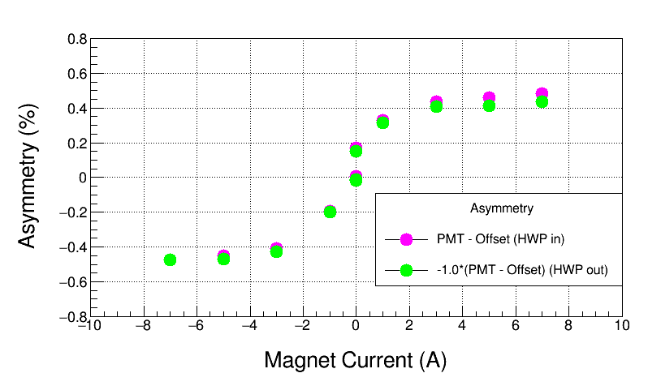
Figure 1: Measured Compton transmission asymmetry as a function of the magnet current for electron beam kinetic energy of 5 MeV. The Compton polarimeter analyzing power at magnet current of 5 Amps is $1.21±0.04 \left(stat\right)\%$
Budget

Summary of total expenditures:

ID # | Item/Task | Baseline  Total Cost  (AY$) | Costed &  Committed  (AY$) | Estimate  To Complete  (AY$) | Estimated  Total Cost  (AY$)
COMTRA | Compton Trans Polarimeter | $400,200 | $338,616 | $61,584 | $400,200
 | Totals: | $400,200 | $338,616 | $61,584 | $400,200

- Note: Costed and Committed numbers are as of December 31, 2022

Summary of expenditures by fiscal year (FY):
FOA Funding | FY 2020 | FY 2021 | Total
a) Funds allocated | $200,100 | $200,100 | $400,200
b) Actual costs to date | $200,100 | $117,572 | $317,672
c) Uncosted commitments | $0 | $20,944 | $20,944
d) Uncommitted funds | $0 | $61,584 | $61,584

